Grammar Lesson Plan
Title: Reported Speech

Instructor:  Bora | Level:  Intermediate | Students:  7 | Length:  25min

Materials:
- a picture of a person and a shadow
- speech bubbles
- 2 worksheets for activities (comparison of direct speech & indirect speech, reported speech with opposite meaning)
- a white board and markers

Aims:
- To know the form, meaning and use of reported speech
- To know the difference of direct speech and indirect speech
- To practice the form and use of indirect speech by answering the worksheets
- To use the reported speech sentence naturally in appropriate situations

Language Skills:
- Listening: listening to teacher’s instruction, demonstrations and CCQs and listening to students’ answers
- Speaking: prediction, sharing the answers and ideas
- Reading: reading the worksheets
- Writing: answering the questions on worksheets

Language Systems:
- Lexis: new vocabularies (grammatical terms)
- Phonology: listening to instruction & explanations, drilling
- Grammar: direct speech & indirect speech
- Function: reported speech used to tell someone about the interview on the newspaper

Assumptions about Students:
- Students already know the teacher’s style of teaching and how the classroom works.
- Students’ level is intermediate.
- Most students don’t know the term “reported speech”.
- Most students don’t know the difference of direct speech and indirect speech

Possible Problems and Solutions:
- Students may not clearly understand the meaning of reported speech
→ Provide more examples and situations
- Students have a hard time drilling
→ Give the error correct immediately & give students more chances to practice
- If students need more time to practice on worksheets
→ Give students more time and share the answers
- If students finish their worksheets earlier than anticipated
→ Give students more time for post activity

References:
- http://www.eslgold.com/grammar/reported_speech.html
- http://a4esl.org/q/h/9901/tm-reported1.html
- http://www.eslbase.com/grammar/reported-speech
- Times Media student workbook

Lead-in:
Materials: a picture of a man and a shadow, speech bubbles
Time | Set Up | Procedure
2 min | whole class | Greeting  Hello, everyone. How are you, today?  Eliciting  Let me ask you a question. Have you ever told someone what another person said? Of course, yes! Susan said that …, Ashley told me that …. Let’s have a look those pictures. This is John. He is talking to a shadow man. What are they talking about? They are talking about Jenny, their friend. John met Jenny yesterday and he wants to report Jenny’s words to a shadow man. (speech bubble) Jenny said, “My parents are fine.” “Jenny said that she was going to learn to drive.” Which is right? Which is correct? Both are right.  Introduce the topic  Today, we are going to learn about reported speech and the use of it.

Pre-activity:
Materials:
Time | Set Up | Procedure
6min | whole class  whole class | Meaning  As these speech bubbles, if you want to tell somebody what the other person said, you can say it with two ways. One is direct speech, the other is indirect speech.  What do you think? Which one is direct and which one is indirect? This is direct speech. The original speaker’s exact words are used within quotation marks. For indirect speech, the original words are paraphrased and no quotation marks are used.  Form (Ask & Answer)  How can we change the direct speech into indirect speech? There are some rules. Let’s learn how to change with examples.  1. In reported speech we usually report what was said at a different time, so we change the tense to reflect the time which we are reporting. We normally “shift back” one tense.  (example: Jenny said, “My parents are fine” When did Jenny say this to John? Yesterday. So we just shift back one tense.  Jenny said that her parents were fine.)  2. Sometimes we need to change the pronoun.  (example: Jenny said, “My parents are fine”  Jenny said that her parents were fine.)  3. We may also need to change other words about place and time.  (example: Jenny said, “I like this car.”  Jenny said that she liked that car.)  Jenny said, “I went to Seoul last week.”  Jenny said that She had been to Seoul the week before.)  To make a reported speech, we need to change the tense, pronoun, and some other words.  Drilling  Let’s practice together.  Instruction  Yesterday you met your friend, Jenny. You had great time talking to each other. Here are some of the things Jenny said to you in direct speech. Today you tell another fried what Jenny said. You have to use reported speech, the indirect speech. How can you say?  Demonstration  Jenny said “I want to buy a car.”  We can change it to “Jenny said that she wanted to buy a car.”  Here are many words Jenny said to you.  Let’s change them into indirect speech.  CCQs  - Who said these words?  - What do we have to make?  - Do we say with direct speech or indirect speech?  (Run the task)  What can you say to your friend about what Jenny said?

Main Activity:
Material: Worksheets #1 & #2, white board & markers
Time | Set Up | Procedure
10min | whole class  individual  individual | Let’s check if you understand the “reported speech” well.  1st Main Activity>  Instruction  Look at here. Who is he? That’s right. This is John. Yesterday you met a friend, John. You hadn’t seen him for a long time. Here are some of the things John said to you.  Later that day, you tell another friend what John said. You have to use “reported speech”.  Demonstration  What can you say to your another friend?  (Writing an example on the board)John said, “I’m living in my own apartment now.”  Hey, John said that he was living in his own apartment now.  Here are 7 speech bubbles left.  CCQs  - When did you meet your friend John? (Yesterday) So you have to change the tense.  - What else do we have to change? (Pronoun and other words)  - What do you have to use? (reported speech)  (Run the task)  Check the answers together.  ^{2nd} Main Activity>  Instruction  Somebody says something to you. But that is opposite of what they said before.  Demonstration  A says “That restaurant is expensive.”  But a few days ago, A said, that restaurant was cheap. So, what can you say to A?  “It is? You said that restaurant was cheap.”  Please complete the answers individually in 3 minutes.  CCQs  - Does A say the same thing as before?  - Is it opposite of what A said before?  - What would you like to do?  (Run the task)  Check the answers together.

Post-activity:
Materials: -
Time | Set Up | Procedure
7min | whole class | Production  Instruction  Now, we will tell our one secret to our partner. Then, your partner goes and tells these secrets to other people in the class. After 4minutes, I’ll ask you other students’ secret. You can say it with reported speech.  Demonstration  For example, I tell my secret to my partner, Sunny. “Actually, my boyfriend is mama’s boy.” Sunny goes to Kevin and tell “Bora said her boyfriend was a mama’s boy.”  CCQs  - What will you tell to your partner?  - What will you do after you hear your partner’s secret?  - What grammar structure will you use?  (Run the task)  What did you hear, David?  Homework  Your homework is “reporting the interview of celebrities you love”. When you go back home, find the interview or news about the celebrities you love, you write it on your note with reported speech.  CCQs  - What will you find?  - What will you read?  - What will you write?

Appendix
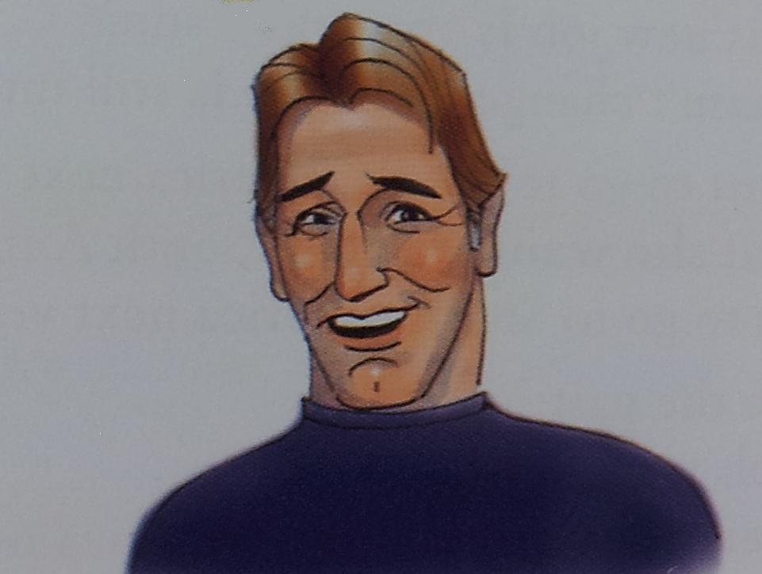
John
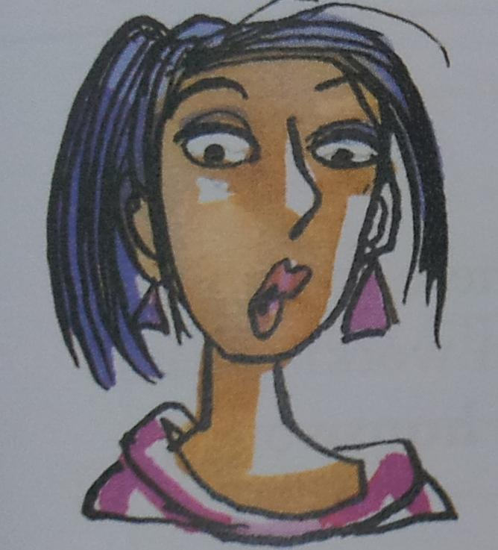
Jenny

Worksheet # 1

Yesterday you met a friend of yours, John. You hadn’t seen him for a long time. Here are some of the things John said to you.

1. I’m living in my own apartment now.
2. I’m not enjoying my job very much.

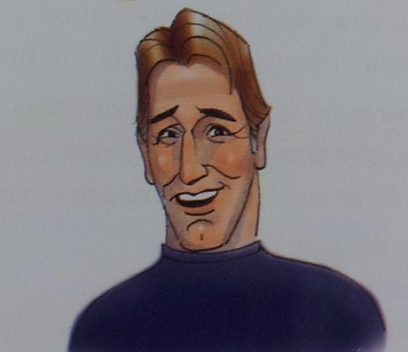
8. I like this car.
7. My parents have gone on holiday.
5. I can’t drive.
3. My father isn’t’ very well.
6. I’m feeling sick.
4. I’m from North Carolina.
John

Later that day you tell another friend what John said.. Use reported speech.

1. John said that .
2. He said that
3. He
4.
5.
6.
7.
8.

Worksheet # 2

Somebody says something to you that is the opposite of what they said before. Complete the answers.

1. A : That restaurant is expensive.
B : It is?

2. A :Sue is coming to the party tonight.
B : She is? I thought you said she

3. A : Ann likes Paul.
B : She does? Last week you said

4. A : I know lots of people.
B : You do? I thought you said

5. A : Pat will be here next week.
B : She will? But didn’t you say

6. A : I’m going out tonight.
B : You are? But you said

7. A : I can speak a little French.
B : You can? But earlier you said

8. A : I haven’t been to the movies in ages.
B : You haven’t? I thought you said

