Listening Speaking Reading Grammar Writing

Topic:
Travel to London

Instructor:  Jaimee(JinMi Lim) | Level:  itermediate | Students:  6 | Length:  40 Minutes

Materials:
- Pictures for eliciting(Flag of England)
- Pre-Activity Worksheet (6 copies)
- Main-Activity Worksheet (London attraction pictures)
- Post-Activity Worksheet (6 copies)
- White board and Board markers

Aims:
- To enable Students to improve their speaking skills by giving a presentation about London attractions
- The students will be able to introduce attraction by playing the role of travel guide

Language Skills:
- Listening: Students will listen to teacher’s instructions and classmate’s speaking.
- Speaking: Students will practice their speaking by becoming travel guide and sharing their ideas
- Reading: Students will read the information about London attractions
- Writing: Students will make sentences by Worksheets

Language Systems:
- Lexis: vocabulary of travel items and attractions of London
- Grammar: future tense “be going to”
- Function: how to introduce attractions and to know about London
- Phonology: Introducing about London attractions
- Discourse: Giving a presentation for role play

Assumptions:
Students already know:
- how the class is set up and run
- the teacher’s style of teaching and the pace of the course
- they are all adults
- where is London
- students speak with few inaccuracies
- students know they should speak only English in the class

Anticipated Errors and Solutions:
- Ss may not know about attractions
→ Give students information pictures
- Ss may need more time the work on the worksheet
→ Give Ss some more time and help them
- If time is running out
→ Cut –off plan

References:
- Times TESOL Workbook
- http://image.search.naver.com
- http://www.aviewoncities.com/london/westminsterabbey.htm

Pre-Task
Materials:
Board and Board Markers
Time | Set Up | Student Activity | Teacher Talk
3min | Whole  Class | Greeting  Listening the teacher talk  Answering the question | 1. Greeting  Hello everyone.  How are you today? Good!  Is there anyone who likes traveling?  I think everyone likes traveling.  2. Eliciting  OK! Today, We will travel to any city.  What is the name of the city? Guess!  This city is a major global city and one of the world's largest financial centre  This city’s Airport is the world's busiest airport by number of international passengers  (Showing the flag of England)  This city is the capital of England and the United Kingdom.  What is the name of the city?  Yes!

Task Preparation
Materials:
Map, Pre- Activity Worksheet, Board and Board Markers
Time | Set Up | Student Activity | Teacher Talk
2min  5min  3min  5min | Whole  Class  Whole  Class  Individually  Whole  Class  Whole  Class  Whole  Class  Individually  Whole  Class | Listening teacher talk  Sharing the experience  Answering the question  Listening teacher talk  Completing worksheet  Answering the question  Sharing the ideas and opinions  Listening teacher talk  Choose a picture  Answering the question | 1. Eliciting  London is a big city.  London has a largest metropolitan area in the United Kingdom, and the largest urban zone in the European Union.  Have you ever been to London?  Do you know where is the London?  (use a map)  CCQ  1. Where is the London?  2. Choosing Items  Instructions  What do you have when you take the travel?  Before we go to London, we will bring some items. I will give you the items picture.  (Giving Students Pre-worksheets)  But you can take only three items.  Choose three items and explain the reason.  Demonstration  For example, I need a guide book because I can get some information and refer to.  (Write the sentence on the board)  I will give you 3 minutes.  CCQ  1. What are you going to do?  2. How many minutes do you have?  (Students do the activity)  Monitor discreetly.  Answer students if they ask questions.  Give time warning: 30 seconds left.  Be flexible with time.  Alright. Are you done? Time is up!  OK. Who want to share your ideas?  Go through the one by one  Students talking time  OK. Everyone did a good job!  Thank you.  3. Prediction  Instructions  (Put the pictures of London attraction on the board)  Now, you guys will travel guide  Do you know travel guide?  The travel guide will introduce tourist attractions.  Do you know attraction?  An attraction is something that people can go to for interest or enjoyment, for example a famous building and place.  Look at this. Here are the pictures of London’s attraction.  You choose a one picture.  CCQ  1. What is the mean an attraction?  2. What is the pictures?

Task Realization
Materials:
Main-Activity Worksheet (picture of attraction), Board and Board Markers
Time | Set Up | Student Activity | Teacher Talk
5min  10min | Whole  Class  Individually | Listening teacher talk  Read a description  Answering the question  Presentation  Listening the other students talk  Sharing the ideas and opinions | 1. Explain activity  Instruction  Do you have a picture?  Do you see a description?  There is some information about the place. Now, You will travel guide!  Read a description and introduce tourist attraction for others.  Demonstration  For example, I choose a London Eyes. London Eyes is a giant observation wheel. The structure was designed by the architectural team of David Marks and Julia Barfield, husband and wife.  The looking capsules have up to 25 passengers. The observation wheel turns slow while it is moving.  A complete turn takes about 30 minutes. Many famous landmarks are clearly visible, on a clear day you can see as far as 40 km.  OK! I will give 3 minutes.  CCQ  1. What are you going to do?  2. How many minutes do you have?  (Students do the activity)  Monitor discreetly.  Answer students if they ask questions.  Give time warning: 30 seconds left.  Be flexible with time.  Give 1more minute if they need it.  2. Presentation  Instruction:  OK. Time is up.  Let’s enjoy London!  Who wants to be first?  Students Talking Time  Good job! Everybody!

Post Task
Materials:
Post-Activity Worksheet, Board and Board Markers
Time | Set Up | Student Activity | Teacher Talk
3min  4min | Whole  Class  Whole  Class | Listening teacher talk  Completing worksheet  Sharing the ideas and opinions | 1. Free production  Instruction  Did you enjoy London?  I hope, you will enjoy real London someday.  Now, let’s talk about the place that you want to go in the future.  I will give you worksheet.  (Giving Students Post-worksheets)  Please answer the questions.  Where do you want to go and why? What are you going to there?  Demonstration  For example, I’ll be going to Brazil. Because I want to experience passionate culture of Brazil.  And I learn to dance Samba!  You have 3minutes.  CCQ  1. What are you going to do?  2. Are you working individually?  3. How much time do you have?  Monitor discreetly.  Answer students if they ask questions.  Give time warning: 30 seconds left.  OK. Time is up!  Who wants to tell us first?  Share students talking time!  2. Conclude lesson  Do you have any questions about today’s lesson?  You did a great job today.  Thank you all of you.

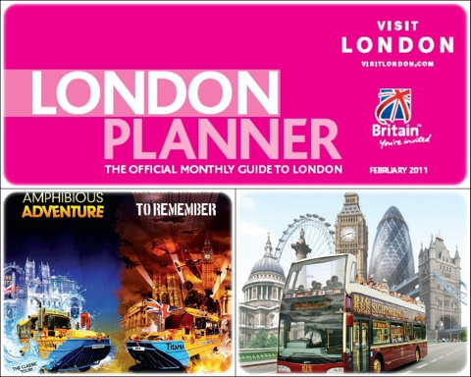
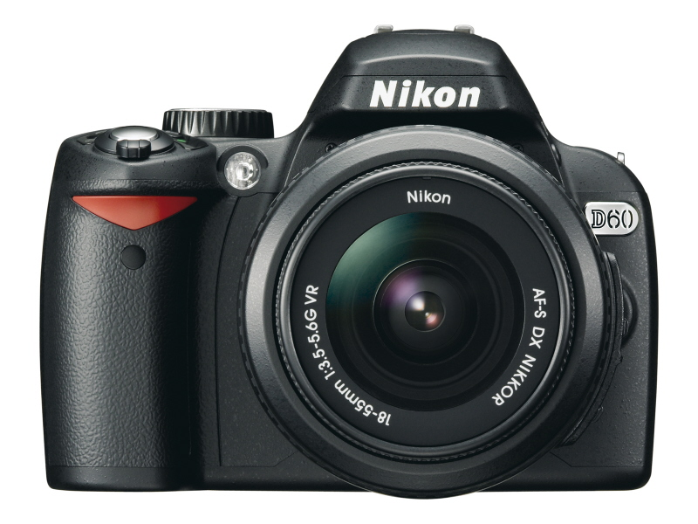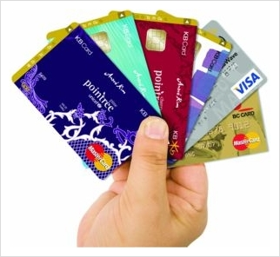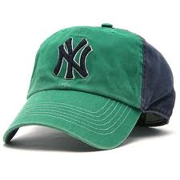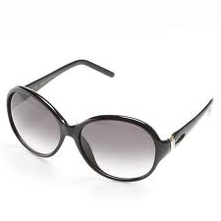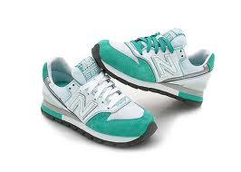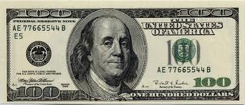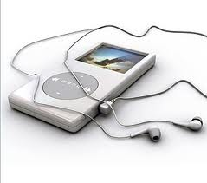

Choose three items you want to take and explain why you need.

1. I need because

2. 1. I need because

3. 1. I need because

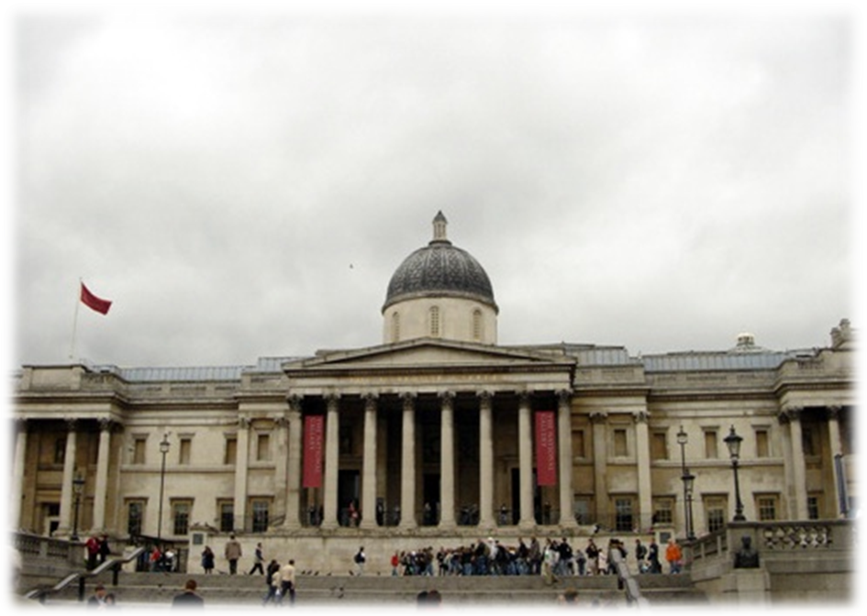

Buckingham Palace
One of several palaces owned by the British Royal family, is one of the major tourist attractions in London. The original building was constructed as a country house in 1705 by the duke of Buckingham, John Sheffield. King George III bought the house in 1761 for his wife and had it altered by William Chambers.
In 1826, King George IV asked famed architect John Nash to expand the house - then known as Buckingham House - into a palace. Meanwhile St. James's Palace was still the principal palace used by the royals for ceremonies and receptions. King George IV as well as his younger brother and successor King William IV both died before the palace was completed. Queen Victoria was the first to reside in the palace. In July 1837, three weeks after her accession to the throne, she moved from Kensington Palace, where she grew up, to the new Buckingham Palace.
The palace was expanded in 1850 with a new east wing. The wing added a large number of rooms to the palace, including an expansive 40 meter (131 ft) long ballroom. The monumental façade of the east wing was built in 1913 by Aston Webb. It is this facade, facing the Mall and St James's Park, which is now known by most people.

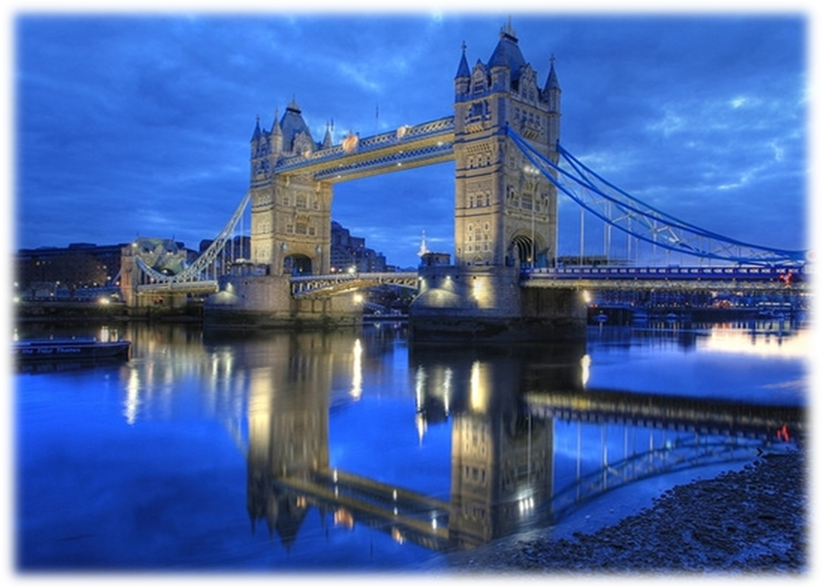
Tower Bridge
Tower Bridge (built 1886–1894) is a combined bascule and suspension bridge in London, England, over the River Thames. It is close to the Tower of London, from which it takes its name. It has become an iconic symbol of London. The bridge consists of two towers tied together at the upper level by means of two horizontal walkways, designed to withstand the horizontal forces exerted by the suspended sections of the bridge on the landward sides of the towers. The vertical component of the forces in the suspended sections and the vertical reactions of the two walkways are carried by the two robust towers. The bascule pivots and operating machinery are housed in the base of each tower. The bridge's present colour scheme dates from 1977, when it was painted red, white and blue for the Queen Elizabeth II's silver jubilee. Originally it was painted a mid greenish-blue colour. Tower Bridge is sometimes mistakenly referred to as London Bridge, which is the next bridge upstream. The nearest London Underground station is Tower Hill on the Circle and District lines, and the nearest Docklands Light Railway station is Tower Gateway.

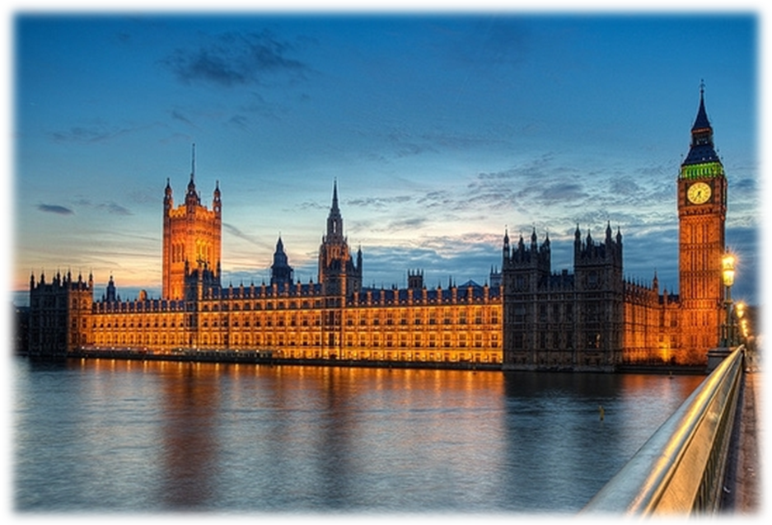
Big Ben
The Clock Tower of the Palace of Westminster is commonly known as the Big Ben. The tower is one of London's most famous landmarks.The clock inside the tower was the world's largest when it was installed in the middle of the 19th century. The name Big Ben actually refers to the clock's hour bell, the largest of the clock's five bells. The other four are used as quarter bells.
There were two bells cast as the clock tower's hour bell. A first, 16 ton weighing bell was cast by John Warner and Sons in 1856. Since the Clock Tower was not yet completed, the bell was hung temporarily in the Palace Yard. The bell soon cracked so it was recast in 1858 in the Whitechapel Bell Foundry as a 13.5 ton bell. The hour bell was probably named after Benjamin Hall, the First Commissioner of Works. Some sources however claim the bell was named after Benjamin Caunt, a British heavyweight boxing champion.The clock is known for its reliability, it has rarely failed during its long life span. Even after the nearby House of Commons was destroyed by bombing during World War II, the clock kept on chiming. The clock's mechanism, designed by Edmund Beckett Denison, has a remarkable accuracy. The clock's rate is adjusted by simply adding small pennies on the shoulder of the pendulum. The clock tower rises 316ft high (96m) and consists of a 200ft (61m) high brick shaft topped by a cast iron framed spire. The clock faces are 180ft / 55m above ground level.
Unfortunately the clock tower is not publicly accessible, but if you're looking for views over London the London Eye is currently the best option.
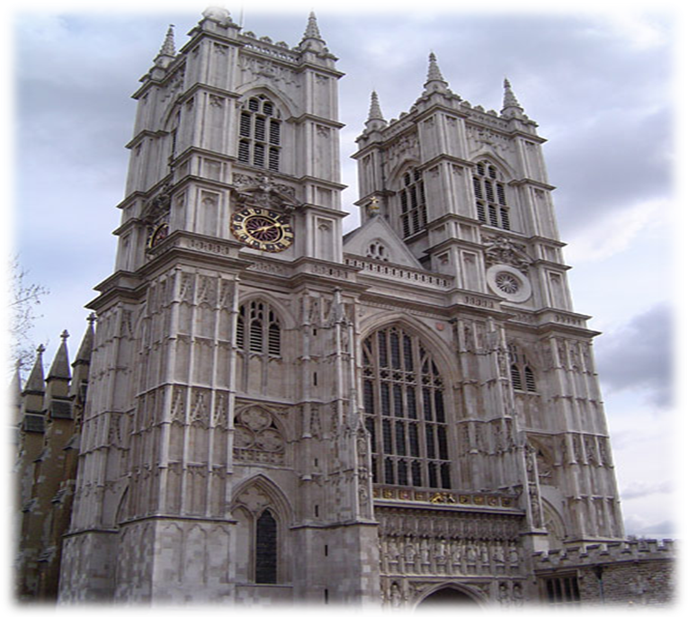
Westminster Abbey

Located near the Houses of Parliament, is more a historical site than a religious site. Since 1066 every royal coronation, with the exception of Edward V and Edward VIII has taken place in Westminster Abbey.
The abbey also serves as the burial ground for numerous politicians, sovereigns and
artists. The abbey is stuffed with tombs, statues and monuments. Many coffins even stand upright due to the lack of space. In total approximately 3300 people are buried in the church and cloisters. Some of the most famous are Charles Darwin, Sir Isaac Newton and David Livingstone. The history of the abbey starts in 1050, when King Edward The Confessor decided to build a monastery. Only a small part of this Norman monastery, consecrated in 1065, survived. The only representation of this original building is shown on the Bayeux Tapestry.
Most of the present building dates from 1245 to 1272 when Henry III decided to rebuild the abbey in the Gothic style. The building was later significantly expanded: the Chapel of Henry VII was added between 1503 and 1512, while the two West Front Towers date from 1745. The youngest part of the abbey is the North entrance, completed in the 19th century.

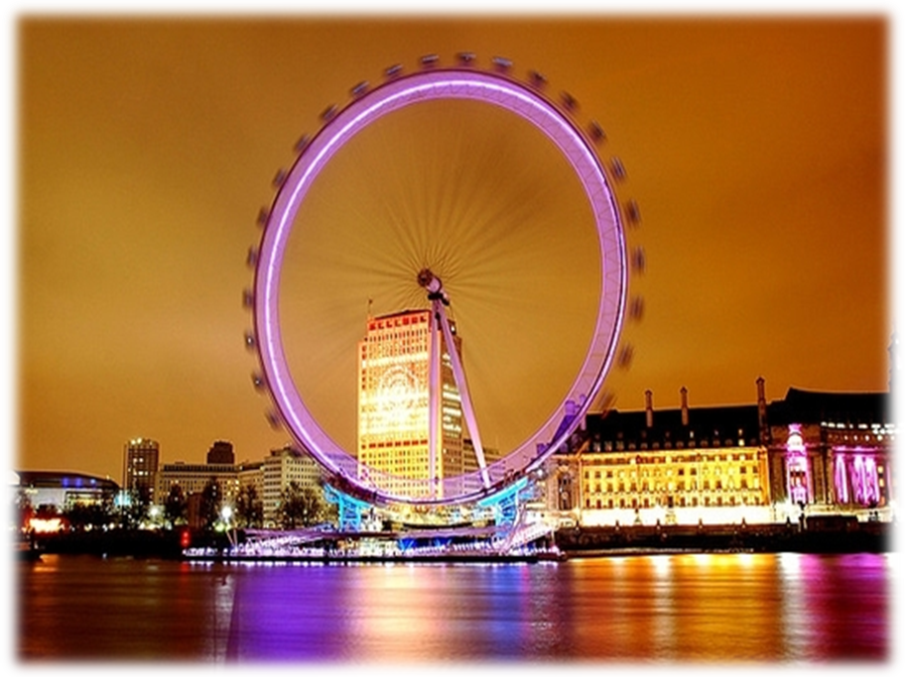
London Eye

A recent but already very popular tourist attraction is the London Eye, a giant observation wheel located in the Jubilee Gardens on the South Bank. The 135 meter (443ft) tall structure was built as part of London's millennium celebrations.
The structure was designed by the architectural team of David Marks and Julia Barfield, husband and wife. They submitted their idea for a large observation wheel as part of a competition to design a landmark for the new millennium. None of the entrants won the competition, but the couple pressed on and eventually got the backing of British Airways, who sponsored the project. The futuristic looking capsules, accommodating up to 25 passengers, were transported all the way from France by train through the channel. Each egg-shaped capsule is 8 meters long and weighs 500kg. The 25 meter (82 ft) long spindle was built in the Czech Republic. The rim has a diameter of 122m (400ft), about 200 times the size of a bicycle wheel. 80 Spokes connect the rim with the spindle.
The observation wheel turns slow enough for people to embark while it is moving. A complete turn takes about 30 minutes. The passengers have a great 360° view over London. Many famous landmarks are clearly visible, including Buckingham Palace, St. Paul's Cathedral and the Houses of Parliament. On a clear day you can see as far as 40 km (25 miles).

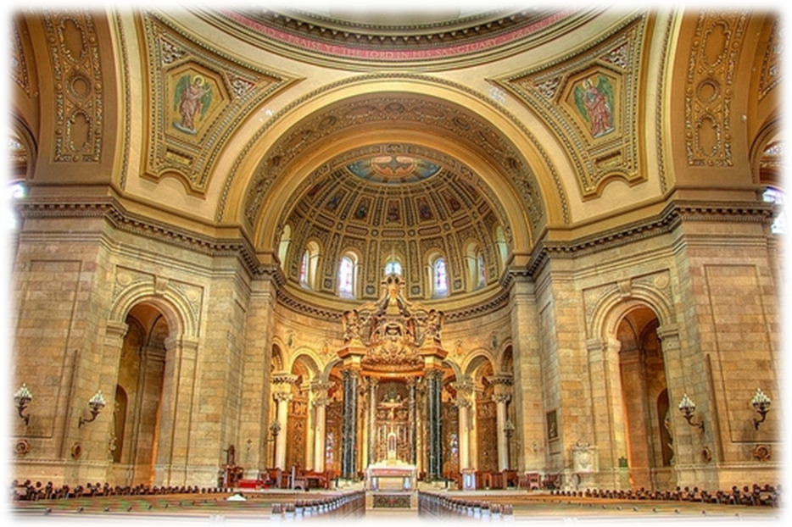
St. Paul's Cathedral
St. Paul's Cathedral has had an eventful history. Five different churches were built at this site. The first church, dedicated to the apostle Paul, dates back to 604 AD, when King Ethelbert of Kent built a wooden church on the summit of one of London's hills for Mellitus, Bishop of the East Saxons. At the end of the 7th century, the church was built in stone by Erkenwald, Bishop of London. In 962 and again in 1087, the cathedral was destroyed by fire, but each time it was rebuilt and expanded. By that time, it had become one of the largest cathedrals in Europe. Renovations and extensions in the 13th and 14th century enlarged the cathedral even more. In 1665 Christopher Wren designed a plan for the renovation of the St. Paul's Cathedral, which was starting to fall into decay. But disaster struck again on the night of September 2, 1666, when the Great Fire of London destroyed 4/5th of all of London, wiping 13,200 houses and 89 churches, including the St. Paul's Cathedral off the map. The dome reaches a height of 111 meters (366 ft) and weights about 66,000 ton. Eight arches support the dome. On top of the dome is a large lantern with a weight of 850 ton. 560 Steps lead visitors along three galleries all the way to the top of the dome. The first gallery, the Whispering Gallery, just inside the dome, is renowned for its acoustics. The second gallery, the Stone Gallery, is situated at a height of 53 meter (174 ft) on the outside of the dome, right above the colonnade. On top of the dome, at a height of 85 meter (279 ft), is the narrow Golden Gallery, which encircles the lantern's base. From here you have a magnificent view over the City.
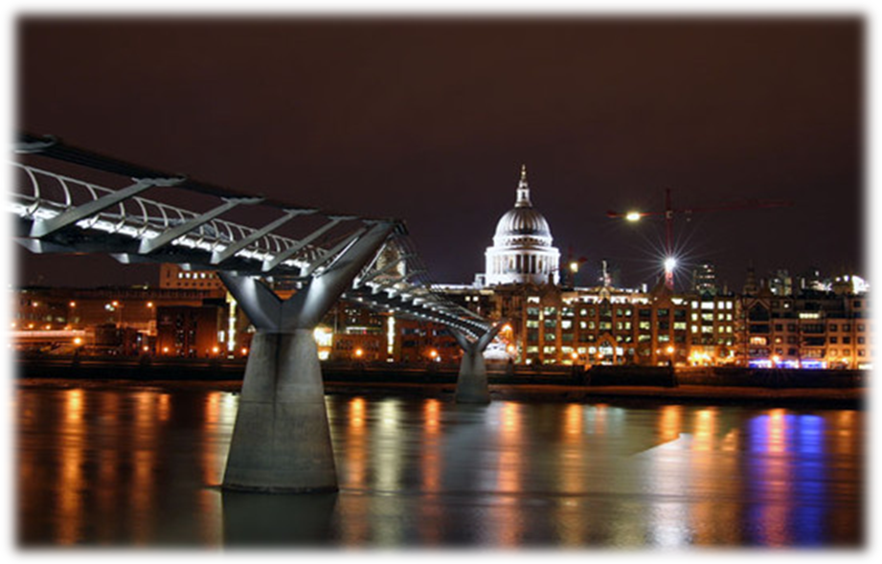
Millennium Bridge
Originally opened in June 2000 then closed almost immediately due to structural problems, London's modern Millennium Bridge is now a favorite with locals and tourists alike. London's Southwark Council sponsored a competition in 1996 to choose the designer of a new Millennium Footbridge that would span the Thames River between the Southwark Bridge and the Blackfriars Bridge. This would be the first bridge built across the Thames River since the building of the magnificent Tower Bridge in 1894 and was to be a part of the city's millennium celebration.
The winning entry, a suspension bridge, was tagged "the blade of light" and was designed by Arup, Foster and Partners and Sir Anthony Caro.
This footbridge would stretch a total of 325 meters (about 1,066 feet) and would include supporting cables below the deck level in order to preserve the view of several landmarks on either side. The design allowed for a 4-meter-wide (13.5 feet) deck for walkers and the structure was designed to hold 5,000 pedestrians at any given time.
Construction of the bridge began in late 1998 and was completed in June 2000, about 2 months behind schedule. The total cost to build the bridge was £18.2m or about €30 million (at the time 1 euro was approx. 1 US dollar). Unfortunately, during the first two
days that the structure was open, the thousands that crossed it noticed that the Millennium Bridge seemed to wobble. It was quickly nicknamed "The Wobbly Bridge" or "The Wibbly-Wobbly" and was immediately closed for modifications, just three days after it opened. Modifications succeeded in entirely eliminating the problem, but those necessary
modifications caused the bridge to remain closed until February 2002.
It cost an additional £5m to complete the changes, but no significant vibrations have been felt since that time.
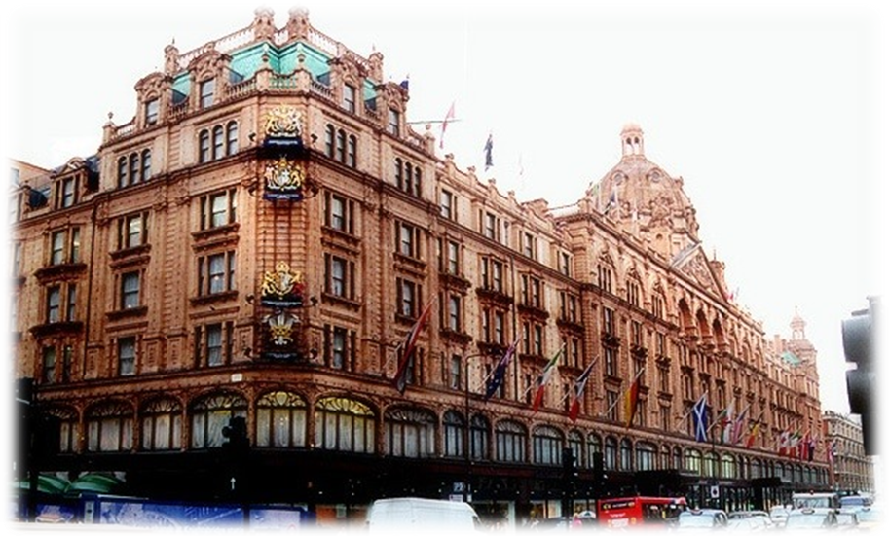
Harrods
Harrods is London's most famous department store. The luxurious store is on many tourists' itineraries, who come to admire the magnificent interior and enormous selection. They often leave the store with a signature green bag; foreign visitors account for a significant part of the store's sales. History of this famous luxury store goes back to 1849 when Charles Henry Harrod opened a grocery at Brompton Road in Knightsbridge, at the time a small village just outside London. Just two years later, the Great Exhibition of 1851, which took place at Crystal Palace in nearby Hyde Park, brought many visitors to the area. Knightsbridge and Harrod's new store boomed.
In 1894 Harrods was taken over by Richard Burbridge who had the store completely rebuilt. He also installed London's first escalator, in 1898. The current building was also commissioned by Burbridge. The impressive domed structure was built between 1901 and 1905 after a design by local architects C. W. Stephens and E. J. Munt.. The enormous array of products is particularly impressive. The company's motto - engraved on the building's pediment - is Omnia, Omnibus, Ubique (Everything, for everyone, everywhere). Harrods used to be known as the store where anything you could think of was for sale. While this may not be the case any more, the assortment is still enormous. You can purchase anything from historic 18th century dinner plates or giant teddy bears to exquisite caviar. One of the most beautiful departments of the store is the magnificent Food Hall on the lower floor, decorated with tiles created by artist Williams James Neatby. Other impressive departments include the Egyptian Halls and the Crystal Rooms. Also of note is the central escalator, decorated with Egyptian motives. And don't forget to visit the toy department - the city's best - where you'll find enormous stuffed animals.
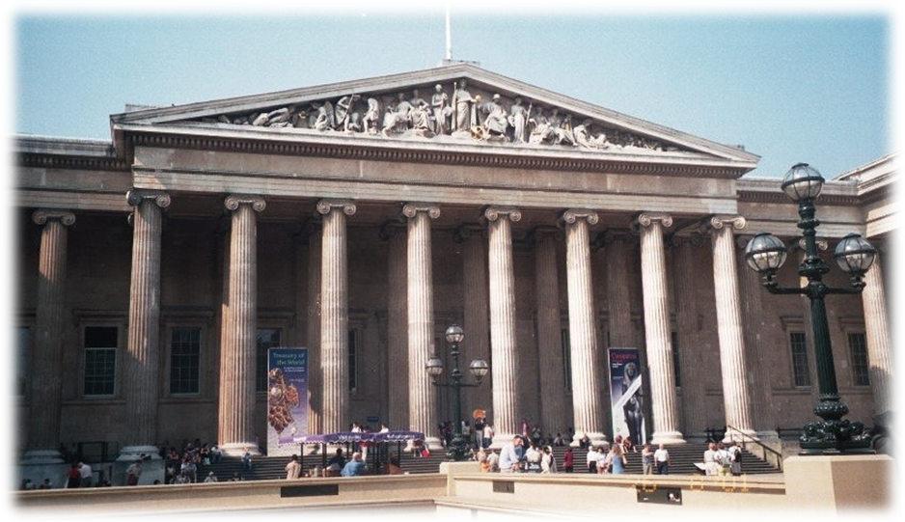
British Museum

Since 1754, the museum's home has sat at the site of the Montague House in Bloomsbury. It wasn't long before this facility became too small to display and store the museum's large collection and plans were made for additions to the museum. The Townley Gallery for classical sculpture was added first, but was later torn down to make way for the Smirke Building, which is the core of the building visitors see today when they visit the museum.
It was originally built to house the personal library of King George III. This new building was a quadrangle situated north of the Montague House. The south wing of the Smirke Building eventually replaced the old house.
The Parthenon Galleries, by American John Russell Pope, was built to house the Parthenon sculptures and opened in 1939. However, because of extensive damage suffered during World War II, the structure had to be rebuilt and was reopened in 1962. Another new wing, opened in 1980, housed public facilities like a restaurant and gift shop.
Finally, the Queen Elizabeth II Great Court opened in 2000. This two-acre square (8000 sq m), enclosed by a glass roof, creates an indoor courtyard with the museum's famed circular reading room in the center. This design made by Norman Foster and Partners makes it easier for visitors to find their way in the museum thanks to the large open space, very similar to the way the
The collection found at the British Museum is enjoyed by millions each year. Because the museum is so large, many visitors take more than one day to explore. Not all of the more than 7 million artifacts are on display, but much of the collection constantly rotates so you'll see something new with each visit.

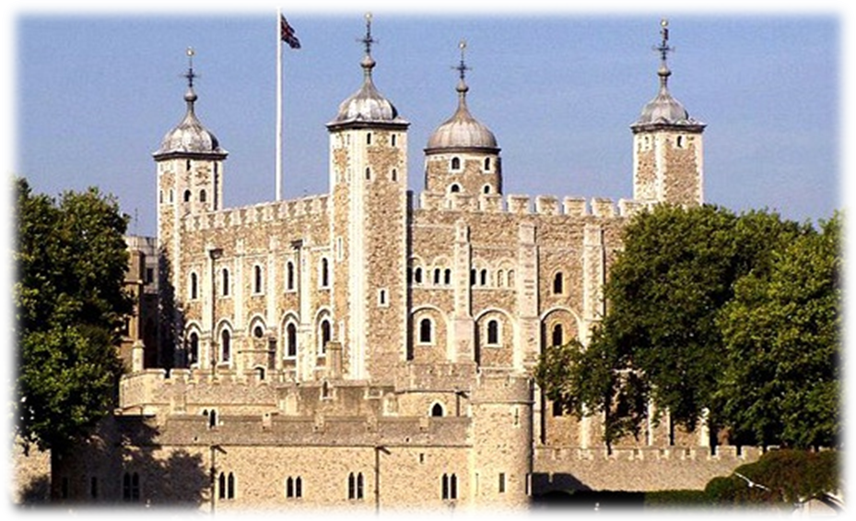
Tower of London

The Tower of London was built at the beginning of the 11th century by William the conqueror. The tower was expanded during the 13th century into the fortified complex that we know today. The Tower's most popular attraction is its famous collection of Crown Jewels.
Construction of the Tower of London was initiated in 1070 by William the Conqueror, shortly after his victory at Hastings in 1066. The Tower was built to enforce the power of the king over the newly conquered region.
The fortress, strategically located at the Thames, was originally not more than a temporary wooden building which was replaced later by the White Tower. Over time the complex was expanded into a stronghold with about 20 towers.
Today the Tower of London is best known for its Crown Jewels, but it used to be notorious for the many political opponents of the kings that were locked, tortured and killed in the Tower. The Tower was also a royal residence: several kings lived here, especially during turbulent times when the donjon seemed a lot safer than the palace in Westminster.
The most famous tourist attraction in the Tower of London is the collection of Crown Jewels that has been on display here since the 17th century, during the reign of Charles II. Most of the jewels were created around the year 1660, when the monarchy was reinstalled. The majority of the older crown jewels were destroyed by Oliver Cromwell.
The jewels can be found in the Jewel House, which is part of the Waterloo Barracks just north of the White Tower. Some of the highlights of the collection are the 530 carat First Star of Africa, which is set in the Scepter of the Cross; the Imperial State Crown with more than 2800 diamonds and the famous Koh-I-Noor, a 105 carat diamond.
★ Let’s talk about the place that you want to go★

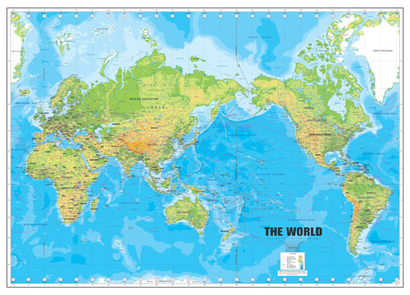

1. Where do you want to go someday in the future?

2. Why do you want to go there? What are you going to do there?

