LISTENING LESSON PLAN

Topic: HOW’S THE BEST TO GET AROUND IN A STRANGE CITY?
WHY?

Instructor:  Lauren(An mi suk) | Level:  Pre-intermediate | Students:  8 | Length  50 minutes

Materials: - Listening CD/ CD player
Listening Worksheet ( 8 Copies each)
Worksheet ( 8 Copies each) - Give it a try ( Practice with partner)
- Bus Service Route
Picture ( Bus/ Leaflet /people looking at a map..)
White board, board maker and tape

Aims: To be able to listen to the stressed phrases ( Mark on the stressed words.)
Asking about public transportation – can be used in real situation
To practice speaking as spontaneously as they can

Language Skills:
Reading – when they finished filling all the blanks / they can use it for reading with their partner.
Listening – CD ( around 3 times)
Speaking – switch the word. ( Bus route / Subway station)
Writing - dictation

Language Systems:
Phonology: Pronunciation
Lexis: New phrases
Function: use of asking expression in a certain situation.
Discourse: talking about another way to answer

Assumptions:
Students already know how the class is set up and run.
The situation in this lesson is so common that they easily get into it.

Anticipated Errors and Solutions:
If time is short
→Cut the time of speaking with their partner.
If time remains
→ Let students memorize the main asking expression.
Students may not be able to listen the phrases ( That should be filled on the blank)
→ Let them listen to the track again until they get the words.

Lead - In
Materials: Picture/ Board

Time  5min | Set Up  Whole  Class | Procedure:  Hello everyone, how was your today? What did you do today?  Was it good? How was the weather? Do you feel hot?  (They say something)  Yes, I think so.  When we feel so hot end like we don’t want to anything,  What would you do usually?  How about going somewhere you have not been to?  You have only one leaflet.  No plan, no much information  In this way you need to know how to ask and how to listen to response.  ( Show the picture)  What can you see in the picture?  What do you think they are doing?  Do you have any experience like that?  What kind of transportation do you usually use? ..etc

Pre - Activity
Materials: White board

Time  5min | Set Up  Whole  Class | Procedure:  ( Main expression)  What’s the best way to get~  You can catch~  Get off~  How far is it?  (Let them guess when they need to use it)  (empty chart is on the white board, Fill it with their answer)  Write down - the names of some places of interest in their city.  - What kind of transportation they can use to get there.  - How much time they need.

Main Activity
Materials: Work sheet, CD & player,

Time  8 min  10min  2min  10min | Set Up  Whole  Class  Individually  Pair work  Pair work  Reverse  roles. | Procedure:  <Instruction 1>  Put your pen down. Close your eyes and listen.  Listen to - what they are talking about /  - Where she/he wants go and where they are.  - Where they are .  Those are you can get while listening.  (playing 1 time, let them listen carefully)  <CCQ>  Did you take a note what I asked ?  What do you think they are talking about?  Where are they?  Do you think she has much information about the city?  (individually get the answer form them)  Aside from that, what did they hear?  <Instruction 2> - General understanding  Distribute worksheet to each of them.  Let them fill the blank on the worksheet .  ( I anticipate they need to listen them 3 times for that)  <CCQ>  What are you suppose to do?  Who got all the answer? Good job?  Who couldn’t get the answer?  Does anybody need to listen again? (y/n)  ( If still have the time, can do that, If not make them guess what it is)  Repeat after record & reading with partner  ( switch their role)  Give it a try ( Main dialogue and city bus route)  Ask your partner about getting there on the board by public transportation.  Using  ( Excuse me,  - What’s the best way to get to the ________  - How do I get to ________  - Can I take the subway/ a bus?  You can catch the number ____ bus.  take the subway to ________ station.  It’s just a short walk from here.  best to take a taxi from here.  Let them have conversation.  Use the cues a city route to ask and to answer.(reverse role)  If the time remains  - Pick up them who did better than others as an example.
Post - Activity
Materials: CD & player

Time  5 min  3 min  2min | Set Up  Individually  group  Whole | Procedure:  ( Check how well they can listen to each other and respond)  Let each of them read as loudly as they can.  (each of them/ divide then into two group)  <CCQ>  Let them talk about anything from today’s lesson.  What did you remember ?  How can you start asking someone you don’t know?  Give homework  Read the worksheet two times more.  They can speak more spontaneously.  Everyone did a good job!  See you guys next week.  I hope all of you will be back here on time  and well done your homework.
Worksheet #1
How do I get there?

Listen carefully and fill the blank with what you hear.

Lauren : __________________to get to Waterfront Park from here?____________________?

Clerk: No. _____________the number 34 bus __________that hotel.
___________Harbor street. Actually, it’s just ___________from here.

Lauren: Really?____________?

Clerk: About 10 or 15 minutes. You know, there are guided tours of the city you can take.

Lauren: What does the city tour include?

Clerk: They take you by all the major points of interest.
You can get a good idea of where everything is.

Lauren: Hmm..______________?

Clerk: It’s 10 dollars per person for an hour-long tour.
If you are interested, ________________________.

Lauren: That sounds like a great idea.

Worksheet #2
Give it a try

Asking about public transportation.

Excuse me,
- What’s the best way to get to the Sports stadium?
- How do I get to the Sports stadium?
- Can I take the subway/ a bus?
You can catch the number 67 bus.
take the subway to Sports stadium station.

It’s just a short walk from here.
best to take a taxi from here.

TAKE TRANSIT
- Cheaper , Faster, More convenient -
- Sports Stadium # 67  - Lotte Department store # 51  - Woori Hospital # 10  - Zoo # 25 | - Seoul National University # 101  - Han river # 99  - Famer’s Market # 33  - Central park # 17

- Lotte Department store / Sudway
- Han river
- Woori Hospital
- Seoul National University
- Central park

( Write down the names of two places of interest in your city, and give them to your partner. He/She will ask you for the best way to get there.)

Picture #1 #2
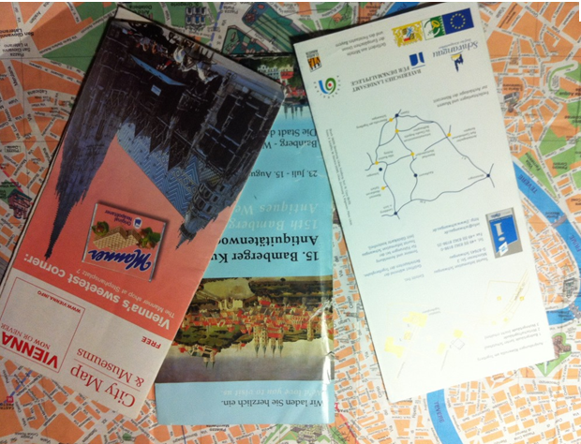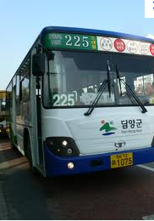

#3 #4


