Topic: Halloween Spells (Book: Little Witch’s Big Night)

Instructor:  Soo-Yeon Kim | Level:  Intermediate | Students:  7  (10 year olds) | Length:  30 min.

Language Skills
- Listening: Ss will practice listening by listening to songs, a story, and other classmate’s presentations.
- Speaking: Ss will practice speaking by singing and presenting their spells.
- Reading: Ss will practice reading by reading the comprehension questions.
- Writing: Ss will practice writing by writing their own spells.

Target Vocabulary:

astronaut | broomstick | cobweb | devil | Jack-o’-lantern | pirate

Target Sentences: < Rhyming Spell >
ex) Whizzy whazzy busy you
Fall asleep when I look at you!

Materials:
- “Have You Seen the Ghost of John” Lyrics | - Balloons, Balloon Board, Darts
- Visuals for Target Vocabulary | - Board & Board Markers
- Book: Little Witch’s Big Night | - Blank Paper & Colored Pencils
- 9 Comprehension Questions | - Prize (Chocolate)

Aims/Objectives:
- Main Aim: Ss will learn about Halloween through singing and writing their own spells.
- Secondary Aim: Ss will improve their language skills by singing, writing and presenting their own sentences, and by listening to other classmates’ presentations.
- Personal Aim: I want to deliver better instructions, speak in a louder and clearer voice, and make a more enjoyable learning environment.

Assumptions:
- Ss already know the teacher’s style of teaching and the pace of the course.
- Ss already learned the key vocabulary through a previous Language Based lesson.
- Ss are familiar with Halloween.
- Ss already know what rhyming words are.

Anticipated Errors and Solutions:

Problems | Solutions
- Ss may have difficulty making their own spells using rhyming words.  - If time is short.  - If students finish their tasks earlier than anticipated. | - Monitor during activity and help anyone that might have any trouble.  - Cut post-activity discussion short and only ask 1~2 Ss to share their spells, or have them finish as homework.  - Have more Ss share their spells and continue on with SOS activity.

References:
- Astronaut Image:
http://www.how-to-draw-funny-cartoons.com/cartoon-astronaut.html
- Broomstick Image:
http://www.freeclipartnow.com/holidays/halloween/witches/broomstick.jpg.html
- Cobweb Image:
http://www.istockphoto.com/stock-illustration-770358-cobweb.php
- Devil Image:
http://www.presentermedia.com/index.php?target=closeup&maincat=clipart&id=3954
- Jack-O’-Lantern Image:
http://www.dreamstime.com/royalty-free-stock-photos-cute-jack-o-lantern-image6483628
- Pirate Image:
http://picturesforcoloring.com/wp-content/uploads/2012/04/pirate-coloring-pages-02.jpg
- Witch Image: http://www.loonwatch.com/2010/04/witch-hunts/
- Skeleton Image: http://printables.kaboose.com/printable-skeleton.html
- Ghost Image:
http://historyatcu.wordpress.com/2012/03/27/franklin-ghost-tour-this-saturday/
- Ghost of John Lyrics: http://www.music-for-music-teachers.com/support-files/have-you-seen-the-ghost-of-john.pdf
- “Little Witch’s Big Night,” Deborah Hautzig, Random House, 1984

Lead-In
Materials: None
Time | Set Up | Procedure
2 min | Whole Class | Greeting the Ss,  “Hello everyone. How’s everyone doing today? Are you ready for another lesson?”  Have Ss prepare for Pre-Activity.

Pre-Activity
Materials:
- “Have You Seen the Ghost of John” Lyrics
- Visuals for Target Vocabulary
- Board & Board Markers
Time | Set Up | Procedure
8 min | Whole Class | Prepare lyrics for “Have you Seen the Ghost of John” and tell Ss you’re going to sing a song.  “Now, before we start today’s lesson, I’m going to sing you a song. I want you to try to guess what our topic will be today, and try to remember as much as you can about what the song is saying.”  Sing song and then ask a few questions.  - What do you think today’s topic will be? Halloween  - Who is the song describing? Ghost  - What’s the ghost’s name? John  - What kind of ghost is John? Skeleton  Hand out lyrics and sing together a couple times.  (If Ss get familiarized with song, try as a round.)  Prepare visuals of target vocabulary on one of the desks in front.  “Now, here are a few words that are related to Halloween. We’ve learned them before, so let’s see if we can still remember. I want all of you to come to the front and post each picture on the board in alphabetical order. You may discuss with your classmates.”  ICQ’s:  - What are you going to do?  - Can you discuss with your classmates?  Once all pictures are on board, have Ss return to their seats and review the words together. Ask CCQs for a few words:  CCQ’s:  - Who makes a cobweb?  - Does an astronaut go under water?  - What is a Jack-O-Lantern usually made of?  “Very good everyone. Do you have any questions about these words? If not, let’s move on.”

Main Activity
Materials:
- Book: Little Witch’s Big Night
- Comprehension Question Balloons, Balloon Board, & Darts

Time | Set Up | Procedure
12 min | Whole Class | Have Ss seated in a half-circle in the middle of the room so they can all see the book.  “Today we’re going to read a book, and you’re just going to listen and enjoy the story. So let’s all move to the center of the room.”  Show book and ask a few questions about the book.  - What’s the title?  - What do you see on the cover?  “So, this is Little Witch, and we’re going to read about her big night.”  Read book.  “Now you’ve heard the story, let’s play a game. So, on Halloween, what do you do? You dress up in costumes and go…?”  Elicit “trick-or-treating.”  “And when you go trick-or-treating, what do you usually expect?”  When Ss answer candy, show them the prize (chocolate) and start giving instructions.  “So now, we’re going trick-or-treating. But instead of knocking on someone’s door, you have to pop a balloon! I’ll give you 2 darts, and if you pop a balloon with your first dart, great, but if you miss both times you’ll have to pass. Inside each balloon, there’s a question about the story, and it’s going to tell you how many points that question is worth. You, as a class will try to answer as many questions as possible, and try to earn as many points as you can. At the end of class, I’m going to hand out 1 piece of chocolate for every 3 points you’ve earned. So, if you earn 9 points, you’ll each get 3 pieces of chocolate. But you only have 5 minutes.”  ICQ’s:  - What are you doing?  - How many darts can you throw?  - What happens if you miss both darts?  - How much time do you have?  - When will you get the chocolate?  Ask for any questions and start activity.  After 5 minutes, or if Ss answer all 9 questions, add up score and conclude activity.  “So, you’ve earned a total of O points, so that makes O pieces of chocolate for each of you. Good job everyone~!”

Post Activity
Materials:
- Blank paper & Colored Pencils (x7)
Time | Set Up | Procedure
8 min | Whole Class | “In this book, what did Little Witch do before doing a trick, such as flying or turning? She said the ‘magic words.’”  Review one of Little Witch’s spell and see how words rhyme.  “When we say ‘magic words’ to make someone do something, we can say that we’re casting a spell on that person.”  Write “cast a spell” on board and read example of “Sleeping Spell.”  “So, this is my “Sleeping Spell.”  Whizzy, Whazzy, Busy You  Fall asleep when I look at you!  Give instructions for next activity.  “Now, I want you to come up with your own spells. You can make a spell for anything, but try to use words that rhyme. I’ll give you 5 minutes.”  ICQ’s:  - What are you going to do?  - How much time to you have?  Hand out Blank Paper and have Ss begin.  If time permits, after 5 minutes go around class and have Ss share what they have written.  “Now let’s share our spells and see if they work.”  Correct any errors and conclude lesson.  If time is short, have Ss finish for homework.

Wrap-Up
Materials: None
Time | Set Up | Procedure
1 min | Whole Class | “Well, this concludes our lesson for today. I hope you enjoy the rest of your day. Bye~”  Hand out chocolate at the end of class.

SOS Activity
Materials: Blank paper & Colored Pencils (x7)
Time | Set Up | Procedure
5 min | Whole Class | “Now I’m going to hand out a blank piece of paper. Design your own Halloween costume.”  Have Ss draw their own costumes and if time permits have Ss share their drawing.  “Good job everyone! Well, that concludes our class for today. Enjoy your rest of the day~!”

< “Have You Seen the Ghost of John” Lyrics >
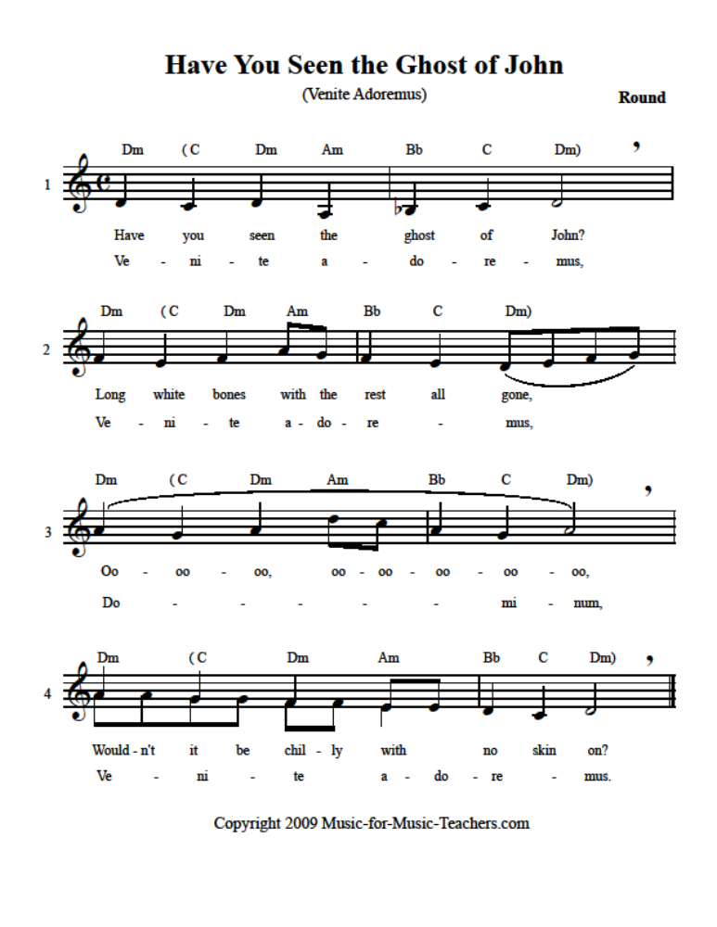

< Visuals for Target Vocabulary >

ASTRONAUT BROOMSTICK
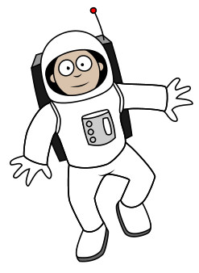 | 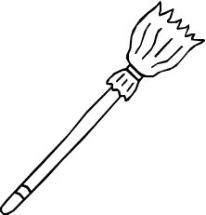

COBWEB DEVIL
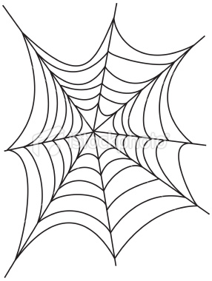 | 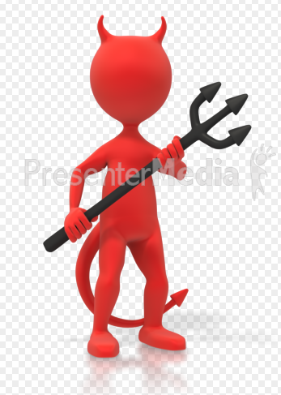

JACK-O’-LANTERN PIRATE
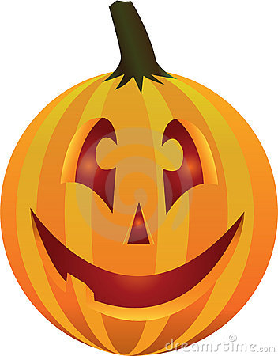 | 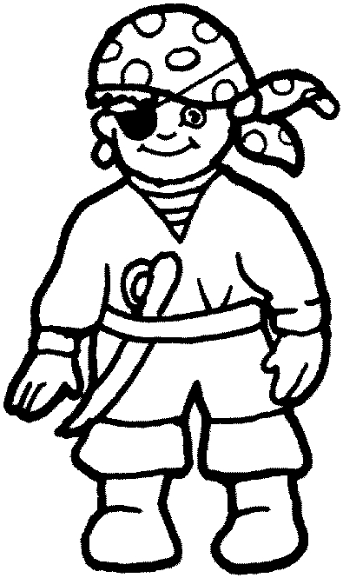

< Comprehension Questions >

- Why was Little Witch left alone at home on Halloween night? (1 pt)

- How many trick-or-treaters came to Little Witch, and what costumes were they wearing? (1 pt)

- What treat did Little Witch give the trick-or-treaters? (1 pt)

- How do you think Mother Witch felt when she left Little Witch alone at home? (2pts)

- How do you think the 3 trick-or-treaters felt when the Little Witch told them she had no treats? (2pts)

- Do you think the 3 trick-or-treaters knew Little Witch was a real witch? (2pts)

- How would you feel if you met a real witch on Halloween? (3pts)

- What costume would you like to wear on Halloween? (3pts)

- If you were Little Witch, how would you act next year? (3pts)

< Book Cover: Little Witch’s Big Night >



