Listening █ Speaking Reading Grammar Writing
Topic: Do you want to be a Celebrity?

Instructor:  Jiny | Level:  Upper-intermediate | Students:  5 | Length:  30 Minutes

Materials:
- Pictures of celebrities (David Beckham, Paris Hilton)
- Flash cards for success
- Cards of occupations
- Interview with a famous celebrity worksheet (5 copies)
- Interview fact sheet (5 copies)
- Name cards of celebrities
- Celebrities’ profile
- Party seating chart worksheet (5 copies)
- Scramble word (btyecelri)
- White board, board markers & tape

Aims:
- Main Aim:
- Students will improve speaking skills by having students talk about ‘The celebrity’.
- Second Aims:
- Students will discuss celebrities through talking about success, interview role play and organizing the table seating.
- Personal Aim:
- I want to adjust my speaking pace and improve my ICQs/CCQs delivery.

Language Skills:

- Speaking: Students will practice their speaking skill by talking about success, role play and organizing table seating activity.
- Reading: Students will practice their reading skill by reading profile of celebrities.
- Listening: Students will practice their listening skill by introduction of celebrities and classmates’ speech about the reason of organizing the table seating.
- Writing: Students will practice their writing skill by writing interview worksheet.

Language Systems:
- Phonology: None to discuss
- Lexis: meaning of celebrity and name of jobs
- Grammar: how to use ‘when’ by conjunction
- Function: introduce celebrities
- Discourse: discussion in whole class
Assumptions:
Students already know:
- how the class is set up and run (there will be a pair of each table)
- the teacher’s style of teaching and the pace of the course
- most students know the famous persons

Anticipated Problems and Solutions:

Problems |  | Solutions
- Students may not be able to follow the passage easily. |  | - Follow the task-feedback circle: let them ask again until they get the content
- Students may need more time to work on the interview role play. |  | - If it takes longer than 5 minutes, cut answer-checking short by verbally sharing the answers.
- If time is short |  | - Cut post-activity discussion short and only ask 2~3 students to share their opinions about organizing table seating.
- If students finish their tasks earlier than anticipated |  | - Ask as many students as possible about their idea of celebrities’ life, and differences between them and common people.

References:
- Learning Teaching by Jim Scrivener
- http://busyteacher.org/classroom_activities-speaking-worksheets/
- http://www.eslprintables.com/vocabulary_worksheets/friendship/birthday_party/BIRTHDAY_PARTY_Speaking_Acti_478348/
- http://www.eslflow.com/teachinglanguagewithmovies.html

Lead-In
Materials: None
Time | Set Up | Student Activity | Teacher Talk
1 min | Whole Class | Sharing students’ dreams in their childhood | Hello everyone.  Did you sleep well last night? You might be worry about your micro-teaching.  Go back to the weekend. Did you watch TV show or News last weekend? Who did come up with?  Do you like her/him? Why?

Pre-Activity
Materials: Pictures of celebrities, Flash cards for success
Time | Set Up | Student Activity | Teacher Talk
2 min  5min | Whole Class  Whole Class | Seeing the picture and guessing who they are.  Speaking about success using flash cards. | 1. Guessing  Demonstration  (Show the pictures and post them on the board)  Eliciting  I have a picture. Can you guess who he is?  Right! He is David Beckham. Do you know what his job is?  Good! He is soccer player.  How about this picture? Do you know who she is?  Right! Paris Hilton. What make she is famous?  It might be her money, wealthy or pets.  We can find many people through the TV show, sports game and newspaper. What do we call the people who are very well-know or very famous?  It starts with “C”.  Yes!!! Ce·le·bri·ties!!!  CCQ  Is a celebrity a common person? (No)  Is a celebrity a well-know person? (Yes)  2. Talking about success  Instruction  Ok. Now imagine how did celebrities get to have they are now? They were happy?  (Write on the board  “It makes me happy when I ______________.  Because _________________”)  For example, in my case, It makes me happy when I get a job. Because I can earn money and buy car and house. (Write down)  There are many things to make me happy. When I graduate university, win a race and so on.  I’ll give you some flash cards individually. And think about for 1 minutes ‘when are you happy and why’ related the picture that you picked up.  I pick up this card. Then, I can make sentence like “It makes me happy when I win a prize. Because it help me to build my career.  Don’t start when I give you a card. Please wait until I say begin.  ICQ  What are you doing to do?  How many minutes do you have?  Do you work in pair or individually?  Can you start when I give you paper?  Can you start when I say begin?  OK. Begin.  (After 30 seconds. Time warning)  You have 30 seconds. Ok. Times up?  Please show your card and tell me about success.  (speaking one by one)  Ok. Well done~~!

Main Activity
Materials: Cards for jobs, Interview with a famous celebrity worksheet, Interview fact sheet
Time | Set Up | Student Activity | Teacher Talk
8min  4min | Group  Whole Class | Be the interviewer and interviewee.  Speaking about your occupation.  Speaking about interviewee. | 1. Interview role-play  Instruction  What was your dream or what did you want to be in your childhood. And why?  Which job prefer for your son or daughter?  Now. Pick up just one. There might be written an occupation. Then you should be the person who has that occupation.  And then, we make two groups. Pick up one.  Someone who pick up team A move to this side.  Someone who pick up team B move to that side.  I’ll give you two pieces of paper. One is interview dialogue for interviewer and interviewee. Another is interview fact sheet.  This part for interviewer and this part for interviewee in this sheet. Interviewee must be the person who you pick up. Finally you become a interviewer and interviewee together.  If I pick up a doctor, I have to answer appropriated answer of my occupation.  For example, my partner asks me “What’s your biggest challenge?” Then, I can say “To save my patients.”  Ask partner for these questions and make dialogue complete this fact sheet for your interviewee.  I’ll give you 5 minutes.  If there are 3 persons in your group, you can do one by one. You two a pair, you two a pair, you two a pair.  Don’t start when I give you some paper. Please wait until I say begin.  ICQ  What are you doing to do?  How many minutes do you have?  Do you work in group or individually?  Can you start when I give you paper?  Can you start when I say begin?  (Distribute the worksheet)  OK. Begin.  (Time warning)  Times up!!  2. Introduce your interviewee  Instruction  Ok. Who is your interviewee?  Could you introduce your interviewee to the class?  (Speaking one by one)  Ok. Good~!!

Post Activity
Materials: Name cards of celebrities, Celebrities’ profile, Party seating chart worksheet
Time | Set Up | Student Activity | Teacher Talk
10min | Whole Class | Reading celebrities’ profile and speaking about them  Organizing the table seating and explaining the reasons.  Finding the answer  Unscrambling | 1. Organizing table seating  Instruction  Now. Pick up just one. You should be the person who you pick up.  (Let them choose name card)  And then I’ll give you the profile of the celebrity. Read that for 1 minute and introduce shortly.  Don’t start when I give you some paper. Please wait until I say begin.  ICQ  What are you doing to do?  How many minutes do you have?  Do you work in group or individually?  Can you start when I give you paper?  Can you start when I say begin?  (Distribute the profile)  OK. Begin.  (Write matching name on the board)  (Time warning) Times up!!  Could you tell me about you?  (Speaking one by one)  Ok. Now you are a host a party for your birthday. And you have to organize table seating. There 5 seats at the table and 4 guests on the list except you. For 1 minute decide where they will be seated. And Why?  Please wait until I say begin.  ICQ  What are you doing to do?  How many minutes do you have?  Do you work in group or individually?  Can you start when I give you paper?  Can you start when I say begin?  (Distribute the sheet)  OK. Begin.  (Time warning) Times up!!  (Share students’ opinions)  2. Conclude lesson  Error Correction Slot  Today, what did we study?  (Show them scramble word & correct word)  OK. Do you have any question?  If you don’t have it, I’ll close my micro-teaching.  Thank you very much for enjoying this class.
SOS Activities
Materials: Pictures of celebrities
Time | Set Up | Student Activity | Teacher Talk
3min | Whole Class | Explaining celebrities without name. | 1. Speed game  Instruction  Make a group. And one person might be an explainer and other guess who are they for 1 minute.  ICQ  What are you going to do?  Do you work in group or individual?  (counter the correct answer and find winner)

Pictures of celebrities
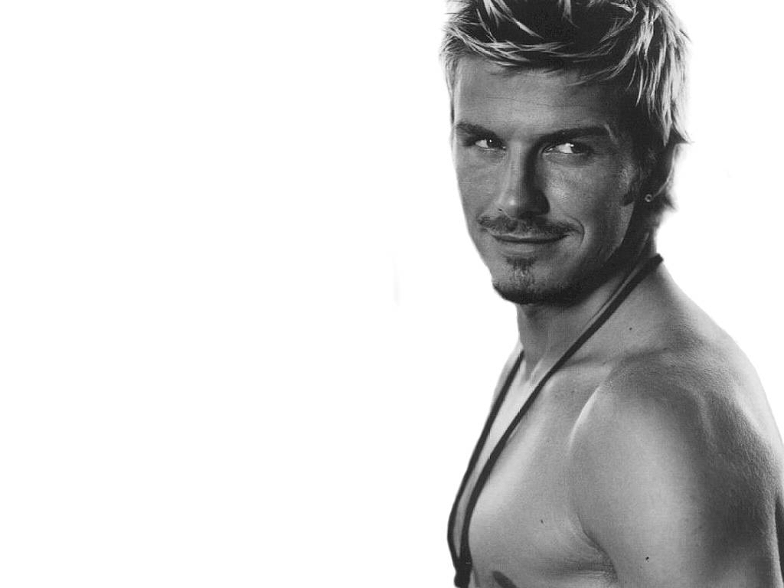
Flash cards for success
Cards of occupations
Wealthy person
Scientist
Doctor
Actor/Actress
Sports man/Athlete
Singer/Musician
Business man
Politician
Interview with a famous celebrity worksheet
Interview fact sheet

Interview Fact Sheet
Name:
From:
Job:
Famous for:
Biggest achievement:
Biggest challenge:
Inspire person:
Favorite movie/song etc.:
Next step in career:
Biggest Regret:
Weirdest Fact about You:
Name cards of celebrities
Steven Spielberg
Lady Gaga
Warren Buffett
Chistiano Ronaldo
Oprah Winfrey

Celebrities’ profile
Director of 26 films, Steven Spielberg scored his 13th Oscar nomination for best picture last year with War Horse. He's hoping to do same with his anticipated holiday film Lincoln. His DreamWorks studio made a big push into TV with four shows including the expensive Terra Nova, which was canceled, and the buzzed-about Smash which, despite weak ratings, has been picked up for a second season under a new show runner. In 1994, with his profits from the film Schindler's List, he set up the Righteous Persons Foundation, which helps fund the Shoah Foundation, among other Jewish projects. He also contributes to the American Film Institute and Cedars-Sinai Hospital, where the pediatric research facility bears his name.

Lady Gaga may have been ousted by JLo on the top spot of FORBES 2012's list of the Most Powerful Celebrities, but she still holds court over some 26 million Little Monsters. She raked in $52 million over the past year, a massive haul for the artist, whose "Born This Way Ball" tour kicked off in April. In addition to the platinum success of her latest album, and the launch of her very own social network, Gaga focused on philanthropic work in 2012. She continues to work with the MAC AIDS Foundation and announced the launch of her own non-profit, the Born This Way Foundation, which is underwritten by the MacArthur Foundation and Harvard University. Always one to flex her muscle, Gaga enlisted friend and mentor Oprah Winfrey for the kick-off event in February. In July, Office Depot officials say they hope to create a "braver, kinder school year" for students by partnering with the Born This Way Foundation for back-to-school. The retail outlet pledged $1 million to Gaga's campaign.

Buffett recently completed radiation treatment for prostate cancer, five months after he notified Berkshire Hathaway shareholders of his condition, assuring them that it was "not remotely life-threatening." Still, he has gotten his house in order: In December he chose his farmer son, Howard, as the future non-executive chairman and "guardian of the firm's values." In February he said he'd picked his CEO replacement but has declined to give a name. He's also stepping up philanthropically. He gave $1.5 billion to the Gates Foundation in July, bringing his total giving to $17.25 billion. On his birthday in August he pledged $3 billion of stock to his children's foundations. His fortune is up $7 billion as class A shares jumped more than 20% since last year. After studying under Benjamin Graham at Columbia Business School, Buffett offered to work for his former professor's investment partnership, Graham-Newman Corporation, for free. According to Buffett, "he turned me down as overvalued." It was only after several years of "pestering" that the father of value investing agreed to take on the younger man in 1954. When Graham retired two years later, Buffett returned to Nebraska to launch his own partnership. In 1962 Buffett began buying up shares of a struggling textile company called Berkshire Hathaway. Though Buffett has called Berkshire "the dumbest stock" he ever bought, the firm has long since shed its textile assets and today serves as Buffett's famed investment vehicle. In May, Berkshire snapped up dozens of local newspapers from Media General after announcing a deal for the Omaha World-Herald in November 2011.

Ronaldo has the highest soccer salary in any league at $20 million annually, including bonuses. But he earns even more off the pitch, thanks to deals with Nike, Castrol, Konami and others. He became the first player in La Liga history to score 40 goals in two different seasons in 2012. The Portuguese winger has more Facebook fans than any other athlete in the world.
Cristiano Ronaldo, is a Portuguese footballer who plays as a forward for Spanish La Liga club Real Madrid and is the captain of the Portuguese national team. Ronaldo became the most expensive footballer in history after moving from Manchester United to Real Madrid in a transfer worth £80 million (€93.9 million/$131.6 million). In addition, his contract with Real Madrid, in which he is paid €12 million per year, makes him one of the highest-paid footballers in the world, and his buyout clause is valued at €1 billion as per his contract.
Ronaldo holds numerous former and current scoring records, including records for most goals scored in a season for Real Madrid, most goals scored per minute in La Liga, first top European league player to reach 40 goals in a single season in two consecutive years, fastest Real Madrid player to reach one hundred league goals, and the first player ever to score against every team in a single season in La Liga.
America's only African-American billionaire weathered some negative headlines in the past year, but her Oprah Winfrey Network (OWN) looks to be turning the corner. Despite low ratings early on, a deal with Comcast means OWN can now be seen in 83 million homes. The September debut of OWN's self-help show Iyanla Fix My Life, hosted by Oprah-approved guru Iyanla Vanzant, was met with much hype and positive reviews. The talk show queen has spent most of 2012 splitting her time between Montecito, Calif., her new home base since she left Chicago, and New Orleans, where she's shooting a film called The Butler opposite Forest Whitaker, due out in 2013. For once, she'll just be in front of the camera, not behind it as a producer. The majority of Winfrey's net worth stems from 25 years of her profitable daytime TV show, plus earnings from her Harpo production company, which has a hand in the Dr. Phil, Rachel Ray and Dr. Oz shows. Forbes figures Winfrey was the highest earning celebrity this past year, pulling in an estimated $165 million in the year through May 2012. She continues to support educational causes and has spent, to date, over $100 million on the Oprah Winfrey Leadership Academy for Girls in South Africa. Her lifetime giving totals around $400 million.
Party seating chart worksheet

Birthday party –
you are invited
You are hosting a party for your birthday and you will write the invitations and organize the seating chart for the birthday table.
You have 5 seats at the table and 4 guests on the list. Now you will decide where they will be seated, write the name on their seats.

You

Scramble word

btyecelri

celebrity

