Listening Speaking █ Reading Grammar Writing
Topic: The New Seven Wonders of the World

Instructor:  Jiny | Level:  Upper-intermediate | Students:  5 | Length:  30 Minutes

Materials:
- Picture of Pyramid
- Name of wonders
- Cards of seven wonders (2 copies)
- Brochure of Phuket
- Information of 7 wonders
- Article for seven wonders (5 copies)
- 8 Wonders of the world Travel Route worksheet (5 copies)
- Scramble word (serodwn)
- White board, board markers & tape

Aims:
- Main Aim:
- Students will improve reading skills by having students practice the reading the article about “New Seven Wonders of the World”.
- Second Aims:
- Students will know the Seven Wonders of the World by having students matching the name & picture, making questions and creating travel route.
- Personal Aim:
- I want to adjust my speaking pace and improve my ICQs/CCQs delivery.

Language Skills:

- Speaking: Students will practice their speaking skill by talking about their own travel brochure and recommending a monument.
- Reading: Students will practice their reading skill by reading the article and information of wonders.
- Listening: Students will practice their listening skill by classmates’ speech about their own travel brochure and recommending a monument.
- Writing: Students will practice their writing skill by writing creating questions about article.

Language Systems:
- Phonology: sounds of words in the article (ex. ancient [|eɪnʃənt])
- Lexis: meaning of words in the article (ex. wonder: very surprising and unexpected)
- Grammar: None to discuss
- Function: to give guide line for travel, information, advertisement
- Discourse: discussion in whole class
Assumptions:
Students already know:
- how the class is set up and run (there will be a pair of each table)
- the teacher’s style of teaching and the pace of the course
- most students know to make sentence

Anticipated Problems and Solutions:

Problems |  | Solutions
- Students may not be able to follow the passage easily. |  | - Follow the task-feedback circle: let them ask again until they get the content
- Students may need more time to work on the making own stories. |  | - If it takes longer than 5 minutes, cut answer short by verbally sharing the answers.
- If time is short |  | - Cut post-activity discussion short and only ask 2~3 students to share their opinions about organizing table seating.
- If students finish their tasks earlier than anticipated |  | - Ask as many students as possible about their best monument to list in wonders of the world.

References:
- https://www.google.co.kr/imghp?hl=ko&tab=wi
- http://www.eguidetravel.com/articles/seven-wonders-of-the-world/
- http://streetride-sevenwonders.blogspot.kr/p/home.html
Lead-In
Materials: None
Time | Set Up | Student Activity | Teacher Talk
1 min | Whole Class | Sharing students’ hobby | Hello everyone.  What are you doing when you have time?  Have you ever been to South America?

Pre-Activity
Materials: Picture of Pyramid, Name of wonders, Cards of seven wonders
Time | Set Up | Student Activity | Teacher Talk
2 min  3min  4min | Whole Class  Whole Class  Group | Seeing the picture and guessing what that is  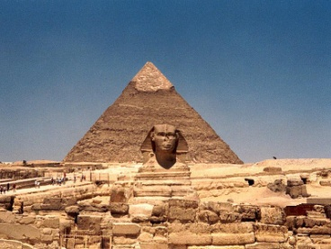  Reading the name of wonders  Matching name and picture | 1. Guessing  Eliciting  I have a picture. Can you guess what this is?  Right! This is The Great Pyramid of Giza.  Where is the Great Pyramid located?  Yes!! In Egypt.  What can we call something that people are very surprising and unexpected?  The word starts with “w”.  Yes. Wonder.  CCQ  Can we call wonders to common things? (no)  Can we call wonders something amazing? (yes)  2. The new seven wonders of the world  Instruction  (Showing the name of wonders)  Could you read this word one by one?  (Post the words on the board)  What should we call these seven monuments?  Hint…how many monuments of these?  And what can we call amazing things?  Yes. These are “ The seven wonders of the world”(Write down on the board)  Grouping  Could you tell me “seven”, “wonders”?  All of seven move this side.  All of wonders move this side.  I’ll give you the name of wonders and pictures. Just match the name and the picture of the wonders with your group for 2 minutes. Don’t stop when I give you the cards. Please wait until I say “Go”.  ICQ  What are you doing to do?  How many minutes do you have?  Do you work in group or individually?  Can you start when I give you paper?  Can you start when I say begin?  (Time warning)  Times up!  (Ask the name to each group and check the answer)

Main Activity
Materials: Article for seven wonders, Brochure of Phuket, Information of 7 wonders
Time | Set Up | Student Activity | Teacher Talk
6min  6min | Whole Class  Whole Class | Creating brochure  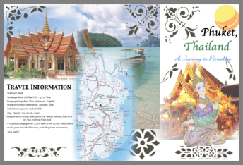  Reading the article and Making questions | 1. Create brochure  Instruction  When we visit to travel agency, we can see the paper like this introducing some place.  Now I’ll give you information about 7 wonders. Create the brochure for 3 minutes individually.  For example, this is my brochure about Taj Mahal.  Don’t start when I give you some paper. Please wait until I say begin.  ICQ  What are you doing to do?  How many minutes do you have?  Can you start when I give you paper?  Can you start when I say begin?  Choose one paper. Start.  (Time warning)Times up!!  (Share)  2. Reading the article and making questions  Instruction  I’ll give you an article. Read the article and make 2 questions about article individually for 4 minutes.  Don’t start when I give you some paper. Please wait until I say begin.  ICQ  What are you doing to do?  How many minutes do you have?  Can you start when I give you paper?  Can you start when I say begin?  OK. Begin.  (Time warning)Times up!!  OK. Put your questions in this cup. And choose one and answer.  (Doing one by one)

Post Activity
Materials: 8 Wonders of the world Travel Route worksheet, scramble word
Time | Set Up | Student Activity | Teacher Talk
7min  1min | Whole Class | Recommending a monument and creating travel route  Finding the answer  Unscrambling | 1. Create ‘Travel Route’  Instruction  I’ll give you worksheet. You can see the locations of the 7 wonders. Just imagine. If you had power to choose one place for 8 wonders, which place would you recommend?  In my case, I would recommend “Sukgulam in Kyoungju, Korea”. Because SukGulAm is very beautiful and was registered as World Cultural Property by UNESCO.  Second question is “Create ‘Travel Route’ with your recommendation.” My theme is the shortest way to travel. So the route is “Korea – Brazil(Christ the Redeemer) – Peru(Machu Picchu)– Mexico(Machu Picchu) – Italy(Colosseum) – Jordan(Petra) – India(Taj Mahal) – China(Great wall) –Korea( Sukgulam)”  I’ll give you 2 min for this work sheet. Work individual. Don’t start until when I say begin.  ICQ  What are you doing to do?  How many minutes do you have?  Can you start when I give you paper?  Can you start when I say begin?  OK. Begin.  (Time warning)Times up!!  (Share students’ opinions)  2. Conclude lesson  Error Correction Slot  OK. I didn’t find any mistake.  I have a scramble word.  (Show them scramble word & correct word)  OK. Do you have any question?  If you don’t have it, I’ll close my micro-teaching.  Thank you very much for enjoying this class.

Pictures for eliciting
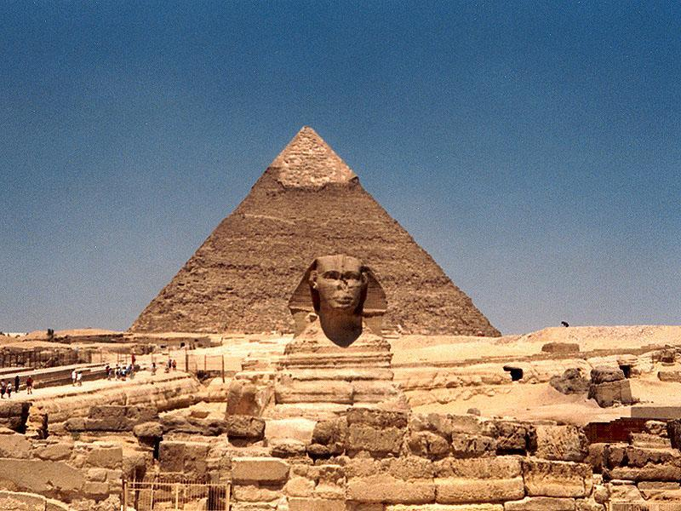
Names of 7 wonders
Colosseum, Italy
Chichen Itza, Mexico
Christ the Redeemer, Brazil
Great Wall of China
Machu Picchu, Peru
Petra, Jordan
Taj Mahal, India
New seven wonders of the world
Colosseum, Italy | 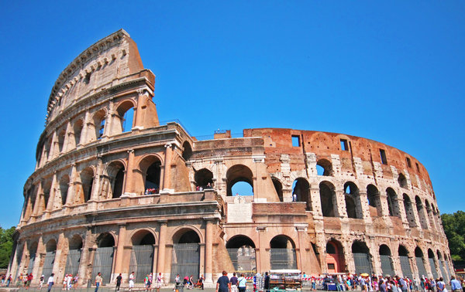 | Machu Picchu, Peru | 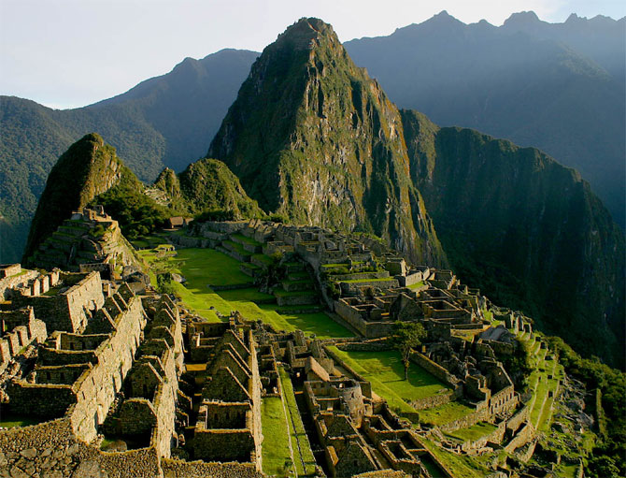
Chichen Itza, Mexico | 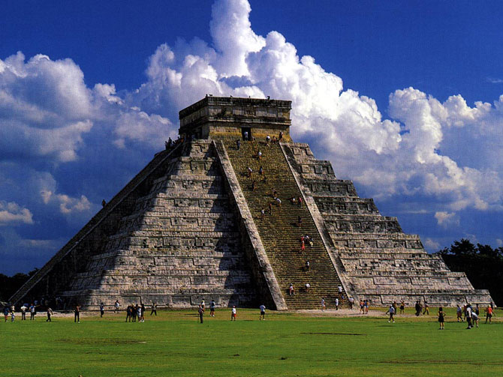 | Petra, Jordan | 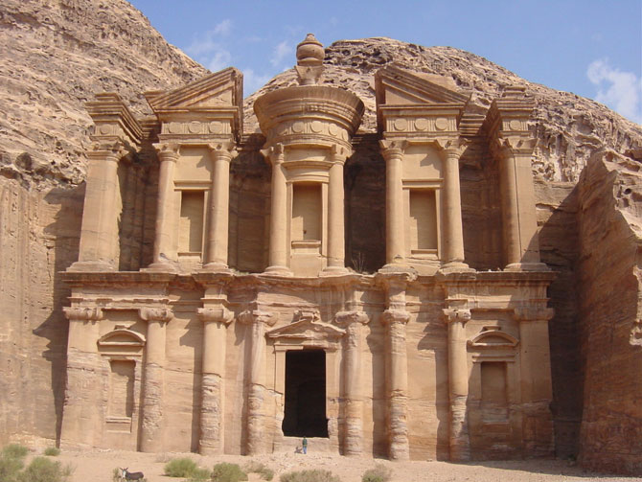
Christ the Redeemer, Brazil | 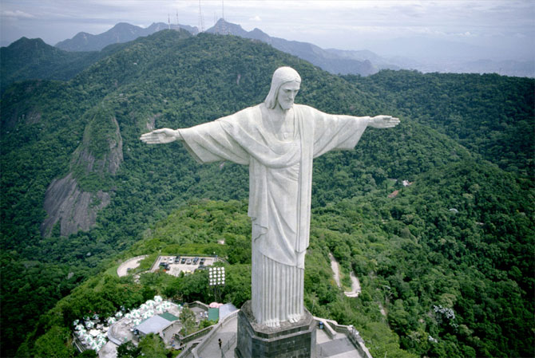 | Taj Mahal, India | 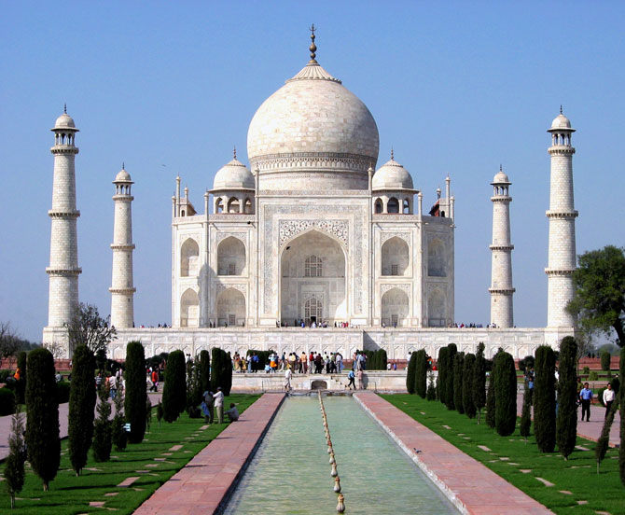
Great Wall of China | 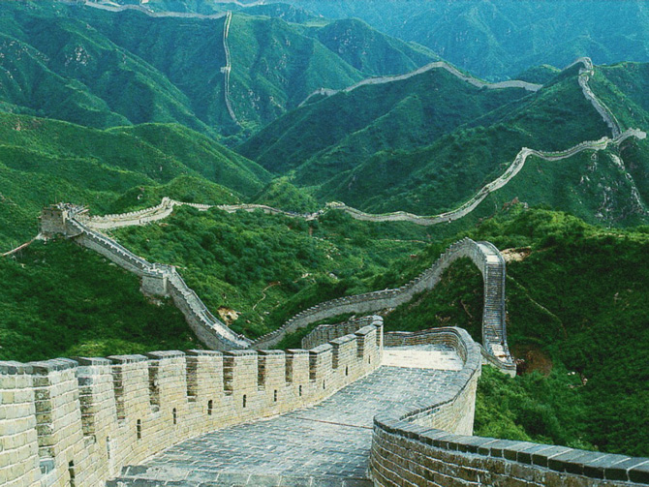
Brochure of Phuket
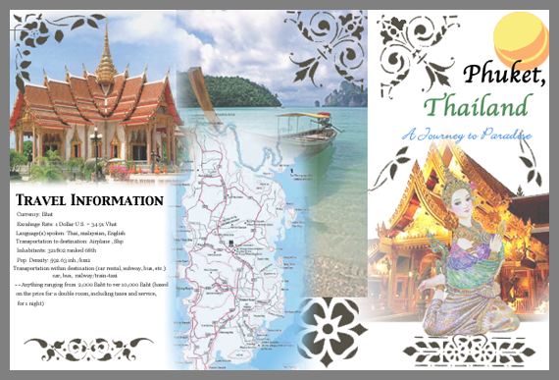
Information of 7 wonders
Great Wall of China
The Great Wall of China is famously known as the only man-made object visible from space. Built in 220 BC and 1368 to 1644 AD, it linked together existing fortifications and its purpose was to prevent Mongol tribes from invading China. Today, less than 30% of the wall remains in good condition, but visitors can enjoy a day trip to one of the many sections of interest or undertake a hiking trip of several days traversing the longer sections.
Machu Picchu, Peru
Machu Picchu, which translates as ‘old mountain’, is a 15th century (1460 to 1470 AD) settlement built ‘in the clouds’ at 2,430 meters above sea level on the side of Machu Picchu mountain in Peru. It was abandoned by the Incas, the exact reason why still remains open to debate, and became a ‘lost city’ for over three hundred years. It was rediscovered in 1911 by Hiram Bingham, an American explorer. Today, visitors can get there by walking the Inca Trail, a four-day trek on average, or by taking the train, a journey of about 90 minutes.
Taj Mahal, India
Built in 1630 AD as a mausoleum to honor the memory of the wife of the fifth Muslim Mongol emperor, Shah Jahan, the white marble Taj Mahal is considered to be a perfect example of Muslim art in India. Visitors can learn about the history of the building, with an inexpensive audio tour available in five languages.
Colsseum, Italy
Built in the centre of Rome as a celebration of all things Roman and the glory of the Roman Empire in general, the design of the Roman Colosseum (70 to 82 AD) is one that is still used today in the building of modern sports arenas all around the world. Although now in ruins, it is still possible to get a sense of the amphitheatre experience, and to imagine yourself as one of the 55,000 spectators who would have been entertained there.
Christ Redeemer, Brazil
Perhaps one of the world’s most recognizable monuments, the statue of Jesus, officially titled Christ Redeemer, stands 38 meters tall and looks over Rio de Janeiro from the Corcovado mountain. It was finally completed in 1931 after five years of building and it has since become a symbol of the welcoming warmth of the Brazilian people themselves.
Petra, Jordan
On the edge of the Arabian Desert, Petra (9 BC to 40 AD) provides an impressive example of Middle Eastern culture. As the capital of the Nabataean empire, visitors to Petra today can see the remaining tunnel constructions and water chambers that demonstrate why the Nabataean people earned a reputation as ‘masters of water technology’.
Chichén Itzá, Mexico
The pyramid at Chichén Itzá, built before 800 AD, was the last Mayan temple to be built in the political and economic centre of the Mayan civilization. Structures such as the pyramid of Kukulkan, the Temple of Chac Mool, The Hall of the Thousand Pillars and the Playing Field of the Prisoners can all still be seen today.
Article
New Seven Wonders of the World

In 2007, a new list of ‘world wonders’ was compiled by public vote. Now officially known as the ‘New Seven Wonders of the World’, they replace the wondrous structures originally listed by the ancient Greeks, of which only one, the Great Pyramid of Egypt, remains today.
If it is your dream to see all of the Seven Wonders, it is clearly going to take some planning, as you will be travelling to China, Peru, India, Italy, Brazil, Jordan, and Mexico. As this is not something you can do over a weekend, the first thing you must do is work out how much holiday time you have available. If you have a realistic amount of time, you could choose to make a ‘round-the-Wonders’ trip out of it, but you could also devise a longer term plan, maybe choosing one or two Wonders to visit each year.
The next thing you must do is research the best time of year to travel to each destination. For example, the best time to visit Petra is early in the year, from January to May, as these are the coolest months. If you intend to walk the Inca Trail to Machu Picchu, the best months are May and June, as they are in the dry season. The summer months can be uncomfortably hot in India, so a visit to the Taj Mahal is best planned between October and March. The coolest months of May through to October are the low season months in Rio de Janeiro and, although you may get rained on, the cost of your trip can be lowered significantly. Interestingly, August is the peak month for tourism in Rome, but it’s also the month in which most locals ‘escape’ the city. This means that the spring or autumn months are best if you’re hoping for a truly authentic Italian experience.
The next consideration is the order in which you wish to visit the Wonders. In the case of Machu Picchu, there are restrictions on the number of people who can travel and camp on the Inca Trail at any one time, so, if you intend to join an organized trip, booking a long way in advance becomes essential to secure a place. The accessibility of each location will also have a bearing on the amount of time needed to make the most of your trip. For example, you can fly directly to Rio de Janeiro and go straight to the statue of Christ Redeemer on the day you arrive, but you can’t fly directly to Petra, so additional transportation times must be factored into your overall holiday schedule.
Once you know where you want to go, when you want to go, and how long you want to go for, all that’s left to do is to book your ticket and make any other you travel arrangements needed, such as accommodation if you’re travelling independently. The more information you have about where you’re going before you go, the more enjoyable your trip is likely to be. So, read up on your destination on the eGuide Travel website and learn from the experiences of those who have been there, done that, and got the t-shirt before you!
Scramble word

serodwn

wonders

