Reading Lesson Plan
Title: The Origins of American Last Names

Instructor:  Debbie(Inok Kim) | Level:  Elementary 6th grade | Students:  8 boys & girls | Length:  20 minutes

Materials:
1. 8 worksheet(#1) of new vocabulary
2. 8 worksheet(comprehensive worksheet, writing comprehensive worksheet)#2,3
3. pictures( mill, ironsmith) #4
4. 4 sheets of character pictures for each group #5
5. Picture of “Bitey” #6

Aims:
1. Students will understand new vocabulary and familiar with them through teacher’s explanation and CCQ.
2. Students will be able to get the main idea by skimming the reading text and answering a guiding question
3. Students will improve scanning skill by answering some questions.
4. Students will improve speaking and listening ability by sharing ideas in group.
5. Students will be able to make each character’s nicknames by their background and share each other in English
6. Students can understand differences of two words ; mill, meal
7.Students can learn how to read a fractional number with cardinal/ordinal number.

Language Skills:
Reading – reading text “The origins of American last names”/worksheet #2
Listening – listening to Teacher’s presentation, instruction, demonstration /
share idea with partners
Speaking – sharing ideas with partners or in a group
Writing – answering the questions with paper work

Language Systems:
phonology – pronunciation related to vocabularies in the text
pronounce mill/meal
Lexis – Key words and new vocabulary in the article and worksheets
Function – Giving and receiving with some vocabulary
Discourse – Context social relationship situation between speakers, expressing own opinion

Assumptions about Students:
Students understand teacher’s simple saying in English
Students already know the teacher's style of teaching and the pace of the course
Students are interested in nicknames
Students are able to express their ideas and opinions in English.
Students already know how they make a pair when it is time for group work.

Possible Problems and Solutions:
Students don’t know many of English nicknames and last names
-Explain by Famous and popular movie stars in abroad.
Students may not understand the new vocabulary
-Show the pictures to the students and encourage the students to guess from
context
Students can’t follow teacher’s pace
-give a chance to express. chunk the listening
-read and speaking clearly
If time is short
- give students homework to finish

References:
www.breakingnewsenglish.com
www.ebrics.co.kr
Times TESOL student book

Procedures

Lead-in:
Materials: White board, Markers, ‘Bitey’pictures
Time | Set Up | Description of activities
2 min. | whole class  #7 | - greeting  Good morning, everyone! How was your big holiday?  Was it fun with your family? What did you meet? Did you have any special things to do?  <Eliciting and Prediction>  (Showing students pictures to elicit the topic)  (picture 1)  - What do you see in the picture?  - When he was a baby, we called him ‘Bitey’ because of his bad habit, biting friends everyday with no reason.  - Give chances to the student to tell their nicknames.

Pre-activity:
Materials: Magnetics, each handout, tape, vocabulary picture(#4), vocabulary word sheet(#1),
Time | Set Up | Description of activities
3 min. | whole class  #4  individually  #1 | 1. Vocabulary  Let’s learn some vocabularies that will help you to read the text : mill, ironsmith, describe, solve, brook, identification, guess, come up with  2. Difference between ‘mill’ & ‘meal’  - /mil/ short vowel sound  A mill is a building in which grain is crushed to make flour.  -/mi:l/ long vowel sound  A meal is an occasion when people sit down and eat, usually at a regular time.  ex) Tim/team, sit/seat, pit/peat, pick/peak, hill/heal,  3. C.C.Q  I’ll pass this sheet to check today’s new vocabularies. You can find the definitions below and fill numbers in each blank. I’ll give you 1minute.  - Are you working in group?  - How much time do you have?  - How many sheets are there?

Main Activity:
Material: text reading, comprehension task, writing task
Time | Set Up | Description of activities
10 min. | whole class  individually  #3(for Ss)  #2(for Ts)  Group work  (4 in 1)  Group work  (2 in 1)  #8 | 1. introducing  Long ago, people had the same last names as their jobs, such as Baker or Smith. Their looks were also used as last names, so they were sometimes called Brown or Young. Where they lived make last names as well, so they were called Hills or Rivers. Others used their fathers’ names and got last names such as Richardson or Wilson.  2. Guiding question  - Do you know any other American last names?  - Can you guess their origins?  - What last names world you like to have?  There is an interesting story about the origins of American Last names. I will pass out 1 copy of the text. And there are 10 mistakes in the text. Now, I will read the text once, and each of you have to find 10 mistakes and correct them.  C.C.Q  - How many mistakes are there?  - How many times will I read?  - Do you work with partner?  3. Task A  Now I will give 1minute to read the text. After reading, you have to find and underline the main idea sentences. Write the number each paragraph. There are 4members in a group.  1) Last names can be connected to a person’s nickname.  2) People were called by their jobs or their fathers’ names.  3) The English used last names to distinguish people.  4) Some names showed where the people lived or how they looked.  C.C.Q  - How much time do you have?  - Do you work with alone?  - What do you have to do after finding answers?  Feedback  Each of group can tell own answer and explain why.  (one paragraph for one group)  4. Task B  Now I will pass out some sheet. I will give you 1 minute. You can share with your partner and find their origin of the last names . Write.  C.C.Q  - How many members work together?  - How much time do you have?  - Do you only read or write the answer?

Post-activity:
Materials:
Time | Set Up | Description of activities
5 min | Group work  (4 in 1)  #5  individually  #7  Whole class | 5. Task C  I will give pretty characters each group. I’ll divide 4 groups. Each of group have to discuss with the character and make their own nicknames. I’ll give 5 minute. After that, each of your group come to the front and explain why you made that nickname.  C.C.Q  - How many members work together?  - How much time do you have?  - Do you only read or write the answer?  Homework  1. Vocabulary review  2. Closing  It’s time to wrap up. We talked about “The origins of American Last Names. I hope you enjoyed and I wish that this class helped you understand American culture. Thanks.

# 1

** Read each vocabulary and its meaning. Then choose and write the correct number.

describe ( ) solve ( ) identification ( )
mill ( ) Ironsmith ( ) guess ( )
brook ( ) come up with ( )

- phrase to create or think of
- to try to answer without knowing all the facts
- place that turns grain into flour
- to find an answer for a problem
- to explain something with words
- facts that prove who someone is
- a person who makes things from iron
- a small stream or river

# 2

The Origins of American Last Names

People are sometimes given nicknames. The nicknames can describe what they are like. For example, a person who is often angry may be nicknamed “Anger”. What about “Trees”? You night call a tall person “Tree”. But did you know that many last names began as nicknames?

Many American names come from England. By the 12th century, about a third of all English men were named William, Richard, or John. It was hard to distinguish one person from another at that time. To solve this problem, the English came up with different ways of identification. They began using last names.

One way was to call people by their jobs. an ironsmith named George would be called George the Smith or George Smith. If he worked at a mill, his last name could be Miller. People also called others by their parents’ names. For example, if Richard had a father named John, Richard could be called Richard John’s son, or Richard Johnson.

Some last names were connected to where a person lived. If a man liver by a brook, his last name could become Brooks. Others were named by how they looked. Can you guess why some people were given Brown or White as their last name? If you lived back then, what night be your last name?

#3
The Origins of American Last Names

** Find the mistake & correct them.(There are 10 mistakes)

People are often given nicknames. The nicknames can describe what they are like. For instance, a person who is often angry may be nicknamed “Anger”. What about “Trees”? You may call a tall person “Tree”. But did you know that many last names start as nicknames?

Many American names come from New Zealand. By the 12th century, about a third of all English men were named William, Richard, or John. It was easy to distinguish one people from another at that time. To solve this problem, the English came up with different ways of identification. They began using last names.

One way was to call people by their hobbies. An ironsmith named George would be called George the Smith or George Smith. If he worked at a mill, his first name could be Miller. People also called others by their parents’ names. For example, if Richard had a mother named John, Richard could be called Richard John’s son, or Richard Johnson.

Some last names were connected to where a person lived. If a man liver by a brook, his last name could become Brooks. Others were named by how they looked. Can you imagine why some people were given Brown or White as their last name? If you lived back then, what may be your last name?
# 4

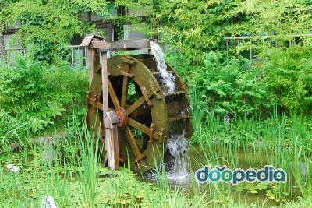

#5

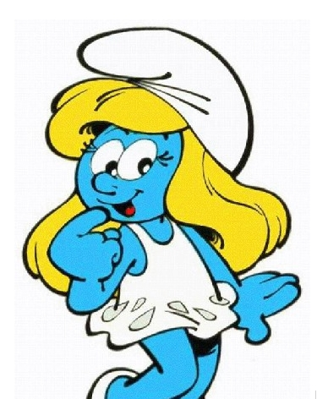

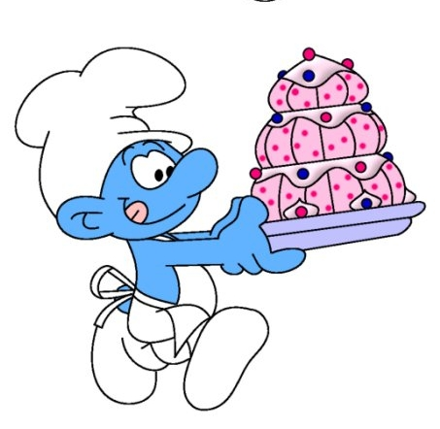
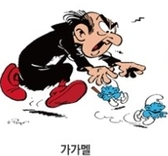
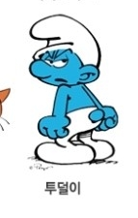

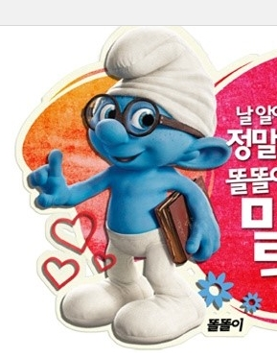

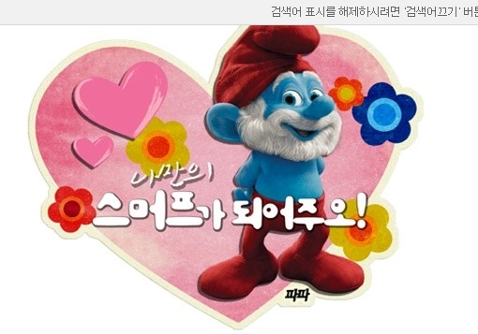

# 6

Choose the most appropriate words.(homework)

1. Drawing is a good way to _________ things. A picture is worth a thousand words.
2. I was sitting by the _________ enjoying the cool breeze and the sun.
3. There is no way I can ________ these questions in 10 minutes.
4. _____________ twins is hard, especially when they are young.
5. My phone line is __________, but I can’t hear anything.
6. Can you ____________ a better idea? If not, just be quiet and listen.
7. I ________ she thought that was pretty smart.
8. No __________, no meal.
9. My grandfather’s job was an ____________. He made many farm tools.
10. Do you have any identification, sir?

solve | mill | identification | guess | brook
come up with | describe | ironsmith | connected | distinguishing

#7. “Bitey”’s 4 pictures.

#8
* Check True or false
1. some last names come from people’s nicknames.(T/F)
2. The English started to use last names during the 12th century.(T/F)
3. The last name smith night be from a location.(T/F)
4. David Jackson might have a father named Jack.(T/F)

* Guess where were these names come from.
a)father’s names b) looks c) jobs d)location

1. brooks( ) 11. Wagner ( )
2. Smith ( ) 12. Ashley ( )
3. Miller ( ) 13.Reid ( )
4. Baker ( )
5. Johnson( )
6. White ( )
7. Armstrong ( )
8. Robertson ( )
9. Peterson ( )
10. Cliff ( )

