READING LESSON PLAN

Topic: Let’s drink a cup of coffee.

Instructor:  Misa Kim | Level:  Pre-intermediate | Students:  14 | Length  20 minutes

Materials:

- Vocabulary worksheet (14 copies)
- Reading material with guiding question (14 copies)
- Reading worksheet – diagram (14 copies)
- White board, board markers

Aims:

- To learn new vocabularies by matching the vocabulary worksheet
- Ss will be able to get the main idea by skimming the article and answering the guiding question
- To improve scanning skill through filling the diagram about coffee
- Ss will improve speaking and listening skill by sharing opinions with their partners

Language Skills:

- Listening: Ts explanation, demonstration, instruction and classmates’ idea
- Writing : Filling the diagram
- Reading : reading article “New study for coffee”, worksheet
- Speaking: Discussion with partner to answer the vocabulary work sheet, sharing the opinions

Language Systems:

- Phonology: Practicing new vocabulary (antioxidant, provider, reduce, caffeinated)
- Function : Question & Answer between teacher and Ss

Assumptions about Students:

- Ss know what coffee is
- Ss have drunk a cup of coffee
- Ss know they should speak only English in the class
- Ss are used to working with classmates
- Ss know how to skim and scan

Possible Problems and Solutions:

- Ss may need more time to answer the worksheet.
- If it takes more than 3 minutes, share the answers as a class
- Ss may have difficulty to understand new vocabulary
- Explain with example sentences
- If time is short,
- Take 1~2 volunteers in the post-activity
- If the Ss finish the worksheet earlier than expected,
- Ask various question about coffee

References:

- http://www.breakingnewsenglish.com/0508/050829-coffee-e.html : Article about coffee
- http://www.ldoceonline.com/ : Longman English-English dictionary
- http://www.google.co.kr/search?q=coffee&hl=ko&newwindow=1&prmd=imvnsulae&tbm=isch&tbo=u&source=univ&sa=X&ei=sidpUPmVC42tiQer-oDgDw&ved=0CJUBEOwJ&biw=1159&bih=632 : Coffee image

Lead – In

Materials: Whiteboard and board marker
Time  2 min | Set Up  Whole Class | Procedure:  <Greeting>  Hello everyone. How are you? Let’s start our class today.  <Eliciting the topic>  Did you sleep well last night? If you are still tired, what you do drink to wake up? That’s right. We drink a cup of coffee.  <Introduce today’s topic>  Today, we will talk about “Coffee”.

Pre – Activity

Materials: Vocabulary worksheet, white board and board marker
Time  3 min | Set Up  Whole Class  Groups  Whole Class | Procedure:  <Vocabulary prediction>  Before we read, let’s learn new vocabulary.  (Distribute worksheets)  Instruction  You can see there are the words on one side and definition on the other side. Try to match the word and definition. Work in your group of 3 or 4, and you have 1 minute.  Demonstration  Let’s look at the first one together. The first word is antioxidant. What do you think of “anti”?  (pause)  It’s “against” or “protect” something. So what would you match with this?  CCQ  Who are you working with?  How much time do you have?  How are you going to find the words meaning?  (Run task)  Monitor discreetly. Answer the students’ questions.  If any student needs more time, be flexible and give 1 more minute.  Check answers : Let them speak out the answers.  So, let’s look at together. Group A, what did you match for 2)provider?  Explain further, if necessary, give them examples as sentences.

Main Activity
Materials: Reading material, reading worksheet, white board and board marker
Time  4 min  7min | Set Up  Whole Class  Individually  Whole class  Whole  Class  Pairs  Whole Class | Procedure:  1.Guiding questions  Is coffee good or bad for our health?  (Distribute reading material and reading worksheet)  Instructions  Let’s look the question below an article. What is the question? (Let Ss read aloud.)  Try to answer this question as you read this article.  Work individually. You have 1minute.  CCQ  How much time do you have?  Do you work alone?  Which question are you going to think about?  (Run the task)  Monitor class. Answer the Ss question.  Do you need more time?  - Yes → Give 30 seconds  - No → Check the answers with whole class  Feedback  Share and summarize Ss opinions.  2. Reading detail  Instructions  Now look at the worksheet (diagram). You can see the diagram about coffee. How many rectangles are there? You are going to fill in this blank with information from the article. You will work in pairs. You have 5 minutes.  Demonstration  Let’s do the one together. Left below one, “Which researcher conclude coffee is good?” Can you find the answer in the first row?  (Pause)  Answer is University of Scranton in Pennsylvania.  CCQ  What should you do?  Who do you work with?  How many minutes do you have?  (Run task)  Do you need more time?  - Yes → Give 1 minute.  - No → Check the answers with whole class.  Feedback  Have you finished filling in the rectangle?  Check answers as whole class.

Post - Activity
Materials: N/A
Time  4min | Set Up  Whole Class  Pairs  Whole class  Whole class | Procedure:  I. Free production : sharing opinions  Instructions  There are lots of coffee menu. Which one do you prefer? Well, I like latte because I love milk. Let’s share your taste with your partner. You have 2 minutes.  CCQ  Who are you going to talk with?  How many minutes do you have?  What are you going to talk about?  Monitor the students and answer if Ss have questions.  Share the students’ opinions as a class.  If the time is short, take 2 ~ 3 volunteers.  II. Conclude Lesson  Elicit today’s key point from the students.  What did you learn today? Did you enjoy it?  You did very well today. See you tomorrow!

<New study for coffee>
Coffee is good for you. That is the conclusion of researchers at the University of Scranton in Pennsylvania. A team led by Dr. Joe Vinson found coffee is a rich source of antioxidants. Coffee is the biggest provider of these vitamins in the U.S. diet. Antioxidants help fight cancer and reduce cell damage and the effects of aging. Dr. Vinson said both caffeinated and decaffeinated coffee provides similar levels of antioxidants. He recommended no more than two cups of coffee a day.
Vinson analyzed the antioxidant content of more than 100 different food items and beverages. Coffee finished top based on serving size and frequency of consumption. However, Vinson advised people not to think of coffee as a health drink. He stressed that high antioxidant level in coffee does not mean the vitamins will find their way into our bodies. The dangers of coffee are that it causes stomach pains, increases blood pressure and can lead to heart problems. Vinson said more research is needed to understand its health benefits.

Q. Is coffee good or bad for our health?

<New vocabulary>

- Antioxidant a. a company or person that
gives/supports what you want

- Provider b. to make something
smaller or less

- Reduce c. some food or beverages
contain caffeine

- Caffeinated d. a substance in some foods
that cleans the body and
protects it from cancer

<Making diagram> - Reading worksheet

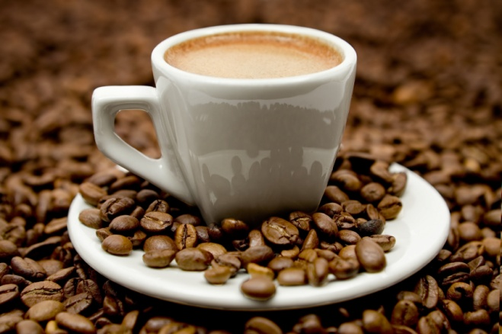
How many cups a day?
Which researcher conclude coffee is good?
If you drink too much…
Antioxidant’s benefits

