Listening Lesson Plan
Title: Saturday’s Chores

Instructor:  Bonnie Park | Level:  Intermediate | Students:  8 | Length:  60 minutes

Materials:
- Pre-teach vocabulary (key vocab & review) worksheet ( 8 copies each)
- Listening CD & CD player
-picture ‘house chore1’ for eliciting
-picture ‘house chore A-L’ for testing listening comprehension & learning additional vocabulary
-picture ‘bingo house chore’ for post activity
- Listening (fill in the blanks) worksheet (8 copies each)
- White board & markers

Aims:
- To learn vocabulary and expressions regarding house shores by completing pre-teach vocabulary work sheet and doing house chore bingo game
- To be able to pick up details from the real life talk through filling in the blanks in worksheet
And compared the listening content to picture ‘house chore A-L’
- To practice speaking by talking about students’ own experience about house chores and working with partner

Language Skills:
- Reading: vocabulary worksheets
- Listening: the speakers’ a short conversation which happened at home on a particular Saturday
- Speaking: prediction, talking about students’ own experience about house chores, group work
- Writing: vocabulary work sheets and bingo game

Language Systems:
- Lexis: Vocabulary and collocations used in describing house chores
- Function: learning how the collocations are used in a real life
- Discourse: T-S interaction by CCQ, S-S interaction through house chore bingo game and group work

Assumptions about Students:
Students already know:
- how the class is set up and run
- the teacher’s style of teaching and the pace of the course
- have their own experiences or knowledge about house chores

Possible Problems and Solutions:
- Students may not be able to follow the passage easily
➞ Follow the task-feedback circle: let them to the tracks again until they get the gist of the context
- Student may not able to pick up details from the listening
➞ Chunk the listening (pause-play-pause-play)
- If it takes longer than 5 minutes
➞ Cut answer-checking short by verbally sharing the answer instead of boarding
- If Ss finish their task earlier than anticipated
➞ Ask as many students as possible about their ideas related to the topic
If some of the Ss seems to have difficulties in coming up with ideas regarding the topic
➞ Helping them to think closer to the topic asking topic- related questions

References:
- http://www.esl-lab.com/chores/chorefra.htm
- Images searching by ‘house chores’ at Google
- Times media students book
- Created by Bonnie Park

Lead-in
Materials: white board
Time | Set Up | Description of activities
5 min | Whole Class | Procedure:  Hello everyone, how are you today? How was your weekend?  What do you usually do on weekends?  (Elicit some work for weekends & write them on the board)  OK, so today, we will listen to a conversation between dad and son which happened at home. But first, we will talk about today’s topic and then learn key vocabulary and idioms in dialogue.

Pre-activity:
Materials: Pre- teach vocabulary worksheet, Board, ‘house chore 1’for Prediction
Time | Set Up | Description of activities
4 min  6 min | Whole Class  Groups  Whole Class | Procedure:  1. Eliciting  (Showing ‘house chore1 picture’ on the board)  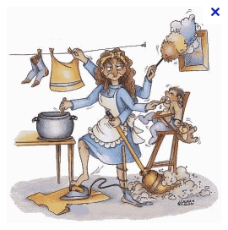  Instruction  Look at this picture. What is this picture about?  Can you give some examples of house chores?  Are you good at house chores?  (Elicit vocabulary related to the house chores and write them on the board)  2. Pre-teach vocabulary  Instructions  Work with your partner. See the 5 words in the box, let match the word in the each blank. You have 3 minutes.  (Distribute the worksheet)  CCQ  Who are you working with?  How much time do you have?  How many words you have to match?  Monitor discreetly. Answer students if they ask questions.  Give time warning: 30 seconds left  Be flexible with time. Give 1 more minute if they need it  - Go through the vocabulary one by one  - Elicit the meaning from students  - Explain the meaning if necessary

Main Activity:
Material: CD& CD player, Listening worksheet
Time | Set Up | Description of activities
10 min  15min  10mins | individually  Whole Class  Individually  Group | 1. Listening for the Main Idea (General understanding)  Instructions  Listen to a dialogue, thinking about what dad wants his son to do. Try to remember the details without taking notes at the first time.  CCQ  Can you take notes at this time?  What are you supposed to focus on while listening?  ( Play all tracks without stopping)  Listening Comprehension Check  (Show the picture ‘house chore A-L’)  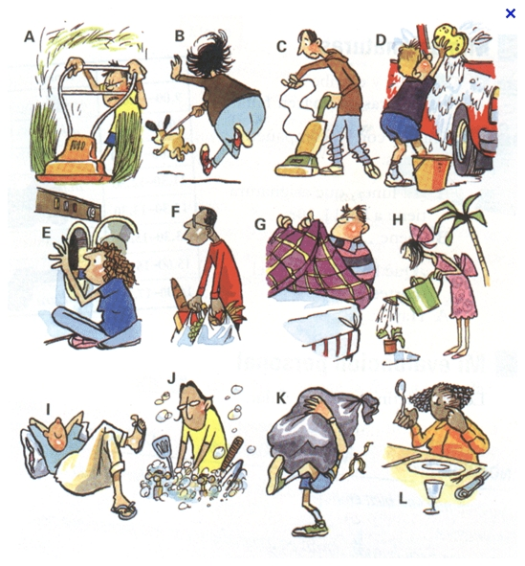  What kind of house chores has the young boy been asked from his father, pick up the pictures. Can you describe the all pictures from A-L?  - Elicit the answers  -Check correct answers together  -Go through the vocabulary and collocations from A-Z  2. Listening for Details  Instructions  Now listen to the speakers’ speech once more. And then fill in the blanks on the sheet as you listen. Work alone.  CCQ  Are you working alone?  Do you dictate while listening?  (Distribute the listening worksheet)  (Play all tracks without stopping)  Let students write answers as they listen. Check Ss are following the task well.  (Play track by track: Follow the same cycle until finished all.)  Now compare the answers with your partner. I will give you 3 minutes and if you have a questions let me know.  Check the answers as a whole class and correct mistakes.  Listen to the tracks one last time.  If there is anything missing: pause the CD right there and let Ss say it out loud.

Post-activity
Materials: N/A
Time | Set Up | Description of activities
10mins | Group work  individually | 1. Free Production  Instructions  Make a table having 25 blanks inside.  (showing the picture ‘house chore bingo’)  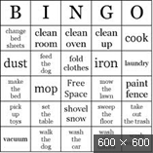  This is an example. Make a table like this in pairs and then fill in the blanks using vocabulary that today we’ve learn  You can use the words to fill the table from this table as well  You have 3 minutes.  CCQ  Are you working in pairs?  How many minutes do you have?  -Monitor passively ,just engage the game if necessary  2. Conclude lesson  Elicit today’s idioms for Ss.  Give homework  Write one sentence for each idiom learned today.  Good job today! See you tomorrow!

(Script)
Son: Dad. Can I go outside to play?
Dad: Well, did you get you Saturday's work done?
Son: Ah, Dad. Do I have to?
Dad: Well, you know the rules. No playing until the work is done.
Son: So, what is my work?
Dad: Well, first you have to clean the bathroom including the toilet. And don't forget to scrub the bathtub.
Son: No, I want to do the family room.
Dad: Well, okay, but you have to vacuum the family room and the hall, and be sure to dust everything. Oh, and don't forget to wipe the walls and clean the baseboards. [Okay.] And after that. [Oh, no.] Next, sweep and mop the kitchen floor and be sure to polish the table in the living room.
Son: Okay. Okay.
Dad: And make your bed and pick up all your toys and put them away. And . . .
Son: More?
Dad: Yeah. And then, how about going out for lunch and getting a big milk shake, but you probably don't want to do that.
Son: No, No. I want to.
Dad: Okay. While you're doing your work, I'll be out in the yard raking leaves and pulling weeds.

(Key Vocabulary)
scrub (verb): clean thoroughly by rubbing hard
dust (verb): to remove small pieces of dirt
baseboards (noun): a piece of wood or molding attached along the bottom of a wall where it touches the floor; also called "skirting board" in Britain and Australia
sweep (verb): to clean a floor by using a broom or brush to collect dirt
rake (verb): to gather with a garden tool with a row of plastic or metal teeth at the head
(Pre-teach vocabulary review worksheet)
- You'll need to really hard to remove that stain from the table.
- Please all the furniture in the front room.
- We need to remove to put down new tile on the floor.
- Be sure to the floor before you mop it.
- I spent all yesterday the leaves in my backyard.
(dust /raking /sweep / baseboards / scrub)

Listening (fill in the blanks) worksheet
Son: Dad. Can I go (1) to play?
Dad: Well, did you get you Saturday's (2) done?
Son: Ah, Dad. Do I have to?
Dad: Well, you know the (3). No playing until the work is done.
Son: So, what is my work?
Dad: Well, first you have to clean the bathroom including the toilet. And don't forget to (4) the bathtub.
Son: No, I want to do the family room.
Dad: Well, okay, but you have to (5) the family room and the hall, and be sure to dust everything. Oh, and don't forget to wipe the walls and clean the baseboards. [Okay.] And after that. [Oh, no.] Next, (6)and mop the kitchen floor and be sure to polish the table in the living room.
Son: Okay. Okay.
Dad: And (7)your bed and pick up all your toys and put them away. And . . .
Son: More?
Dad: Yeah. And then, how about going out for (8)and getting a big milk shake, but you probably don't want to do that.
Son: No, No. I want to.
Dad: Okay. While you're doing your work, I'll be out in the yard (9)leaves and pulling (10)

