Grammar PPP Based Lesson Plan
Title: Tom’s Diner (Present Continuous)

Instructor:  Tasha Kim | Level:  intermediate | Students:  14 | Length:  25 minutes

Materials:
-Music Video (Tom’s Diner)
- Picture
- Work sheet (14 copies)

Aims:

By the end of the lessons, students will be able to:
1. Listen to a recorded song for general understanding and specific detail
2. Recognize and use the present continuous tense
3. Engage personally with a song

Language Skills:

- Listening: The teacher’s explanation about new vocabulary related to funeral
Listen to the song.
- Reading: Read a worksheet. Read a lyrics of song
- Writing: create one’s own sentences.
- Speaking: Answers about the teacher’s question, giving one’s individual opinion
Language Systems:

- Phonology: Practicing new vocabulary
- Discourse: Communicating and sharing about personal opinion and experience
- Function : Describing situation in still continue the action.

Assumptions about Students:

-Students already know the Present Simple Tense
-Students already know the Be-verb ( I am/You are/They are/She is…)
-Students may have basic ability to listening
-Students are sufficiently interested in the topics to speak

Possible Problems and Solutions:
☞ Students may need more time to finish their activity → Need to be time management in the class. Cut post-activity discussion short and only. Ask 2~3 students to share their experience.

☞ If most Students finished their activity too fast
→ Give more information about topic
References:
# Song (Music video) : http://www.youtube.com/watch?v=avCeJnw9WbQ
# Picture :http://www.google.com.au/imghp?hl=ko&tab=ii
# Dictionary: http://endic.naver.com/

< Procedure >

Lead-in
Materials: Picture, White board and marker
Time | Set Up | Description of activities
1min  2mins | Whole class  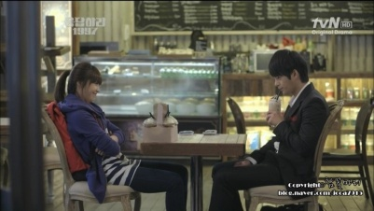  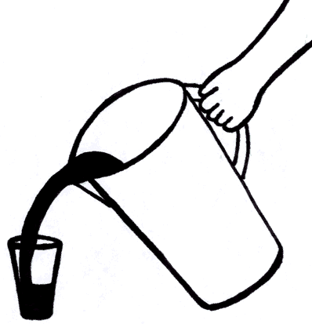->Drawing  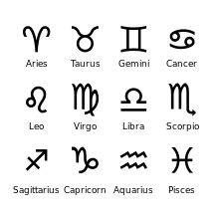 | Hello! Everyone. How was your weekend?  (greeting)  Review  Do you like to go out to eat for your dinner?  Where do you go? – café, restaurant, buffet…..  Okay, before we do the class firstly we see this picture. Let’s look at this picture.  This one from a part of drama session.  Can you see the picture? Where is the place?  Yeh.. It looks like the situation in the Café.  Think about it. It is not picture. You also stay in same café now. You can see them in front of you.  What is there’s action now?  (Write down on the board)  He is drinking a coffee.  They are sitting on the chair.  He is drinking a coffee ->He continues drinking a coffee. He doing now.. He is still drinking the coffee.  They are sitting on the chair -> They are acting right now.  Eliciting  Key Vocabulary :  Diner, Fills it halfway, Horoscope, Straighten  1) Diner [|daɪnə(r)]:  A diner is a small cheap restaurant that is open all day.  2) Fills it halfway :  Drawing / Gesture  3) Horoscope :  A lot of people read their this(horoscope) every day in newspapers or magazines  Normally in the eastern use animal symbol and western people use this.. what is this?  ->Can use picture from newspaper  CCQ> Is diner very expensive and fancy restaurant?

Pre-activity : Presentation
Materials: music video, laptop, worksheet
Time | Set Up | Description of activities
1min  3mins  2mins | Whole class  ->watching video  Group work | Now, We will listen to the song about ‘Diner’.  We are going to watching music video about this story.  We are working with group. Start from here! You 1,2,3.4 Group1..1.2.3.4 Group2….1.2.3.4.5 is group3.  Guiding question:  This music video is not real version. You will see the funny video. 1 thing is different between song and video.. You need to check what is wrong with this video..  And also you need to find what happening in the diner.  CCQ) So video and song is same story?  Are you working alone?  (Give lyrics before listening)  Do: Use the song ‘Tom’s Diner’ (using music video)  - Walking around the classroom during the students doing work.  Recall: Ask student what they just did.  Reflect: Elicit Grammar form  (asking and get the answer from the students )  - I am sitting in the morning  - He is looking out the window  >>What about this? This is from the past? What about acting?  It already happens? Or in the future..?  Conclude:  - form=> substitution table  - Meaning=> CCQ  CCQ> What is be-verb?  What is need before –ing form.
Main Activity : Practice
Material: worksheet 1>2>
Time | Set Up | Description of activities
2min  2mins | Whole class  Individual | # Controlled practice  - Worksheet 1> fill in the gaps below the box.  #Less controlled practice  - Worksheet 2> Finish the sentence  CCQ>  Are you working with group?  How many minutes for this activity?

Post-activity : Production
Materials:
Time | Set Up | Description of activities
5mins  5mins | Group | Free practice  Now, We are going to make the group divide into 3 groups in this class. I will give to you some of picture. Each group has different picture for some situations.  You are 1.2.3.4 is group number A, you are 1.2.3.4 is group number B, and you! you! You! You! you! Group number 3.  <Group A>  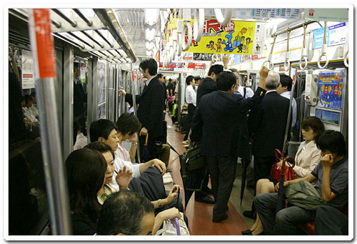  <Group B>  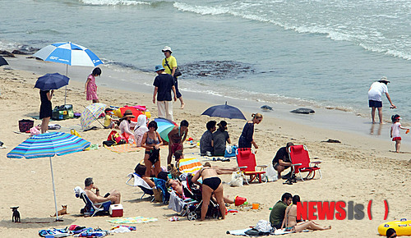  <Group C>  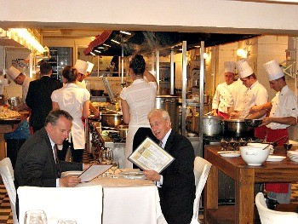  Describe the picture with your group member. You have 5 mins to do. Use ‘Be+ing’ form. Find 4 kinds of action from your one.  Let’s start it~!  CCQ> Are you working with your partner? Is it pair work?  Feedback  >> Have you ever finished?  If no, give more time.  Let’s share with class. (pointing the students from each group)  Did you have fun today?  I hope you enjoyed today’s lesson.  Today we learn about ‘be+ing’ we call it ‘present continous tence’ .  Tomorrow, pleasese bring your home work is write down your 3sentence used by p.c tence.  Thank you so much!!

Tom’s Diner
Suzanne Vega

I am sitting in the morning
At the diner on the corner
I am waiting at the counter
For the man to pour the coffee

And he fills it only halfway
And before I even argue
He is looking out the window
At somebody coming in

"It is always nice to see you"
Says the man behind the counter
To the woman who has come in
She is shaking her umbrella

And I look the other way
As they are kissing their hellos
I'm pretending not to see them
Instead, I pour the milk

I open up the paper
There's a story of an actor
Who had died while he was drinking
It was no one I had heard of

And I'm turning to the horoscope
And looking for the funnies
When I'm feeling someone watching me
And so I raise my head

There's a woman on the outside
Looking inside, does she see me?
No she does not really see me
'Cause she sees her own reflection

And I'm trying not to notice
That she's hitching up her skirt
And while she's straightening her stockings
Her hair is getting wet

Oh, this rain, it will continue
Through the morning as I'm listening
To the bells of the cathedral
I am thinking of your voice

<<Worksheet 1>>

Fill in the gaps.

1. The young woman is reading the newspaper.

2. The woman outside the diner at her reflection.

3. The waiter the coffee.

4. The woman at the door her umbrella.

Read, Shake, Pour, Look

<<Worksheet 2>>

Using the words from the box, you need to finish the sentence by yourself. Then share with your partner.

1. I am reading a worksheet.

2. shake

3. Pour .

4. Look .

