Work sheet 1
My car is making strange noises...
I'm going to a wedding next week...
My skirt is too long...
I need a new passport...
This room looks terrible...
Do you like my suit? ...
I can't give you the document personally...
My computer has been working beautifully...
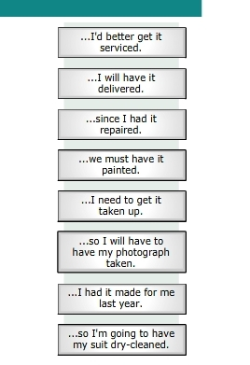
Work sheet 2
Make your own sentences based on your experience. Write down 2 things that you have arranged for somebody else to do something for you.

1.

2.

