t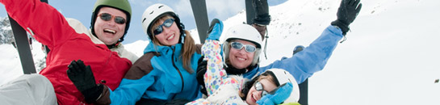

Ski Holidays in Mt. Wonder s!!!
Perfect for families, couples and those with a sense for adventure, a ski holiday is a great opportunity to get out and about and have fun in the great outdoors. Choose your ideal ski destination from the world's best ski resorts.
- 5 nights in Twin Shared dormitory style accommodation.
- Three gourmet buffet meals per day.
- Ski passes and fully equipment. Shared twin room : 1450$/person
- 2 sessions of 2-hour ski/snowboarding group lessons Single room : 2500$/person
- Price Included travel insurance
- Price is per person for the twin share room.

Student A> You and your partner are planning to take a trip on this winter vacation. You have a brochure for a ski trip, and your partner has a brochure for a spa trip. You need to find out information about the spa trip. Ask your partner questions about these things.
How much about the cost? What is includes in that package? What about accommodations?
What kind of entertainment option available? What about the conditions about room ?

.
Choose the 3 nights Dream Break for couple, your stay will feel like the dream break you have always wanted. This spa break provides you with a perfect mix of luxury accommodation, decadent spa treatments, and wonderful food all included in your package. This will definitely be a dream you don’t want to wake up from!!!
- 3 nights accommodation at the 4.5-star Daydream Island Resort & Spa in a Garden view Room.
- Buffet breakfast daily.
- FREE guest activities.
- Scuba diving and kayaks one day class.
- Open car cinema on Monday, Wednesday and Friday.
- Dolphin feeding experience Garden view room : 1350$/person
- Rainforest walk activities and much more. Ocean view room : 1700$/person
- The room suitable for a couple (queen size bed )
Student B> You and your partner are planning to take a trip on this winter vacation. You have a brochure for a spa trip, and your partner has a brochure for a ski trip. You need to find out information about the ski trip. Ask your partner questions about these things.
How much about the cost? What is includes in that package? What about accommodations?
What kind of entertainment option available? What about the conditions about room? j

Ice fishing camp for 2day 3nights !!

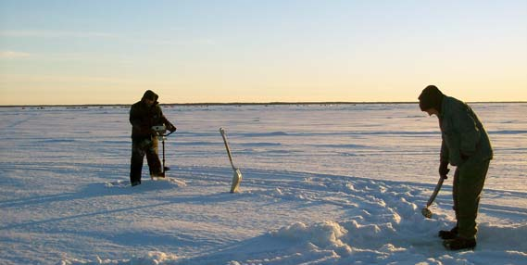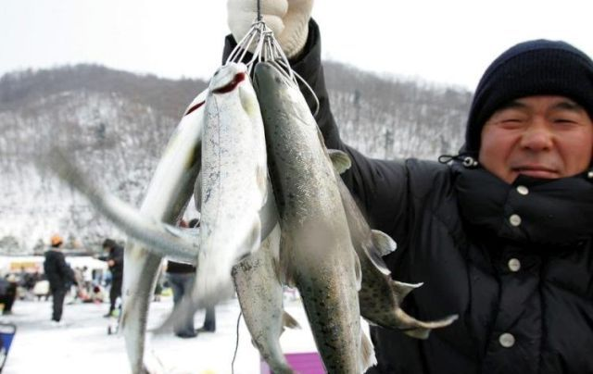

- Single or double rooms in beachfront hostel
- Daily ice fishing fully equipment rental included. Single room : $350/person
- 1 hour beginner’s ice-fishing class Double room : $250/person
- Once of indoor BBQ, and homemade style breakfast for every morning.
- You can catch your fish. You can carry it too!!
- Penguin water park within 5mins by car

