‘ Turning Point Stories’

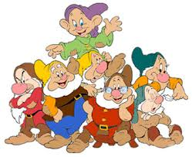 | 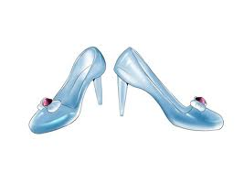 | 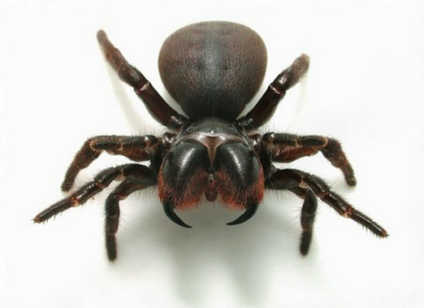
7 Dwarves | Glass Slippers | Spider

- Cinderella met a prince because of _______________. Without a chance for that Cinderella will never live a happily life with a prince.

- In the movie ‘Spider man’, the hero ‘Peter’ was bitten by ____________. Without a chance for that Peter will never became a HERO.

- As soon as the Snow White was thrown out of the house, she met __________. Without a chance for that the Snow White will never became princess again.

Life Venn diagram of ‘Turning Point’

Me

What would be changed in
‘TESOL’ turning point.

TESOL

