Listening Lesson Plan

Topic: Picnic Preparations

Length:

45 min
Students:

10 students
Level:
High beginner /
Pre-intermediate
Instructor:
Shin Ae Kwon
(Kristy)

Materials:
- Pictures of the picnic& supermarket
- Vocabulary worksheet(10 copies each)
- Listening CD & CD player
- Listening worksheet(10 copies each)
- White board, board markers

Aims:
- To learn new vocabularies regarding of the picnic by completing matching worksheet
- To expand language skill to use new words and sentences by practicing listening and speaking
- To communicate with the partners by some activities like doing worksheets or discussing
- To be able to pick up details from the fast-paced real-life talk by answering details questions on a worksheet
- To bring more interest to English learning through the activity like discussing

Language Skills:

- Reading: vocabulary& listening work sheet
- Listening: the speakers’ short conversation about picnic preparations
- Speaking: prediction, comparing answer with partners, and free production
- Writing: details(doing on the worksheet)

Language Systems:

- Lexis: vocabularies used in people conversation regarding with the picnic
- Function: how to use the languages in sentence within real-life conversation
- Discourse: relative clauses

Assumptions:

Ss already know:
- how the class is set up and run
- the teacher’s teaching style and the pace of the course
- have experiences and knowledge for the picnic
- can read and write simple material on familiar topics

Anticipated Errors and Solutions:
- Students may not be able to follow the passage easily
- Follow the task-feedback circle: let them to the tracks again until they get the gist of the content
- Students may not be able to pick up details from the listening
- Chuck the listening
- If time is short
Cut post-activity discussion short and only ask 2-3 students to share their opinions about preparations of their own picnic
- If students finish their tasks earlier than anticipated
Ask as many students as possible about their idea of picnic

References:
- listening script & exercise _ http://www.esl-lab.com/picnic/picrd1.htm#post
- pictures _ http://www/naver.com

Lead-In
Materials: Board and markers
Time  3 min | Set Up  Whole Class | Procedure:  Hello everyone, how was your weekend?  Is there any person who have been to somewhere for a picnic on the last weekend?  What did you bring on your picnic?  And if you have a plan to go on a picnic, what are you going to prepare on your picnic?  (Elicit key words from the today’s topic and write them on the board)  Ok, so today, we are going to listen to two people who are preparing for their picnic. But first, we will learn some vocabularies the speakers use.

Pre-Activity
Materials: pictures, white board and makers, worksheet#1
Time  8 min  4 min | Set Up  Whole Class  Pairs  Whole Class  Whole Class  Pairs | Procedure:  T: Before we do listening exercise, let’s learn some new vocabulary.  - Pre-teach vocabulary  T: Now we are going to do a matching activity.  Before distribute the worksheet to Ss, T will explain about new vocabularies with the meaning of it with writing on the board. Not directly. Give some situation and T can elicit from Ss.  T will give some examples how to use the words in the sentences.  Instructions  Macht the word on the left to the blank of the sentence on the right. Draw a line to match. Work with your partner. (make pairs of Ss)You have 3 minutes.  Demonstration  Here is an example. The first word on your worksheet is “package”. Find the right place of “package” on the right-hand side. (Ss will guess and answer) When you find the answer, Draw a line. (share the answer of ‘package’)  (Distribute the worksheet)  CCQ  Are you working alone?  How much time do you have?  What are you supposed to do?  (monitor discreetly and make sure time limits)  Let’s check the answers together.  Check all the answers orally with the Ss.  Explain the meaning of some difficult word.  - Prediction  Instructions  (A picture of ’supermarket’ shown on the board.)  T: Where is it?  (Ss answer: a supermarket)  Imagine you have been asked to organize a picnic? Where would you hold the picnic and what food, appetizers, and drink would you buy? Make a list and discuss it with a partner.
Main Activity
Materials: CD&CD player, Listening worksheet#2
Time  8 min  14 min | Set Up  Whole Class  Whole Class  Individually  Pairs  Whole Class | Procedure:  - Listening for the Main Idea(general understanding)  Instructions  Put your pens down. Just listen carefully.  There are 2 speakers on the dialogue.  During the listening think about those questions.  (Write on the board below questions)  - What are they going to do?  - What are they talking about?  CCQ  Can you take notes?  (Play audio tracks)  Do you want to listen again?  - Yes Have them listen one more time.  - No Have them share their answer and thoughts of guide questions.  - Listening for Details  Instructions  Now listen to the speakers more carefully and fill in the blanks on the worksheet as you listen. Work individually.  CCQ  Are you working alone?  Are you working during the listening or after the listening?  What are you supposed to do?  (Distribute the worksheet)  Play audio track.  Let Ss write answers as they listen and monitor discreetly.  If Ss need to listen again or cannot follow to do their task, let them listen one more time.  Now I will give 2 minutes compare the answers with your partner.  Check the answers and make corrections of mistakes.  After checking the answers, go through the worksheet with listening the audio track.

Post-Activity
Materials: White board and makers
Time  8 min | Set Up  Whole Class  Groups  Whole Class | Procedure:  - Free Production  Instructions  Make a plan a picnic or barbecue with a friend or classmate. Where would you have your picnic? What foods would you buy or prepare for the picnic? What activities or games would you plan to entertain your friends?  (Make small groups)  Share your ideas with your partners. You have 4 minutes.  CCQ  Are you working alone?  How much time do you have?  Monitor actively and participate within each group.  Share students’ opinions.  Take 2~3 volunteers if running out of time.  - Conclude lesson  Elicit today’s vocabularies for Ss.  Good job today. See you next time!

Pictures
1.
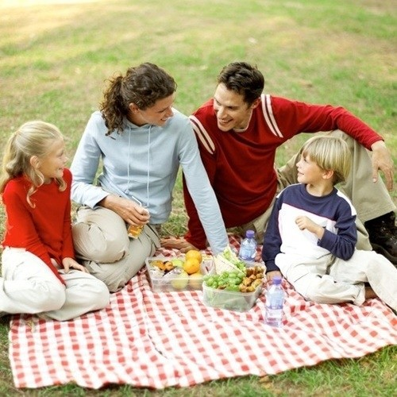

2.
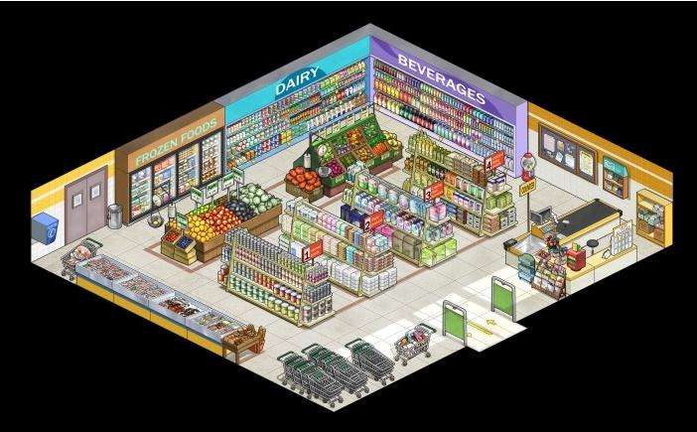

Vocabularies worksheet

I don’t think two ___________ of hot dogs will feed all of the kids for lunch.

packages

My boyfriend ___________ with my dad, and they are planning to get together to play golf after the picnic on Saturday.
hit it off

whip up
How about _____________ meals for the family gathering?

talking about
Mom, can you ___________ something for lunch? I’m really hungry.

supermarket

Let’s go to the ____________ and buy some orange juice for breakfast.

================================================================
Listening worksheet

Scott: Dave. I'm going to the supermarket to pick up food and drink for Saturday's picnic later. Any (1) ?
Dave: Well, everyone has been talking about having a barbecue down by the river, so why don't you pick up some hamburger and hot dogs?
Scott: Okay, but how much hamburger meat are we going to need? And hot dogs too?
Dave: Uh, I don't know. How about three pounds of hamburger and a couple (2) of hot dogs?
Scott: Oh, that's not going to be enough. Do you remember the last picnic we went on? Your (3) , Jim, ate about ten hamburgers by himself!
Dave: You're right. Let's see. I'd better write this down. Uh, let's see about nine pounds of hamburger meat and, uh . . . , seven packages of hot dogs.
Scott: And you better pick up some (4) for those who don't like hamburger or hot dogs.
Dave: Okay. How about five or six bags of potato chips?
Scott: Humm. Better make that (5) or so.
Dave: Alright. Oh, and we're gonna [going to] need some hamburger and hot dog buns. How about five packages a piece? I think that sounds about right.
Scott: Yeah, you better pick up some mustard, catchup, and mayonnaise too.
Dave: Okay. What else? Uh, we're gonna [going to] need some soft drinks. How about ten of those big 2-liter bottles?
Scott: Sounds fine, but be sure to buy a (6) of drinks.
Dave: Okay. And what about dessert?
Scott: Well, maybe we could ask Kathy to make a few (7) pies like she did last time.
Dave: Well, I wouldn't mind that, but you know, she's been very busy working two jobs, so I'd hate to ask her, [Oh, hum . . . ] and uh . . . Hey, why don't you whip up some of your oatmeal cookies? [Well . . .] Hey, you could even ask, uh . . . , what's her name . . . yeah that new girl, Susan, the one that moved in across the street! [Well . . .] I (8) she'd be willing to help you! [I don't know . . . ] She's a real knockout!
Scott: Nah, I don't think I could ask her . . .[Ahh!] I don't know her phone number, plus . . .
[ Door bell rings . . . ]
Dave: Hey, you don't need to. She's at the door!
Scott: What do you mean?
Dave: Well, I thought you two would hit it off, so I called her up saying I was you, and I (9) her over to watch a movie.
Scott: You did what???
Dave: Wait, wait, wait . . . [uhhhhh . . . ]
Listening Script

Scott: Dave. I'm going to the supermarket to pick up food and drink for Saturday's picnic later. Any suggestions?
Dave: Well, everyone has been talking about having a barbecue down by the river, so why don't you pick up some hamburger and hot dogs?
Scott: Okay, but how much hamburger meat are we going to need? And hot dogs too?
Dave: Uh, I don't know. How about three pounds of hamburger and a couple packages of hot dogs?
Scott: Oh, that's not going to be enough. Do you remember the last picnic we went on? Your roommate, Jim, ate about ten hamburgers by himself!
Dave: You're right. Let's see. I'd better write this down. Uh, let's see about nine pounds of hamburger meat and, uh . . . , seven packages of hot dogs.
Scott: And you better pick up some chicken for those who don't like hamburger or hot dogs.
Dave: Okay. How about five or six bags of potato chips?
Scott: Humm. Better make that eight or so.
Dave: Alright. Oh, and we're gonna [going to] need some hamburger and hot dog buns. How about five packages a piece? I think that sounds about right.
Scott: Yeah, you better pick up some mustard, catchup, and mayonnaise too.
Dave: Okay. What else? Uh, we're gonna [going to] need some soft drinks. How about ten of those big 2-liter bottles?
Scott: Sounds fine, but be sure to buy a variety of drinks.
Dave: Okay. And what about dessert?
Scott: Well, maybe we could ask Kathy to make a few cherry pies like she did last time.
Dave: Well, I wouldn't mind that, but you know, she's been very busy working two jobs, so I'd hate to ask her, [Oh, hum . . . ] and uh . . . Hey, why don't you whip up some of your oatmeal cookies? [Well . . .] Hey, you could even ask, uh . . . , what's her name . . . yeah that new girl, Susan, the one that moved in across the street! [Well . . .] I bet she'd be willing to help you! [I don't know . . . ] She's a real knockout!
Scott: Nah, I don't think I could ask her . . .[Ahh!] I don't know her phone number, plus . . .
[ Door bell rings . . . ]
Dave: Hey, you don't need to. She's at the door!
Scott: What do you mean?
Dave: Well, I thought you two would hit it off, so I called her up saying I was you, and I invited her over to watch a movie.
Scott: You did what???
Dave: Wait, wait, wait . . . [uhhhhh . . . ]

