- Transcript of listening
Betty: Mary! It’s good to see you.
Mary: Hi, Betty. Good to see you, too.
Betty: Our school Halloween party is coming.
It is going to be fun. Are you going to go to the party?
Mary: Of course. Did you know that there will be a dance?
Betty: Yes. And I am hoping to find a nice dance partner. Do you see the tall boy with the short black hair by the door?
Mary: I do. Is he the boy that you want to dance with?
Betty: Yes. His name is Andrew. He is cute.
Mary: Yes, he is. Where is he from?
Betty: He’s from France.
Mary: I hope you can dance with him.
Betty: What about you? Is there anyone you want to dance with?
Mary: Yeah. It’s Pablo. He is the one with brown curly hair by the snack table.
Pablo is Italian. He is a little short but I like his blue eyes.
Mary: You are right. I will ask Pablo to dance with me.
- Worksheet #1

- Key vocabulary worksheet
- Tall : adj. high in stature <-> Short

- Curly : adj. having curls or waves

- France: n. the largest country wholly in Europe

-> French n. the people of France

- Italy: n. a republic in southern Europe -> Italian n. a native of Italy

- Halloween: n. often devoted to pranks played by young people

- Describe the person who is in the picture.
Using the words in each box.
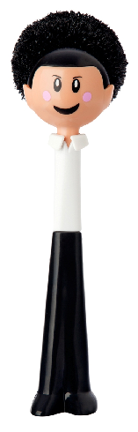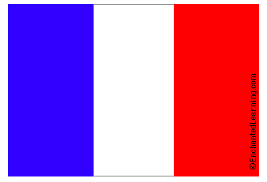 | 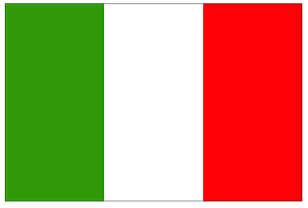
Tall, black hair, France | Short, brown, curly hair, Italy
He is from ___________.  He is _______.  He has __________hair. | He is from ___________.  He is _______.  He has __________hair.
Worksheet #4
- Complete the chart.
Name
 | 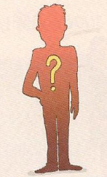 | 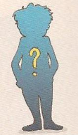
Heights | He is ____________. | He is _____________.
Hair style | He has ________________ hair. | He has _______________ hair.
Which country | He’s _____________. | He’s ______________.

Worksheet #3
Comprehension check up Questions
- Listen again and choose the correct answer.

- What kind of party is it?
- It’s a birthday party.
- It’s a dance party.
- It’s a Halloween party.
- Where is Andrew right now?
- By the door b. Behind the door c: By the desk
- What color is Pablo’s hair?
- Brown b. Blue c. Green
- Where is Andrew from?
- Korea b. USA c. France
- Who does Betty want to the party with?
- Daniel b. Pablo c. Andrew

Worksheet #2
- Listen and fill in the blanks.

Betty: Mary! It’s _____to see you.
Mary: Hi, Betty. Good to see you, too.
Betty: our school __________ party is coming.
It is going to be fun. Are you going to go to the party?
Mary: Of course. Did you know that there will be a______?
Betty: Yes. And I am hoping to find a nice dance_______.
Do you see the tall boy with the short _____ _____by the door?
Mary: I do. Is he the boy that you want to dance with?
Betty: Yes. His name is Andrew. He is ______.
Mary: Yes, he is. Where is he______?
Betty: He’s from_______.
Mary: I hope you can dance with him.
Betty: What about you? Is there anyone you want to dance with?
Mary: Yeah. It’s Pablo. He is the one with brown _____hair
by the snack table.
Pablo is ______. He is a little _____but I like his blue eyes.
Mary: You are right. I will ask Pablo to dance with me.

Worksheet #5
- Draw and describe who you want to go party as a partner.
- Using these form
He/ she has ______hair.
He/ she is from ________.
He/ She is ___________.

