Han. JiHye (Jade)  Teacher Ben  81th TC WK  3 November 2012 | Micro Teaching Lesson plan #2

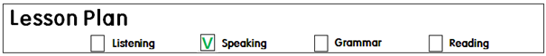

Title: Giving Directions

Instructor :  Jade . (JiHye).  Han | Level :  Intermediate  8~10 year olds | Number of  Students: 8 | Length  : 30 minutes

Materials :
♣ Flash cards of direction words.
♣ Flash cards to ask CCQ’s
♣ A big Road map to put on the board for the students to see.
♣ A student character on a wooden stick.
♣ Pictures of houses(same pictures) with each student’s name on it.
- one for themselves
- one for themselves to ask someone how to get their houses.
♣ Little bigger size of houses for each student to put on the big road map to see where they live and why they want to live there. (share their ideas in front of the class)
♣ Road map worksheets for each student.
♣ Making Tayo materials (made out of felt board) – 2 buses (blue, yellow)
- mouth, eyes, bus number, side mirrors
- blindfolds
♣ Memory matching cards – SOS activity

Aims
Main Aim - To enable Students to improve their speaking skills by having Students talk and ask about
giving directions.
Secondary Aim - Students will talk about giving direction through a silent way activity, worksheet and playing a game ‘making Tayo’s face’
Persona Aim - I want to improve my CCQ’s, explicit ICQ’s and ICQ’s
- I want to be better on board management and preparation.

Language Skills
Listening : Students will listen to teacher’s instructions
Speaking : Students are going to describe how to get to the specific places using the direction words.
Reading : Students will read the names written on the flash cards.
Writing : Students will be engaged in writing the names of the signs on their papers.

Language Systems
Phonology : Each words (pronunciation)
Lexis : names of each direction words (left, right, corner, straight, up, down, turn)
Grammar : Preposition (Turn right at the corner)
Function : None to discuss
Discourse :Students will talk about how to get to the specific places
(Times media, house and why)

Assumption
Students already know : some direction words to describe how to get to some points. (Verbally)

Anticipated Errors and Solutions :

If the lesson finishes early : SOS activity #1 (5 minutes)
Language problem – pre teaching, modeling, demonstration
Classroom management – monitoring, ICQ’s, Explicit ICQ’s
Student’s involvement – encourage the students with more variety of fun activities
and more kinesthetic activities.

References :

www.google.com

Lead in
Time | Set Up | Student Activity | Teacher Talk
2 minutes of Lead in |  | Hello teacher~.  I’m ok~  Not so good~  Tired~  No~  Tina :_____________________  Kate : ___________________  If any students raised their hands, they will get a chance.  Jennifer : _________________  Ian : ___________________ | Hello, everyone~  How are you?  Why~  Is anyone absent today?  I see everyone~  Did you have a good week?  How was your week Tina?  How was your week Kate?  I had a Halloween part with our children. Decoration was not easy. But it turned out really well.  Did anyone have a Halloween party?  What about you Jennifer?  What about you Ian?

Pre-Activity
Materials :
♣ Flash cards of direction words.
♣ Flash cards to ask CCQ’s
♣ A big Road map to put on the board for the students to see.
♣ A student character on a wooden stick.
♣ A picture of my house
Time | Set Up | Student Activity | Teacher Talk
2 minutes of Eliciting  2 minute of checking their vocabularies  Activity 1 :  3 minutes of Silent way activity  2 minutes of writing words  9 minutes ---- | Eliciting | Right, Left  Up, Down  Right  Straight  Turn right  Turn left  Corner  Let’s _________________  Yes.  Change  Yes. U turn  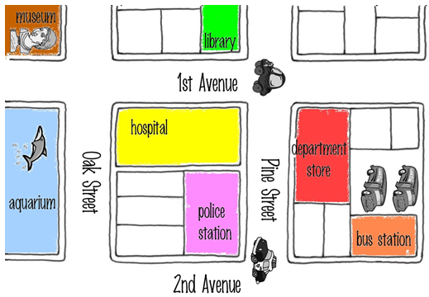  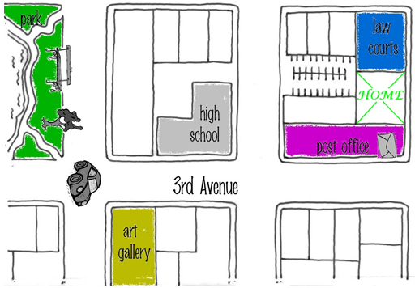  No.  Recycle  Museum  Aquarium  Hospital  Police station  Library  Department store  Bus station  High school  Law courts  Post office  Art gallery  Park  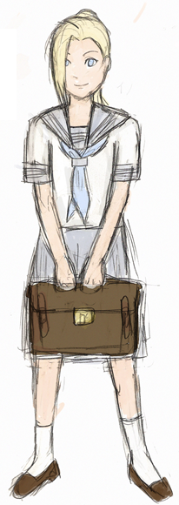  Lead you to Times Tesol building  2 minutes  Yes.  No.  Yes.  Students will lead me(teacher’s character) to the Times media building.  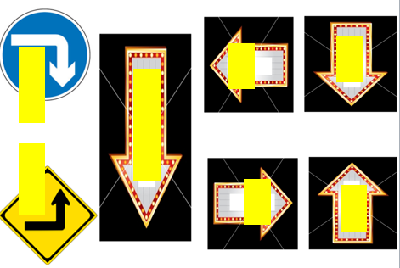  Write the direction words for right signs.  1 minute  Yes.  Ok~  Students will read the words one by one. | Eliciting  What do you call this?  When you want to explain how to the specific places.  Schemata – a wheel concept  Right~ Directions  Can you give me specific direction words  Here are very useful words to describe how to get to the places  What is this?  What is this?  What about this?  What is this?  How do you make sentence with this word?  Using “Let’s _________________  CCQ’s  Is this a direction word?  What is this?  What about this,  is this a direction word?  What is this?  Is this a direction word?  What is this?  Good~  I have a big road map here.  What do you see in this road map?  Yes. Very good  Who is she?  This is me wearing a school uniform.  I am going to Times Media to do Tesol course. But I can not move by myself.  I will give you 2 minutes.  You have to tell me where to go using those direction words.  But I can not speak.  Demonstration  For example, If you say go straight then I will move myself to this side slowly.  ICQ’s / Explicit ICQ’s  What are you going to do?  How many minutes do you have?  Do not start before I say go.  Can I speak?  Can only you speak?  Go~  1 minutes  30 seconds  10 seconds  Times up  Yes. Finally I got to the building.  I am not be counted as late.  Thank you.  I will give you a worksheet.  It has the pictures of directions we have seen on the flash cards.  I will give you 1 minute.  You will work individually to write  the words in the right signs.  ICQ’s / Explicit ICQ’s  What are you going to do?  How many minutes do you have?  Are you working individually?  Do not start until I finish passing all these papers.  Now. Begin~  30 seconds  10 seconds  Times up  Please read the words from this side one by one.  Well done.  everyone.
Main Activity
Materials :
♣ Pictures of houses(same pictures) with each student’s name on it.
- one for themselves
- one for themselves to ask someone how to get their houses.
♣ Little bigger size of houses for each student to put on the big road map to see where they live and why they want to live there. (share their ideas in front of the class)
♣ Road map worksheets for each student.
Time | Set Up | Student Activity | Teacher Talk
2 minute of explaining and demonstrating about the activity.  2 minute of putting their houses and picking up their partners.  4 minutes of doing actual activity  5 minutes of sharing  13 minutes |  | Students will listen to Teacher’s instruction.  Jade  Put my house on the road map and ask partner where they live and how to get to their house.  And think of why I want to live there.  3 minutes  No. work in pairs  OK  Students will share where they live and tell the reason why they want to live there.  If the time is ok, then  All the students will be able to present.  If not!  1/3 of students will present. | I have a picture of my house.  I am going to put my house somewhere else. but not showing to you. Then I will explain where my house is by leading you from the “start point”  Demonstration  For example. If I put my house over here and you do not know where I live. I will have to explain to you to come to my house.  I am going to give you the road map same as I have on the board.  I will give you the house with your names on.  You have to put your house somewhere first.  I don’t want you to show anyone.  ICQ’s / Explicit ICQ’s  What are you going to do?  Are you working individually?  Do not start until I say start.  Can you show it to your frinds?  You will pick your partners from this cup.  If you are rights raise your hands  If you are lefts raise your hands  If you are ups raise your hands  If you are downs raise your hands.  Did you check your partners?  If you are rights please sit over here. Lefts here, ups here, downs here.  Then you will work in pairs asking how to get to your house.  I am going to give you 3 minutes to work together and think of why you want to live there.  For example, I want to live here because I like reading book so I want to live close to the library.  ICQ’s / Explicit ICQ’s  What are you going to do?  How many minutes do you have?  Are you working individually?  Do not start until I say start.  Start  2 minutes  1 minute  30 seconds  10 seconds  Times up  Let’s find where everyone lives.  Here are your houses again.  I want everyone come to the board and put the houses on your spots.  Come on.  Presentation  First~ Let’s see.  OO why do you want to live there?  UU what about you?  NN Why do you want to live there?  Thank you for sharing

Post Activity
Materials :
♣ Making Tayo materials (made out of felt board) – 2 buses (blue, yellow)
- mouth, eyes, bus number, side mirrors
- blindfolds

Time | Set Up | Student Activity | Teacher Talk
2 minutes of explaining the game  3 minutes of playing the game.  5 minutes |  | Students will make the Tayo’s  face by putting eyes, mouths,  bus numbers, side mirrors with  putting blindfolds.  The most perfect team gets win.  Eyes. Mouth, bus number,  side mirrors | We are going to play a game.  I have a character.  Do you know what his name is?  Yes. His name is Tayo.  But we are going to play with this.  But somethings are missing.  I am going to divide you into 2 teams.  Ta  Yo  If you are Tas come here and line up here.  If you are Yos come here and line up here.  I have blindfolds, first players will wear these blindfolds and run to the pictures and put the pieces on.  The team with the most perfect bus wins this game.  ICQ’s / Explicit ICQ’  What are you going to do?  Are you working individually?  Don’t start until I sat go.  Well done everyone.
Close  1 minute |  | Great job  I did not hear any mistakes.  Let’s unscramble these words  “idetrconi”  I hope you enjoyed the lesson with me. I will be followed by _____.

SOS Activity
Materials :
♣ Memory matching cards
Time | Set Up | Student Activity | Teacher Talk
5 minutes |  | Have students to get involved in memory matching game. | I have a memory matching cards.  Here are the direction words that we have learned so far.  I am going to face the cards down on the table, then you will get to pick up same cards.  The person who got the most cards will be the winner.  You have 3 minutes  ICQ’s / Explicit ICQ’  What are you going to do?  How many minutes do you have?  Are you working individually?  Do not start until I say go.  Are you going to start while I put the cards on the table?

