Listening Speaking Reading Grammar Writing

Topic: Aladdin

Instructor:  Lina | Level:  9-11 Intermediate | Students:  8 | Length:  30 Minutes

Materials:
- White board
- Board markers
- Board erasers
- Tapes
- Two pictures (a Genie, Aladdin and Jasmine)
- Vocabulary worksheets (8 copies)
- Pieces of Aladdin summary (4 copies)
- Reading comprehension worksheets (4 copies)
- Three wishes worksheets (8 copies)
- “A whole new world” lyrics wall chart
- Sample lyrics wall chart
- Two papers
- Wishes and the favorite character worksheets (8 copies)

Aims:
- Main aim: To enable students to improve their reading skills by having talk about Aladdin
- Secondary aim: Students will talk about Aladdin through worksheets, pieces of summary, and lyrics wall chart
- Personal aim: I want to adjust my speaking speed to the level of learner

Language Skills:
- Listening : Students will listen to the teacher’s instruction and classmates’ opinion
- Speaking : Students are going to talk about Aladdin and present own opinion
- Reading : Students will read Aladdin summary, worksheets, and lyrics.
- Writing : Students will write about Aladdin on worksheets and lyrics on a paper.

Language Systems:
- Phonology : Listen to the teacher’s instruction
- Function : Talking with pairs, Giving and receiving opinions
- Discourse : Expressing opinion and asking questions
- Lexis : Idioms, key vocabularies in activities
- Grammar : Use of complete sentences on class work

Assumptions:
Students already know
- The definition of basic words
- The story of Aladdin
- The song of “A whole new world”

Anticipated Problems and Solutions:
- Students may have problem pronunciation with new vocabulary
→ Clearly read the vocabulary and make them to read several times.
- Students may not know the meaning of vocabulary
→ Encourage Students to guess from context.
- Students may not be able to pick up details from the listening
→ Chunk the listening
- If Students finish their tasks earlier than expected
→ Do a SOS activity
- If time is short
→ Reduce the time of group working

References:
- Penguin Kids Level 5 : Aladdin (Penguin Kids Readers), Pearson
- http://www.google.co.kr/imghp?hl=ko&tab=ii

Lead-In
Materials:

Time | Set Up | Student Activity | Teacher Talk
1 min | Horse  shoe | Open class conversation | Greeting :  Hello, everyone.  Guiding questions :  What is your favorite animation?  Why do you like that?

Pre-Activity
Materials:
Two pictures (a Genie, Aladdin and Jasmine), Vocabulary worksheet (8 copies), Tape

Time | Set Up | Student Activity | Teacher Talk
6 min | Horse  shoe | Answer to the questions  Answer to the CCQs  Look and listen to the teacher  Answer to the ICQs  Answer to the explicit ICQ  Do a worksheet  Say answers to others.  Look and listen to the teacher | Eliciting :  (Show students a picture 1)  What do you see in the picture?  What can a Genie do?  (Show students a picture 2)  What do you see in the picture?  What do you think about the relationship of them?  CCQs :  Is he a Genie?  Is he Aladdin?  (Stick two pictures on the board)  Instruction :  Let’s learn some vocabularies that will help you to read a story. I will give you a worksheet to draw lines and fill in the blanks about the key vocabularies. I want you to do individually for 3 minutes.  Demonstration :  Look at the worksheet. First, you should match vocabularies with the pictures and the meaning. Second, you should complete the sentences using the vocabularies.  ICQs :  What are you going to do?  How much time do you have?  Are you working in pairs?  I don’t want you to touch the paper until I say go.  Explicit ICQ :  Can you touch the paper when I give you the papers?  (Distribute worksheets)  (Start with saying “go” and monitor discreetly. Answer students if they ask questions. Give a time warning.)  Let’s check the answers.  Good job, everyone.

Main Activity
Materials:
Summary of Aladdin(4 copies), Reading Comprehension worksheets(4 copies), Three wishes worksheets (8 copies)
Time | Set Up | Student Activity | Teacher Talk
13 min | Pair work | Change seats  Look and listen to the teacher  Answer to the ICQs  Answer to the explicit ICQ  Make orders of Aladdin summery  Say answers to others.  Look and listen to the teacher  Answer to the ICQs  Answer to the explicit ICQ  Do worksheets  Present own answers to others  Look and listen to the teacher  Look and listen to the teacher  Answer to the ICQs  Answer to the explicit ICQ  Do worksheets  Present own wishes to others  Look and listen to the teacher | Instruction :  Say Genie and Aladdin.  Students who say Genie sit here and students who say Aladdin sit there.  ○○ and △△ work together.  With a new pair, Make orders by reading the summary of Aladdin. I will give you 3 minutes.  Demonstration :  There are four pieces of Aladdin summary. I will give you a hint. Aladdin made three wishes, so you can make orders by ordering three wishes.  ICQs :  What are you going to do?  How much time do you have?  Are you working individually?  I don’t want you to start until I say go.  Explicit ICQs :  Can you start when I give you the papers?  What is the hint to make orders easily?  (Distribute summaries)  (Start with saying “go” and monitor discreetly. Answer students if they ask questions. Give a time warning.)  What part is the first?  And what is the next part?  Well done.  Instruction :  Now we are going to check how well you read the story of Aladdin. I want you to do in pairs for 3 minutes.  Demonstration :  Look at the worksheet. First, find the three wishes Aladdin made. Second, match the names to the descriptions. You can refer to the summary of Aladdin.  ICQs :  What are you going to do?  How much time do you have?  Are you working individually?  I don’t want you to start until I say go.  Explicit ICQs :  Can you start when I give you the papers?  Can you refer to the summary of Aladdin?  (Distribute worksheets)  (Start with saying “go” and monitor discreetly. Answer students if they ask questions. Give a time warning.)  Let’s present your answers to others.  Good job, everyone.  Instruction :  If you can rub the magic lamp three times. What do you want the genie to do? Write and talk about it in pairs for 4 minutes.  Demonstration :  This is the worksheet. You can write three wishes on the boxes and share them with a pair.  ICQs :  What are you going to do?  How much time do you have?  Are you working individually?  I don’t want you to start until I say go.  Explicit ICQ :  Can you start when I give you the papers?  (Distribute worksheets)  (Start with saying “go” and monitor discreetly. Answer students if they ask questions. Give a time warning.)  Let’s present your partner’s wishes to others.  Good job, everyone.

Post Activity
Materials:
White board, Board markers, Board erasers, “A whole new world” lyrics wall chart, Sample lyrics wall chart, Two papers

Time | Set Up | Student Activity | Teacher Talk
10 min | Group work | Divide into Two groups  Look and listen to the teacher  Answer to the ICQs  Answer to the explicit ICQ  Write the lyrics of “A Whole new world”  Present the lyrics to others  Look and listen to the teacher  Answer “Aladdin” | Instruction :  I will divide into two groups. □□, △△, ○○, ☆☆ are a team. Have you heard about “A Whole new world” which is the OST of Aladdin? We are going to write the lyrics of “A Whole new world” after looking at the original lyrics and thinking. And then, we are voting for the best lyrics. I will give you 5 minutes for writing the lyrics in a group.  Demonstration :  To help you do better, look at the lyrics. Someone says something to another person. You should change the underlined lyrics. What kind of thing do you want to say? I will give you an example.  ICQs :  What are you going to do?  How much time do you have?  Are you working individually?  I don’t want you to start until I say go.  Explicit ICQ :  Can you start when I give you the papers?  What part of lyrics do you change?  (Monitor discreetly. Give a time warning.)  Present the lyrics to other students.  Let’s vote for the best lyrics.  Closing :  I didn’t hear any mistakes so can you  unscramble this?  (Write “aaddeiln” on the board)  Aladdin is correct. Well done.  See you next time.
SOS Activities
Materials:
Wishes and the favorite character worksheets (8 copies)

Time | Set Up | Student Activity | Teacher Talk
7 min | Horse  shoe | Look and listen to the teacher  Answer to the ICQs  Answer to the explicit ICQ  Start with saying “go”  Present to others  Look and listen to the teacher | Instruction :  I will give you a worksheet to work about wishes and the favorite character. I want you to work individually for 4 minutes  Demonstration :  Look at the worksheet. First, match the wishes to the people. Second, draw your favorite character from the story and write the reason.  ICQs :  What are you going to do?  How much time do you have?  Are you working individually?  I don’t want you to start until I say go.  Explicit ICQ :  Can you start when I say “go”?  (Distribute worksheets)  (Start with saying “go” and monitor discreetly. Answer students if they ask questions. Give a time warning.)  Let’s present to others.  Good job, everyone.
Appendix
#1. Two pictures (a Genie, Aladdin and Jasmine)

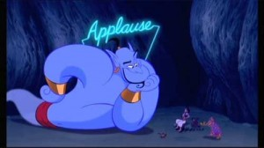


#2. Vocabulary worksheet
★ Match the vocabularies to the pictures and the meaning. Draw lines.
1. prisoner | a. 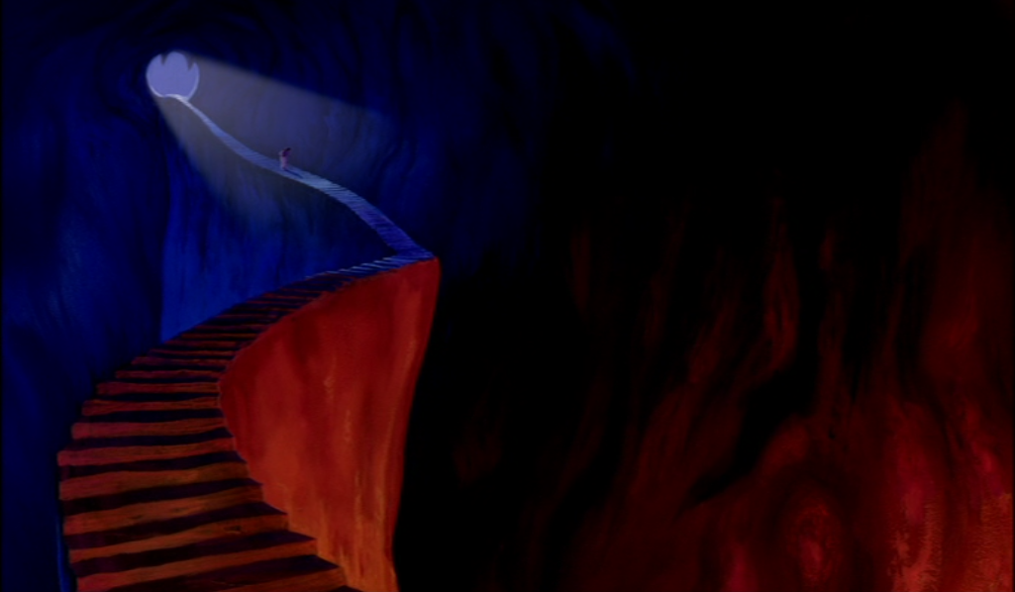 | A. a geological formation consisting of an underground enclosure
2. snakehead | b. 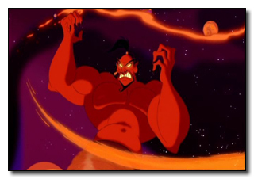 | B. move over something with pressure
3. wicked | c.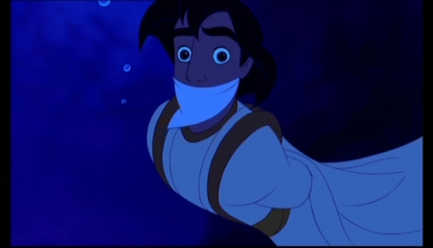 | C. has the head like a snake
4. cave | d.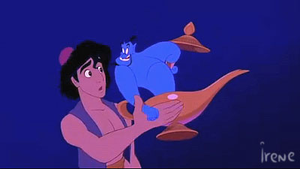 | D. morally bad in principle or practice
5. rub | e.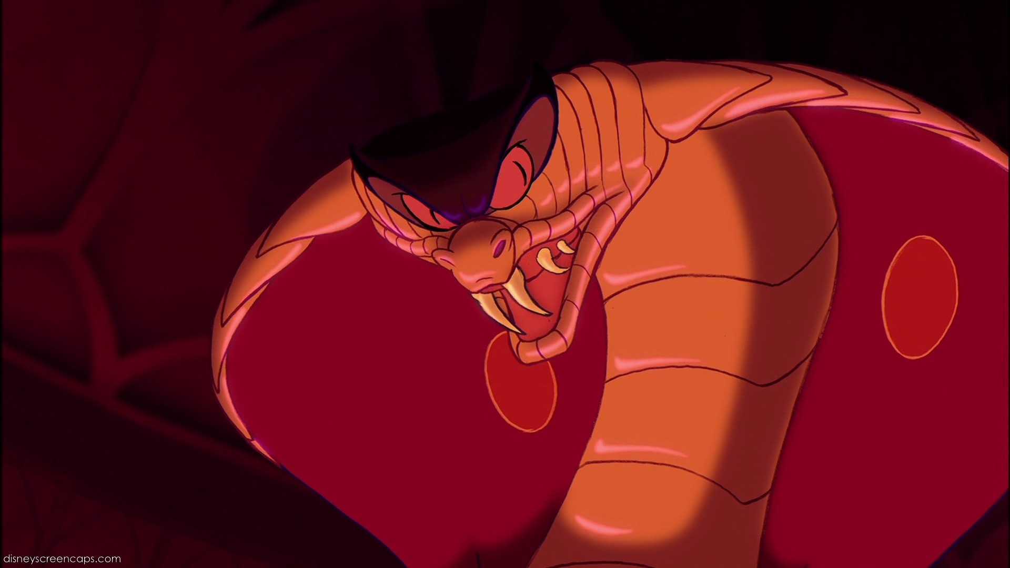 | E. getting water into the lungs
6. drown | f.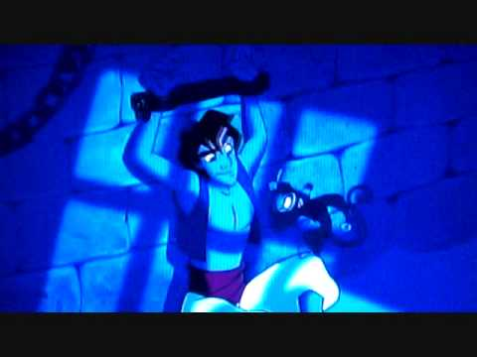 | F. a person who is confined
★ Complete the sentences using the vocabularies.
- Jafar, the Sultan’s advisor, wants the magic lamp from the of Wonders.
- He the lamp and a genie appears.
- Jafar is very angry and uses his staff to make the Sultan agree that Jasmine must marry Jafar and not a prince.
- Aladdin still has the lamp so he makes his second wish for the Genie to save him from .
- His wish is granted and he becomes a prisoner inside the lamp.
#3. Summary of Aladdin

Jafar, the Sultan’s wicked advisor, wants the magic lamp from the Cave of Wonders. He discovers that only “a man who is better than he looks” can enter the cave. Jafar tricks the Sultan and takes his magic ring. The ring tells him that Aladdin, a poor boy, is good enough to go into the cave and bring out the lamp.
Aladdin goes into the cave for Jafar, but he gets shut inside. He rubs the lamp and a genie appears. The Genie tells him that he has three wishes and takes Aladdin out of the cave. Outside the cave, Aladdin makes his first wish to be a prince because only a prince can marry the Sultan’s daughter, Jasmine. (Aladdin met Jasmine in the market and they had fallen in love with each other.) His third wish will be to free the Genie from the lamp. But he does not make his third wish yet!
Jafar is very angry and uses his snakehead staff to make the Sultan agree that Jasmine must marry Jafar and not a prince. Jafar finds Aladdin and throws him into a river. But Aladdin still has the lamp so he makes his second wish for the Genie to save him from drowning. Jafar’s parrot, Iago, then tricks Aladdin and Jafar gets the lamp at last. Jafar is about to marry Jasmine when Aladdin returns and they fight. Aladdin wins by tricking Jafar into saying he wishes to be a genie. His wish is granted and he becomes a prisoner inside the lamp.
Jasmine and Aladdin are about to marry and they are both very happy. Aladdin frees the Genie with his third wish and the Genie goes off to see the world.

#4. Reading Comprehension Worksheet
★ What is the three wishes Aladdin made?
1.
2.
3.
★ Match the names to the descriptions. Draw lines.
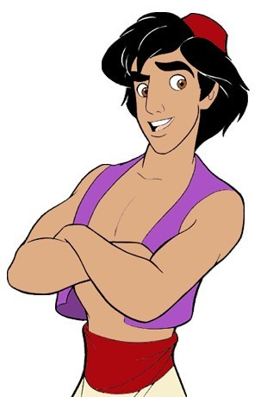  1. Aladdin |  | a. lives in the magic lamp. He wants to be free.
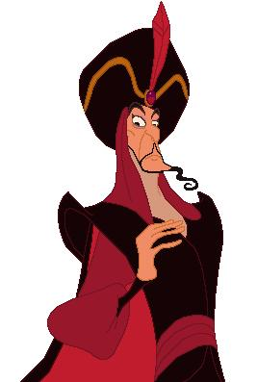  2. Jafar |  | b. is Aladdin’s pet monkey. He becomes an elephant in the story.
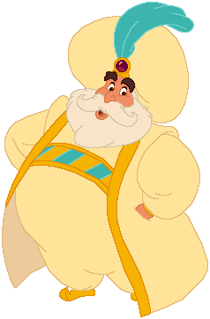  3. The Sultan |  | c. is the Sultan’s advisor. He wants to have power.
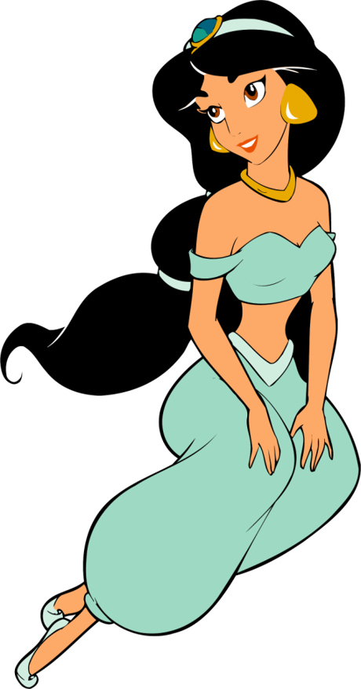  4. Jasmine |  | d. is a street boy. He wants to be a prince to marry Jasmine.
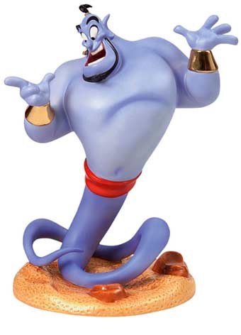  5. The Genie |  | e. is Jafar’s parrot. He is very clever and helps his master.
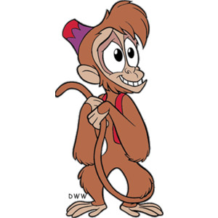  6. Abu |  | f. is a beautiful princess. She wants to marry for love.
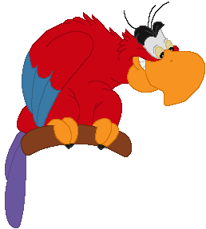  7. Iago |  | g. is Jasmine’s father. He wants his daughter to marry.

#5. Three wishes Worksheet
★ You can rub the magic lamp three times. What do you want the genie to do?
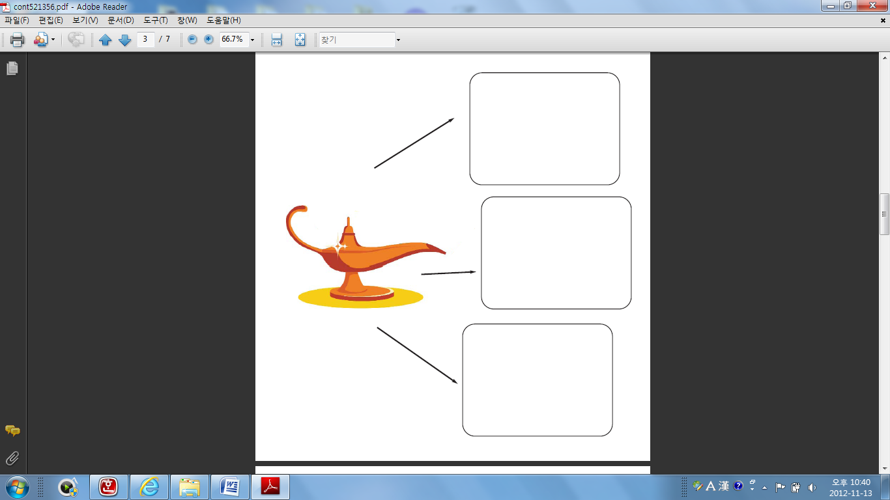
#6. “A whole new world” lyrics wall chart
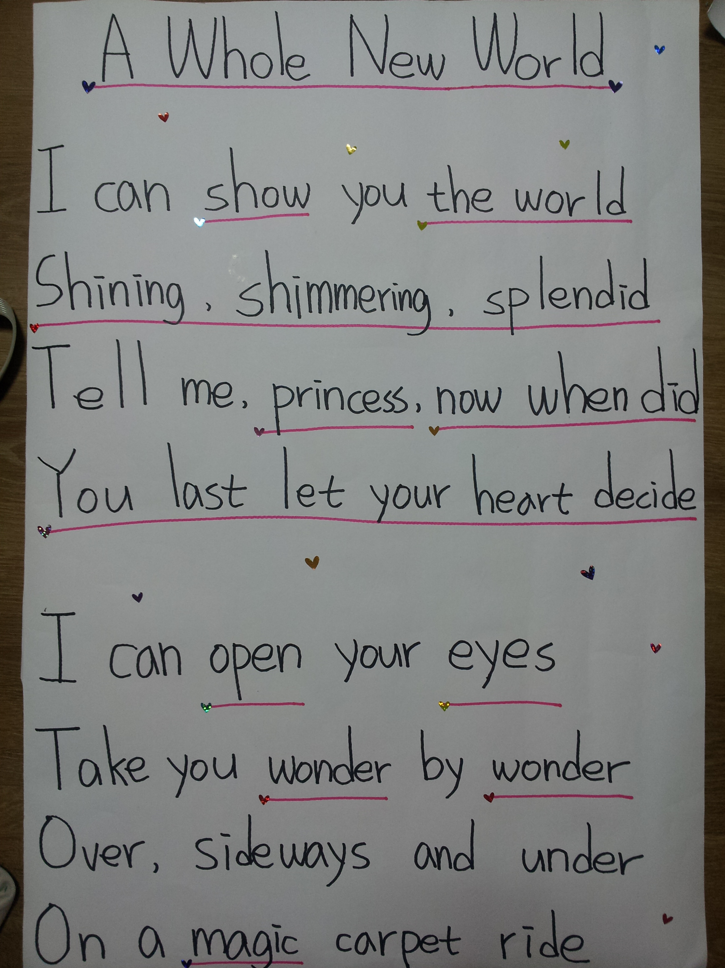

#7. Sample lyrics wall chart
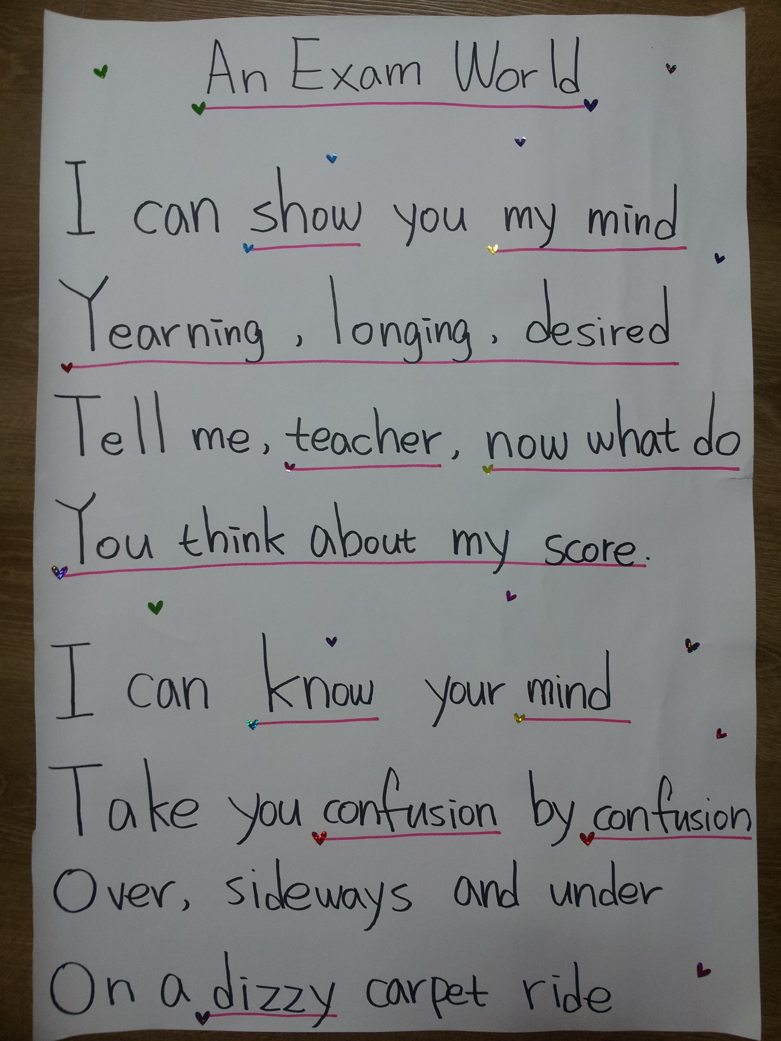

#8. Wishes and the favorite character worksheets

★ Match the wishes to the people. Draw lines.

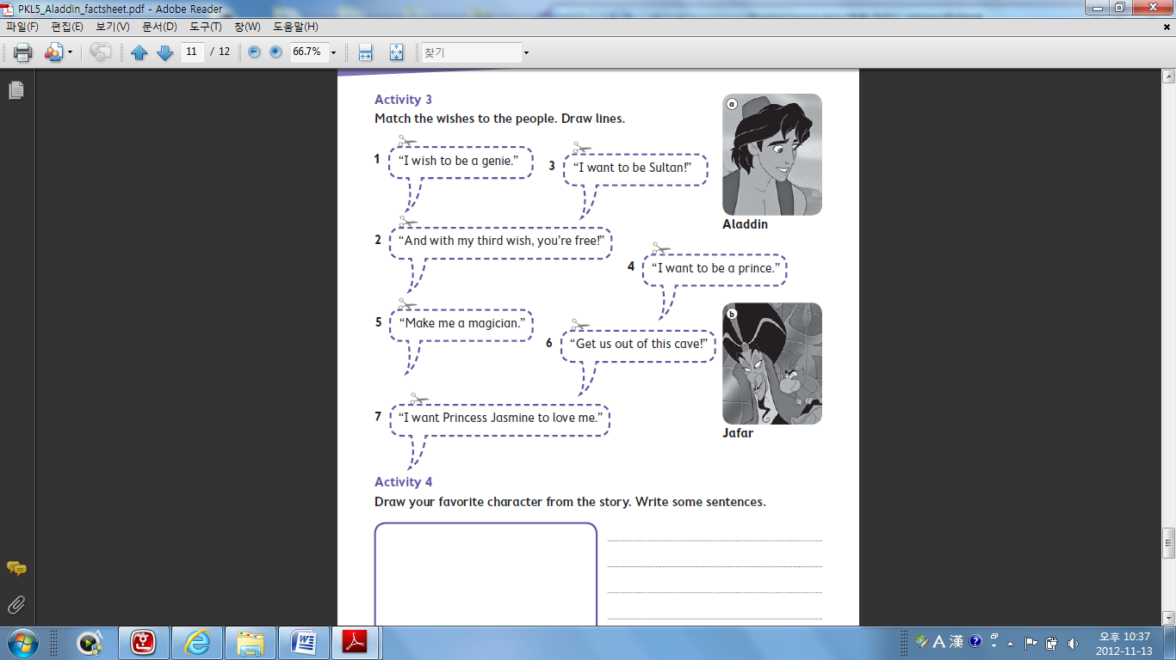

★ Draw your favorite character from the story and write the reason.



