Grammar Lesson Plan

Instructor:
Mi-sun Hwang

Level:
intermediate
Students:
12 Students

: Length:
35 minutes

Present Progressive/Continuous
Materials:
Video clip from Youtube
Worksheet for controlled practice / Worksheet for less-controlled practice
Worksheet for free production
A white board, marker
A laptop computer

Aims:
Students will be able to predict the meaning of present progressive by watching a video clip and doing activity.
Students will know how to use present progressive by worksheet practice and pair activity.
Students will be able to practice speaking & writing by group activity.
.

Language Skills:
Listening: listening to the video conversation, teacher’s instruction, classmate’s ideas.
Reading: reading worksheet to answer.
Speaking: asking and answering the questions.
Writing: writing through activities.
Language Systems: Phonology: various verbs
Grammar: present progressive
Function: present progressive statements/ negative statements
Discourse: Difference between present and present progressive

Assumptions:
Students can speak and write their opinions in English.
Students have already known verb+~ing form.

Anticipated Errors and Solutions:
Students may have confusing in differences of present and present progressive.
- Give more examples and explanation.
If students can’t finish the task in time,
- Give them extra time to finish the task.
If students do their task earlier,
- Let students write sentences using with present progressive.

References:
http://www.youtube.com/watch?v=a6Eozn55Lqs
<Focus on Grammar> published by PEARSON Longman

Lead-In
Materials: Whiteboard, projector, screen, computer
Time  5 min. | Set Up  Whole class | Procedure:  Hello, everyone. How’s it going? It’s getting colder and colder. Be careful not to catch a cold.

Present
Materials: Power point slide, whiteboard, marker
Time  10 min | Set Up  Whole class | Procedure:  - Guided Warmer Activity  Today we’re gonna watch some video clip. While watching video, please think about what Lonney is doing.  <CCQ>  What should you do when you watch a video clip?  - Recall  Was it interesting? What did we just watch? Who is the main character?(Lonney) What is he doing?(He is playing baseball.) He is ~(throwing.) He is ~(hitting.) He is ~(running.) He is ~(catching.)  - Reflect  Then what am I doing right now? I’m talking. What are you doing? You are listening. What are we doing? We are studying. Look! Tell me more What I am doing. What am I doing? (You are jumpimg. You are flying. You are swimming. You are dancing…)Now you can guess what.  If I jump right now we can say I am?~ (jumping). If you swim right now you are?~ (swimming). If she runs right now she is?~(running). If they sing right now they are?~(singing). That’s what we’ll learn today. It’s present progressive.  - Conclude  Form  Now, let’s look at this substitution table.  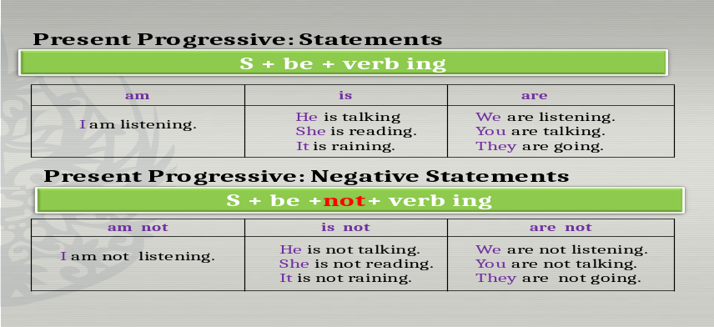  Drilling  Just listen and repeat after me.  (Listen->Repeat choral->Repeat individually)  Meaning  We’ve learned present progressive form. When do we use present progressive? Look at this timeline.  Present progressive  Past-------------------present---------------future  When we do something that is happening now, at the moment, as we speak, we use present progressive. We use present progressive in the temporary situation. On the contrary we use present in the permanent period or general facts. For example The sun rises in the east.(general fact) I live in Seoul.(permanent period)  I am talking now. (temporary situation)  <CCQ>  If I say I am studying everyday, do you think it is right?(No.)  Then how could you correct the sentence? (I study everyday.) How about I am knowing that news.’ Is it right? (No.) We have to use present. The correct sentence is I know that news. Good job!!
Practice
Materials: Worksheet for practice, whiteboard, marker
Time  5 min | Set Up  Whole class  Individually  Whole class  In pairs  Whole class | Procedure:  1.Controlled practice  Next, I’ll give you a worksheet to practice present progressive. Correct the sentences. You can do it alone. You have 3 minutes.  <Demonstration>  Let’s have a look at the number 1. ‘She wearing a new T-shirt today.’ What’s wrong with this sentence? You can correct like this. She is wearing a new T-shirt today.  Now your turn.  <CCQ>  Do you work alone?  What are you supposed to do? (Correcting sentences)  (worksheet)  <Checking answers>  Are you finished? Let’s check the answers.  2. Less controlled practice  Now Let’s make some sentences using with present progressive. Here is another worksheet. Do it with your partner. I’ll give you 3 minutes.  <Demonstration>  Look at the picture. What is A doing?(She is singing) Yes, she is singing.  Now your turn.  <CCQ>  Do you work alone?  What are you supposed to do?(Look at the picture and make sentences.)  (worksheet)  <Checking answers>  Are you done? Let’s check the answers

Production Group discussion/homework
Materials: Worksheet for game, dice
Time  15 min | Set Up  Whole class  In groups  Whole class | Procedure:  - Free production  Now we’ll play a game. Let’s make 3 groups with 4 people and number all 1,2,3,4. I’ll give you a worksheet and dice. If your dice shows a ‘bomb’, you should delete previous sentence. If your dice shows 1,2,3, or 4, make your own sentence using present progressive and write on your worksheet. If you make 3 sentences first, you’ll be a winner. I’ll give you 5 minutes.  <Demonstration>  Take a look at me. (If I’m number 2) after throwing the dice when it shows a ‘bomb’ I can’t make a sentence. But I’ve got my number 2, I can make any present progressive sentence. I am sleeping. I am running…etc. O.K?  <CCQ>  Do you work alone?  If your dice shows a ‘bomb’, what shall you do?  If you wanna be a winner, how many sentences do you have to make?  How much time do you have?  (Group games)  - Wrap up  Are you done? Was the game interesting? It’s easy and fun, I think. Who is the winner in each group? You are lucky guys. Here are some presents for winners. What am I doing? I am giving presents to winners. Today we’ve learned present progressive. It’s time to finish. You did a great today. I hope you enjoyed today’s lesson. See you next time. Good-bye.

Worksheet for controlled practice>>>

*Correct these sentences.

- She wearing a new T-shirt today.

- We no are eating pasta now.

- They’re make chicken right now.

- He reading the newspaper now.

- It no is raining today.

- I no drinking water. I drinking soda.

- She isn’t talk. She’s listen.

- You not listening to me.

- Steve working hard.

- Tom Cruise and Suri Cruise is playing tennis.

Worksheet for less-controlled practice>>>

*Look at the picture and make 6 present progressive sentences.

<A picture>

A.

B.

C.

D.

E.

F.

Worksheet for game>>>

* Throw a dice. If you have your number, make a sentence using present progressive. If you have a ‘bomb’ you should erase one sentence.

1)

2)

3)

4)

5)

Worksheet for game>>>

*Throw a dice. If you have your number, make a sentence using present progressive. If you have a ‘bomb’ you should erase one sentence

1)

2)

3)

4)

5)

