Grammar Lesson Plan

Topic: Manners (Should)

Length:

35 min
Students:

12 students
Level:

High beginner
Instructor:
Shin Ae Kwon
(Kristy)

Materials:
- Pictures
- Worksheet (12 copies each)
- White board, board markers

Aims:
- To predict the meaning of should modal by guessing and discussing with the picture of public place
- To know the form of should modal by teacher’s explanation and substitution table
- To practice should modal by answering concept check questions and completing the worksheets
- To practice speaking and listening ability by sharing ideas in a group and present each other’s opinion

Language Skills:

- Reading: reading the work sheets to answer questions
- Listening: listening to Ts presentation, instruction, demonstration/ classmate’ ideas
- Speaking: drilling, practice activities, and sharing ideas
- Writing: doing on the worksheet (controlled&less-controlled)

Language Systems:

- Phonology: drilling
- Grammar: use of ‘should+verb’
- Function: giving advice and opinions

Assumptions:

Ss already know:
- how the class is set up and run
- the teacher’s teaching style and the pace of the course
- grammar of do or don’t modal

Anticipated Errors and Solutions:
- Ss may have difficulty in understanding the meaning
- Provide more examples
- Ss may have a hard time drilling
Give the Ss more chances to practice
- If Ss need more time to finish their activity (cut-off plan)
- Be flexible with the time as giving Student more time to finish their activity and cut off the time of post activity
- If Ss finish their tasks earlier than anticipated(SOS plan)
- Give them more time on final activity

References:
- Substitution table and tasks _ Center Stage 3(Grammar to Communicate) -Lynn Bonesteel & Samuela Ecstut-Didier
- Knowledge and task _ www.englishgrammarsecrets.com

Lead-In
Materials: Board and markers. Pictures
Time  2 min | Set Up  Whole Class | Procedure:  Hello everyone, how are you today?  Every time and everywhere we are belong to the public places like this classroom. Have you seen someone is doing things wrong in the public places? I can see so many people doing without manners. Sometimes I would like to give some advise them.  Anyway, look at these pictures.  (Showing 2-3 pictures of the public places)  Where is this?  (Ss will answer ‘theater’, ‘subway’, ‘classroom’ and ‘park’)  Before start the class, we are talking about the manners when you are in the public places.

Pre-Activity
Materials: pictures, white board and makers, substitution table
Time  4 min  1 min  3min  5 min | Set Up  Whole Class  Group Work  Whole Class  Whole Class  Whole Class  Group Work  Whole Class | Procedure:  - Guided Warmer Activity  - Instructions  I will make three groups and give you each picture. You guys are talking about the manners when people are at those kinds of public places. You can make a list people do or don’t things. You don’t have to make many of it. Just 2 of each will be fine. I will give 2 min.  - Demonstrations  First, Look at the picture together. It is a park. I made my list.  do – prepare a plastic bag for trash  walk with dog on a leash.  (Ss will ask about the word ‘leash’. Leash means ‘a chain or rope to hold/restrain an animal’.  Don’t – throw trash  smoking  (Making three groups & giving each picture.)  - CCQ  How much time do you have?  Are you working with your group members?  What are you supposed to do?  Ok, you may start.  (monitor discreetly and make sure time limits)  Collect answers from each group.  (write down on the board)  - Recall  We have just talked about the public places’ manners. I have just write down on the board which you made the list.(do or don’t)  When we give some advice for the manner to someone, we can say different way instead of do or don’t.  - Reflect  We can use should or should not instead of do or don’t.  Can you complete the sentences with should or should not (shouldn’t) with your group member? I will give 1 min.  - Demonstrations  For example, when you recommend friends to go to the park. You can advice to your friend.  - You should prepare a plastic bag for trash.  - You should not throw trash.  - CCQ  What are you supposed to do?  How much time do you have?  Are you working alone?  (Let Ss make sentences with group members and monitor discretely)  - Conclude  Collect the sentences which are made by Ss.  - Meaning  Good job guys! We have just did practice to make some expression with ‘should’  - We use 'should' for giving advice.  - We use 'should' to give an opinion or a recommendation.  - 'Should' expresses a personal opinion and is much weaker and more personal than 'must' or 'have to'. It is often introduced by ' I think'.  Let’s look at this picture(smoking)  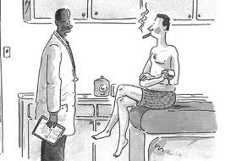  Give some advice to him.  (examples)  He should stop smoking.  He should not keep smoking.  - CCQ  - Does the man want to smoke?  - Is it helpful to his health to stop smoking?  - Form  When we make expression with ‘should’ always is combined with verb. ‘should’ is kind of a helping verb.  (showing the form with examples on the board.)  Should(not) + verb  - Drilling  <Simple Repetition Drill>  I should(not) study hard.  You be polite.  We / They be rude.  She/He apologize.  (Show Ss the Substitution table)  Ok. Listen to what I say and don’t repeat.  CCQ) Are you going to repeat?  (point to Substitution table while reading)  Ok. Now listen and repeat.  CCQ) This time, what are you going to do?  Now I will pick one of you to read loudly.  (pick Ss and point to the substitution table to read)
Practice
Materials: board, markers, and 12copies of the task
Time  4min  4 min  6 min | Set Up  Whole Class  Individually  Whole Class  Whole Class  Individually  Whole Class  Whole Class  Pair Work  Whole Class | Controlled Practice #1  Instructions  Do the worksheet questions only number1. Fill in the blanks with should or shouldn’t. Work individually. You have 2 min.  (Pass out the worksheet)  Demonstrations  Look at the letter ‘a’. What do you think in the blank?  (Ss will answer) Yes, the answer should be ‘should’  CCQ  Are you working alone?  How much time do you have?  What do you do?  (Run the task)  You may begin.  (monitor discreetly)  Feedback  Do you need more time?  - Yes give 30 seconds extra time to do the task  - No check answers together  Controlled Practice #2  Instructions  Loot at the question number2. Complete the sentences. Work individually. You have 2 min.  Demonstrations  Let’s look at the letter ‘a’ together. First you can choose one clause in the box and then complete the sentence with should or shouldn’t. The answer should be ‘should say “please”.  CCQ  Are you working alone?  How much time do you have?  (Run Task)  (monitor discreetly)  Feedback  Have you all done the answers?  - No give 30 seconds extra reading time  - Yes check the answers by having Ss read each question and say the answer  Less-controlled Practice  Instructions  Look at the picture. People are doing things wrong. Make a sentences with should or shouldn’t. Answers will vary. You can work with your partner. I will give 3min.  Demonstrations  Can you see the left side on the top? The boy enters the door. The old lady seems to follow the boy to enter the inside. So I can make a sentence like this,  ‘The boy should hold the door for the old lady.’  CCQ  Are you working with your partner?  How much time do you have?  Is there only one answer?  (Run the task)  Monitor discreetly and give time warning.  Get the volunteers and share the answers

Production
Materials:
Time  6min | Set Up  Whole Class  Groups  Whole Class  Whole class | - Free Practice  Instructions  Imagine, your foreign friend is going to visit to Korea. She/He asked some advice for travelling Korea. Write 2 or 3 advice for your friend. Work with your partner. I will give 2 min.  Demonstrations  In my case, I will advice to my friend like,  - You should bring some warm clothes like a coat and a jumper.  - You should bring comfortable shoes.  CCQ  Are you working alone?  How much time do you have?  Monitor actively and participate within each group.  Share students’ opinions.  Take 2~3 volunteers if running out of time.  - Wrap-up  Did you enjoy today’s lesson?  We will learn about another ‘should’ structure next time. You should practice what we learned today.  Ok. Good job today. See you next time!

- Should or shouldn’t

- I hate my job. I start looking for a new one.
- This room is a mess! You tidy it up.
- What are those children doing in the street? They be at school.
- To have clearer skin, you eat more fresh fruit and vegetables.
- You believe everything he tells you. You can’t trust him.
shouldn’t
should
should
should
should
should

- Complete the sentences. Use should or should not(shouldn’t)
cover your mouth say “ please” send a thank-you note

knock on the door send a card start eating

- When you ask for something from someone, you ________________________.
- Before you enter someone’s room, you _________________________________.
- You _____________________________, when you cough.
- After you stay at someone’s home, you ________________________________.
- You _____________________________, before other people at the table start.
- When someone is in the hospital, you __________________________________.

- Look at the picture. People are doing things wrong. Make a sentences with should or shouldn’t

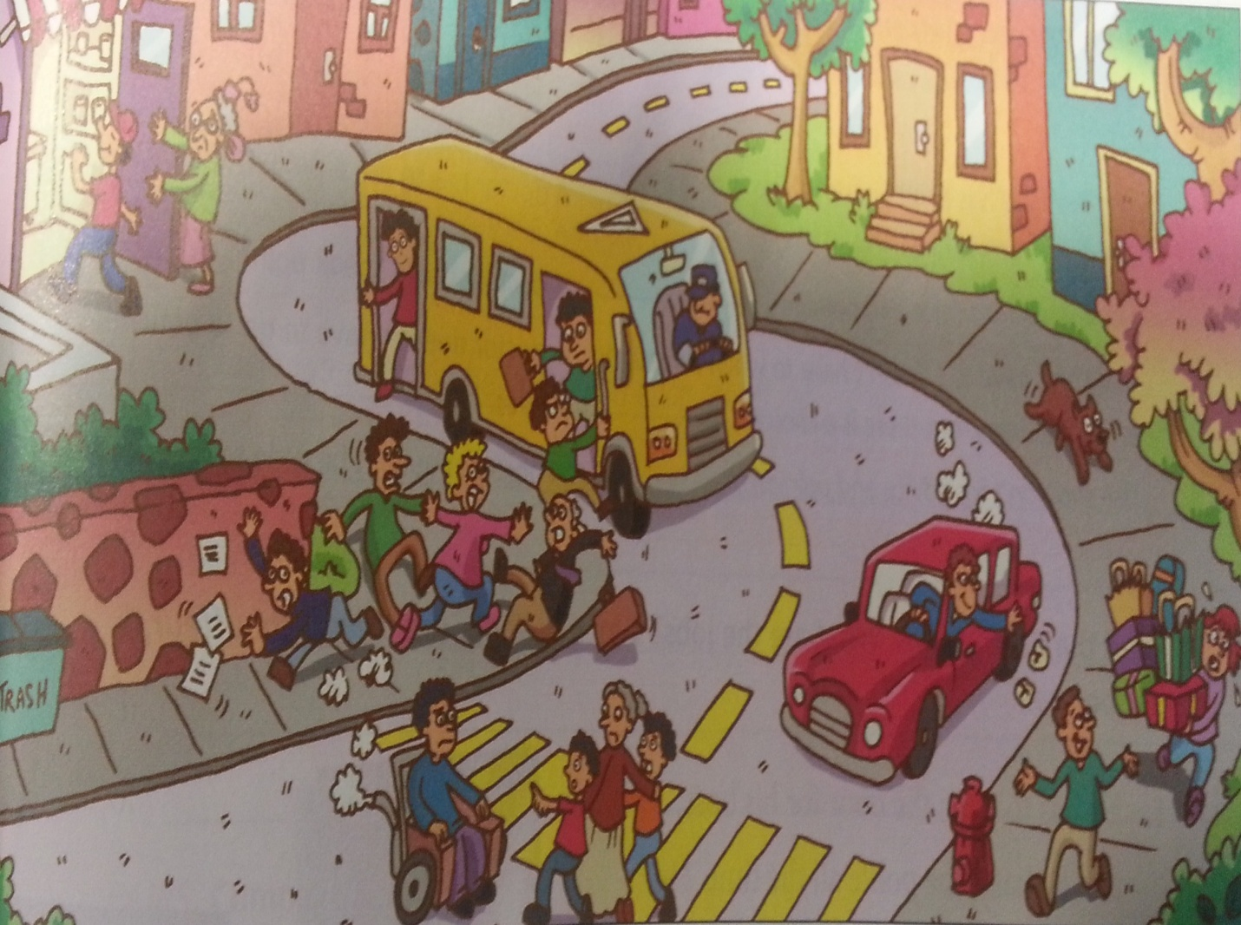

- ___________________________________________________________________________
- ___________________________________________________________________________
- ___________________________________________________________________________
- ___________________________________________________________________________
- ___________________________________________________________________________

Guided warmer activity
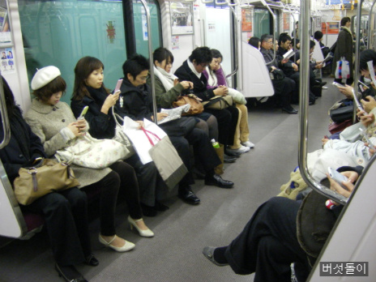

- Do

- Don’t

Guided warmer activity
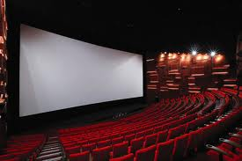

- Do

- Don’t

Guided warmer activity
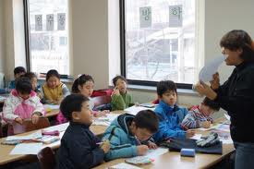

- Do

- Don’t

Pictures in the classroom
