Topic: Stuff and Things

Instructor:  KWON SHIN AE  (KRISTY) | Level:  High-Beginner/  Pre-Intermediate | Students:  11 Students | Length:  33 minutes

Materials:
- 11 role cards(2 different roles for each pairs)
- Pictures
- Worksheet(11copies)
- White board and markers

Aims:
- To practice using all-purpose words like “stuff” and “things” to ask for things they don’t know the word for English
- To practice descriptions about things or stuff through doing the tasks and the role play
- To speak fluently through doing the role play
- To practice listening and writing ability by T’s explanation and doing the tasks

Language Skills:
- Listening: T’s elicitation; T’s reading of descriptions; T’s example of vocabulary; other Ss’ represent of the role play
- Reading: role card; worksheet
- Speaking: answering of the tasks; doing the role play
- Writing: write T’s reading on the paper; Do the tasks

Language Systems:
- Function: asking for things they don’t know the word; describe things
- Lexis: stuff, thing, a kind of
- Discourse: doing the role play with descriptions

Assumptions:
- Some Ss may know the vocabulary of descriptions(like coffee, glue, and etc.)
- Ss enjoy doing the role play

Anticipated Errors and Solutions:
- Some Ss may not be active in the role play
- Encourage S by asking for descriptions of things and giving advice
- If Ss need more time to finish their activity (cut-off plan)
- Be flexible with the time as giving Student more time to finish their activity and cut off the time of post activity
- If Ss finish their tasks earlier than anticipated(SOS plan)
- Give them more time on final activity

References:
Topic and worksheet: http://www.onestopenglish.com/skills/speaking/lesson-plans/pdf-content/speaking-skills-stuff-and-things-lesson-plan/147360.article

Pre Task
Materials: board, markers, handout(11copies)
Time | Set Up | Student Activity | Teacher Talk
3min  3min | Whole Class | Try to describe with the pictures  Listen to the T’s talking, make a note and think about the answers(with a partner) | <Greeting &Brief Rapport>  Do you have any experience when you buy something in a store, you cannot remember exact name for things or stuff? If you do, have you described about thing or stuff what you want?  <Introduction of Task>  (show the pictures of chocolate and a mug)  Look at the picture.(one by one)  Can you describe this?  Good job guys.  Today we are going to practice using the words “stuff” and “things” to ask for things you don’t know the words in English.  <Background Information>  I’m going to read describe some words, if you can; I want you to write down on the paper and think the answers what I am describing. You don’t have to write down perfectly as I read.  When I finish the reading, compare your answers with your partner, I will give 1 min.  CCQs:  What are you supposed to do?  How much time do you have?  (After reading)  (Continue with next part)

Task Preparation
Materials: board, markers, handout(11copies)
Time | Set Up | Student Activity | Teacher Talk
8 min | Whole Class  Work Alone  Whole Class  Work Alone  Whole Class  Pair Work | Do the worksheet  Listen to T’s talk  Write a description for a dice | Stage 1 - Worksheet  Did you write down something what I have described just before? Can you remember what words I used to describe them?  (Once a few have volunteered answers, pass out the worksheet)  <Instructions>  Read the descriptions and match to the picture. There is one extra picture. And try to complete the descriptions with your note what you made. I will give 2 min. Work individually.  <CCQs>  Are you working alone?  How much time do you have?  (monitor discretely)  (Before the end of time limits)  Can you complete the descriptions?  If you cannot, look at the board. (Write the words “stuff”, “a kind of”, and “thing”.)  I will read first. Listen and repeat.  I will give 1 min to complete the sentences.  (monitor discretely)  Share the answer with Ss.  - Vocabulary  (point “stuff” & “thing” on the board)  Do you know what difference between these words is? Can you guess the function for the description? “Stuff” uses to replace an uncountable noun (for material) or about a plural countable noun (for a variety of items) “Thing” uses to replace an object (singular countable noun).  <CCQs>  (prepare water bottle)  Look at my water bottle.  What can you replace with water?  How about this bottle?  What can you replace with a water bottle?  (point “a kind of” on the board)  This uses to describe a type of person or thing.  <CCQs>  Sue! Do you like chocolate?  (asking question to other Ss)  What kind of food Sue like?  Sue likes kind of sweet food.  <Instructions continued>  Now we are doing some exercise. Can you see the picture for extra one? What is this? It’s a dice. Try and write a similar description for it. I will give 3 min. Work with you partner.  <CCQs>  Are you working alone?  How much time do you have?  (monitor discretely & give time warning)  Two or three Ss get their own descriptions and share with all Ss. If something wrong, make corrections.

Task Realization
Materials: pictures, role cards
Time | Set Up | Student Activity | Teacher Talk
14min | Whole Class  Work Alone  Whole Class  Pair Work  Whole Class | Read the role card  Do the Role Play  Change the roles  Represent Ss Role Play | Stage 2 – Role play  <instructions>  Now you will work in pairs. I will give role cards to each Ss. Imagine the big department store in New York like the macy’s. If you have a role card for A is a customer. And B is a staff in the store.  I will give 1 min. Just read your role card first.  CCQs:  How much time do you have?  (Give role cards to each Ss)  (After time limit)  Do you have any questions for your role?  <Instructions continued>  (Give 2 pictures to Ss who only have the role card for A)  Don’t show your pictures to your partner. That pictures what you want to buy at the department store. I will give you 5 min.  CCQs:  How much time do you have?  Are you working in pairs?  Let’s start!  (monitor and make note)  (Ask if they need more time. If so, give them 1 more min.)  After 5 min,  Ask Ss them to swap the role card. (Give different 2 pictures Ss who roles A) I will give 5 min again. Let’s do it.  (monitor and make note)  (Ask if they need more time. If so, give them 1 more min.)  Ok. You did great job. I need some volunteers. Let’s share what you did.  (one or two team show their role play in the front of class)

Post Task
Materials: board, markers
Time | Set Up | Student Activity | Teacher Talk
5 min | Whole Class |  | <Feedback>  Did you enjoy today’s activity? Do you think is it helpful to describe for something?  <Error correction>  (If Ss made errors during the role play, write it on the board. Let the Ss to correct as a whole class.
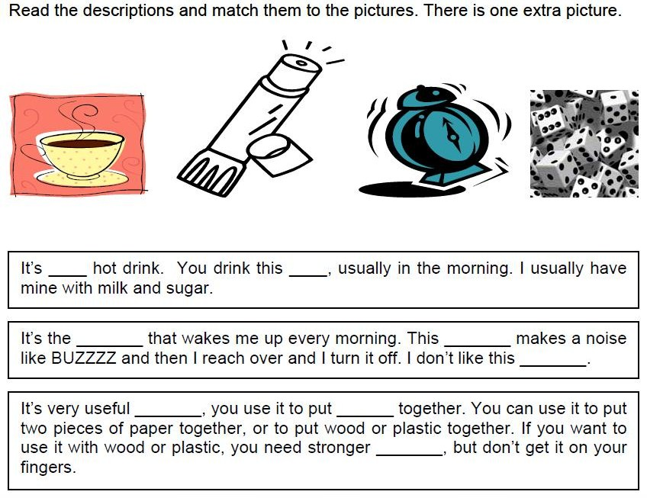
- Role Card
