Essay no.2

Classroom management without weapon

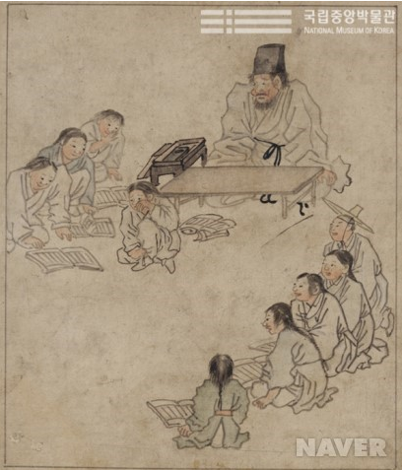

Marcelo

The end doesn’t always justify the means.
-anonymity-

One boy is crying in the middle of the drawing. One old man with a rigid face is staring at the crying boy behind him. Next to the old man looks like a teacher, one thin stick is laid on the floor. What was happening? There is a korean word ‘kyo pyun’. It means thin stick used by teacher at school. So ‘grab the ‘kyo pyun; means teaching students at school. Also It means hitting students using thin stick as suggestive meaning. But Since setting the rule to support the right of student 2years ago, the teachers in some region cannot use corporal punishment. A Lot of teachers complain about the rule. They said that they cannot control the students who make disruptions without physical punishment and the students ignore teacher without hitting them. Yes, it is obvious that not only students are used to corporal punishment but also teachers. We cannot go back to the past. We don’t have to use old methods that let the students down. We should respect the student’s self image. Of course we should succeed in classroom management for teaching English to the students.

If our students use only English in our class, English level of students improves considerably. Firstly, I think Tee is a good way to encourage the students to use only English. Tee is acronym for teaching the English in English. Teacher is an important role model to students. So teacher only uses English if possible. Secondly, we teach the classroom English to the students for running class smoothly at orientation. Classroom is as easy as possible for lower students. Thirdly, let the students individually pledge that we can use only English in front of students. Because person keep the rule tightly when they said it. Finally, teacher praise the students who only use English. This praise reinforces using the English. Then using the English is to be a habit to the students.

There is am idiom. “Well begun, half done.” In case the students are late, it is hard for them to learn the English well. So we let the students punctuate in keeping class time. Firstly, teacher is to be a role-model. If the teacher is often late, students don’t want to keep the rule. Teachers should be on time like as if he were Kant. Secondly, we set the group points system. Group member can get the points if their members are on time. So they take care of each other. And individually they have responsible to the group. Lastly, If one student continually late in your class, you should listen to him carefully. If he has inevitable reason for tardiness, teacher and students consult and make a flexible rule to the student.

We teach English to all sorts and condition of students. So their English levels are very diversified. There are also varieties of personalities in students. Some students need help but other students like to do by themselves. How can we help these students in the activity. Firstly, You have to treat the students kindly. Then if they have a need, they call for your help. Secondly, you are to apply scaffold to the students when they need your help. It means you don’t have to help your students always. Only help if your student cannot it although he did his best. If you help your students often, it discourages students to do activities and your students is waiting for your help. There is no improvement in the class. Lastly, smile to your students. It is the easiest and best way to encourage the students to do something. Comfortable environment makes the students participate in activities joyously.

We want to be a teacher. Not a trainer. We don’t need to depend on meaningless corporal punishment. It raises not only our self respect, but also self respect of our students. There are the greatest teachers in the world. What makes the teacher to be great teacher? Are they good at hitting the students? Absolutely, No! They are good at techniques and strategies for dealing the students. So It is very good news that we can’t use the corporal punishment. Because we need to develop skills for our classroom management. At the conclusion, we can move the horse to the goal by using a stick. We cannot develop the human by using the one.

