Grammar Lesson Plan

Instructor:
EstherSong

Level:
Intermediate
Students:
16 students
Length:
30 minutes
When tomorrow comes
Materials:
Picture
Musical video “les miserables” (shown on screen)
Substitution table
grammar worksheet A,B (16 copies)
Group activity worksheet (16 copies)
White board, board markers

Aims:
Students will predict the meaning of the simple future tense by watching and listening to ‘do you hear people sing?’ in Les miserables.
Students will know the form of the simple future tense by teacher’s explanation and substitution table.
Students will practice the future simple tense by answering concept check questions and completing the worksheets.
Students will practice speaking and listening ability by sharing ideas in a group and present each other’s opinion.
Language Skills:
Reading: reading worksheets to answer questions
Writing: worksheet answers
Speaking: discussion in a group activity.
Listening: listening to the music, teacher’s instructions, explanation, and classmates’ ideas
-
-
Language Systems:
Phonology : drilling
Grammar: Use of simple future tense (will+base verb)
Function: discussion
Assumptions:
Students already have learned the simple past, present tense in a previous class.
Students can speak and write in English, not fluently.
How the class is up and run (there will be 4 student groups at each table)
All students are 3rd grade in the middle school. (Boys $ girls mixed)
Most students have been interested in musical ‘les miserables’.
Ss can speak and write in English, but not fluently.
Ss are used to working individually, pairs, and in groups of 3~4

Anticipated Errors and Solutions:
- Students may have difficulty in understanding the meaning.
- Teacher provides more examples.
- Teacher gives the students more chances to practice.
- If students need more time to finish their activity (cut-off plan)
- Be flexible with the time as giving student more time to finish their activity and cut off the time of post activity.
- If students finish their tasks earlier than anticipated.
- Give students more time on final activity.
- Cut post-activity discussion short and give them an assignment.
- If students finish their tasks earlier than anticipated
- Compare to punishment from other countries and discuss in a group.

References:
Grammar in Use (intermediate pg.40~45
http://en.islcollective.com/worksheets/worksheet_page?id=21941 http://stickyball.net/esl-grammar-worksheets.html?id=49
http://blog.naver.com/ind02213?Redirect=Log&logNo=60180367764&jumpingVid=DB3E221E7AC1BC0AD66E9EDD011FB740EE46
http://www.glasbergen.com

http://blog.naver.com/cradmaser?Redirect=Log&logNo=80178696991&jumpingVid=A8394CCC125FA3C63C535E6EEFC2B03AC631

Lead-In
Materials: Board, markers, picture
Time  3 min | Set Up  Whole class | Procedure:  Hello, everyone. How are you?  Contextualization  Does anyone like musical movie? If so, what’s your favorite musical movie?  (Try to elicit les miserable and write the name on the board)  Can anyone tell me any of les miserable?  [Let Ss answer]  Right. This musical is a story depicting life in 19th century France. What happened then?  [Let Ss answer]  [Show the pictures]  Here are some pictures of life in the 19th century France.  What can you see? How is the life? What might be the problems?  [Let Ss talk]  Good.  Would you like to see the musical of les miserables?  OK, let’s watch.  Guided warmer Activity  We’re going to see the last part of les miserables. The actors are singing about the life when tomorrow comes. Try to imagine what will happen tomorrow.  [Write the question on the board]  CCQ  - What should we do when we watch?  (Play video and let students watch.)

Presentation
Materials: Board, Substitution table
Time  5 min  6min  3min | Set Up  Whole class  group  Whole class |  | Procedure:  1. Recall  Did you enjoy the musical? What was the question before we watch the video?  [Ss answer: what will happen when tomorrow comes]  Now I want you to find out problems they might have and how the life will be changed tomorrow. Work with a group and write down in a worksheet. You have 5 minutes and afterwards we’ll discuss together.  Demonstration  Let’s look at the first picture and describe their life. What might be the problem? Are they free?  [Ss answer: No, they are slaves now.]  What will happen when tomorrow comes?  [Ss answer: They will be free tomorrow.]  [Distribute the worksheet]  CCQ  Who are you working with?  What do you discuss?  How much time do you have?  Monitor discreetly. Answer students if they ask questions.  Give time warning: 1 minute left.  Be flexible with time. Give 1 more minute if they need it.  2. Reflect  Good job. Now can you tell me what will happen when tomorrow comes.  [Let Ss talk]  (The rules to try to elicit are the following:  We use the future tense to talk about things that will happen after now.)  What do you see in the form of this sentence?  (Let students tell of each word and write the part of speech/form under the sentence)  (T: What is the subject? What is the verb? What about the verb? What is it before the verb? How about the rest of the sentence?....)  3. Conclude  Meaning  Great job guys! We have just learned simple future tense.  (Write the simple future tense on the board)  OK. Let’s talk about the meaning of simple future tense.  [Draw a timeline]  For example, I forgot to bring money one hour ago. Ash lends me the money now. What do you expect me to do tomorrow? I will pay you back.  CCQ  Do I pay you back now? (X)  Does it already happen? (X)  Is it expected? (O)  In this case, it refers to expectation/ prediction.  Aron : Let’s have a party.  Lana: That’s a great idea. We will invite some of classmates.  When do they decide to have a party?  [Ss answer]  CCQ  Have Aron and Lana decided before? (X)  Having a party is a new idea? (O)  In this case, we use ‘will’ when we decide to do something at the time of speaking. The speaker has not decided before. The party is a new idea. It refers to unplanned situation.  Form  We can use the simple future tense when we talk about future events.  (Teacher shows the substitution table to the students on the white board)  OK. To use the future tense, you just add will before the verb. To make a negative future tense sentence, just add will not(or won’t ) before the verb.  Drilling  (Show students the substitution Table)  Let’s practice. Just listen. Repeat after me.  (Point to the substitution table while reading and whole class repeat)
  subject | Will | Base form of verb | The rest of the sentence
  I  You  We  They  He  She  It | will | play baseball  go to Spain  play any games  give me money  brush his teeth  be in school  be hot | tomorrow  next week  next month  next year  in 2 days  in 2 weeks  tonight
  I  You  We  They  He  She  It | won’t
Practice
Materials: board, markers
Time  1 min  5min | Set Up  Whole class  Whole class  Pairs  Whole class | Controlled Practice 1  Instruction  Do the worksheet questions number 1-12. Fill in the blank using “will+verb” or “won’t+verb” You have 1 minutes.  Work individually.  [Distribute the worksheet]  Demonstration  Let’s look at the worksheet together. What is the #1?  [Ss answer: ]  Right.  CCQ  1. What are you supposed to do?  2. How much time do you have?  [Monitor discreetly]  T: You have 1 minute left.  Now, let’s check the answers together. What is the second question? Do you agree with the answers?  [Same for question 3-12]  (If there are any wrong answers, correct them with Ss)  Less-controlled practice  Write “will+verb” or “won’t+verb” to complete the Future Tense sentences below.  Instruction  Do the worksheet questions number 1-11. Fill in the blank using “will+verb” or “won’t+verb” Work in pair. You have 4 minutes.  [Distribute the worksheet]  Demonstration  Let’s look at the worksheet together. What is the #1?  [Ss answer: ]  Right.  CCQ  1. What are you supposed to do?  2. How much time do you have?  3. Are you working in pair?  [Monitor discreetly]  T: You have 1 minute left.  Now, let’s check the answers together. What is the second question? Do you agree with the answers?  [Same for question 3-11]  (If there are any wrong answers, correct them with Ss)

Production
Materials: speaking activity worksheet, board
Time  7 min | Set Up  Whole class  Group  Whole class | Procedure:  1. Free production  Instruction  Now, look at the comic-strip together. We’re going to complete it. Write down what will happen next.  Make 2~3 sentences using will or won’t. You can draw a picture. Work in groups. Q1 is for group 1, Q2 is for group 2, Q3 is for group3, Q4 is for group 4. I will give you 5 minutes.  [Distribute the worksheet]  Demonstration  Let’s look at the worksheet together. What is the #1?  CCQ  1. What are you supposed to do?  2. How much time do you have?  3. Are you working in group?  [Monitor discreetly]  T: You have 1 minute left.  2. Wrap-up  What have you learned?  When can we use simple future tense?  I hope you enjoyed today’s lesson.  Thank you.
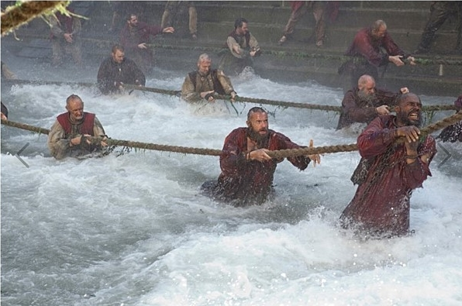
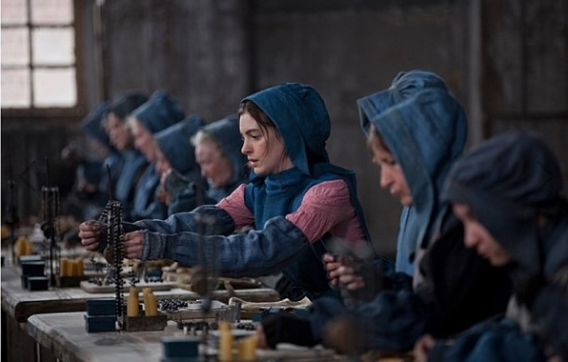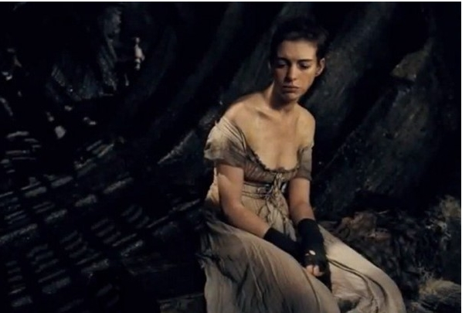

Describe the picture | What happens when tomorrow comes?

Describe the picture | What happens when tomorrow comes?

Use the Future Tense to talk about things that will happen after now.
Future Tense is easy. To use the Future Tense, you just add will before the verb.

*To make a negative Future Tense sentence, just add will not (or “won’t”) before the verb.
subject | Will  Won’t | Base form of verb | The rest of the sentence
I  You  We  They  He  She  It | will | play baseball  go to Spain  play any games  give me money  brush his teeth  be in school  be hot | tomorrow  next week  next month  next year  in 2 days  in 2 weeks  tonight
I  You  We  They  He  She  It | won’t

Grammar worksheet (A)
Write “will+verb” or “won’t+verb” to complete the following sentences.

1. Martha and Timmy _______________ to the park tomorrow night. (go)

2. Vic and Tammy _______________ their homework next week. (do)

3. Walter _______________ the piano after school. (play)

4. Andrew _______________ to Italy in 2 weeks. (go)

5. Gina _______________ with her friends next weekend. (play)

6. Chris _______________ because he too tired. (sleep)

7. Robert and Alan _______________ in an expensive restaurant tomorrow night. (not go)

8. Stephanie _______________ to class today because she is sick. (not come)

9. Brian _______________ with his friends next year. (trip)

10. Jennifer _______________ tennis with me tonight. (not play)

11. Gabe and Brooks _______________ their bicycles to the university. (ride)

12. Lily ________________ a difficult test tomorrow, so please don’t bother her when she is studying. (have)

Grammar worksheet (A) (Teachers’)
Write “will+verb” or “won’t+verb” to complete the following sentences.
1. Martha and Timmy will go to the park tomorrow night. (go)

2. Vic and Tammy will do their homework next week. (do)

3. Walter will play the piano after school. (play)

4. Andrew will go to Italy in 2 weeks. (go)

5. Gina will play with her friends next weekend. (play)

6. Chris will sleep because he too tired. (sleep)

7. Robert and Alan won’t go in an expensive restaurant tomorrow night. (not go)

8. Stephanie won’t come to class today because she is sick. (not come)

9. Brian will trip with his friends next year. (trip)

10. Jennifer won’t play tennis with me tonight. (not play)

11. Gabe and Brooks will ride their bicycles to the university. (ride)

12. Lily will have a difficult test tomorrow, so please don’t bother her when she is studying. (have)

Grammar worksheet (B)

Write “will+verb” or “won’t+verb” to complete the Future Tense sentences below.

1. I _______________ when I grow up.

2. I _______________ tonight.

3. I _______________ tomorrow morning.

4. I _______________ next week.

5. I _______________ next year.

6. I _______________ when I am old.

7. I _______________ the day after tomorrow.

8. I _______________ in a few minutes.

9. I _______________ after I finish my homework.

10. I _______________ in a few years.

11. I _______________ next Monday.

Group activity

Discuss with a group what will happen next? Use “will+verb” or “won’t+verb” to complete the sentence. Write down 2~3 sentences.
- (2)
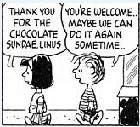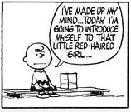
(3)
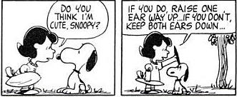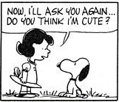

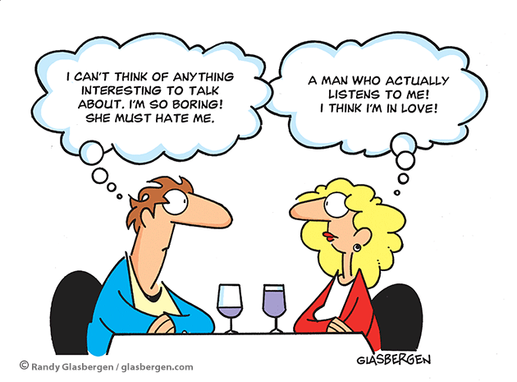 (4)

