Worksheet 1 – Fill in the blanks

Complete each blank with the correct word from this list.

charming bored relaxing disgusting tired
appalling invigorating interested exciting fascinating

Bath is a small city about 150 kilometers west of London. It was founded in the first century by the Romans who had discovered (a)________ hot springs. It is easy to imagine the Roman soldiers. (b)________ and exhausted from a busy day fighting the natives. (c)________ in their luxurious hot swimming pools!
After the Roman era the city declined in importance but it was rediscovered by upper classes in the eighteenth century. Wealthy aristocrats, (d)________ with life on their country estates, came to Bath to enjoy the (e)________ social scene and to ‘take the waters’. In fact the local mineral water tastes quite (f)________, but people believed it had medicinal qualities and could cure some of the (g)________ diseases which were common at the time.
Fortunately, today’s visitors are more (h)________ in the (i)________ architecture and (j)________ history than in the rather unpleasant water!

Worksheet 2 - Example

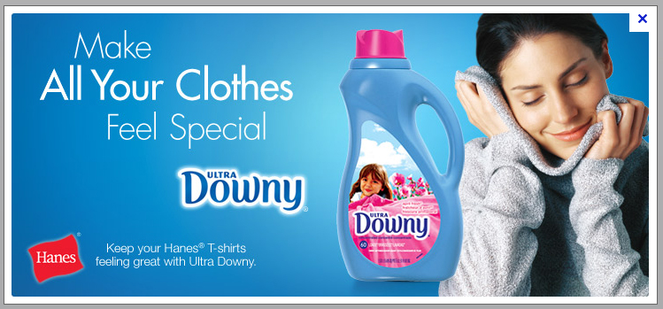

You work for an advertising agency. Your job is to think of slogans.
Now, write a short script for a radio commercial for product. Try to use –ed and –ing adjectives in your script.

Are you embarrassed by static electricity? Upgrade your fabrics with Ultra Downy. It makes your fabrics and you amazing. Choose Ultra Downy.

Worksheet 2

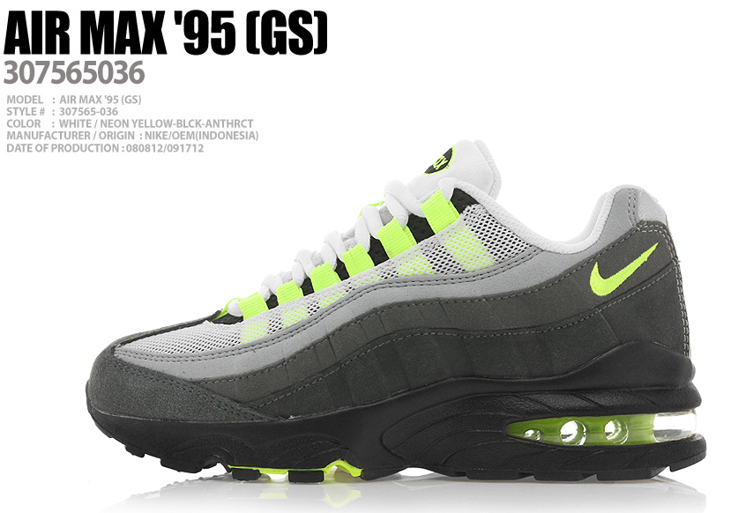

You work for an advertising agency. Your job is to think of slogans.
Now, write a short script for a radio commercial for product. Try to use –ed and –ing adjectives in your script.

Worksheet 2

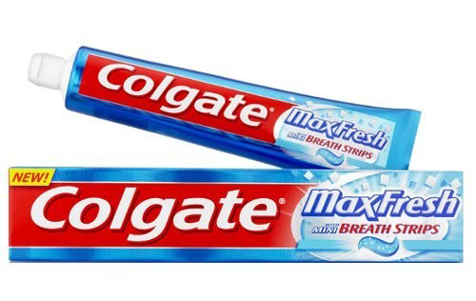

You work for an advertising agency. Your job is to think of slogans.
Now, write a short script for a radio commercial for product. Try to use –ed and –ing adjectives in your script.

Worksheet 2

You work for an advertising agency. Your job is to think of slogans.
Now, write a short script for a radio commercial for product. Try to use –ed and –ing adjectives in your script.

Worksheet 2

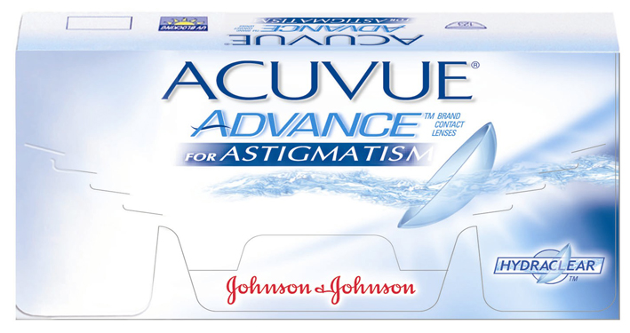

You work for an advertising agency. Your job is to think of slogans.
Now, write a short script for a radio commercial for product. Try to use –ed and –ing adjectives in your script.

Worksheet 2

You work for an advertising agency. Your job is to think of slogans.
Now, write a short script for a radio commercial for product. Try to use –ed and –ing adjectives in your script.

Worksheet 2

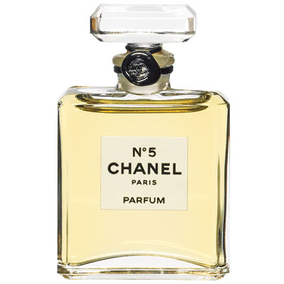

You work for an advertising agency. Your job is to think of slogans.
Now, write a short script for a radio commercial for product. Try to use –ed and –ing adjectives in your script.

Worksheet 2

You work for an advertising agency. Your job is to think of slogans.
Now, write a short script for a radio commercial for product. Try to use –ed and –ing adjectives in your script.

Worksheet 2 – Word list

I feel, I am...  embarrassed  humiliated  interested  fascinated  bored  tired  exhausted  frightened  terrified  annoyed  confused  frustrated  discouraged  encouraged  inspired  disgusted  horrified  amused  entertained  surprised  amazed  astonished  astounded  shocked  convinced  unconvinced  satisfied  disappointed  depressed  devastated  excited  thrilled  relaxed | This is, It is...  embarrassing  humiliating  interesting  fascinating  boring  tiring  exhausting  frightening  terrifying  annoying  confusing  frustrating  discouraging  encouraging  inspiring  disgusting  horrifying  amusing  entertaining  surprising  amazing  astonishing  astounding  shocking  convincing  unconvincing  satisfying  disappointing  depressing  devastating  exciting  thrilling  relaxing

Worksheet 3 – Speed quiz

embarrassing
interesting
boring
confusing
surprising
exiting
terrifying
relaxing
shocking
tiring
disgusting
embarrassed
interested
bored
confused
surprised
exited
terrified
relaxed
shocked
tired
disgusted

Worksheet 4

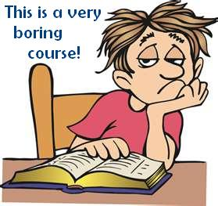
*Word search

ADJECTIVES ENDING -ED AND -ING
F | A | S | C | I | N | A | T | I | N | G | G | I | A | G
U | H | R | G | N | S | G | C | F | W | N | J | N | C | N
C | W | U | Y | N | F | X | L | L | I | E | N | T | O | I
Y | S | I | M | M | I | D | E | S | X | O | H | E | K | Z
R | U | P | V | I | P | T | S | M | Y | F | B | R | B | A
I | P | V | J | U | L | A | I | I | I | I | V | E | L | M
F | K | X | T | D | R | I | N | C | E | B | E | S | F | A
Z | L | F | E | R | Z | G | A | L | X | U | Z | T | M | U
V | E | R | A | H | J | H | I | T | M | E | I | E | W | F
Z | I | B | F | E | Y | J | S | A | E | Q | S | D | X | G
T | M | D | E | S | U | F | N | O | C | D | W | T | S | E
E | E | O | J | C | T | A | O | H | O | X | F | Q | N | Z
G | S | A | Q | A | N | T | K | E | Z | R | Y | Z | O | G
J | M | A | C | N | J | N | N | W | R | W | U | G | B | G
B | O | R | E | D | G | H | C | Z | U | R | Z | N | V | X

AMAZING BORED
ANNOYING CONFUSED
EXCITING INTERESTED
EMBARRASSING TIRED
FASCINATING HUMILIATED

Visual aids – Les Miserables

Visual aids – Downy’s advertisement

