Listening Speaking Reading Grammar Writing

Topic: Game of Power

Instructor:  Hansol Lee | Level:  Upper Intermediate | Students:  13 | Length:  30 Minutes

Materials:
- White board, board markers & tape
- Visual aid of parliament
- 14 Election campaign worksheets
- 28 Blank papers

Aims:
- Main Aim: To enable students to improve their speaking skills by having students talk about power-politics
- Secondary Aim: Students will talk about power-politics by students pretend to be politicians, do a role-play activity, and write a journalistic article about it
- Personal Aim: I want to improve my modelling and reduce my commentary to a minimum

Language Skills:
- Reading: Students will read written opinions
- Listening: Students will listen to other student’s speeches
- Speaking: Students will speak in role-play
- Writing: Students will write political opinions

Language Systems:
- Phonology: /r/ /l/
- Lexis: Parliament (Parliamentarian), Congress (Congressman), Politics (Politician)
- Function: None to discuss
- Grammar: None to discuss
- Discourse: Dialogue, Monologue

Assumptions:
- Students already know:
  - How the class is set up and run
  - The teacher’s style of teaching and the pace of the course
- All the students are college graduates (Age 23 and up)
- Students understands basic politics

Anticipated Problems and Solutions:
- Students may not be able to pronounce some words
  - Use repetition and drills
- Students may not understand complex vocabulary
  - Model
- Students may find the topic boring
  - Add excitement by making the topic controversial

References:
- Learning Teaching by Jim Scrivenener
- Teaching & Principles in Language Teaching by Diane Larsen-Freeman and Marti Anderson

Lead-In
Materials: Board
Time | Set Up | Student Activity | Teacher Talk
1 min | Whole Class | Answering teacher’s questions | Hello everyone! How was everyone this week?  _____, what is your favourite cuisine?  _____, did you vote during the election?

Pre-Activity
Materials: Board, Visual Aid, Election Campaign Worksheets
Time | Set Up | Student Activity | Teacher Talk
3 min  5 min  2 min | Whole Class  Individually | Answers elicited questions  Students begin writing down their reasons for wanting political office  Students will present their reasons  Students will do error correction | Elicit the word, “parliament”  - “What is a place where lawmakers meet and debate?” “It starts with a “P””  - Put up visual  Model “parliament”  - Congress, assembly, legislature  - Politics, politician  - Laws, acts, bills  CCQ  - “Do you go to parliament to watch movies?”  - “Is parliament a place where laws are passed”  Election Campaign  Instructions  “Now let’s pretend that we are all wannabe politicians here and it is election year. We all want to be the president of Korea. So now each of you has to tell us why people should vote for you by giving us three things you will do once in office. You will have five minutes to do this.”  Demonstration  “I’ll go first: when I become president I will; 1. Encourage small businesses, 2. Increase ‘autonomy’ for local government, 3. Declare war on North Korea (laugh).”  Model “autonomy” – “independent/free”  ICQ  - So what are we doing?  - Are we working in groups?  - Are we working individually?  - How much time do you have?  “Now please don’t start before I say go”  - Are you going to start as soon as I give you the paper?  - Are you going to start when I say go?  (Distribute worksheets)  “Now begin”  Monitoring  Monitor discreetly. Answer students if they ask questions.  Give time warning: 3 minutes; 1 minute; 30 seconds. Be flexible with time. Give students 1 more minute if they need it.  “Time’s up”  Ask students individually to present their election promises  Error correction and/or word scramble “election”

Main Activity
Materials: Board
Time | Set Up | Student Activity | Teacher Talk
2 min  4 min  2 min | Pairs | Listening  Students begin discussing about election promises  Students share the discussions | Good Citizens  Instructions  “Congratulations, the election is now over and you are the president! But now you have to deal with the people of your country, or the ‘citizens’ regarding your election promises. So now I am going to divide into two groups, ‘election’ and ‘promise’”  Divide into two groups then pairs  “The ‘elections’ are the politicians while the ‘promises’ are the citizens. You will work in pairs and have five minutes where the ‘promises’ will ask questions on how they will keep their election promises while the ‘elections’ will answer them.”  Demonstration  Pick a volunteer, get them to ask a question on election promise then answer in turn.  ICQ  - So what are we doing?  - Are we working individually?  - Are we working in pairs?  - How much time do you have?  “Now begin”  Monitoring  Monitor discreetly. Answer students if they ask questions.  Give time warning: 3 minutes; 1 minute; 30 seconds. Be flexible with time. Give students 1 more minute if they need it.  “Time’s up”  Ask students to share the questions and answers  Error correction and/or word scramble “citizen”

Post Activity
Materials: Board, Blank Paper
Time | Set Up | Student Activity | Teacher Talk
2 min  3 min  2 min  3 min  1 min | Individually  Individually | Listening  Students begin writing down opinions  Listening  Students begin writing down news report on someone else’s opinion  Students present news report | 1. Political Opinion  Instruction  “So the citizens are now all happy with your promises. Now you need to write an opinion a particular issue.”  Issue is North Korea  “You will have three minutes working individually to write what you plan to do about North Korea on this sheet of paper.”  Show piece of paper  Demonstration  Give an example of opinion such as nuking the country (write on board)  ICQ  - So what are we doing?  - Are we working in groups?  - Are we working individually?  - How much time do you have?  “Now please don’t start before I say go”  - Are you going to start as soon as I give you the paper?  - Are you going to start when I say go?  (Distribute paper)  “Now begin”  Monitoring  Monitor discreetly. Answer students if they ask questions.  Give time warning: 1 minute; 30 seconds. Be flexible with time. Give students 1 more minute if they need it.  “Time’s up”  Collect paper  2. Media Journalism  Instruction  “Okay so everyone wrote about North Korea? Good, because you guys are now ‘journalists’”  Model “journalist”  “I’m going to hand out these opinions to you, but they will be someone else’s. So what I want you to do is write a news report about the opinions I am going to give you. You will have three minutes to do this and will be working individually.”  Demonstration  Say how terrible the person nuking North Korea is (write on board)  ICQ  - So what are we doing?  - Are we working in groups?  - Are we working individually?  - How much time do you have?  “Now please don’t touch the paper before I say go”  - Are you going to touch the paper when I give it to you?  - Are you going to start when I say go?  (Distribute opinions and blank papers)  “Now begin”  Monitoring  Monitor discreetly. Answer students if they ask questions.  Give time warning: 1 minute; 30 seconds. Be flexible with time. Give students 1 more minute if they need it.  “Time’s up”  Ask students individually to present their news report  Error correction and/or word scramble “power”  “This concludes this speaking lesson, ‘Game of Power’, and I will be followed by Ben.”
SOS Activities
Materials: None are needed
Time | Set Up | Student Activity | Teacher Talk
3 min  1 min  30 sec | Individually | Listening  Students think about their speech  Students give their speech | Swearing In (Pledge)  Instruction  “Once you become elected into office you need to do a speech saying thank you and what you will do for the office. I want all of you to individually think about what you are going to say, you will have one minute.”  Demonstration  “Thank you citizens for voting me into office, you have made the right choice where I will do my best to bring good for the country.”  ICQ  - So what are we doing?  - Are we working in groups?  - Are we working individually?  - How much time do you have?  “Now begin”  Monitoring  Monitor discreetly. Answer students if they ask questions.  Give time warning: 30 seconds. Be flexible with time. Give students 30 more seconds if they need it.  “Time’s up”  Ask students individually to give their speech  Error correction and/or word scramble “speech”

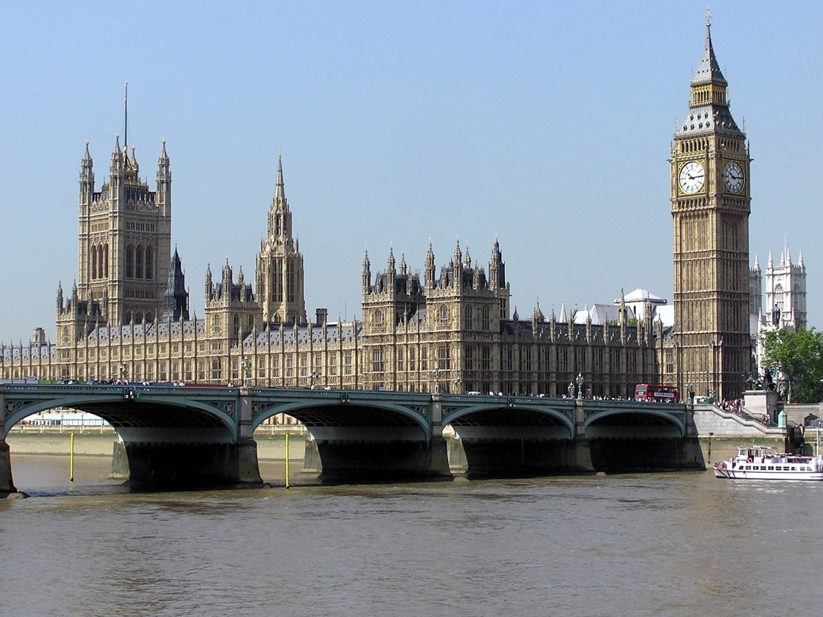

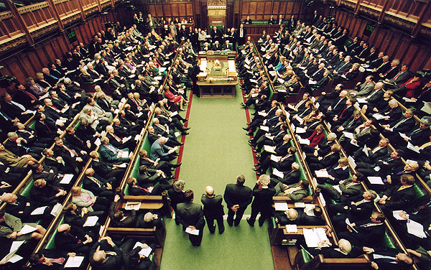

You should vote for me because when I become President I will:

You should vote for me because when I become President I will:

