Listening Speaking Reading Grammar Writing

Topic: Concept of Time

Instructor:  Hansol Lee | Level:  Upper Intermediate | Students:  13 | Length:  30 Minutes

Materials:
- White board, board markers & tape
- Visual aid of clock
- Tense worksheet
- Taboo cards

Aims:
- Main Aim: To enable students to improve their grammatical skills by having students learn about tense and its relation to time
- Secondary Aim: Students will fill in the blanks for the tense worksheet, then apply the tense, and guess said tense without using the words
- Personal Aim: I want to improve my monitoring and timing

Language Skills:
- Reading: Students will read grammatical sentences
- Listening: Students will listen to sentences of different tense
- Speaking: Students will speak sentences of different tense
- Writing: Students will write a story using grammatical tenses

Language Systems:
- Phonology: None to discuss
- Lexis: None to discuss
- Function: Relationship of words
- Grammar: Tense
- Discourse: Monologue

Assumptions:
- Students already know:
  - How the class is set up and run
  - The teacher’s style of teaching and the pace of the course
- All the students are degree holders (Age 23 and up)
- Students understand basic grammar
- Students can distinguish between past and non-past words

Anticipated Problems and Solutions:
- Students may not understand some structure
  - Elaborate
- Students may not understand complex vocabulary
  - Model
- Students may confuse different spellings for past tense verbs
  - Give an example and explain

References:
- Learning Teaching by Jim Scrivenener
- Teaching & Principles in Language Teaching by Diane Larsen-Freeman and Marti Anderson

Lead-In
Materials: Board
Time | Set Up | Student Activity | Teacher Talk
1 min | Whole Class | Answering teacher’s questions | Hello everyone! How was everyone this week?  _____, what did you do yesterday?  _____, what are your plans for tomorrow?

Pre-Activity
Materials: Board, Visual Aid, Tense Worksheets
Time | Set Up | Student Activity | Teacher Talk
5 min  3 min  2 min | Whole Class  Individually | Answers elicited questions  Students begin worksheet  Students will present | Elicit the word, “tense”  - “In grammar, what do we call the concept that deals with time?”  - Put up visual  Model “tense”  Pre-teach  “Does anyone know how many tenses there are in the English language?”  “In terms of the ‘main’ ones, there are only two; past, and non-past. For the purpose of this lesson, for non-past we will only deal with the future. The tense of the verb is dependent on the indication of time of the sentence such as ‘is’ and ‘was/were’.”  Two different examples of a past and a non-past/future  CCQ  - “Is my name a tense?”  - “Does tense have something to do with yesterday and/or tomorrow?”  Time Comprehension  Instructions  “For this activity, I’m going to give each of you a worksheet. Now, individually, I would like you to fill in the correct tense for each sentence. You’ll only have three minutes for this activity.”  Demonstration  Point towards the examples  ICQ  - So what are we doing?  - Are we working in pairs?  - Are we working individually?  - How much time do you have?  “Now please don’t start before I say go”  - Are you going to start as soon as I give you the paper?  - Are you going to start when I say go?  (Distribute worksheets)  “Now begin”  Monitoring  Monitor discreetly. Answer students if they ask questions.  Give time warning: 1 minute; 30 seconds; 10 seconds. Be flexible with time. Give students 1 more minute if they need it.  “Time’s up”  Ask students individually to present

Main Activity
Materials: Board, Previous Worksheet
Time | Set Up | Student Activity | Teacher Talk
2 min  4 min  2 min | Pairs | Listening  Students begin writing a story  Students share the story | Tense Building  Instructions  “Now, I would like you to in pairs, to write a story using the tenses given to you on the worksheets from the previous activity. For this activity, you will have five minutes.”  “So…” <Pair everyone>  Demonstration  “For example…”  Write: Jayme ran away from Gangnam because Sun shot the sheriff. So Deputy Ben decided he will hunt them both down.  ICQ  - So what are we doing?  - Are we working individually?  - Are we working in pairs?  - How much time do you have?  “Now begin”  Monitoring  Monitor discreetly. Answer students if they ask questions.  Give time warning: 3 minutes; 1 minute; 30 seconds; 10 seconds. Be flexible with time. Give students 1 more minute if they need it.  “Time’s up”  Ask students to share the story

Post Activity
Materials: Board, Taboo Cards
Time | Set Up | Student Activity | Teacher Talk
3 min  6 min | Team | Listening  Students begin | Taboo Relay  Elicit the word, “taboo”  - “Does anyone know another word for forbidden?”  Model “taboo”  CCQ  - “Is it taboo to talk to your friends?”  - “Is doing something terrible a taboo?”  “Can we say ‘past’ and ‘future’? You guys are now two different teams”  Instruction  “This game will use the concept of ‘taboo’ in that you will be given a card with a word which you must explain to your teammates without using any of the words on the card, though you can indicate which tense it is. Also, no actions allowed. Your teammates must guess the word on the card. Each team members will have a turn per card like a relay. Each team will have three minutes each. The team who guesses the most cards wins!”  Demonstration  “If the word is ‘practiced’, I cannot use the words; ‘practice’, ‘practiced’, or ‘practicing’ However, I can say it is a past tense and that it is what we did to prepare for our micro-teaching.  ICQ  - So what are we doing?  - Are we working individually?  - Are we working in a team?  - How much time do each team have?  “Now begin”  Monitoring  Monitor discreetly. Answer students if they ask questions.  Give time warning: 1 minute; 30 seconds; 10 seconds. Be flexible with time. Give students 1 more minute if they need it.  “Time’s up”  Repeat the “now begin” to “time’s up” one more time  Error correction and/or word scramble “tense”  “This concludes my grammar micro-teaching; I hope that it was enjoyable.”
SOS Activities
Materials: Board, Previous Worksheet
Time | Set Up | Student Activity | Teacher Talk
3 min  1 min  30 sec | Individually | Listening  Students do worksheet  Students share | Illusion of Now  Instruction  “What was the non-past apart from ‘future’? Yes, present was the other non-past. Now I would like each of you to work individually and convert all the sentences on your worksheet from the first activity to the present tense. You will have one minute.”  Demonstration  “For example; ran/will run becomes running.”  ICQ  - So what are we doing?  - Are we working in groups?  - Are we working individually?  - How much time do you have?  “Now begin”  Monitoring  Monitor discreetly. Answer students if they ask questions.  Give time warning: 30 seconds; 10 seconds. Be flexible with time.  “Time’s up”  Ask students to share

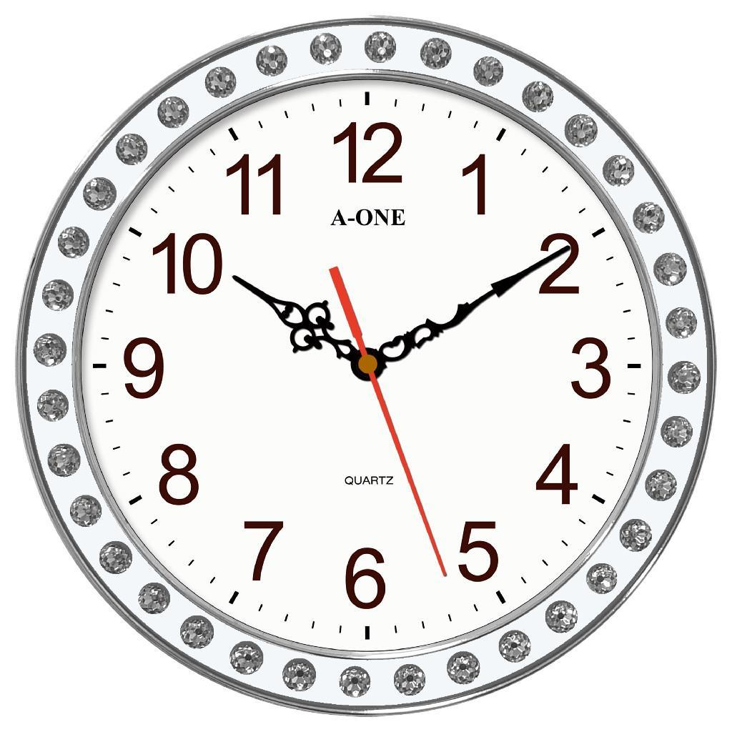

Tense Worksheet – Fill in the Blanks
1. Ran/will run 2. Spoke/will speak 3. Hunted/will hunt 4. Sailed/will sail
5. Built/will build 6. Sunk/will sink 7. Drove/will drive 8. Flew/will fly
9. Scratched/will scratch 10. Ate/will eat 11. Practiced/will practice
12. Taught/will teach
- Kate ________ in an hour.
- James _______ in a lecture when John is sick.
- Simon _________ for a wild boar last week.
- The ship _________ across the seven seas when it is summer.
- Peter _________ a house next year.
- The boat ________ to the ocean floor last month.
- Someone ________ the car next week.
- Tomorrow, we __________ in an aeroplane.
- The cat ________ the curtains when left alone.
- The dog ________ the grammar micro-teaching homework two days ago.
- Yesterday, everyone _________ for their micro-teaching today.
- Hansol ________ grammar after Beri.

Taboo Relay
Run  Ran  Running | Shoot  Shot  Shooting | Fire  Fired  Firing
Walk  Walked  Walking | Eat  Ate  Eating | Spoke  Speaking  Speak
Teach  Taught  Teaching  Teacher | Studied  Studying  Study | Drive  Drove  Driving
Flew  Flying  Fly  Aeroplane | Laugh  Laughed  Laughing | Slept  Sleeping  Sleep  Nap
Smoke  Smoked  Smoking | Cook  Cooked  Cooking | Fought  Fighting  Fight
Wrestled  Wrestling  Wrestle | Box  Boxed  Boxing | Jumped  Jumping  Jump
Dead  Died  Dying  Die | Drink  Drunk  Drank  Drinking | Think  Thought  Thinking
Look  Looked  Looking | Played  Playing  Play | Sing  Sung  Singing  Song
Loved  Loving  Love | Dreamt/Dreamed  Dreaming  Dream  Nightmare | Killed  Killing  Kill  Murder
Hunt  Hunted  Hunting | Sink  Sunk  Sinking | Built  Building  Build

