Listening Speaking Reading Grammar Writing
Topic:
Playing

Instructor:  Jessie | Level:  intermediate | Students:  13 | Length:  30 Minutes

Materials:
Reading worksheet of “Boys and Girls”.
Task comprehension worksheet
Picture of children’s play
white board, board markers
wall chart

Aims:
Main Aim : To enable students to improve Their reading comprehension skill to get the gist and get the details by answering paraphrasing questions
Secondary Aim : Students will learn unfamiliar vocabulary by word matching and practice speaking and listening by discussing ideas in a group. They will write about their childhood story.
Personal Aim : I want to improve time management. and CCQ and ICQ

Language Skills:
Listening : They will listen to other student`s speeches.
Reading : They will read article.
Writing : They will write their opinions
Speaking : They will speak in activity.

Language Systems:
Phonology : None to discuss
Lexis : hierarchy, negotiate, elaborate, boast, intimacy, propose, achieve, preference, suggestion, frequently, possessions, differentiation.
Function : self-reading with article
Discourse : article
Grammar : None to discuss

Assumptions:
Students already know
How the class is set up and run
The teacher’s study of teaching and the pace of the course..

Anticipated Problems and Solutions:
- If students may need more time to work in the group
→ If it takes longer than 5 minutes, Teacher may be able to give 1~2 more min.
- If students may find the topic boring
→ Add excitement by making the topic controversial.
- If students may finish their tasks earlier than anticipated,
→ teacher lets them do SOS activities

References:
-Images from various website : Google, naver,

Lead-In
Materials:
Time | Set Up | procedure
1min | Whole class | (greeting)  Hello everyone, how are you today?  What did you have for dinner?  What are you going to do after class?

Pre-Activity
Materials: vocabulary sheet.
Time | Set Up | procedure
10min | Whole class | Eliciting  (Show each picture and ask students What they are doing.)  T : What are they doing?  S : Boys are playing in a group  T: What are they doing?  S : Girls are playing in pair.  CCQ  (show the picture)  Is it playing?  (show the picture)  Is it playing?  Ok! Today we are going to read an article about how boys and girls play  (Teacher makes groups)  Before you read the article, You are going to match the vocabulary with meaning. It will help you to understand the article. I will give you 3 min.  I.C.Q  What are you going to do?  How much time do you have?  Are you going to work individually?  Please don`t touch this until I say go  ICQ  Do you touch this paper before I say go?  No.  (distribute worksheets)  And begin  (timing)  1 min/30 seconds/10 seconds/ times up  .  Teacher ask students` answers and let them read aloud  Good job everybody

Main Activity
Materials: Article, worksheet, wall chart.
Time | Set Up | Procedure
15min | Whole class | <Grope work>  Can you say each word?  Boys, Girls  They move to sit with team  You are going to read an article individually.  I will give you 2 min.  ICQ  What are you going to do?  How much time do you have?  Are you going to work in group?  Are you working individually?  Please don`t touch this paper until I say go  ICQ  Do you touch this paper before I say go?  (distribute worksheets)  (timing)  1 min/30 seconds/10 seconds/ times up  From Suk to Eunmi you are going to read boys part loudly.  From Annie to Jayme you are going to read girls part loudly.  ICQ  What are you going to do?  Ok boys first.  (They read out their part)  Teacher makes 4 groups  Turn the page and you are going to do worksheets in group  And the last of worksheet, you are doing to write your opinion.  Demonstration.  Look at the board.  (Read teacher`s opinion)  I will give you 5 min  ICQ  What are you going to do?  How much time do you have?  Are you going to work in group?  (timing)  1 min/30 seconds/10 seconds/ times up  They are going to share their answer and opinion.  Well done everybody

Post Activity
Materials: paper
Time | Set Up | procedure
7min | Whole class | Let`s think back to your childhood. And write about what were you like and how you played when you were young.  Demonstration.  Look at the board.  (Read teachers)  I will give you 3 min  ICQ  What are you going to do?  How much time do you have?  Are you going to work individually?  Please don`t touch this paper until I say go  ICQ  Do you touch this paper before I say go?  (timing)  “1 min/30 seconds/10 seconds/ times up  Teacher calls their name and they will share their story.  Good job guys  <Error Correction>  Write the errors on the board and have the Ss correct them  lypa  Ok Thank you for participation . See you later.
Sos-Activity
Materials:
Time | Set Up | procedure
5min | Whole class | What was the best game and frolic when you played.  You can introduce your best game and frolic  Think and write in 3 min.  I.C.Q  What are you going to do?  Are you going to work individually?  How much time do you have?  please don’t start before I say go  I.C.Q  Are you going to start before I say go?  (distribute a paper)  [timing]  1 min/30 seconds/10 seconds/ times up  ( Monitor students’ work. Answer if students ask questions.)

Reading worksheet
Boys
Boys tend to play outside, in large groups that are hierarchically structured. Their groups have a leader who tells others what to do and how to do it, and resists doing what other boys propose. It is by giving orders that high status is negotiated. Another way boys achieve status is to take centre stage by telling stories and jokes, and by challenging the stories and jokes of others. Boys’ games have winners and losers and elaborate systems of rules that are frequently the subjects of arguments. Finally, boys are frequently heard to boast about their skill, likes and possessions, and argue about who is best at what.

Girls
Girls, on the other hand, play in small groups or pairs. The center of a girl’s social life is her best friend. Within the group, intimacy is key: differentiation is measured by relative closeness. In their most frequent games, such as jump rope and hopscotch, everyone gets a turn. Many of their activities (such as playing with dolls) do not have winners or losers. Although some girls are certainly more skilled than others, girls are expected not to boast about it, or show that they think they are better than the others. Girls don’t give orders: they express their preferences as suggestions, and suggestions are likely to be accepted.

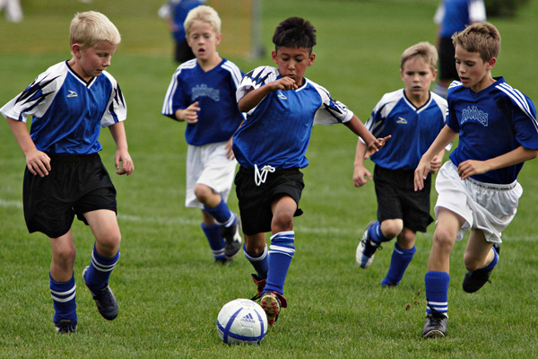
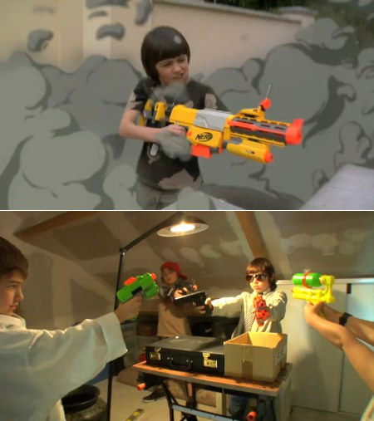
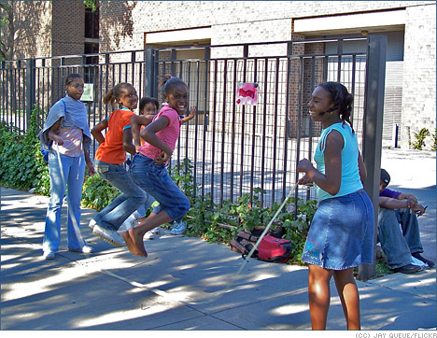
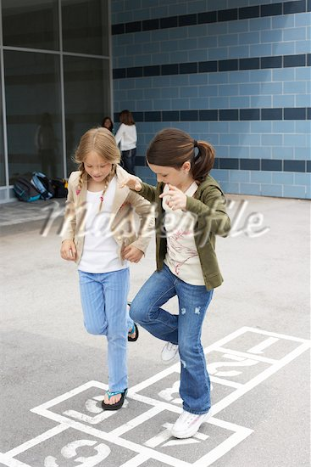
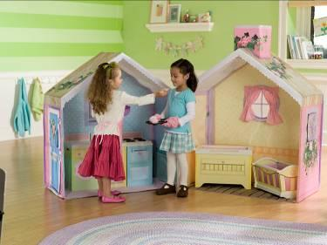

(boast) to praise oneself in speech, self admiring way
(intimacy) that is a very close personal relationship
(hierarchy) a system of organizing people into different ranks of levels of
importance
(negotiate) to talk about a problem or a situation in order to solve the problem
or complete the arrangement
(elaborate) to describe something that is very complex because it has a lot of
different parts
(propose) suggest own idea and plan for people to think about and decide upon.
(achieve) to get particular aim or effect, you succeed in doing it or causing it to
happen, usually after a lot of effort.
(preference) you would like to have or do that thing rather than something else.
(suggestion) to put forward an idea or plan for someone to think about
(frequently) something happens often
(possessions) you have it, because you have obtained it or because it belongs to you.
(differentiation) between the two product ranges.

Write down 5 characters of boys
1)
2)
3)
4)
5)
Write down 5 characters of girls
1)
2)
3)
4)
5)

What kind of game would boys play? (ex. gun fight..)

What kind of game would girls play?(ex, play with doll..)

Do you agree or disagree? Share your ideas and opinions.

