Listening Speaking Reading Grammar Writing

Topic:
Comparative & Superlative

Instructor:  Jessie | Level:  intermediate | Students:  13 | Length:  30 Minutes

Materials:
Wall chart.
White board and marker.
Paper. Worksheets
Some candies
3 pictures

Aims:
Main Aim : To enable students to improve their grammar skill by having students use comparative and superlative..
Secondary Aim : Students will use comparative and superlative by students make stories.
Personal Aim : I want to improve time management. and CCQ

Language Skills:
Listening : They will listen to other student`s speeches.
Reading : They will read worksheets
Writing : They will write story
Speaking : They will speak in activity.

Language Systems:
Phonology : None to discuss
Lexis : some adjective.
Function : self-making story with grammar point
Discourse : story
Grammar : comparative and superlative

Assumptions:
Students already know
How the class is set up and run
The teacher’s study of teaching and the pace of the course.
Students understand how to make comparative and superlative.

Anticipated Problems and Solutions:
- If students may need more time to work in the group
→ If it takes longer than 5 minutes, Teacher may be able to give 1~2 more min.
- If students may find the topic boring
→ Add excitement by making the topic controversial.
- If students may finish their tasks earlier than anticipated,
→ teacher lets them do SOS activities

References:
-Images from various website : Google, naver,

Lead-In
Materials:
Time | Set Up | procedure
1min | Whole class | (greeting)  Hello everyone, how are you today?  What did you have for dinner?  What are you going to do after class?

Pre-Activity
Materials : worksheet, wall chart
Time | Set Up | procedure
10min | Whole class | Eliciting  (Show each picture and ask students how they look.)  Can you describe this picture? And this picture too?  Can you describe 2 pictures in one sentence?  .(And show one more picture)  Let`s make one sentence with 3 pictures  Ok! Today we are going to learn about comparative and superlatives  CCQ  Are comparative and superlatives used to describe one thing?  Are comparatives and superlatives used to compare more than 2 things?  Teacher put the wall chart written regular verb  (1 syllable/2 syllables)  Explain the rule of comparatives and superlatives.  -tall-taller-tallest/ happy-happier-happiest  -beautiful-more beautiful- most beautiful  And some irregulars(Good/ bad/far)  T : you read worksheet and complete sentences  (Teacher shows a short story and complete sentences)  I will give you 3 min.  I.C.Q  What are you going to do?  How much time do you have?  Are you going to work individually?  Please don`t touch this paper until I say go  ICQ  Do you touch this paper before I say go?  (distribute worksheets)  Demonstration.  Ok look at the paper. Look at the first sentence. I wrote more expensive. Please use comparative and superlative.  And begin  (timing)  1 min/30 seconds/10 seconds/ times up  .  Teacher calls students name and check their answer.  Good job everybody

Main Activity
Materials:
Time | Set Up | Procedure
15min | Whole class | <Grope work>  Can you say each word?  Comparative – er, more – superlative – est, most  They move to sit with team  You are going to make a story with comparative and superlative.  Every member in each group has to be in a story.  Demonstration.  Teacher put wall chart.  Ex) Sun, Hyunni, Beri, Jessie are in a team  I made a story. Let`s read together  Comparative team would be Jessie.  Er, more team would be Sun.  Superlative team would be Hyunni and est, most team would be Beri  They read a story  You can make a funnier story than mine.  I will give you 5 min  ICQ  What are you going to do?  How much time do you have?  Are you going to work in group?  Please don`t touch this paper until I say go  ICQ  Do you touch this paper before I say go?  (distribute worksheets)  (timing)  1 min/30 seconds/10 seconds/ times up  Every team gets a turn.to tell their story.  Well done everybody

Post Activity
Materials: some candies, bag
Time | Set Up | procedure
7min | Whole class | Each student picks up some candies from a bag and then show their candies on the table.  Demonstration.  I have 3 candies. Well.. I feel more comfortable than before, and I am the nicest person in my work I think and I am younger than Eunmi.  Please make sentences about you as many as you have candies.  I will give you 3 min  ICQ  What are you going to do?  How much time do you have?  Are you going to work in group?  Please don`t touch this paper until I say go  ICQ  Do you touch this paper before I say go?  (timing)  “1 min/30 seconds/10 seconds/ times up  How many candies did you get?  Ok tell us about you  Good job guys  <Error Correction>  Write the errors on the board and have the Ss correct them  vampctireoa  Ok Thank you for having me. See you later.
Sos-Activity
Materials: paper, wall chart
Time | Set Up | procedure
5min | Whole class | Guys please listen carefully.  (put wall chart on the board)  (Teacher read an home shopping article)  “What about article?”  “Yes, It’s kind of an advertisement of home shopping”  Work individually and make an advertisement of an item. Write it with comparatives and superlatives in 4 minutes  I.C.Q  What are you going to do?  Are you going to work individually?  How much time do you have?  please don’t start before I say go  I.C.Q  Are you going to start before I say go?  (distribute a paper)  [timing]  1 min/30 seconds/10 seconds/ times up  ( Monitor students’ work. Answer if students ask questions.)

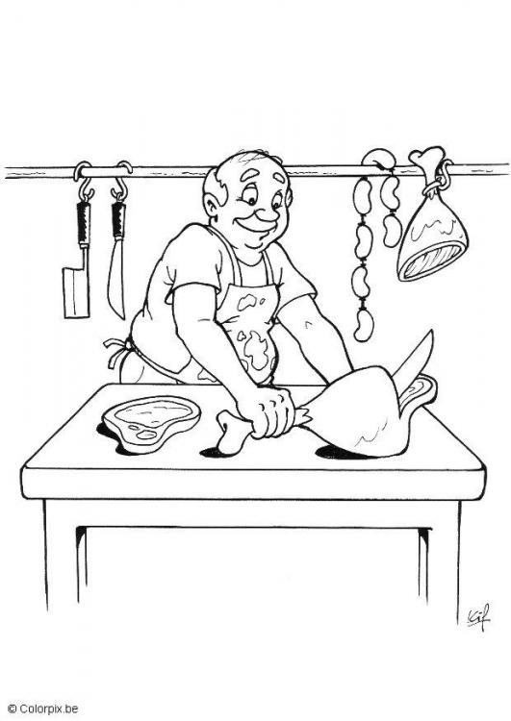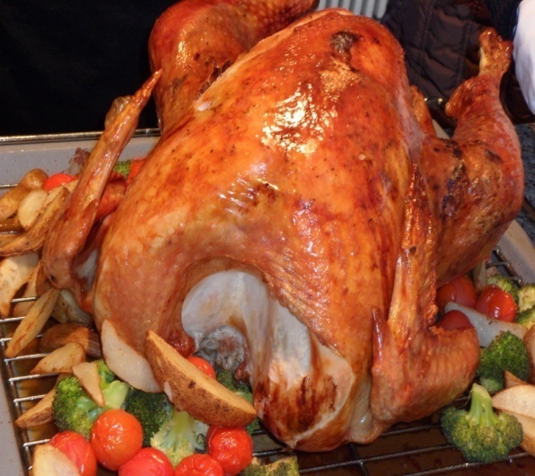
A woman went into (1) the most expensive (expensive) butcher`s town and
asked for (2)______________________(big) chicken in the shop. The shopkeeper
showed her a chicken and said
“This is (3)_________________________(good) chicken in the shop, madam”
“It is very small”, She said, “Have you got a (4)______________________(large) one?”
“Just one moment.” said the shopkeeper. He took the chicken into another room. In fact
it was the only chicken he had. So he put some sausages inside to make it look
(5)_______________________(big).
“Here you are.” He said, “This is our (6)____________________________(delicious)
chicken, And you can see that it is (7)___________________________(big) than the
other, But I am afraid it is also (8)________________________________(expensive)”.
“Hmm. But I`m not sure if it`s (9)_________________________(good) than the other.
OK. Can I have both of them, please?”
