Reading Lesson Plan
Language Systems:
- Lexis : vocabularies related to types of shoes
- Discourse: none to discuss
- Function: to give advice
- Grammar: imperatives
- Phonology: none to discuss

Language Skills:
- Reading: students will practice skimming when matching titles to paragraphs in the fashion article worksheet.
- Listening: students will listen to the script read by the teacher and organize the store accordingly.
- Speaking: students will tell descriptions of the shoes when role-playing.
- Writing: students will write sentences using imperative form to give advice when making titles for articles.
Aims:
- Primary aim: By the end of the class, students will be better able to skim through to find the main idea by coming up with titles to the corresponding paragraphs in a limited time.
- Secondary aim: Students will be better able to describe what they are looking for in words by learning names for various types of shoes and practicing through role-playing.

- Personal aim:
To improve asking CCQs
To be able to pace myself in class and adjust my speaking speed as needed
Materials:
- Shoe Store worksheet (5 copies)
- 9 pictures of various shoes (5 copies)
- Shopping Tip Worksheet (5 copies)
- Fake money
Instructor:
Kris (EunAe) Cho
Level:
Advanced
Students:
19
Length:
25 minutes
es
Shopping for shoes
References:
- “Learning Teaching”, Macmillan Books for teachers
- http://www.dailymail.co.uk/femail/article-67995/The-dos-donts-shopping.html
Anticipated Problems and Solutions:

- Students may not be able to follow the passage easily
Help with vocabulary they don’t understand. Paraphrase sentences they find difficult.
- If students finish their tasks earlier than expected
SOS activity
- If students take longer time to finish their tasks than expected
Give time warning or be flexible with time.
Assumptions:

Students already know:
- how the class is set up and run
- the teacher’s style of teaching and the pace of the course
- most students already know various types of shoes
- all students have gone shopping for shoes before

Lead-In
Materials: n/a
Time  2 min | Set Up  Whole Class | Procedure:  Hello everyone, hope everyone had a great weekend. The weather’s changing. What do you do to prepare yourself for the summer? What do you do to relieve stress?
Pre-Activity
Materials: Shoe Store Worksheet, pictures of various shoes
Time  2 min  2 min  1 min | Set Up  Whole Class  Groups  Whole Class | Procedure:  I. Organizing the shoe store  Look at this picture. Do you know what this type of shoes is called? Yes, it’s called boots.  I will now read an instruction given by the store owner. You will listen and try to place shoes to the right place and write down signs on the space above it. Let me read you the first sentence and we can go over it together.  “People always ask for comfortable loafers, so put it at the bottom left corner.” So where would you put the loafers? That’s right. And there we have the signs already. I will tell you the instruction three times.  Instruction  Work in a group of 4. Organize the shoe store by matching the pictures of shoes to the right place and make signs for them.  ICQ  How many times will you listen to the instructions?  What are you doing with the pictures?  (Distribute the worksheet)  (Read the instruction script thrice)  Check answers: let students take turn to answer.  - Go through the vocabulary one by one

Main Activity
Materials: Blown-up picture/realia of Magazine, Shopping Tip Worksheet
Time  3 min  6 min  2 min | Set Up  Whole Class  Groups  Whole Class | Procedure:  I. Giving advice on shoe-shopping  Elicit what magazine is, and what the written pieces are called: articles. We are going to look at one article that gives advice on shopping for shoes.  (Distribute the worksheet)  Demonstration  Let’s look at the first paragraph. (to a student) ____, would you mind reading it out loud for us? (when she’s done reading) Okay. We are going to come up with a title for this paragraph. Does anyone have any idea they’d like to share?  Good. What kind of forms would you use when giving advice? (If they can’t answer) would you use future tense ‘you will take your time’ or imperative sentence like ‘take your time’?  Instruction  Work in groups- same as before. Come up with titles for each paragraph. You have 5 minutes.  ICQ  Who are you working with?  How long do you have?  Monitor discreetly.  Give time warning: 1 minute left, 15 seconds left.  Be flexible with time. Give them as long as 3 minutes if they need it.  Have them write their answers on the board. Pick the best titles for each paragraph.  CCQ  How can you change the sentence ‘She drinks coffee’ to imperative sentence?  When do you use imperative forms?
Post-Activity
Materials: Fake money, pieces of paper
Time  7 min | Set Up  Whole Class | Procedure:  I. Role play  Instructions  Divide the class into 2 big groups.  One group will be the store clerks, the other customers. The customer will describe the shoes she wants, and the clerk will draw the picture as described. If the customer is satisfied with the picture, she will buy the shoes. Go around the class and repeat as many times as you can. You can only buy from/sell to once for each person. Change the role after 3 minutes and repeat.  ICQ  Which role are you playing?  How many can you buy from one person?  -Who has shoes the most?  -Who sold the most?  -Whose shoes got a ribbon on it?  -Whose shoes do you like the best?  II. Conclude lesson  Ask which activity they enjoyed most.  Good job today. See you guys tomorrow!

SOS-Activity
Materials: Blank paper
Time  10 min | Set Up  Groups | Procedure:  I. Word Battleship  Instructions  Work in pairs. Draw two copies of 8X8 box on separate blank papers. On one of them, write 2 5-letter words, 2 4-letter words, and 2 3-letter words horizontally or vertically and hide it from your opponent. Call out row and line number to shoot missile. When the missile hits where there is a letter, write down the letter on the piece of paper for the opponent to see and your opponent will continue the attack. If missed, put an X mark and it is now your turn. Take turn to shoot missiles to sink every words.

Shoe Store Worksheet
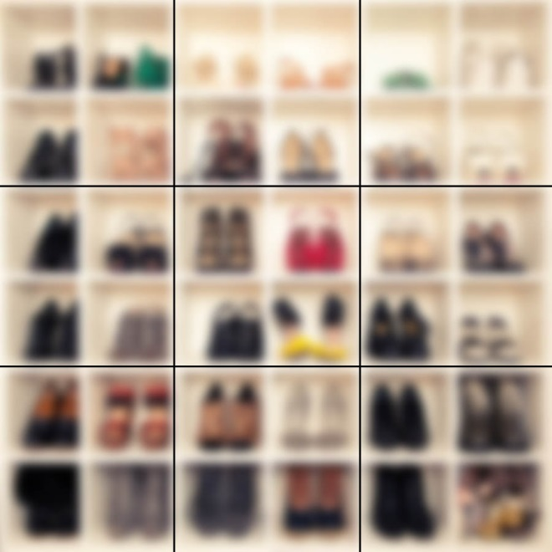

Moccasins
Loafers / slip-ons

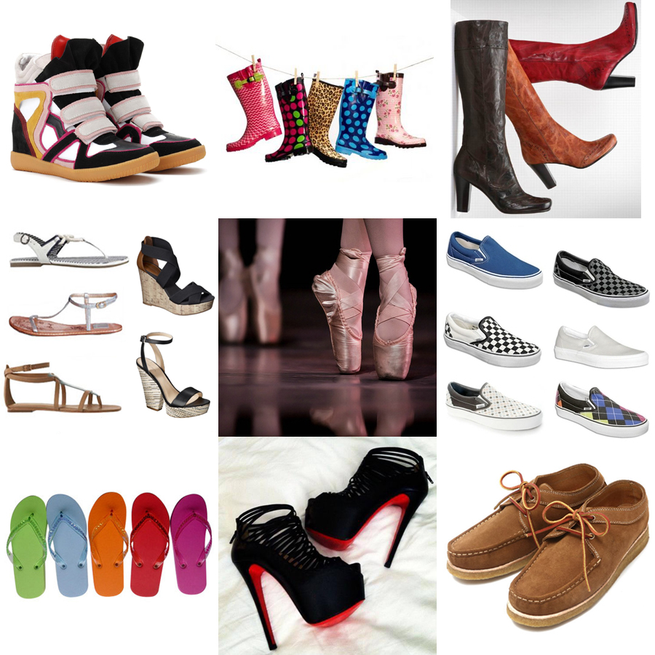

Script for Shoe Store Activity: instructions of the store owner.
I’ll be out for an hour. By the time I get back, I want you to finish organizing the shoes exactly the way I want or you are fired. People always ask for comfortable loafers, so put it at the bottom left corner. Put cowboy boots on the right side of sandals. I want sneakers near cowboy boots and high heels, but make sure rain boots isn’t on the same line as sneakers or high heels. Obviously, put rain boots and flip-flops next to each other- they are both famous in summer. But I don’t want flip-flops on the bottom row. Oh, and those ballet shoes, just put it above the moccasins.
7 useful tips when shopping for shoes
- __________________________________________________________
There is no need to rush even if there is only one pair left for your size. You will find the same kind of shoes just around the corner, and it might even be better. Try on many different shoes before actually purchasing them.
- __________________________________________________________
Here is something you should consider when you look for comfortable shoes. The toe box should be rounded or oval to mirror the shape of your feet. If the toe box is too narrow, it can aggravate bunions and cause corns or a pinched nerve. There should be a fingertip of length between your longest toe and the tip of the shoe.
- __________________________________________________________
High heels put pressure on the metatarsal bones in the balls of the feet, as well as your lower back. Over time, wearing high heeled shoes also functionally shorten the muscles and tendons in the back of your legs. So how high is too high? Doctors advise looking for heels less than 2 inches. If you do wear ultra-high heels, avoid wearing them on consecutive days or for longer than four hours at a time.
- __________________________________________________________
How often should you replace your shoes? It depends on how much you stand and walk in them. You need to replace your primary walking shoes at least once a year, but if you are active, you may need to replace athletic shoes every three to six months.
- __________________________________________________________
Unlike a friend an assistant wants to make a sale so their advice may not be impartial. Go with a friend or trust your own instinct - you know what you'll feel most confident wearing.
- __________________________________________________________
Avoid the temptation of buying that sale-priced shoe that is too big or small since improper fitting shoes can cause you to slip, fall, or develop a foot deformity. The length of your shoe should be a thumb’s spacing from the longest toe to the end of the shoe. Also, buy shoes in the afternoon, as feet tend to swell during the day.
- __________________________________________________________
If it's a fashionable item you only intend to wear for a month or so then going cheap is fine. But if you want more classic pieces to last more than one season try to double the amount you'd normally spend.
