SB: 93
Speaking Lesson Plan

Movie

Length:
25 minutes
es
Students:
19
Level:
Advanced
Instructor:
Jinhwa Lee

Materials:
- Posters of movie & name of movies
- Movie’s title(chart)
- Discussion worksheet
- Picture of movie star
- White board

Aims:
- Primary aim: Encouraging students speaking skills by having students speed quiz.
- Secondary aim: I want to students speak and write what they think about movie by having discussion.
- Personal aim: I want to keep time limit and make students having fun with some activity. Even though students are not interested in movies, they can be familiar with movies more by having the lesson.

Language Skills:
- Reading: Students will read some question on a worksheet.
- Listening: Students will listen to story about movie.
- Speaking: Students will tell a story about movie and discuss about their thinking about movie.
- Writing: Students will write some partner’s answer on a worksheet.

Language Systems:
- Lexis : vocabulary
- Function: None to discuss
- Grammar: None to discuss
- Discourse: None to discuss
- Phonology: None to discuss

Assumptions:

Students already know:
- how the class is set up and run (there will be 5 student groups at each table)
- the teacher’s style of teaching and the pace of the course
- most students have experienced watching movie in theater or home.

Anticipated Errors and Solutions:

- Students may not be able to understand instructions
Check them instructions by ICQ
- Students may need more time to discuss
Remind them left time (1min, 30sec, 10sec)
If they need more time to work activity, I can give them extra time to work done.

References:
- www.onestopenglish.com
- www.naver.com

Lead-In
Materials: None
Time  1min | Set Up  Whole Class | Procedure:  Hello everyone, good to see you again. What do you do in your free time?

Pre-Activity
Materials: discussion worksheet
Time  7min | Set Up  Whole Class  In pairs | Procedure:  I. discussion  Eliciting  I got a picture to show you guys. Have you ever seen this guy? What is his job? Where can we see him? So my topic is movie.  instructions  I will give you a worksheet. Discuss about some questions written on it and write down your partner’s answers on the paper. I will give you 4 minutes to discuss and work in pairs.  (I distribute a worksheet to students and give them 4minutes.)  ICQ  Who are you working with?  How much time do you have?  CCQ  What was the last movie you saw?  Do you like to eat food at the cinema?
Main Activity
Materials: movie’s title, chart
Time  12min | Set Up  Groups | Procedure:  1. speed quiz  Instructions  I will divide you into three groups. I will show you some titles of movie. It is speed quiz. Choose one person to guess right in each group and come up here and turn back and cannot see it, and rest people should tell him about the movie’s story of title that I write. If you answer all titles before time is up, let me know. Here is important thing, when you tell a story, don’t use your hands. I will give you 7 minutes.  (I show them a chart.)  ICQ  How much time do you have?  Do you work alone?  What should you tell about?  Do you use your hands?  Check a score in each group.  CCQ  Do you have to buy tickets to watch a movie?  Can we see a movie only in theater?  Materials (Title of movie)  -Iron Man  -Home Alone  -Dark Night  -E.T.  -Matrix  -Life Is Beautiful  -Pirates Of The Caribbean  -Toy Story  -The Sixth Sense

Post-Activity
Materials: posters of movie, movie’s title
Time  5 min | Set Up  Groups | Procedure:  I. matching posters and name of movies  Instructions  I am going to move on post activity. I will make you into 5groups. I will hand out some posters and name of movies. You should match them. Find out right names for the posters you have. Work with your groups. I will give you 3 minutes.  ICQ  How much time do you have?  Do you work with group?  After they match every poster, I check them.  -Iron Man  -Home Alone  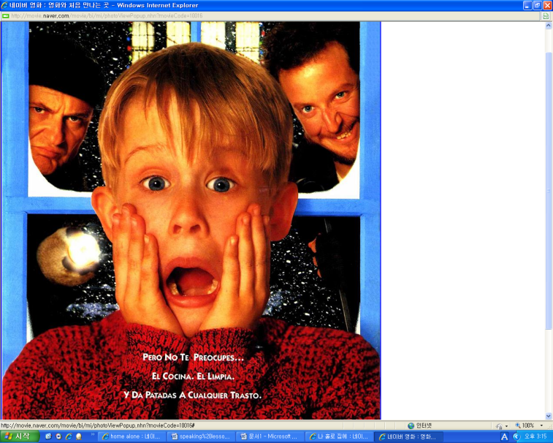  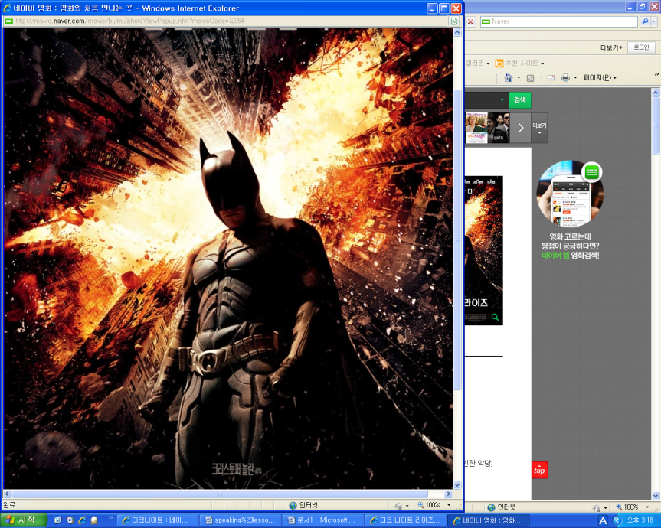-Dark Night  -E.T.  -Matrix  -Life Is Beautiful  -Pirates Of The Caribbean  -Toy Story-The Six Sense  -Harry Potter  -Shrek  II. Conclude lesson  Thank you for cooperation with me.  Good job today. See you guys tomorrow!
Sos-activity
Materials: movie, projector, screen
Time  3 min | Set up  Whole Class | Procedure:  I. Matching the pictures  Instruction  I will show you previous seen of movie. After watching the movie, guess what the movie’s story will be about with your partner. I will give you 2minutes to guess and talk about that with your partner.  ICQ  Are you working alone?  What do you suppose to do?  How much time do you have?  After they finish, I ask them what do them think about.

Speaking
Lesson Plan

Date : 9.April.2013
Name : Jinhwa Lee(Jina)

