SB: 93
Grammar Lesson Plan

Advices (Grammar : Should)

Length:
25 minutes
es
Students:
19
Level:
Advanced
Instructor:
Jinhwa Lee

Materials:
- worksheet (cause & result)
- picture
- pieces of paper & pen
- strips of paper
- White board & marker

Aims:
- Primary aim: Encouraging students grammar skills by having students matching cause and result about ‘should’.
- Secondary aim: I want to students speak and write what they advices using the word ‘should’.
- Personal aim: I want to keep time limit and make students having fun with some activity.

Language Skills:
- Reading: Students will read other students problem on a piece of paper.
- Listening: Students will listen to student’s advices of problems that I made when they present.
- Speaking: Students will tell their advices of problems that I gave them.
- Writing: Students will write their problems and advices on piece of paper.

Language Systems:
- Lexis: Do you know the meaning of auxiliary?
- Function: None to discuss
- Grammar: about ‘should’
- Discourse: present
- Phonology: None to discuss

Assumptions:

Students already know:
- how the class is set up and run (there will be 5 student groups at each table)
- the teacher’s style of teaching and the pace of the course
- most students have experienced that they advice their friend’s problem.

Anticipated Errors and Solutions:

- Students may not be able to understand instructions
Check them instructions by ICQ
- Students may need more time to discuss
Remind them left time (1min, 30sec, 10sec)
If they need more time to work activity, I can give them extra time to work done.

References:

- Oxford Grammar book

Lead-In
Materials: None
Time  1min | Set Up  Whole Class | Procedure:  Hello everyone, good to see you again. How was your weekend?

Pre-Activity
Materials: worksheet, white board, marker
Time  6min | Set Up  Whole Class  Individually | Procedure:  I. Matching the cause and result  Eliciting  I got a picture to show you guys. Do you think they have a problem? What problem? So, if your friend has a problem like this, what should we give them to go better way? (Advice)  instructions  I will distribute a worksheet. Guess which number can match with letter. Work individually and I will give you 3 minutes.  Material  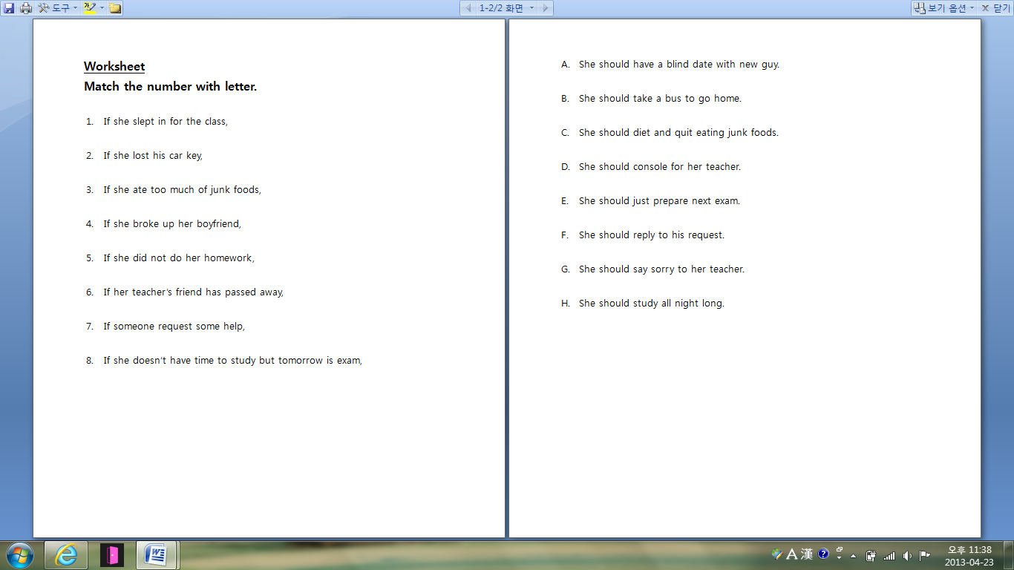  (I distribute a worksheet to students and give them 3minutes.)  ICQ  Do you work with group?  How much time do you have?  Check the answers.  After they finish the work, I ask them about ‘should’.  As we have done this activity, what word do we use when we want to advice to someone? (If they don’t know at the first time, I can give them a hit.) It starts with ‘S’. (I write ‘Should’ on the board.)  Should is an auxiliary verb. Do you know about the meaning of auxiliary? It means such as assistance. So, function of should is assist in a verb. We can use should to say what is the right thing to do. And in the negative we use shouldn’t. And a verb has to comes after should.  ‘Should’ cannot be used by itself without a verb.  CCQ  Dose a verb come after should?  Ok, let’s move on to main activity.
Main Activity
Materials: strips
Time  12min | Set Up  Groups | Procedure:  1.making solution and advice  Instructions  I will make you into 5 groups. I will give you some strips written a short problem someone has on it. Read and then discuss about the solution or advice that you want to say to her by using should. After finish discussion, present your solution or advice in each group. Work with your groups and I will give you 4minutes.  Material  ICQ  How much time do you have?  Do you work alone?  What should you present about?  After finish discussion, let one student come out in front of the class and present in each group.  CCQ  If your friend has a problem, what should you give him?

Post-Activity
Materials: pieces of paper, pen
Time  6 min | Set Up  individually | Procedure:  I. writing letter  Instructions  I am going to move on post activity. I will give you some pieces of paper. Write your problem briefly on piece of paper I gave you. Work individually and I will give you 1minute.  ICQ  How much time do you have?  Do you work with group?  After 1 min, I collect them all and mix them up.  I will give it again and write some advice about the problem on back side of the paper. Work individually and I will give you 2 minutes. I will give something to best advisor.  After they finish the work, I check their advice of some of students.  ->Can you tell us your friend’s problem and your advice?  If I don’t have enough time to ask them, I can ask them. “Who got a best advice?”  II. Conclude lesson  Thank you for cooperation with me.  Good job today. See you guys tomorrow!
Sos-activity
Materials: none
Time  3 min | Set up  Whole Class | Procedure:  I. discussion  Instruction  Share your experience you were given advice from other with your partner. I will give you 2 minutes.  ICQ  Are you working alone?  What do you suppose to do?  How much time do you have?  After they finish, I ask them their experiences.

Grammar
Lesson Plan

Date : 23.April.2013
Name : Jinhwa Lee(Jina)

