X Listening/Speaking Reading Grammar Writing
Topic: Body Language
Instructor:  Alex | Level:  Pre-intermediate | Students:  12 | Length:  50 Minutes
Materials:

- White board and markers,
- Picture of the bear doll
- Picture of the American man
- 10 pictures of each gestures
- Chocolate
- 10 Word Cards
- ‘Guessing the gesture’ Worksheet
- Papers
Aims:
- Improve student’s speaking skills by answering questions and discussing in groups.
- Improve student’s speaking skills by speaking how to pronounce 10 words.
- Improve student’s listening skills by listening to the explanation of the body language.
- Improve student’s listening skills by listening how to speak the word correctly.

Language Skills:
- Speaking: answering questions, discussing in groups, speaking 10 words.
- Listening: teacher’s explanation about the body language, how to pronounce the words.
- Reading: worksheet.
- Writing: write sentences by using 10 Word Cards.
Language Systems:
- Phonology: discussion, pronounce of words
- Function: creative, group working
- Lexis: vocabulary.
- Grammar: N/A
- Discourse: discussion, responding the teacher
Assumptions:
- All Ss understand the conception of body language.
- All Ss use body language to help others to understand what they are saying.
- All Ss like to share their opinions.
- All Ss can create the new gesture.
Anticipated Errors and Solutions:
- If Ss have no idea about creative gestures ☞ Solution: show an example to help them.
- If activity lasts too long. ☞ Solution: shorten the main activity and give students time warning.
- Ss do not participate ☞ Solution: encourage them to make them brave.
- If activity finishes too soon. ☞ Solution: explain more about their weak parts.
References: none

Lead-In
Materials: - White board and markers
- a picture of the bear doll
- a picture of ‘an American man’

Time | Set Up | Student Activity | Teacher Talk
1min  2min  2min  2min | Whole  Whole  Whole  Whole | Ss greet the teacher.  Ss observe  One Ss volunteer  Ss response  Ss listen  Ss observe  Ss listen  Ss listen | Greeting.  Stand at the center of the classroom.  Make one student to draw the picture of elephant by using body language.  How did the student know that I wanted him/her to draw this picture?  Collect opinions from students and integrate the idea.  Show students pictures of bear and an American man.  Explain basic things about body language.  “Now let’s start the gesture activity.”

Pre-Activity
Materials: - ‘Guessing the Gesture’ worksheet
- 10 pictures of each gestures

Time | Set Up | Student Activity | Teacher Talk
5min  5min | Whole  Individual  Whole | Ss observe and read the material.  Ss watch and answer.  Students say their opinion.  Ss listen | Provide the worksheet  Showing the pictures of the body language as the activity  Ask students to find out the meaning or the situation that the word may match.  Ask the most impressive gesture from the worksheet.  “And we’ll do the activity by using our creativity.”

Main Activity
Materials: - White board and markers.
- Chocolate

Time | Set Up | Student Activity | Teacher Talk
1min  1min  10min  5min | Whole  Group  Group  Whole | Ss listen  Follow teacher’s instruction  Ss discuss and make a new gesture.  Ss present their ideas.  Ss listen | Give instruction about the ‘Create gestures’ activity.  Divide Ss 6 groups  Give 10 minutes each groups and let them discuss about the creative gesture and make one creative gesture.  Let Ss to present their ideas.  Give a chocolate to the best group.  “Good job! And now we’ll see some cards.”

Post Activity
Materials: - White board and markers
- 10 Word Cards
- Papers
Time | Set Up | Student Activity | Teacher Talk
1min  5min  5min  4min  1min | Whole  Whole  Individual  Whole  Whole | Ss listen and observe.  Ss listen and respond  Ss write a sentence.  Ss speak their sentences.  Say goodbye to the teacher. | Show the word cards and explain it.  Teach how to pronounce the words and make students repeat after me.  Provide one word card to each person.  Give them the papers and let them write a sentence on their paper by using the words.  Let Ss to speak their sentences.  End the class.  See you tomorrow. Bye.

Work Sheet- “Guessing the Gesture”

a. Talking too much-Blah Blah - Pressing one’s lips to another person’s cheek.

b. Be quiet - Extending the thumb and pinky finger upward.

c. Hitchhiking - Raising the palm of the hand to the face.

d. I love you - Touching the side of the nose with the index finger.

e. Loser - Move your index finger to your lip.

f. Time-out - Fingers are kept straight and together, held upwards, while thumb points downwards. The fingers and thumb then snap together repetedly.

g. Friendship or greeting - One hand with flat palm placed perpendicular to the other hand with flat palm, roughly in the center.

h. Frustration or embarrassment - Sticking one thumb upward toward the road.

i. We share a secret - Extending the thumb, index finger, and little finger while the middle and ring finger touch the palm.

j. A gesture of friendship in Hawaii - Extending the thumb and forefinger to resemble a letter.

Picture of the bear doll

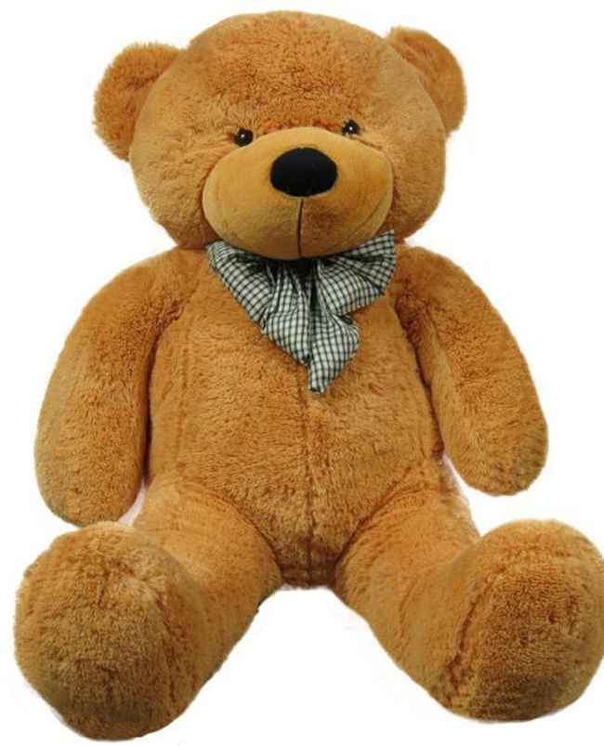

Picture of the American man

10 Pictures

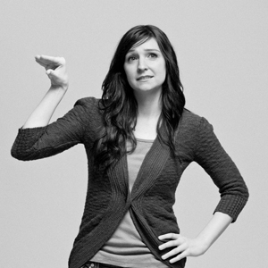

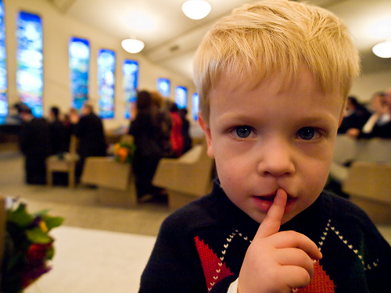

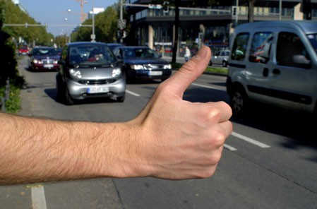

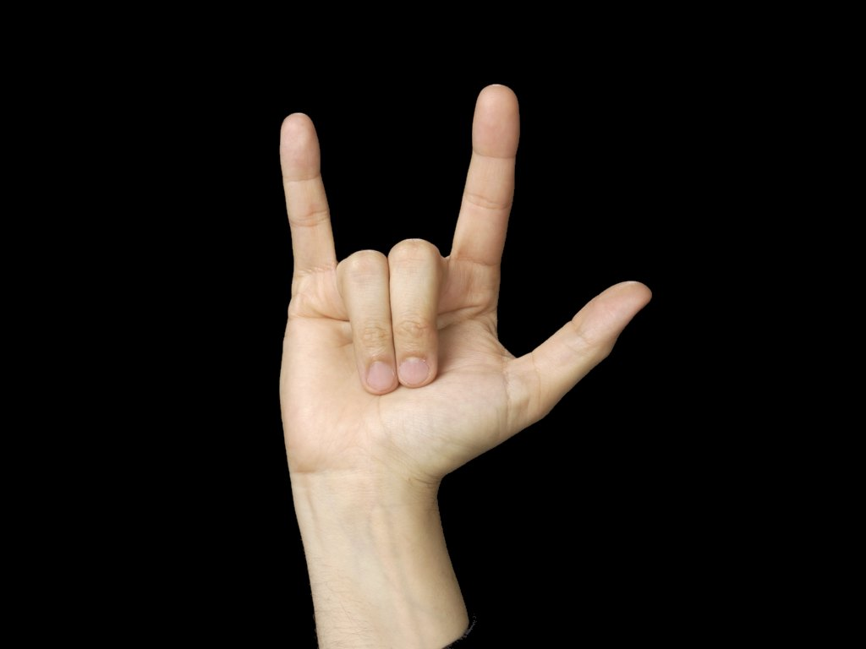

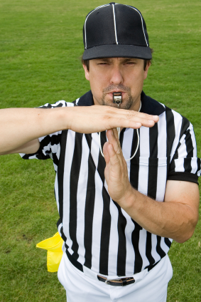

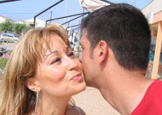

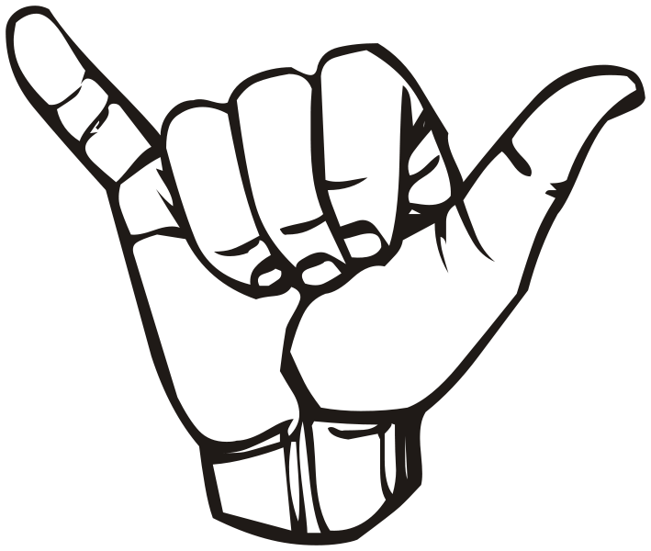
10 Word Cards

