■Listening / Speaking □Reading □Grammar □Writing
Topic: A Hope Chest (Preparing for a Wedding)
Instructor:  Suzy |  |  | Level:  Pre-intermediate | Students:  12 |  | Length:  50 Minutes
Materials:
- White board, markers and board erasers,
- A box,
- Pictures of hope chest, and ham which is Korea traditional box.
- Picture of newlyweds,
- Word scrambles that are related to wedding,
- 3 different kinds of work sheets for group discussion
- Finding the words activity related to honeymoon

Aims:
- Improve speaking skills by responding T’s question, discussion in group and sharing opinion in group.
- Improve listening skills by listening to T instruction, questions and listening to other Ss statements during group discussion.
- Improve writing skills by completing work sheet, taking notes during discussion.
- Improve communication skills by having discussion in a group and answering the teacher.

Language Skills:
- Speaking: small group discussion, answering the teacher.
- Listening: T talk, instruction, and discussion.
- Reading: reading the board and work sheet.
- Writing: writing words or short sentences when Ss do work sheet.
Language Systems:
- Phonology: discussion, teacher talk.
- Function: Planning,
- Lexis: vocabulary.
- Grammar: N/A
- Discourse: group discussion, responding the teacher.
Assumptions:
- All Ss have opinion about the topic.
- All Ss understand the wedding ceremony.
- All Ss know the meaning of honeymoon.
- All Ss have attended someone’s wedding.
- All Ss will enjoy discussion and sharing their opinion.
- All Ss cooperate with each other during the group activity.

Anticipated Errors and Solutions:
- If Ss may have difficulties on the word scrambles
Solution: work in a group so that stronger S helps weaker S.
- If Ss don’t give their opinion during the group discussion
Solution: T gives examples first.
- If the time may not be enough for working on the activity
Solution: T gives 1 more minute.
- If the post activity may take longer than anticipated
Solution: T gives time warning and asks fewer students than planned to share.
References: - www.naver.com
Lead-In
Materials: - A box, Pictures of hope chest and ham, Board and markers.

Time | Set Up | Student Activity |  |  | Teacher Talk
2min  2min  2min | Whole  Whole  Whole | Ss greet and listen to teacher.  Ss listen and look at the pictures that T has.  Ss give the words that they think and listen what T says |  |  | Greeting. Tell T’s stories that T experienced about wedding ceremony for interesting introduction.  Show a box and some pictures to explain the origin of the hope chest. (the wedding box)  Ask Ss the words which come up with ‘wedding’

Pre-Activity
Materials: - Word scrambles, Board and markers.

Time | Set Up | Student Activity | Teacher Talk
1min  1min  2min  2min | Whole  Group  Group  Group | Ss listen what T says.  Ss move into group.  Ss do word scrambles and compare their results.  S comes up and writes the answers on the board. | Introduce the word scrambles.  Divide class into 3 groups of 4 members.  Hand out the word scrambles.  Tell Ss don’t touch the paper until T says “Go”.  Monitor Ss how they are doing.  One of teammate come up and writes down the answers on the board.  Correct errors if necessary.

Main Activity
Materials: - A Picture of newlyweds, Work sheet ① Home appliances, ② Furniture, ③ Honeymoon for each team, Board and markers.
Time | Set Up | Student Activity | Teacher Talk
1min  5min  6min | Whole  Group  Whole | Ss get the work sheet.  ① Home appliances  ② Furniture  ③ Honeymoon  Ss listen  Ss discuss what they given subject. Ask question to T if they have.  Every S from each group delivers short speech.  All Ss listen another S says. | T gives instruction and hand out the work sheets.  Let Ss work with the same group.  Instruction: Discuss about the Topic which you assigned. After discussing, every teammate should participate to make the short speech to the other Ss. Finish discussing in 5 min and deliver the speech for 2 min.  Let Ss discuss and share their opinion one another for 5 min. Help if somebody are not participating the discussion.  Let every S from each group deliver short speech one by one. Encourage Ss and give positive feedback about their opinion.

Post Activity
Materials: - Finding words

Time | Set Up | Student Activity | Teacher Talk
1min  2min  2min  1min | Whole  Whole  Whole  Whole | Ss receive the finding words.  Ss do the activity.  Ss tell the answers.  Ss listen what T says. | Transition: Since we have decided a destination for the honeymoon, shall we go to the airport?  Give Ss finding words sheet.  T tells them do it individually and give 2min.  Time warning  1 minute, 30 seconds, 10 seconds, Times up!  Compare the answers with whole class.  Close by giving Ss feedback about their accomplishment and improvement.  T dismisses Ss.

Unscramble the words that related to wedding below.

- souiilmen
- eonhoyomn
- nsigr
- sovw
- mogro
- ynerecom
- edsadimibr
- rolfews
- keac
- sntdnaetat
- eosrppo
- cedan
- levi
- noroh
- simuc
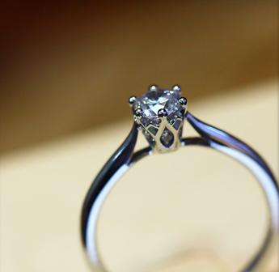

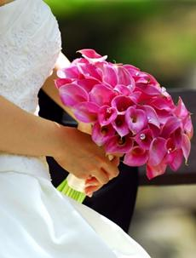

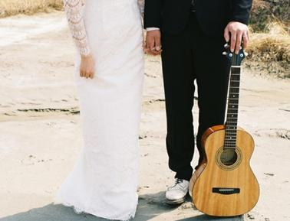

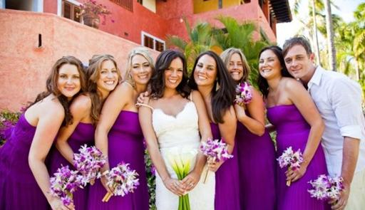

Home appliances List for Newlyweds

1.
2.
3.
4.
5.
6.
7.
8.
9.
10.

The Reason, You Need To Buy.

1.

2.

3.

How Much Do You Expect It To Cost?

Purchasing the Furniture for Newlyweds

1.
2.
3.
4.
5.
6.
7.
8.
9.
10.

The Reason, You Need to Buy.

1.

2.

3.

How Much Do You Expect It To Cost?

Where to Go on a Honeymoon?

Destination Candidates

The Reason For Choosing

How Much Do You Expect It To Cost?

Things that you will need for a honeymoon

A trip to the ⓐⓘⓡⓟⓞⓡⓣ

P | B | W | L | H | Y | Q | T | L | P
X | L | G | L | A | M | B | Z | O | I
C | I | A | W | U | S | S | S | U | K
Q | L | T | N | B | G | T | L | N | F
E | E | J | F | E | I | G | O | G | A
J | E | A | Q | C | S | R | A | E | J
G | N | I | K | R | A | P | L | G | L
B | C | E | K | Y | N | X | W | I | E
N | T | W | I | X | A | T | A | R | W
S | L | M | V | Z | B | T | R | I | P

JETWAY PLANES PARKING

LOUNGE TAIL TICKETS
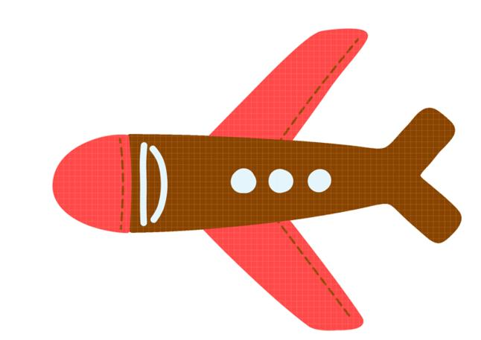
LUGGAGE TAXI

