Listening Speaking Reading Grammar Writing
Topic: You Do It
(Making Imperative Sentences)

Instructor:  Cindy | Level:  Pre-Intermediate | Students:  12 | Length:  54 Minutes
Materials:
Board and markers
15 pictures
12 Abby cards (for writing their own worry)

Aims:
To improve speaking skills by giving suggestions in ‘Abby’ activity
To improve listening skills by listening to teacher and classmates
To improve writing skills by writing their worry on the ‘Abby’ cards
To improve grammar skills by making imperative sentences

Language Skills:
Listening: Listening teacher’s instruction and presentation, classmates’ talking
Speaking: Repeating sentences after teacher and giving suggestions to classmates
Writing: Making imperative sentences

Language Systems:
Grammar: (Dropped subjective) + verbs (Be verbs, do, make, get, have, take..)
Phonology: Having strong stress on verb in a sentence
Function: giving suggestions to classmates

Assumptions:
Students can make simple sentences.
Students know the teacher's style of teaching and the pace of the course.
Students know verbs (be verbs, do, make, take, have, get)

Anticipated Errors and Solutions:
Activity can be finished earlier than expected
-Prepare extra activities
Activity can be finished longer than expected
-Pick students randomly
Students didn’t know some meaning of words
-Explain meaning for them
Students don’t participate in activity
-Teachers can give more examples to encourage students to participate
Students can’t understand instruction well
-Teacher gives long and detailed instruction, demonstrate again

References:

Lead-In
Materials:

Time | Set Up | Student Activity | Teacher Talk
1 min  3 min  5min | Whole  Whole  Whole | Greet teacher  Follow my directions  Listen | Greet students  Say some imperative words  (Look at me, Raise your index fingers, close your eyes, open your eyes, and clap your hands four times)  Tell students my story-  “My Terrible 20th birthday with a police officer”

Pre-Activity
Materials: Board and markers

Time | Set Up | Student Activity | Teacher Talk
6 min | Whole | Listen | Presentation on my topic “Imperative sentences”  -Write 3 sentences on the board  (Get out from the car, stand behind me, follow the line)  Syntax: Subject of the sentence is dropped.  “You get out from the car” becomes  “Get out from the car”,  Function: Most often used when giving directions or giving instructions  Phonology: Find common in sound.  Stressing on first verb

Main Activity
Materials: 15 pictures for making imperative sentences

Time | Set Up | Student Activity | Teacher Talk
1 min  12min | Whole  Whole | Listen  Watch pictures, guess  And Repeat | Give instructions  Show 3 pictures. Explain situations. And fill the blank.  For example: Mom is standing in the room. Son is sleeping even though he was supposed to go to class. What is mom going to say? “WAKE UP”. Everyone listen and repeat after me. 3 Times repeating.  Point student and ask him/her to guess.  Speak together and make them repeat 3times  & Error Corrections  (A, could you please stand up? Look at this picture. Imagine you are sitting on the passenger’s seat, and your boyfriend is driving. When you see this sign, what are you going to say to your boyfriend?  Listen and repeat after me “Be careful, Be careful, Be careful.”)

Post Activity
Materials:12 Abby cards

Time | Set Up | Student Activity | Teacher Talk
2 min  20min  3 min  1 min | Whole  Whole | Listen  Tell his/her worry  11 other students say imperative words to him/her  Listen  Say goodbye to teacher | Introduce “Abby” activity.  We are going to be Abby. When you receive Abby’s card, you are going to write own problem. You are going to stand in front of your classmates and say, “I’m Abby. I have a problem. My problem is that I have sleeping problem at night. What should I do?” And your 11 classmates will give you suggestions.  Get students each in front of class  Congratulation students,  Closing and Dismiss class

<Pictures for Main activity>

#1
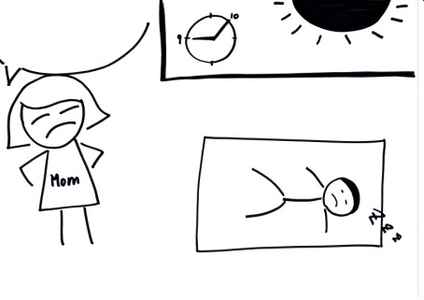
#2
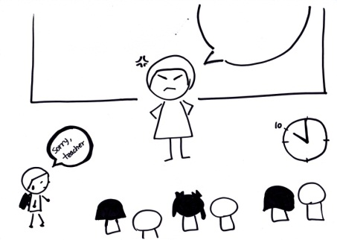
#3
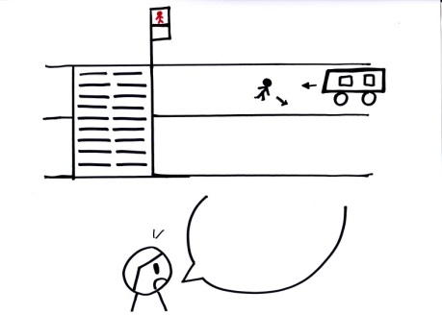
#4
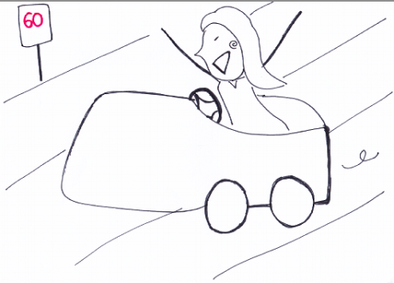
#5
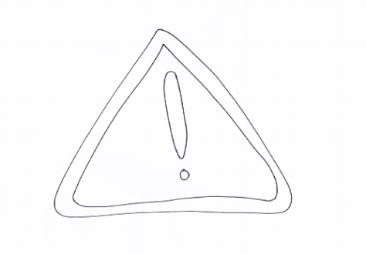
#6
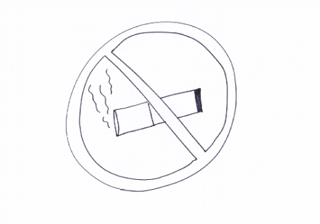
#7
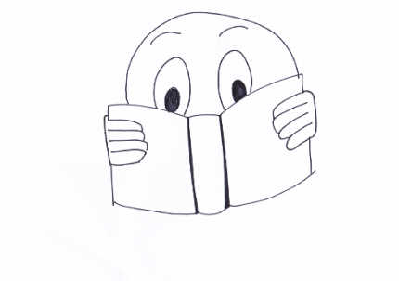
#8
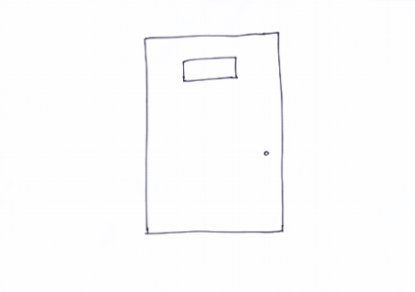
#9
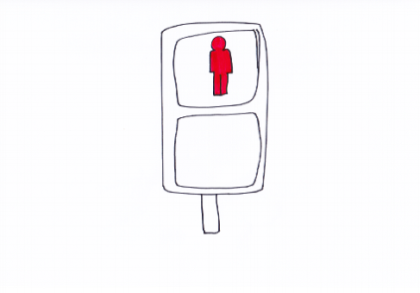
#10
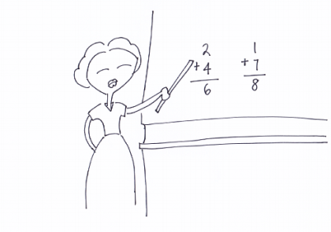
#11
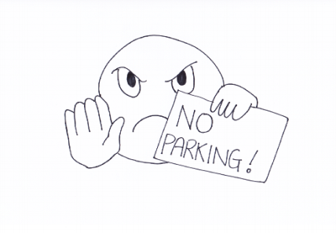
#12
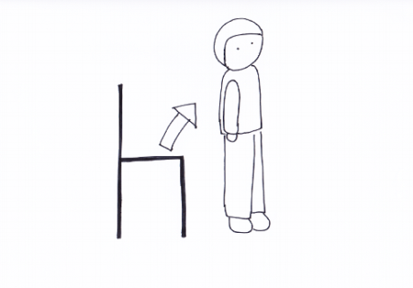
#13
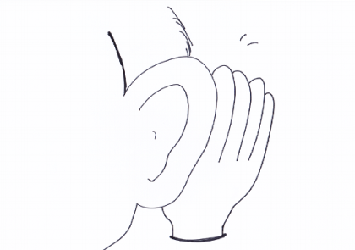
#14
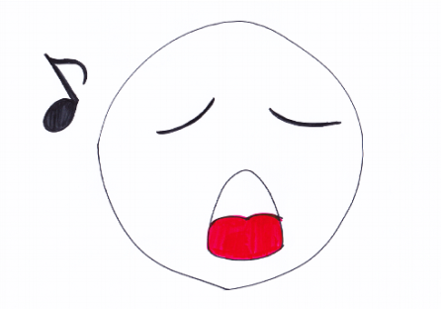
#15
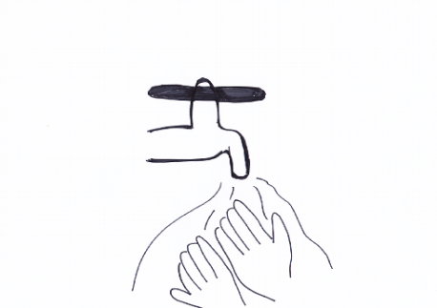

< Materials for post activity>
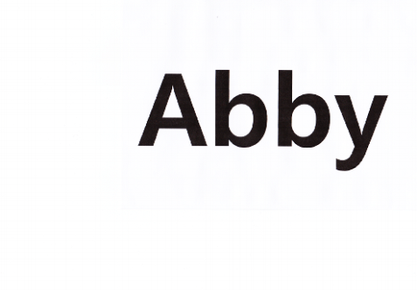 Card’s Front
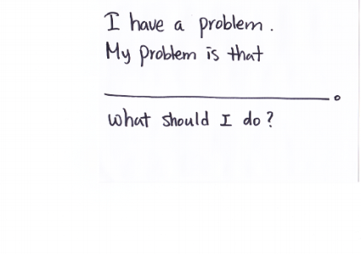Card’s Back

