Listening/Speaking Reading X Grammar Writing
Topic: I’m Better Than You.(Making Comparative Sentences)
Instructor:  BORA | Level:  Upper Beginner | Students:  12 | Length:  50 Minutes
Materials:
- White board and markers.
- 2 pictures of two guys.
- 13 pictures about comparison.
- ‘Promote Yourself!’ worksheet for each group.
Aims:
- Improve speaking skills by repeating sentences after T, saying sentences from pictures, discussion in group, having presentation, responding T’s question and answering CCQs.
- Improve listening skills by listening to T’s introduction, demonstration, questions and CCQs, listening to other Ss opinions during group discussion, listening to other group’s presentation.
- Improve reading skills by reading comparative sentences.
- Improve writing skills by completing worksheets.
- Improve communication skills by having discussion and sharing ideas in group.
- Improve grammar skills by listening to T’s explanation and making comparative sentences.
Language Skills:
- Speaking: small group discussion, presentation, responding to T’s.
- Listening: listening to T (T talk, instructions, CCQs, etc.), listening to other Ss’ opinions during discussion.
- Reading: looking at the board and worksheets.
- Writing: writing sentences in worksheet and taking notes.
Language Systems:
- Phonology: repetition, discussion, presentation, teacher talk.
- Function: introduction, persuasion, presentation, respect.
- Lexis: adjective, more, than
- Grammar: adjective -er + than, more adjective + than
- Discourse: group discussion, responding the teacher.
Assumptions:
- All Ss can make simple sentences.
- All Ss know adjectives.
- All Ss know the T’s teaching style and the flow of the class.
- All Ss probably are excited about compare something.
- All Ss will enjoy discussion and sharing their opinions in group.
- All Ss cooperative with one another during the group activity.
- All Ss know how to have presentation in front of the other students.
Anticipated Errors and Solutions:
- If Ss don’t understand instructions. ☞ Solution: T shows demonstration.
- If Ss don’t know the meaning of words. ☞ Solution: T explains meaning giving some examples.
- If Ss don’t know the meaning of pictures. ☞ Solution: T gives them some hints.
- If some Ss are too shy to participate during the group discussion.
☞ Solution: T encourages Ss to participate and give positive feedback.
- If some Ss don’t give their opinion during the group discussion.
☞ Solution: T gives her opinion and leads them to participate in communication.
- If activity takes too long. ☞ Solution: T gives them time warning.
- If activity finishes too soon. ☞ Solution: T makes suggestions and shares ideas.
References:
Finding pictures from the website - http://www.naver.com

Lead-In
Materials:
- White board and markers.
- 2 pictures of two guys.
Time | Set Up | Student Activity | Teacher Talk
1min  3min  2min  1min | Whole  Whole  Ss  Whole | Ss greet the teacher.  Ss listen to teacher and look at the pictures that teacher has.  Ss share their experiences.  Ss guess today’s topic and look at the board. | Greeting.  Tell T’s interesting experience while at university showing 2 pictures. The story is about the situation that I had to choose between two guys.  Elicit the stories from Ss.  Let Ss guess today’s topic and write the sentence ‘I do better than you’ in the board.  What expressions are they we can use when we compare something?

Pre-Activity
Materials:
- White board and markers.
Time | Set Up | Student Activity | Teacher Talk
2min  1min  1min  2min  2min  2min  1min  1min  2min  2min | Ss  Whole  Whole  Whole  Whole  Ss  Whole  Whole  Whole  Whole | Ss respond.  Ss look at the board.  Ss find something in common and say it.  Ss listen to T’s explanation.  Ss listen and repeat after T.  Ss respond.  Ss look at the board.  Ss find something in common and say it.  Ss listen to T’s explanation.  Ss listen and repeat after T. | Ask some questions to Ss about their height, age, etc.  Write some comparative sentences including ‘adjective –er + than’.  Let Ss find something in common in the sentences.  Explain comparative adjective.  Let Ss listen and repeat the sentences after T.  Ask some questions to Ss about how much their clothes are, what time they get up and what they are interested.  Write some comparative sentences including ‘more adjective + than’.  Let Ss find something in common in the sentences.  Explain comparative adjective applied to two or more syllables.  Let Ss listen and repeat the sentences after T.  Now, let’s compare pictures and make the sentences.

Main Activity
Materials:
- 13 pictures about comparison.
Time | Set Up | Student Activity | Teacher Talk
1min  1min  10min | Whole  Ss  Ss  Whole | Ss listen what T says.  Ss respond.  Ss look at the pictures and say the sentences.  Ss listen and repeat after T. | T gives instruction and an example.  <Instruction>  Look at the pictures and make the sentences comparing two things.  <CCQ>  What will you do?  Show the pictures and let Ss make the comparative sentences.  Let Ss listen and repeat the sentences after T.  Now, it’s time to compare and boast yourself.

Post Activity
Materials:
- ‘Promote Yourself!’ Worksheet for each group
Time | Set Up | Student Activity | Teacher Talk
2min  1min  1min  5min  3min  2min  1min | Whole  Ss  Ss  Group  Whole  Ss  Whole | Ss look at the worksheet and listen to T’s instruction.  Ss respond.  The student who is a boss comes up to the front.  Ss share their ideas one another and complete the worksheet.  Ask questions to T if they have.  Each group appeal themselves to the boss.  The boss chooses one group and tells the reason.  Ss say good bye. | Introduce worksheet and give instruction.  <Instruction>  Make two groups of five. You’re singers in a group. A boss has to choose only one group to debut. So two groups should promote themselves to be chosen for debut. Think about the strengths of your group comparing with the other group. Write the sentences on worksheet.  <CCQ>  How will you complete this worksheet?  How much time do you have?  Pick one student as a boss.  Let Ss discuss and complete the worksheet.  Monitor Ss how they are doing and facilitate them.  Let Ss promote themselves to the boss using comparative sentences.  Let the boss choose one group and ask why.  Close by giving Ss feedback about their accomplishment and improvement.
1. Pictures of two guys(Lead-in)

Jaeseok Dongwon
2. Pictures about comparison(Main Activity)
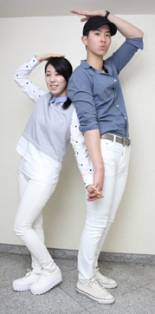(example)

Quiz1  Quiz2 2+3=? | Wonbin Okdongja

Taehee JIsun. | Hodong Minkwan.
24years old 47years old  The wife The husband | 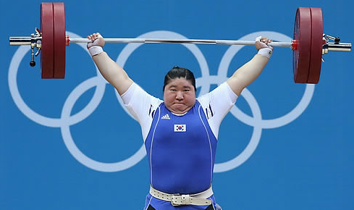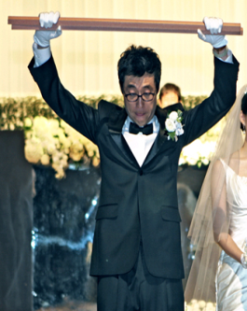  Miran Yoonseok.
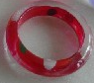  Diamond Plastic. | .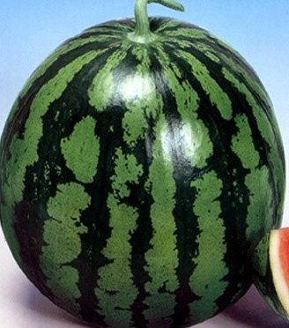 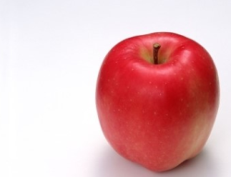  A watermelon An apple.
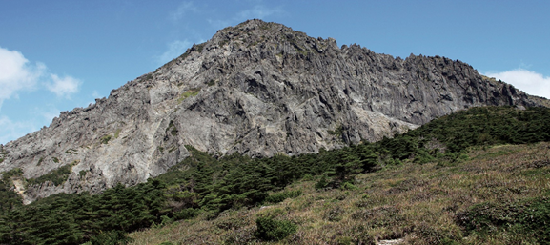  Mt. Baekdu : 2,744m Mt. Halla : 1,950m | Amazon river: 6516km Han river: 514km
A rabbit A tortoise. | The North Pole The desert.

3. Worksheet(Post Activity)

Appeal Yourself!

