□ Listening ■ Speaking □ Reading □ Grammar □ Writing
Topic: Job Interview

Instructor:  Jane Kim Mi-gyeom | Level:  Upper-intermediate | Students:  15 | Length:  30 Minutes

Materials:
- Board & Markers
- pictures of interview 1,2,3
- ‘to do list’ or ‘not to do list’ worksheets (4copies for 4 groups)
- Interview worksheets for interviewer (15copies)
- rank worksheets (15copies)
- ‘Good candidate & Bad candidate points’ strips(4sets for 4 groups)

Aims:
- To enable students to improve speaking skills by taking a speaking class to express their idea to share and answer
- To develop intensive listening, speaking, reading and writing skills by having activity; make a list, interview, determine the ranking
- To build team work and cooperation skills through discussion
- To get some knowledge about interviewing by taking various activities

Language Skills:
- Reading: Students will read sentences and questions to take a class.
- Listening: Students will listen to others’ short talks
- Speaking: Students will be talking by expressing their opinions what they want to share and what they guess to find out the answers.
- Writing: Students will write short summaries by interviewing

Language Systems:
- Lexis : vocabulary used in worksheet; teacher’s explanation or find from dictionary
- Function: answering questions and completing worksheets
- Discourse: interviewing each other
- Grammar: None to discuss
- Phonology: Listening teacher’s pronunciation or other student’s pronunciation

Assumptions:
- Students already have some experience about interviewing. Or not, they heard the stories of interview.
- Students can assume there will be some group works and know how to run.
- Students are willing to participation the class.

Anticipated Problems and Solutions:
Students have difficulties to present.
=>Give some questions related with their topics
If a student’s presentation time is over
=> NO chance to the next presenter, or adjust other activity time
If time is short,
=> Take one or two minutes until students finished their task
If students finish their tasks earlier than anticipated,
=>Run SOS activity

References:
www.google.co.kr
To activity:
http://esl.about.com
www.onespotenglish.com
www.ourfactsyourfuture.org
To vocabulary:
www.merriam-webster.com
www.thesaurus.com

Lead In
Materials:
pictures of interview 1,2,3
Time | Set Up | Student Activity | Teacher Talk
Total:  3min | Whole | Greeting with T  Thinking and talking with T about T’s questions. This process makes Sts concentrate on the class and find out what they will learn by themselves inductively. | Greeting  Hello guys. How are you?  Eliciting  Before we start, I will show you a picture. (showing a picture 1)  So, what are they doing in this picture?  “They are interviewing”  Then who are these three people?  “These are interviewers”  How about him? Who is he?  “He is interviewee”  (showing pictures 2,3)  I will show you two different atmosphere pictures of interview. Check interviewers face. Can you read their feeling? First picture is really bright atmosphere. However, second picture is really depressed. Which interview do you like better?  1. Do you have a job now? Or have you ever worked before?  2. What have you tried to meet the hiring requirements?  For the future and for a better job, today, we will talk about a job interview.  I hope you guys learn a lot from this class.
Pre-activity
Materials:
‘to do or not to do list’ worksheets (4copies for 4 groups)
Time | Set Up | Student Activity | Teacher Talk
Total:  8min  1min  3min  4min | Whole  group | Thinking about T’s questions. And try to answer.  Sts work in group.  One student in each group presents their ideas. Share their opinion from providing opportunity to speak | CCQs  1. What attitudes do you think the interviewees should have for a job interview?  2. What attitudes do you think the interviewees should avoid during a job interview?  Instructions  Before we start a very interesting activity, I will divide you into 4 groups.  In each group, discuss for interviewees’ ‘to do list’ or ‘not to list’. You have to write 4 more things in both lists. I will give you 3 minutes.  (Distribute 1 worksheet to each group.)  ICQs  1. Do you work alone?  2. How much time do you have?  Monitoring  Giving students a time warning by noticing how much time is left.  “30 seconds left. 15 seconds left. And, time’s up! Have you all finished?”  (When times up, tapping on the board)  Feedback  After writing, one student in each group read their ideas.
Main-activity
Materials:
Interview worksheets for interviewer (15copies)
Time | Set Up | Student Activity | Teacher Talk
Total:  10min  1min  6min  1min  2min | Whole  pair | Thinking and talking with T about T’s questions. Students answer freely.  This process makes Sts concentrate on the class and find out what they will learn by themselves inductively.  Interviewing each other as an interviewer or interviewee.  From their partner’s feedback, they can know their speech ability roughly. | CCQs  1. During the interview, which one is more important, be polite or confident?  “Both are important. Interviewees show confidence but not to be arrogant.”  2. When you get a job, do you seek just for money? Or try to find a job that you can enjoy?  Instructions  You and your partner should have an interview each other.  “I will give you number, remember it.”  1,2... 1,2..1,2..  Number 1 students will be an interviewer and number 2 students will be an interviewee first. If done, change your role.  (Distribute ‘interview sheet’ to every Sts.)  I’ll give you 6 minutes. Then each person should have 3 minutes.  ICQs  1. What will you do now?  2. How many minutes do you have?  Monitoring  Giving students a time warning by noticing how much time is left.  “30 seconds left. 15 seconds left. And, time’s up! Have you all finished?”  Feedback  After their own time for interview, give 1 minute to check their score. Share their opinions.  2 students have a presentation about their interview.
Post-activity
Materials:
rank worksheets (15copies)
Time | Set Up | Student Activity | Teacher Talk
Total:  9min  1min  4min  4min | Whole  group | Thinking and talking with T about T’s questions. This process makes Sts concentrate on the class and find out what they will learn by themselves inductively.  Do their activity within group  Share their opinions. | CCQs  1. Do interviewer and interviewee have same important concerns when interviewing?  2. What skills are most valuable for interviewers?  Instructions  “From now, you are all interviewers. Look at the worksheet. You will rank the skills of interviewers from one to ten. One is the most important. Discuss in your group.”  Using the worksheet provided, have students rank the priority from one to ten (one being most important and ten being least).  (Distribute ‘rank worksheets’ to every Sts.)  I’ll give you 4 minutes.  ICQs  1. What will you do now?  2. How many minutes do you have?  Monitoring  Giving students a time warning by noticing how much time is left.  “30 seconds left. 15 seconds left. And, time’s up! Have you all finished?”  (tapping on the board)  Feedback  After their discussion, one student in each group has a presentation and tells other students why they pick.  Teacher asks what your top 3 skills are and why.  Ending  Did you get an interview tips from this lesson? Today, you guys did a great job. Thank you very much!

SOS-activity
Materials:
‘Good candidate & Bad candidate points’ strips(4sets for 4 groups)
Time | Set Up | Student Activity | Teacher Talk
Total:  5min  3min  2min | Whole  group | Using given strips, Sts work in group.  During checking their answer, one St in each group writes their important 1 good and bad attitude on the board. | Instructions  Before we start a very interesting activity, I will divide you into 4 groups.  You have to sort out these strips by good and bad attitudes. I will give you 3 minutes.  (Distribute 1 set of strips to each group.)  ICQs  1. Do you work alone?  2. How much time do you have?  Monitoring  Giving students a time warning by noticing how much time is left.  “30 seconds left. 15 seconds left. And, time’s up! Have you all finished?”  (When times up, tapping on the board)  Feedback  “Is everything OK?”  (give the answer sheets)  “Please pick 2 things are really important to you guys in each attitude. And one student in each group tells your ideas.”  Let 2 students read each attitude loudly.

Pre Activity
To Do List |  | Not To Do List
1. | Prepare a complete, attractive resume that stresses your qualifications in a positive manner. | 1. | Do not give inaccurate information.
2. |  | 2.
3. |  | 3.
4. |  | 4.
5. |  | 5.
Main Activity

Interviewer:

1. Tell me about yourself.

2. What are your strengths?

3. What are your weaknesses?

4. What is your expected salary range?

5. What kind of previous working experience do you have?

6. What are your long-term plans?

7. What do you do in your free time?

Interviewee: ( )
Area | Score | Comments
interviewee’s presence  Fluency, Eye Contact, Gestures, Cheerful | 1 2 3 4 5
interviewee’s talk  Accuracy, Pace, Clarity | 1 2 3 4 5
total | / 10

Post Activity

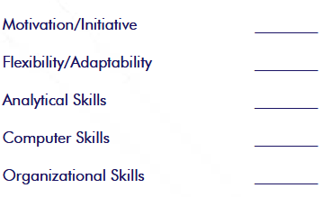
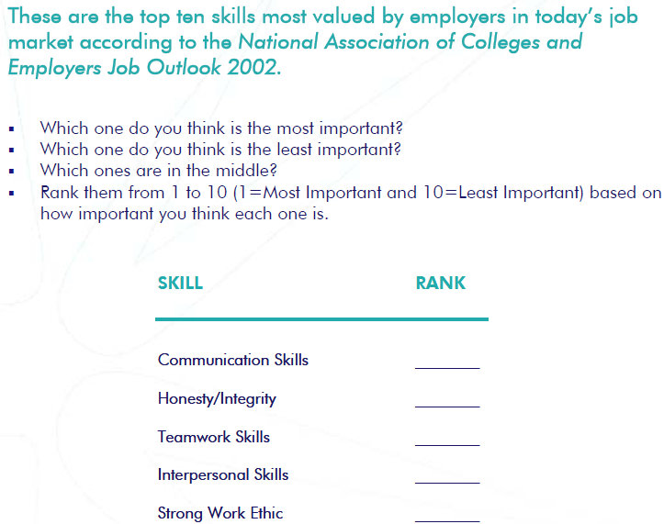

SOS Activity

<Good candidate attitudes>
• Dressed professionally
• Good handshake
• Good posture while sitting
• Came prepared with a resume and references
• Smiled
• Likes to learn new things
• Listens well
• Learning another language to communicate better with others
• Made a personal weakness less of a weakness by planning differently
• Indicated how much they liked interacting with people, even people who were depressed, at a previous job in a cafeteria.
• Thanked the interviewer and shook hands

<Bad candidate attitudes>
• Not dressed professionally
• Tattoos on arm exposed
• Bad posture
• The strength they highlighted made it sound like they are the life of the party, rather than a good communicator
• The weaknesses they admitted had nothing to do with work habits. Liking to sleep in could indicate a problem being on time for morning shifts.
• Didn’t say they learned anything from it or took advantage of any training while in prison
• Wants to work there for free food, and to meet parole conditions. It’s all about the candidate’s needs and not the employer’s.
• Didn’t give enough information about the previous job. It appears they quit or were fired because of their poor customer service.
• The question the candidate asked showed no concern or interest in the needs of the employer.
• Didn’t thank the interviewer or shake hands.

