SB: 93
Reading Lesson Plan

Shopping

Length:
50 minutes
es
Students:
5
Level:
Upper Intermediate
Instructor:
YOUNG

Materials:
- Idioms worksheet
- Text from “confessions of a shopaholic”
- Movie poster
- Vocab flashcards & pictures
- Complaint & complimentary situation sheet(5copies)

Aims:
- Primary aim: to enable students to improve reading comprehension by reading the text..
- Secondary aim: to understand idioms, to become confident in writing letter and speaking by group
- Personal aim: to be confident in teaching the lesson, to give clear instruction, to maximize student – student interaction in class, to be better at time management.

Language Skills:
- Speaking: students will share ideas and opinions to class on activities.
- Reading: students will read text from novel and post activity conversation sheet. .
- Listening: students will listen to teacher’s instruction, speakers and partners.
- Writing: students will write complain or complimentary letter.

Language Systems:
- Grammar:
- Lexis: fashion-related idioms and key vocabularies
- Phonology: pronouncing new vocabulary
- Function: summarizing story after reading
- Discourse: discussion on activities and writing letters

Assumptions:

- Students are interested in shopping and familiar with fashion-related expressions.
- Students are able to comprehend for reading novel and use appropriate language on real situation such as writing complain letter.

Anticipated Problems and Solutions:

- Students may not be able to find out the meaning of fashion-related idioms.
Ask other students to help them out
- If I fail to time management.
If time is short, skip the presentation part of post activity
If time is left, give students sometime to work on the SOS activity.

References:
- http://www.idiomconnection.com/clothes.htmlWhat You Need to Know about Idioms by Virginia Klein
- from “confessions of a shopaholic” by Sophie Kinsella

Lead-In
Materials: N/A
Time  3 min | Set Up  Whole Class | Procedure:  Greeting students  Ask 2guiding questions  -When & where did you buy your _________?  -What would you buy for birthday present for your best friend?

Pre-Activity
Materials: Idiom worksheet, Vocab flash cards, Pictures, Board & maker
Time  15 min | Set Up  Group | Procedure:  I. Idioms Worksheet  Instruction  -Divide in two teams.  -This is a race.  -These are the idioms & its meanings.  -Match the idiom with right meaning.  (Distribute the worksheet)  ICQ  -Is it a race?  -What do you have to do?  Monitor discreetly.  Answer students if they ask questions.  Check their answers time to time and tell them whether wright or not.  Announce winner team.  .  CCQ  -Can you understand idioms by definition of each word?  -Are idioms used frequently in everyday life?  2. Vocabulary flashcards  -Key vocabularies  Chiclit , confession, shopaholic,요기  -Instruction  1. Present word flashcard  2. Ask students to guess the vocabulary  3. Present a pictures for each word  4. Explain the meaning of the word writing on board.  CCQ  -Do you know other popular chiclit books?  -is alcoholic consuming excessive amount of alcohol?  -is workaholic working at office from 9 to 5?
Main Activity
Materials: Movie poster, Text from “confessions of shopaholic”
Time  15 min | Set Up  Whole Class  Group  Whole Class | Procedure:  Elicit topic by presenting movie poster.  -Look at this poster.  -Did you watch this movie?  -What is this movie about? Do you know about story?  -Do you know this movie is based on best-selling book?  Instruction  (Divide in two teams and make them sit together)  -I will give text from original book.  -Face down paper. Don’t look it.  -You have 5 seconds turn it over and read bold-faced letters only.  -Start! (Count 5 seconds), Face down the paper.  -Discuss what did you read and make a guess about story.  -You have 1 minute. Discuss!  (Check their answers)  -Now, you have 10minutes to read the whole text. After 10minutes, each team will make title of text you have and present about story. Start!  ICQ  -How long do you have to read the text?  -After reading, what do you present?  (Monitor discreetly. Do time monitoring.  Each team presents to class)  Feedback  -What was the title of team B?  -What was the title of team A?

Post-Activity
Materials: Pictures, Customer-clerk worksheet.
Time  13 min | Set Up  Whole Class  Group | Procedure:  1.Wrinting letter to customer service representative.  Eliciting  After presenting Pictures, for each picture  -What do you think about this picture?  -Who are they?  -Does she look happy (angry)?  -What happen to her?  Instruction  -This is individual work.  -Each of you will read conversation between customer and clerk at the store.  -You are the customer. After reading, write letter to customer service representative about this situation.  -You have 10 minutes.  ICQ  -Is this teamwork?  -What are you going to do?  Hand out worksheet.  Monitor discreetly.  Answer students if they ask questions.  Give time warning: 30 seconds left.  Make each student presents letter to class.  CCQ  -Is (student name) happy about situation?  -Why was she/he satisfied, upset?  -Is it complaint letter or complementary letter?  -How would you handle if you were service representative?
Feedback
Materials: n/a
Time  4 min | Set Up  Whole Class | Procedure:  -What did we talk about today?  -What did you do for pre/main and post activity?
SOS
Materials: n/a
Time  5~10 min | Set Up  Whole Class  Group | Procedure:  1.Planning itinerary  Elicit by asking question.  -What do you do when you travel overseas?  -Have you ever guided tour foreigner?  Instruction  (Divide two group)  -You have 5 minutes.  -You will plan itinerary for your foreign friend.  -Your friend visit Korea for the first time,  And he/she is crazy about shopping,  Lastly, your friend will spend 48hours in Korea.  ICQ  -How long will your friend stay in Korea?  -What’s his/her interest?  -What are you going to do for your friends?  Monitor discreetly. Give time warning: 30 seconds left.  Each team presents their itinerary to class.  CCQ  -If a foreign friend wants to try live octopus where do you bring your friend?  -Your friend is interested in Korean traditions where do you bring your friend?  Feedback  -What do you remember in Team A’s itinerary?

.

Chiclit
Shopaholic
Confession

1. You went to jewelry shop for looking for mom’s present.
There are many clerks but no one approach to you, they just chat each other.

You: I’m looking forward for present for my mother. Can you help me?
Clerk: (frowned face) How much do you have?
You: Um, Can I see some rings fist?
Clerk: (with folding her arms) I’m not sure we have anything to meet your budget.
You: (pointing a ring on display) How much is it?
Clerk: $7,000.

2. You are traveling by plan with your daughter(5years old)
You forget to order child meal for her. A little boy next her have child meal.
Your daughter really wants to try it and is about to cry.

Stewardess: Is everything okay?
You: My daughter wants to have child meal. Is there extra child meal for her?
Stewardess: I’m sorry to hear that. Could you wait for seconds? I will check and let you know.
(after a few seconds)
Stewardess: I found extra child meal for her. Here is your meal. Please enjoy and let me know if you have any further request.

3. You are in front of cashier to purchase pants.
You just notice that you don’t bring credit card.
It costs $55, but you only have $53 in cash.

Casher: Can I help you?
You: I didn’t have credit card now, I have just $53 in cash. I will visit next time.
Casher: You visit our store often. I recognize you! Let me give you discount.

4. You are at the clothing store to purchase for nice dress.

Clerk: That dress looks great on you! It is handmade-dress by craftsman.
You won’t find same design anywhere.
You: How much it?
Clerk: It costs $250. It’s expensive a bit but it is worth it.
You: Okay, I will take it.

A few days later, you found 5 women who wear same dress at the party. And one of them said she bought it $150 at outlet store.
5. You call customer service center to report lost credit card.

Operator: Good afternoon. Citi bank call center. How may I help you?
You: I lost my credit card, so I want to check,
Representative: (suddenly cutting in) Hold on please, I will connect with someone in charge.
(Waiting for 1 minute)
Operator B: Good afternoon. Citi bank call center. How may I help you?
You: I lost my credit card, so I want to check balance and report .
Operator B: Is it debit card?
You: I said credit card!
Operator B: Sorry, I will connect to credit card department. You called wrong number.
You: Excuse me, I just called,
(Waiting another 2 minutes)

Dear customer service representative,

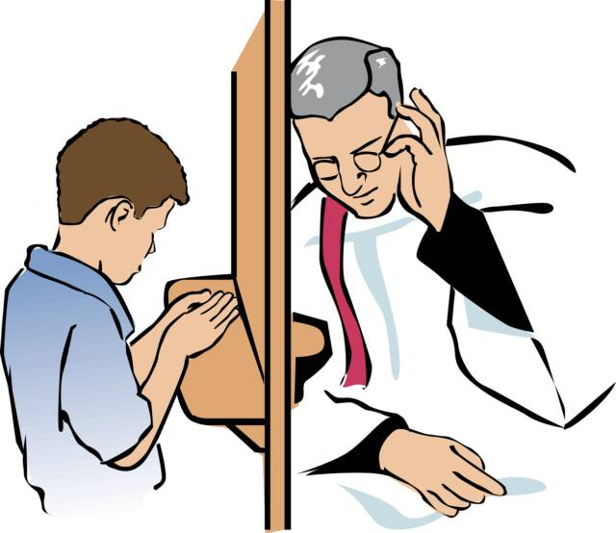

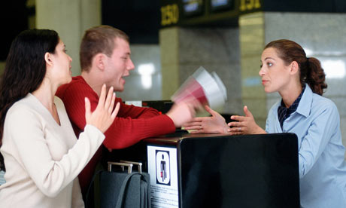

Confessions of a shopaholic by Sophie Kinsella

Ok. Don’t panic. Don’t panic. It’s only a VISA bill. It’s a piece of paper; a few numbers. I mean, just how scary can a few numbers be?
I stare out of the office window at a bus driving down Oxford Street, willing myself to open the white envelope sitting on my cluttered desk. IT’s only a piece of paper, I tell myself for the thousandth time. And I’m not stupid, am I? I know exactly how much this VISA bill will be.
Sort of. Roughly.
It’ll be about… 200 pounds. Three hundred, maybe. Yes, maybe 300pounds. Three-fifty, max.
I casually close my eyes and start to tot up. There was that suit in Jigsaw. And there was that gorgeous red and yellow rug. The rug was 200, come to think of it. But it was definitely worth every penny-everyone’s admired it. Or, at least, Suze has.
And the Jigsaw suit was on sale-30 percent off. So that was actually saving money.
I open my eyes and reach for the bill. As my fingers hit the paper I remember new contract lenses. Ninety-five pounds. Quite a lot. But, I mean, I had to get those, didn’t I? What am I supposed to do, walk around in a blur?
And I had to buy some new solutions and a cute case and some hypoallergenic eyeliner. So that takes it up to… 400pounds?

Do you want to know about my secret dream? It’s based on a story I once read in The Daily World about a mix-up at a bank. I loved this story so much, I cut it out and stuck it onto my wardrobe door. Tow credit card bills were sent to the wrong people, and—get this—each person paid the wrong bill without realizing. They paid off each other’s bills without even checking them.
And ever since I read that story, my secret fantasy has been that the same thing will happen to me.

Nine hundred and forty-nine pounds, sixty-three pence. In clear black and white.
For thirty seconds I am completely motionless. Then, without changing expression, I stuff the bill back into the envelope. I honestly feel as though this piece of paper has nothing to do with me. Perhaps, if I carelessly let it drop down on the floor behind my computer, it will disappear. The cleaners will sweep it up and I can claim I never got it. They can’t charge me for a bill I never received, can they?

That afternoon, Philip, the editor, calls my name, and I jump in fright.
“Rebecca?” he says. “A word.” And he beckons me over to his desk. His voice seems lower all of a sudden, almost conspiratorial, and he’s smiling at me, as though he’s about to give me a piece of good news.
Promotion, I think. It must be. He read the piece I wrote on international equity securities last week and was bowled over by how exciting I made it all sound. He knows it’s unfair I earn less than Clare, so he’s going to promote me to her level. Or even above. And he’s telling me discreetly so Clare won’t get jealous.
“Rebecca?” He’s thrusting a card at me. “ I can make this press conference,” he says. “But it could be quite interesting. Will you go? It’s at Brandon Communications.”
I can feel the elated expression falling off my face like jelly. He’s not promoting me. I’m not getting a raise. I feel betrayed. Why did he smile at me like that. He must have known he was lifting my hopes.

Confessions of a shopaholic by Sophie Kinsella

Frugality. Simplicity. These are my new watchwords. A new, uncluttered, Zen-like life, in which I spend nothing. Spending nothing. I mean, when you think about it, how much money do we all waste every day? No wonder I’m in a little bit of debt. And really, it’s not my fault. I’ve merely been succumbing to the Western drag of materialism- which you have to have the strength of elephants to resist. At least, that’s what it says I my new book.
You see, yesterday, when Mum and I went into Waterston’s to by her paperback for the week, I sidled off to the self-help section and bought the most wonderful book I’ve ever read. Quite honestly, it’s going to change my life. I’ve got it now, in my bag. It’s called Controlling Your Cash By David E. Barton, and It’s fantastic. What it says is that we can all fritter away money without realizing it, and that most of us could easily cut our cash consumption by half in just one week.
In one week!
You just have to do things like make your own sandwiches instead of eating in restaurants and ride a bike to work instead of taking the tube. When you start thinking about it, you can save money everywhere. And as David E. Barton says, there are lots of free pleasures which we forget because we’re so busy spending money like parks and museums and the simple joy of a country walk.

So on Monday morning, I stop off at Lucio’s on the way into work and buy an extra large cappuccino and a chocolate muffin, just like I usually do. I have to admit this is my last-ever cappuccino and my last-ever chocolate muffin. My new frugality starts tomorrow-and cappuccinos aren’t allowed. David E. Barton says if you have a coffee habit you should make it at home and take it into the office in a flask, and if you like eating snacks you should buy cheap cakes from the supermarket.

David E. Barton says that when you make a real effort, particularly in the early stages, you should reward yourself- so I pick up some coconut bath oil from the Natural rage as a little treat. Then I notice there are double advantage points on the moisturizer I use.
I love advantage points. Aren’t they a wonderful invention? If you spend enough, you can get really good prizes, like a beauty day at a hotel. Las Chrismas I was really canny- I let my points build up until I’d accumulated enough to buy my granny’s Chrismas present. What happened in fact was, I’d already built up 1,653 points-and I needed 1,800 to buy her a heated roller set. So I bought myself a great big bottle of Samsara perfume, and that gave me 150 extra points on my card-and then I got the heated roller set absolutely free! The only thing is, I don’t much like Samsara perfume-but I didn’t realize that until I got home. Still, never mind.
The clever way to use advantage points-as with all special offers-is to spot the opportunity and use it, because it may not come your way again. So I grab three pots of moisturizer and buy them. Double advantage points! I mean, it’s just free money, isn’t it?

