X Listening/Speaking Reading Grammar Writing
Topic: My special someone?
Instructor:  Chuwon | Level:  Intermediate | Students:  8 | Length:  72 Minutes
Materials:
- White board and makers,
- Role and situation cards –Jude, Aelxsandro, Bridget, Julia
Aims:
- Students improve listening, speaking and writing skills by role play and discussion in groups.
- Students improve communication skills by having discussion in a group.
Language Skills:
- Speaking: role play, small group discussion, answering teacher.
- Listening: teacher talk, during the role play, discussion.
- Reading: role cards.
- Writing: note.
Language Systems:
- Phonology: role play, discussion, teacher talk.
- Function: meeting, finding, believing.
- Lexis: vocabulary.
- Grammar: N/A
- Discourse: discussion, responding the teacher, role play.
Assumptions:
- Students understand about what is a role play.
- Students might have experiences about relationships.
- Students have their own opinion about the ‘right one’ for them.
Anticipated Errors and Solutions:
- If students may not have many ideas. ☞ Solution: Teacher makes suggestions.
- If activity lasts too long. ☞ Solution: T cuts the unnecessary parts.
- If activity finished too soon. ☞ Solution: Teacher suggests another situation.
- If Ss may not understand ☞ Solution: T demonstration.
- If certain Ss are shy: ☞ Solution: T encourages them, gives positive feedback, and changes roles for them.

References: none

Lead-In (15min)
Materials: - White board and markers.

Time | Set Up | Student Activity | Teacher Talk
1min  8min  5min  1min | Whole  Whole  Students  Whole | Listening response  Listen to teacher’s story  Students share their stories  Students listen | Greeting.  Share story about ‘My mistake to think about the guy was the one’.  Elicit stories form students  Introduce and transition to role play

Pre-Activity(16min)
Materials: - Role and situation cards –Jude, Alexsandro, Bridget, Julia
Board
markers

Time | Set Up | Student Activity | Teacher Talk
2 min  2min  7 min  5 min | Whole  Groups  Groups  Groups | Listen to teacher receive role card.  Ss move into group and pick roles.  Listen and take note  Prepare role play  Students practice role play | Intro role play  Handout role cards.  Divide Ss into group and to pick roles.  Tell students in groups to prepare for role play  (encourage to write note)  Teacher monitors and facilitate for students making suggestions

Main Activity(20min)
Materials: - Role and situation cards –Jude, Alexsandro, Bridget, Julia
Board
Markers

Time | Set Up | Student Activity | Teacher Talk
1min  15min  4min | Groups  Groups  Whole | Listen and response  Students do the role play  Listen and response | Ask students to present role play  Teacher monitors role play  Teacher feedback and congratulate on role play

Post Activity(21min)
Materials: - White board and markers.
Time | Set Up | Student Activity | Teacher Talk
5min  8min  7min  1min | Whole  Groups  Groups  Whole | Listen, plan and decide new situation  Prepare and present  Response  Say bye to teacher | Discuss and plan new situation  Give time to groups to prepare role play and present role play  Feedback  Thank Ss and close the class

Role and Situation Cards
Jude(35) – Bussiess man  Julia’s boyfriend for 1 years  Hansome and rich  Likes pretty and fasionalbe women  Belives in feeling and desnity  Active and funny  Heavy drinker  Does not like to be boring | Alexsandro (35) –Pubilc elemantry school teacher  Bridget’s boyfriend for 5 years  Very smart and romantic, normal salary  Likes to talk  Believes in sharing life and the same religion is really important in relationship.  Likes staying home  Does not like to drink acohol.  Loves Bridget.
Bridget(28) – Intern doctor at the hospital.  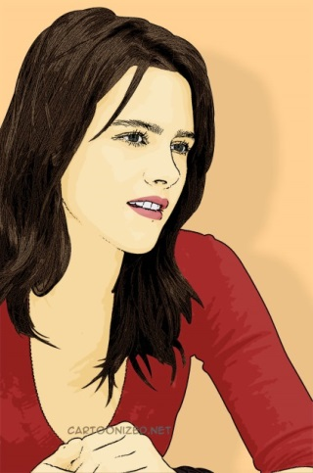  Alexsandro’s girl friend for 5years  Smart, kind and beatiful smile  Likes man who has sence of humer.  No religon  Want to get merried before 30years old  Does not like shopping  Loves wine | Julia (28) – no real job/ sometimes has part time job  Jude’s girlfriend for 1 years  So sexy and unkind  Thinks the best beautiful woman by herself  Think Jude proposes to her very soon  Likes man who has big money
Liko(24)-student  - Cory’s girlfriend for six months  - Always smiles, very kind person  - likes to hang out  - does not like serious situation and working | Mio(31)-book designer/single  - makes lot of money.  - Very responsible person  - a little aggressive,  - wants to get married soon,  - likes men who are passionate.  - Vegetarian.
Cory (28)-student  - Niko’s boyfriend for 6months  - wants a soul mate  - cool, funny, smart.  - likes sports.  - does not like being alone. | ?

