Listening █ Speaking Reading Grammar Writing

Topic: Aesop’s Fables

Instructor:  Kelly | Level:  Upper Intermediate | Students:  8 | Length:  30 Minutes

Materials:
- White board, board markers
- Visual aid of Aesop’s Fables
- 3 Story Telling worksheets
- 8 Worksheets of Original Aesop’s Fables
- 8 Word Search worksheets

Aims:
- Main Aim: To enable students to improve speaking skills through Story Telling activity
- Secondary Aim: Students will learn about Aesop’s Fables in English
- Personal Aim: I want students to have interests about English.

Language Skills:
- Reading: Students will read original Aesop’s Fables of Activities
- Listening: Students will listen to Aesop’s Fables and listen to other students as they story telling activity
- Speaking: Students will speak through story telling activity
- Writing: Students will write down the stories on the story telling worksheets

Language Systems:
- Phonology: None to discuss
- Lexis: Butcher, Hare, Tortoise, Reflection, Crow, Pitcher
- Function: Learning Aesop’s Fables and Proverbs in English
- Grammar: None to discuss
- Discourse: Dialogue, Monologue

Assumptions:
- Students already know:
- How the class is set up and run
- How the Aesop’s Fable story goes
- All the students are college graduates (age 23 and up)
- Students understand proverbs and saying

Anticipated Problems and Solutions:
- Students may not be able to hear some words
- Use repetition and drill
- Students may not understand some vocabulary
- Model
- Students may find the topic boring
- Add excitement by making the topic controversial

References:

Aesop’s Fables http://www.youtube.com/

Word Search http://www.theteacherscorner.net/

Lead-In
Materials: Board, Pictures

Time | Set Up | Student Activity | Teacher Talk
1 min | Whole class | Answering teacher’s questions | “Hello everyone! How are you today?”  Lead-in Pictures  - “I have three pictures. What can you see in this picture?”  - “Are you familiar with these stories?”

Pre-Activity
Materials: Board, Pictures, Word Search Worksheets

Time | Set Up | Student Activity | Teacher Talk
6 min | Whole class | Answers elicited  questions  Words:  Butcher, Hare, Tortoise, Crawl, Ridicule, Challenge, Footbridge, Stream, Reflection, Greedy, Crow, Pitcher, Beak, Pebble, Ingenuity | Elicit the word, “ Aesop’s Fables ”  - “What are the stories about?”  - “Do you know the words for these kind of stories?”  Model “ Aesop’s Fables ”  Brainstorming for words  - “What can you see in this picture?”  - “How can the tortoise move?”  - “What is the dog holding?”  - “Where is he?”  - “What kind of bird is this?”  - “How can we call this kind of water pot?”  “We looked over some words.”

Main Activity
Materials: Board, Story Telling Worksheets

Time | Set Up | Student Activity | Teacher Talk
3 min  1 min  5 min  10 min | Whole class  Pair Works  Pair Works | Attention to teacher’s speech  Pick one paper from a box  “5 mins”  “1 Narrator and 1 Actor or 2 Actors”  Writing  Play in turn (Speaking)  Reading | Instructions  - “Now you are going to “Play” Aesop’s Fables in pairs. Two, two, three. You are pairs. You’re going to play one aesop’s fable from these 3 stories. The team in three have no option but to play “The Hare and The Tortoise.” Between two groups, one person from the pair should pick one colored paper you like in the box. There is a Title on it. That will be your team’s play. I will give you Story Telling Worksheets. You have to write down the sentences you need. I will give you 5 mins to prepare. After the time your team has to play in front of the classroom. And there should be one narrator and one actor. Narrator should explain the situation and actor should act and speak while playing. Your group have two actors, the hare and the tortoise, and one narrator. Don’t do the bottom line: Proverbs.”  (Distribute the Story Telling worksheets)  ICQ  - “How much time do you have?”  - “There are two roles in pairs. What are they?”  “Now begin”  (Prepare Story Telling)  Monitoring  Monitor discreetly, Answer students if they ask questions.  Give time warning: “1 min left”  “Times up”  “Who go first?”  “Give them a big hand.”  “Thank you, everyone. You all did good job.”  “I will give you original stories of Aesop’s Fables. Keep it for future use.”

Post Activity
Materials: Board

Time | Set Up | Student Activity |  | Teacher Talk
2 min  2 min | Whole Class | Think of the Proverbs  “Slow but steady wins the race.”  “Necessity is the mother of invention.”  “Greed gets us nothing.”  “Enough is as good as feast.”  “It is very foolish to be greedy.”  Find Words  “2 mins” |  | Wrap Up  - “First Play was “Hare and Tortoise.”  - “What can we learn from the play?”  - “The next one, “The Crow and the Pitcher.” What can we learn from the story?”  - “The last one, “The Dog and The Reflection.”  Instruction  - “I will hand out the Word Search worksheet. I’ll give you 2 min.”  ICG  - “How much time do you have?”
SOS Activities
Materials: Visual Aids (Computer)

Time | Set Up |  | Student Activity |  | Teacher Talk
2 min | Whole class |  | Watching Videos |  | “I will show you some video clips which are about Aesop’s Fables. They are good sources for story telling.”  (Show “Youtube”)
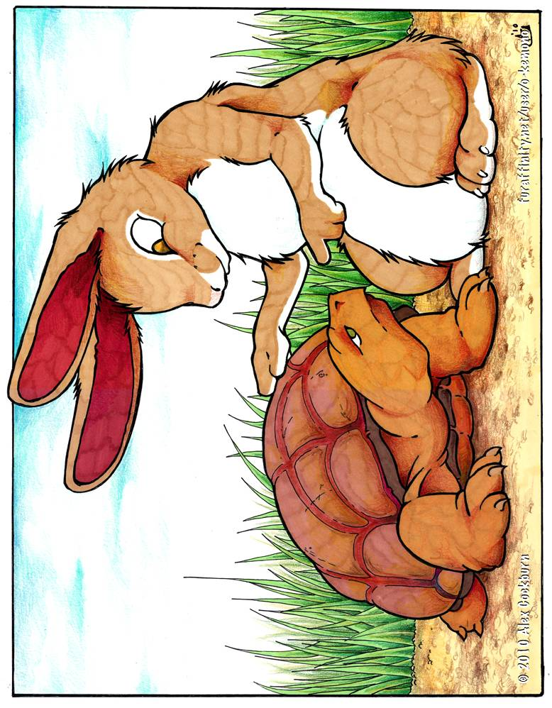
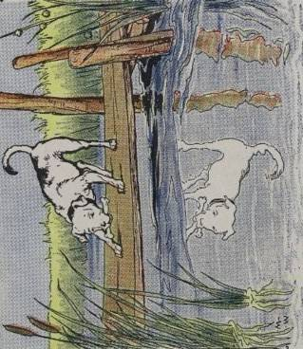
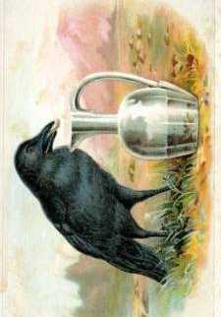

Dog
and Reflection

Crow and Pitcher

The Dog and His Reflection
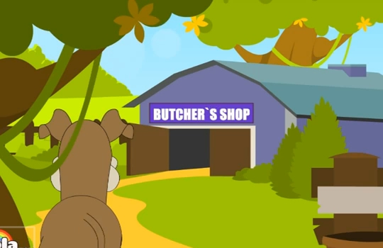 | 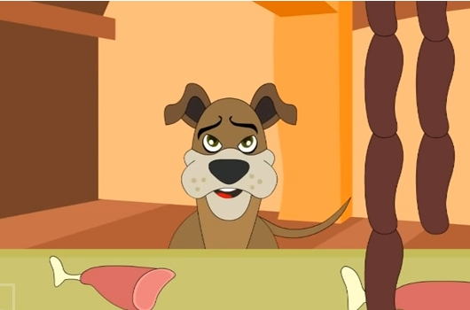
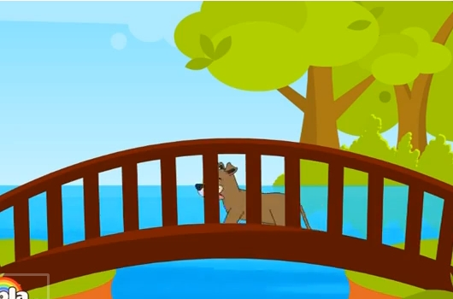 | 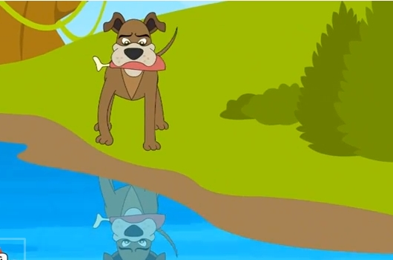
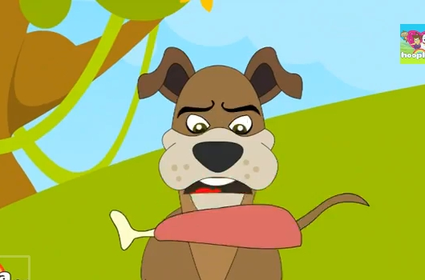 | 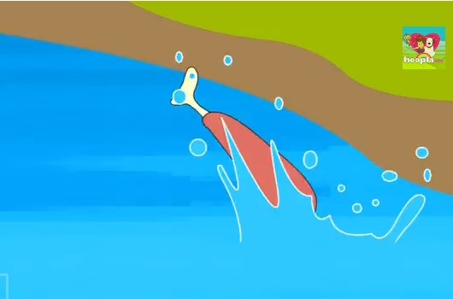

Proverbs : __________________________________
The Hare and The Tortoise
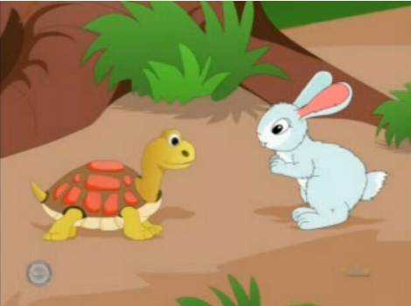 | 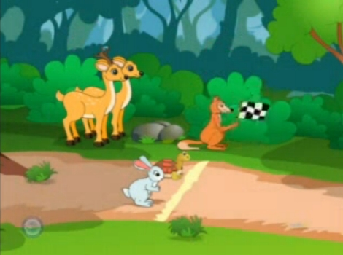
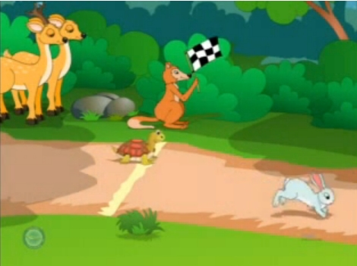 | 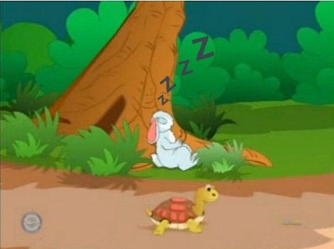
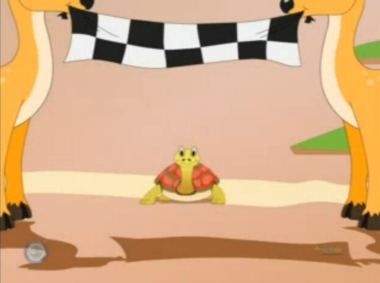 | 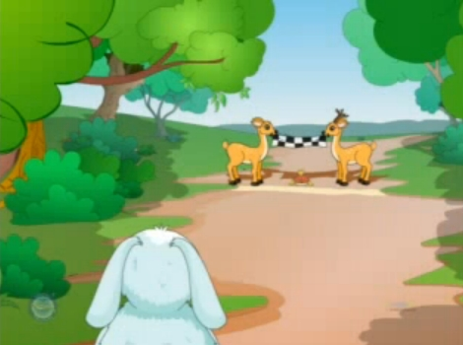

Proverbs : __________________________________
The Crow and The Pitcher
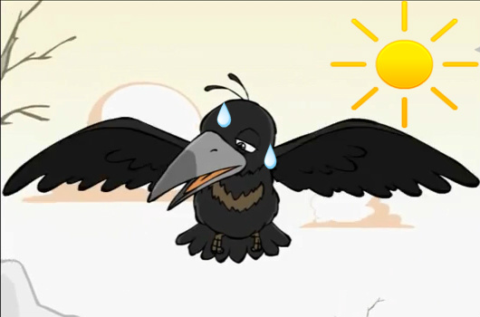 | 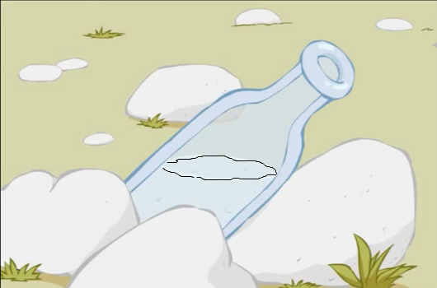
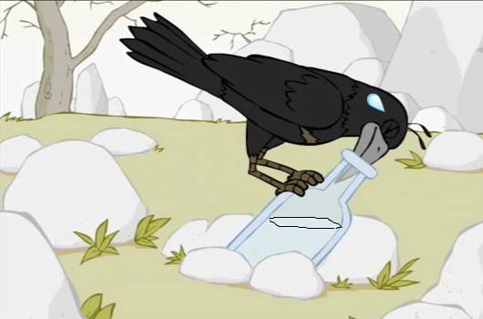 | 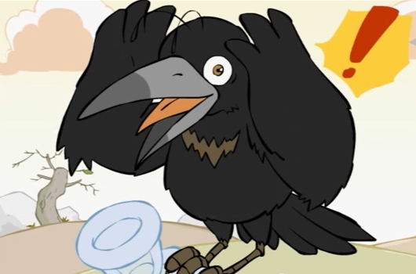
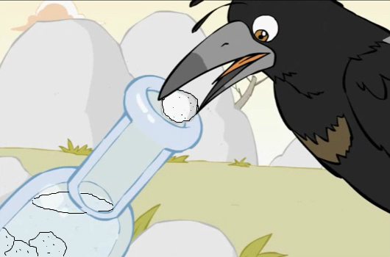 | 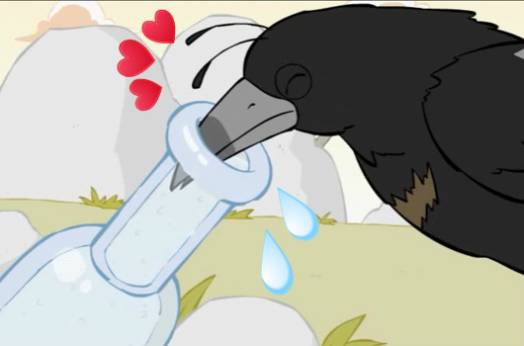

Proverbs : __________________________________
Aesop’s Fables
█ The Hare and The Tortoise
The story concerns a hare who ridicules a slow-moving tortoise who challenges him to a race. The hare soon leaves the tortoise behind and, confident of winning, takes a nap midway through the course. The tortoise gets tired but he keeps going. When the hare awakes, however, he finds that his competitor, crawling slowly but steadily, has arrived before him.

█ The Dog and His Reflection
A dog that is carrying a stolen bone from a butcher’s shop. As he crossed a narrow footbridge, he happened to look down and saw himself reflected in the quiet water as if in a mirror. But the greedy Dog thought he saw a real Dog carrying a bone much bigger than his own. He opens his mouth to bark at the "other" and in doing so drops what he was carrying. And as he stood sadly thinking about the good bone he had lost, he realized what a stupid Dog he had been.

█ The Crow and The Pitcher
The story concerns a thirsty crow that comes upon a pitcher with water at the bottom, beyond the reach of its beak. After failing to push it over, the bird drops in pebbles one by one until the water rises to the top of the pitcher, allowing it to drink.



