v
Listening Speaking Reading Grammar Writing
Topic: How You Have Changed.

Instructor:  Dina | Level:  Pre-intermediate | Students:  4 | Length:  50Minutes
Materials:
T’s Pictures
Drilling Wall Chart
Drawing sheets
Color pencils
Glue
Scissors
Work sheet
Word cards
Aims:
- Improve Ss listening skills by listening to T’s introductions and Ss presentations.
- Improve Ss speaking skills by answering T, Ss presentations.
- Improve Ss grammar skills about past tense (used to~) by presentation and do the work sheet.

Language Skills:
- Listening: T talk, Ss presentations.
- Speaking: Ss presentations.
- Reading: drilling wall chart and work sheet.

Language Systems:
- Phonology: drilling.
- Function: description.
- Lexis: past tense (-used to~).
- Grammar syntax: Subject + ~ed verb (used) + to + verb + none.
- Discourse: exchange information.

Assumptions:
- All Ss have changed
- All Ss can express how they have changed.
- All Ss already know some of the past tense.

Anticipated Errors and Solutions:
- If Ss take too long time in drawing: T gives ideas to finish up drawing.
- If Ss afraid of presentation: T encourage Ss ; give Ss some example ideas.

References:
None

Lead-In (8 min)
Materials:
T’s Pictures
Time | Set Up | Student Activity | Teacher Talk
1 min  3 min  4min | Whole  Whole  Whole | Greet T.  Listen to T.  Share Ss’s story. | Greet Ss.  Tell how I have changed with the pictures.  Ask Ss to share their story.

Pre-Activity (10 min)
Materials:
Drilling wall chart.
Time | Set Up | Student Activity | Teacher Talk
7 min  3 min | Whole  Ss | Listen to T and follow the drilling.  Ss drilling. | Put the drilling chart. Drilling with the wall chart and explain about past tense.  Let Ss do drilling themselves.

Main Activity (14min)
Materials:
Work sheet.
Word cards.
Glue.
Scissors
Time | Set Up | Student Activity | Teacher Talk
2 min  8min  4 min | Whole  Ss  Ss | Listen to T.  Read the work sheet, cut and stick a word cards on the work sheet.  Read the work sheet together. | Give a work sheet, word cards, scissors and glue to Ss and explain how complete the work sheet.  Monitor Ss activity and help Ss if someone has difficulty in reading work sheet.  Let Ss do it and complete work sheet correctly.  Let Ss read the sentence and confirm that correctly.

Post Activity (18min)
Materials:
Drawing sheets
Color pencils
Scissors
Time | Set Up | Student Activity | Teacher Talk
3 min  10 min  4 min  1 min | Whole  Ss  Ss  Whole | Listen to T.  Drawing pictures and cut to divide.  Presentation in front of other student. Presentation what other Ss drew.  Ss say good bye. | Give drawing sheets, scissors and color pencils to Ss and explain how complete and present.  Monitor Ss activity and help Ss if someone does not have any idea.  Let all of Ss have presentation with their picture.  Close by giving Ss feedback.

T’s Pictures

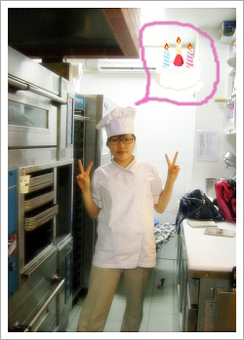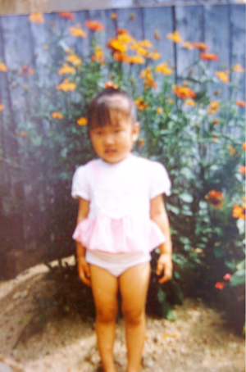

Worksheet

- When I was a high school student, I could read French. But I cannot read it now because, I forgot everything about French.

->

- Amy has moved to Busan. Before that she lived in Seoul.

->

- Kristin sold her piano 1month ago.

->

- Andrew swam every morning but now, he doesn’t have enough time to swim.

->

- When I was young, I did not like tomatoes.

->

- Do you know where Sally lived before she came here?

->

………………………………………………………………………………cut

I | Sally | Where | used to read | used to live | French.
I | Andrew | did | use to like | used to have | in Seoul.
Amy | Kristin | didn’t | use to live | used to swim | a piano.
 |  |  | every morning. | before she came here? | tomatoes.

Wall chart

I used to read French.
Amy used to live in Seoul.
Kristin used to have a piano.
Andrew used to swim every morning.
I didn’t use to like tomatoes.
Where did Sally use to live before she came here?

Used to~

Past Now

Past/Now
О→X
X→О

