Listening ■ Speaking Reading Grammar Writing

Topic: Wedding culture

Instructor:  Kibi | Level:  Upper Intermediate | Students:  6 | Length:  30 Minutes

Materials:
▪ White board and board markers
▪ Visual aid of Korean marriage culture (pictures)
▪ 7 Kinds of Situation explanations for each role-players (Worksheet)
▪ 2 worksheets for debate

Aims:
▪ Main Aim
- Ss will improve their speaking skills by talking about marriage of spanking their opinion and solving methods
▪ Secondary Aim
- Ss will share their experiences and opinions by negotiation of their marriage problems.
▪ Personal Aim
- I want to understand our culture and they try to solve the culture problems
Peacefully.
- I want they can speaking more freely than before.

Language Skills:
▪ Reading: Students will read the example situation before they do a role-play.
▪ Listening: Students will listen to other students’ opinions and thoughts.
▪ Speaking: Students will talk about their experiences.
▪ Writing: Students will write their own opinions.

Language Systems:
▪ Phonology: None to discuss
▪ Lexis: compromise, dealing, culture, wedding, groom, bridal, honeymoon
▪ Grammar: None to discuss
▪ Function: Expressing opinions, making suggestions, negotiations
▪ Discourse: None to discuss

Assumptions:
- Students already know: How the set up and run.
- All the students are college graduates (age 21 and up).
- Students have experiences of their neighbors, relatives, friends or own
- Students know how to do their role (family members)

Anticipated Problems and Solutions:
-Students might have troubles in activities and argue as feeling real.
->Monitor students and guide them.

References:
Visual aids (pictures, movie)

Lead-In
Materials: None

Time | Set Up | Student Activity | Teacher Talk
2 min | Whole class | Answering teacher’s questions | Hello everyone! How are you today?  Are you feeling lovely today?  ____, Do you like sweet dating with your lover?  ____, Do you have ever experienced falling in love with someone?  ____, Do you want to be together with somebody for your future?  If you meet somebody to be with you forever, what do you want to do with the person?

Pre-Activity
Materials: Visual Aids, Board and a marker, Worksheets
Time | Set Up | Student Activity | Teacher Talk
5 min  1 min  2 min  1 min | Whole class  Whole Class  In pairs  Whole Class | Answering elicited  questions  Listen to teacher  connect vocabulary and picture with line  Each team will say words in turn. | Elicit the word, “Wedding culture”  - Show them some pictures.  For some pictures,  - What can you see in these pictures?  -What are they doing?  - What kind of situation do you see in this picture?  - Do you think they are funny or serious?  - Can you guess what are they talking about?  - What is it? Where is it?  Model  -Yes, they meet their new family for the first time to discuss their marriage.  We have our special wedding culture.  (write it on the board)  - wedding culture, the seals of love  - dealing, culture, wedding, groom, bridal, honeymoon  CCQ  - Do you like this way to marriage?  - Usually, what kind of rule people follow for their marriage?  Play connect vocabulary  Instructions  We will play connect vocabulary now.  In this worksheet, there are 7 kinds of pictures and words. You can connect point to the point with straight lines between the right picture and word.  You have 1 minute.  Demonstration  Show the line to connect. Make 2 groups.  ICQ  -Are we working individually?  -How much time do you have?  “Now begin”  Monitoring  Monitor discreetly.  Answer students if they ask questions.  Give time warning: 30 seconds.  Be flexible with time.  “Times up”  Each team will choose words and try to have straight lines to win the game.

Main Activity
Materials: Example situations of role-play

Time | Set Up | Student Activity | Teacher Talk
2 min  5 min  1 min | Whole Class  In pairs  Whole Class | Listen to teacher  Make a role-play  Students will present their role-play | Do a role-play  Instructions  You will make a role-play with your partners. I’ll make yours for 2 teams.  And will sit down middle of the classroom  As sitting down to see each team.  I will give you 7 different example situations. After 1 minute, you will need to do the role-play in front of class.  You can be the person of role and talk freely. I’ll give you a 5 miniutes.  Demonstration  For example, let’s suppose I’m a grand mother of groom and ___ are the bride mother. We can discuss what we do together for happy wedding of the new couple. This is dialogue.  -Teacher: 사돈, I want to live with my grand-son. What do you think about it?  -Student: I don’t know, but that’s great to stcik with you and my daughter.  Like this, you can talk your opinions.  ICQ  -Are we working individually?  -How much time do you have?  “Now begin”  Monitoring  Monitor discreetly.  Answer students if they ask questions.  Give time warning: 3 minutes,1 minute. Be flexible with time. Give students 1 more minute if they need it.  “Times up”  Each team will come in front of the class and do the role-play.

Post Activity
Materials: A paper and a pen (for each team), Board and a board marker(for differences)

Time | Set Up | Student Activity |  | Teacher Talk
1 min  5 min  3 min | Whole Class  Groups  Whole Class | Listen to the teacher  Students will discuss about different wedding cultures.  Students share their ideas. |  | Have a discussion  Instructions  Now, I will divide you guys into 2 groups. Have a discussion in your group. Think about the differences between Korea and other countries wedding cultures.  And discuss with your partners about it and put it down in the each blanks.  You will have 5 minutes to do this.  Demonstration  -Show the paper.  -For example, I think Korean wedding photo is a bit different with western’s.  What do you think and write down it.  ICQ  -Are we working individually?  -How much time do you have?  “Now begin”  Monitoring  Monitor discreetly.  Answer students if they ask questions.  Give time warning: 3 minutes, 1 minute, 30 seconds. Be flexible with time. Give students 1 more minute if they need it.  “Times up”  Now, let’s hear from each team what they discussed.  (Write what they say on the board.)  Conclude lesson  Good job today.  Thank you for your participation!!
SOS Activities
Materials: Word search worksheet

Time | Set Up |  | Student Activity | Teacher Talk
1 min  3 min | Whole Class  Individually |  | Listen to teacher  Watch a movie | Instruction  I will show some movie.  This is a wedding movie.  Watch and think what is different.  I’ll give you 3 miniutes.  ICQ  - So what are we doing?  - How much time do we have?  “Now begin”  Monitoring  “Times up”  It is a bit different wedding cultures.  And you can find and check other movies yourself if you want.

Materials
- Dialogue.

-Teacher: 사돈, I want to live with my grand-son. What do you think about it?

- Student: I don’t know, but that’s great to stick with you and my daughter.

1. Play connect vocabulary
- Talking and make a line between 7 pictures and words devided with 2 groups within 1 miniutes
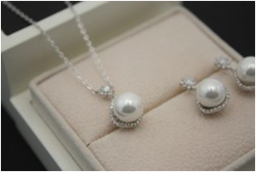 | · |  | · | wedding ceremony
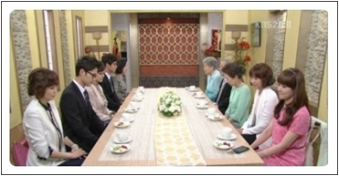 | · |  | · | rings
 | · |  | · | brooms
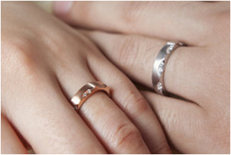  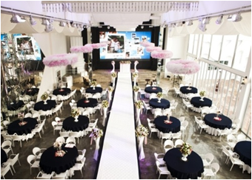     | · |  | · | bride
 | · |  | · | honeymoon
 | · |  | · | new family meeting
 | · |  | · | Jewels

2. Role-play activity
- Talking as each person devided with 2 groups within 5 miniutes
- Second group- Groom’s side
groom's  father | He thinks nothing to need son's marriage
groom's  father | He doesn't want to buy a house for his son
groom's  father | He wants to live his son together after son's marriage
groom's  father | He wants to get his grand-son ASAP
groom's  mother | She thinks something to need son's marriage
groom's  mother | She doesn't want to buy a house for his son
groom's  mother | She wants to live his son together after son's marriage
groom's  mother | She worrys about bride's age to get her grand-son
groom | 33years old groom no money and wants to marry bride ASAP, easily

- Second group- Bride’s side
bride's  elder brother | He thinks nothing to need sister's marriage
bride's  elder brother | He doesn't think that groom need to buy a house
bride's  elder brother | He wants to simple wedding for her sister's (because of his future wedding)
bride's  mother | She wants bride live with groom without groom's parents in new house
bride's  mother | She wants to buy many things for bride not to hear any bad words & get a new house
bride | 37years old bride has some money  and wants to marry groom with a new house without groom's parents

- Debate- activity
- Think and Talk about different wedding cultures with your own group members within 5 miniutes
- Different wedding cultures between Korea and foreign country
 |  | korea | Foreign country
1 | House
2 | Wedding ceremony
3 | The seal of love
4 | Meeting family
5

- Visual aids
Korean wedding culture – “ Dangerous of meeting parents “
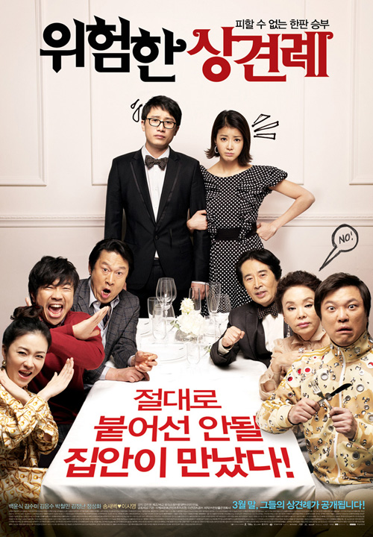
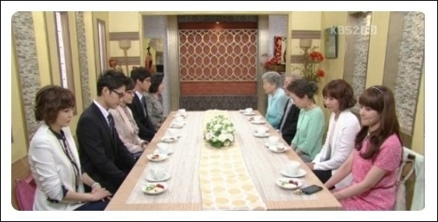
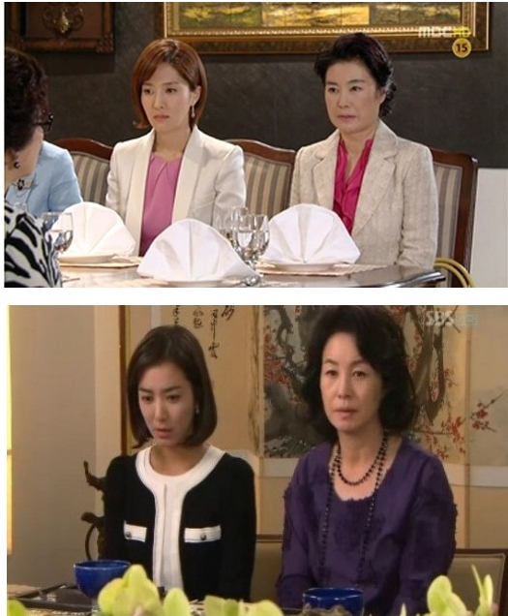
1. Developed wedding industries (parents and korean culture)
: Electronic preparation (bridal for the new house)


- Buy a new House, rings : the seal of love, Jewel sets …(groom for bride)
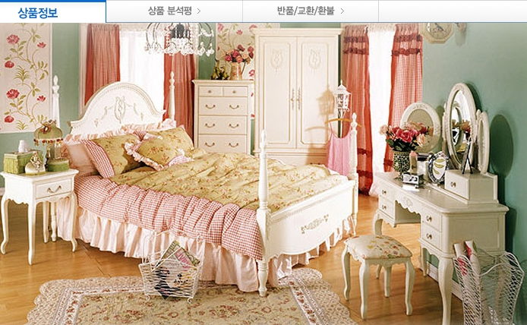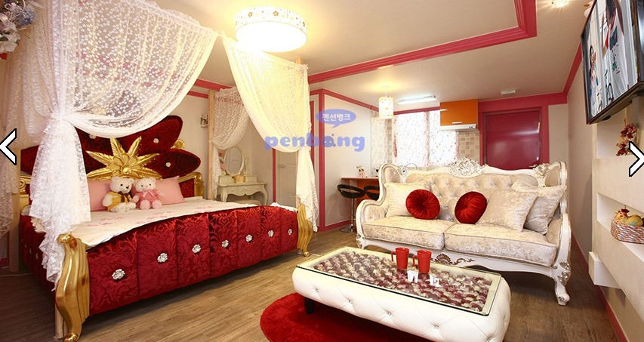



3.Expensive watches (bridal prepare for wedding couple) 
3. Electronic preparation (bridal for the new house)

4. Wedding ceremony, 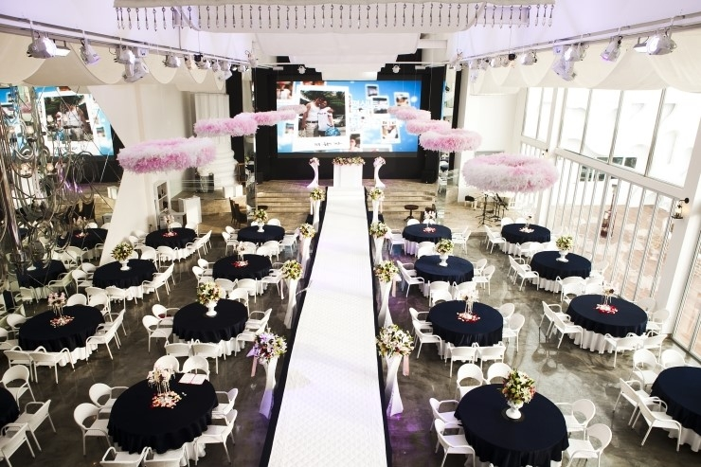
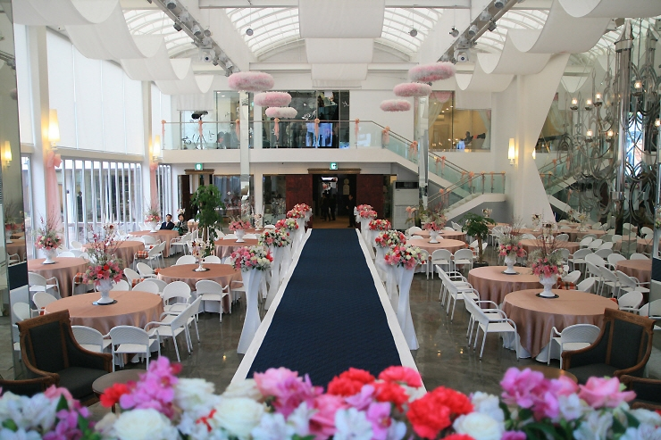
honeymoon




