Listening Speaking Reading Grammar Writing

Topic: Blood Type Predicts Personality?

Instructor:  So, Hyun Hee | Level:  Intermediate | Students:  6 | Length:  30 Minutes

Materials:
- Visual aids
- White board, board markers
- Blood Types with each feature cards
- Matching words worksheets(3 copies)
- The text/worksheet(6 copies)
- Pieces of paper
- Word search Worksheet for SOS activity

Aims:
- Main Aim: Students will know about the story of different blood types and characteristics by reading the text.
- Secondary Aim: Students will improve scanning skill by answering matching questions.
- Personal Aim: I want to improve my time management and speak clearly.

Language Skills:
- Reading: Students will read the text about different blood types and characteristics.
- Listening: Students will listen to teacher’s instruction and classmates’ ideas.
- Speaking: Students will speak to each other their opinions.
- Writing: Students will complete worksheet and write about themselves related to the blood type.

Language Systems:
- Phonology: Correctly pronounce- discern, mediator, compatibility
- Lexis: Vocabularies in the text
- Function: None to discuss
- Grammar: None to discuss
- Discourse: Q&A

Assumptions:
- Students already know: how the class is set up and run.
- Students have some knowledge about the blood types.
- Students know how to skim and scan
- Students have an adequate ability to understand T’s instruction in English and to perform the productive skill activities.

Anticipated Problems and Solutions:
- Ss may not understand the teacher’s instructions clearly.
→ Give instructions as simple as possible. Check their understanding by asking specific concept questions.
- Ss may have troubles in activities.
→ Monitor students and give some demonstrations
- Ss may run into problems completing their pair work because of their proficiency in English.
→ During the pair work, monitor the students’ progress and give them a helpful feedback.
- If students finish their tasks earlier than anticipated.
→ Do SOS activity ready

References:
- Visual aids from Google images
- Word definitions from www.Dictionary.com
- Text from The Korea Times

Lead-In
Materials: None

Time | Set Up | Student Activity | Teacher Talk
1 min | Whole class | Answering teacher’s questions | Hello everyone! How are you today?  - Do you like to talk in front of people?  - If you could describe yourself with any word, what would you be?

Pre-Activity
Materials: Visual Aids, White Board and markers,
Blood Type cards with each feature,
Matching words worksheets(3 copies)

Time | Set Up | Student Activity | Teacher Talk
2 min  1 min  1 min  1 min  1 min  2 min  1 min | Whole class  Whole class  In pairs  Whole class  Whole  class  In pairs  Whole class | Answers elicited  questions  Listen to teacher  Match the blood types with each feature  Speak aloud  Listen to teacher  Do the worksheet  Check the worksheet together | Procedure:  1. Elicit the topic “Blood Types and Characteristics”  (show pictures to the students)  - What can you see in this picture?  - What is she doing?  - Let’s find the common thing of pictures!  Model  Write on the board  ‘blood types and characteristics’  Today, we are going to learn about Blood Types and Characteristics  CCQ  - Is your blood type related to your parents?  - Are you having the same blood type with other people?  2. Matching the Blood Type cards with each feature  Instructions  Here are the personality features ascribed to the basic types: A, B, AB, and O. I need you to work in pairs and match the blood types with each feature. You have 1 minute.  Demonstration  For example, each blood type connects with each feature. Match them.  ICQ  - Are we working individually?  - How much time do you have?  “Now begin”  Monitoring  Monitor discreetly. Answers students  If they ask questions.  Give time warning: 30 seconds.  Be flexible with time.  Give students more time if they need it  “Times up”  “Did you match the blood types with each feature correctly?  “Let’s check.”  3. Matching words worksheets  Instructions  We are going to matching words with meaning. Read each meaning and  find its word  I will hand out the worksheets.  Do it with your partner  You have 2 minutes.  (Distribute the worksheet)  “Please do not start until everyone has a paper”  Demonstration  Look at #1. “to distinguish or discriminate” will be match with “discern”  ICQ  - Are we working individually?  - How much time do you have?  - What are you going to do?  “Now begin”  Monitoring  Monitor discreetly. Answers students  If they ask questions.  Give time warning:  1 minute, 30 seconds.  Be flexible with time.  Give students more time if they need it  “Times up”  “Let’s check the answer.”

Main Activity
Materials: The text/worksheet(6 copies)
Pieces of paper

Time | Set Up | Student Activity | Teacher Talk
2 min  2 min  1 min  6 min | Whole class  Individually  Whole class  In pairs | Listen to teacher  Read the text  Listen to teacher  Answering by write the answers on a piece of paper | Procedure:  1. Read the text  Instructions  Now I will give you the text about different blood types and characteristics. You have some knowledge about the blood types. First, please read it carefully. You have 2 minutes to read it.  Keep in mind that you’ve learned about the vocabularies.  ICQ  - So what are you going to do first?  - How much time do you have for read the text?  “Now begin”  Monitoring  Monitor discreetly. Answers student  If they ask questions.  Give time warning:  1 minute, 30 seconds.  Be flexible with time.  Give students 1 more minute if they need it  “Times up”  2. Do scanning activity  Instructions  It’s a group work. Write the answers on a piece of paper. The team who has the most correct answer will be the winner.  Now I will check for the details.  Are you guys ready?  Ok, Listen carefully.  Demonstration  For example, “What are the four basic blood types?  And you can say “A, B, AB, and O.” “Do you have any questions?”  ICQ  - So what are you going to do?  - How much time do you have?  (Give the students questions and check their answers.)  Good job, guys.  _______‘re the winner.

Post Activity
Materials: Pieces of paper

Time | Set Up | Student Activity | Teacher Talk
2 min  3 min  4 min | Whole class  Individually  Whole class | Listen to teacher  Write about yourself related to the blood types  Talk to each other | Procedure:  1. Write about yourself  Instruction  Do you believe in blood type personality theory? Believe it or not, I hope no one to feel depressed or disappointed with this theory. It would be great if you make up your own great personality, not fitting your characteristic into this theory.  Now, write about yourself related to the blood types.  Any experiences will be fine.  You have 3 minutes.  Demonstration  For my personal experiences, I can get bored easily.  So, I like to do more creative things. Can you guess my blood type? Yes, It’s B!  ICQ  - So what are we doing?  - How much time do we have?  “ Now begin”  Monitoring  Monitor actively and participate within each group.  Answer students if they ask questions.  Be flexible with time.  “Times up”  Share students’ opinions.  2. Conclude lesson  What do we talk about today?  (Do error correction if they have.)  Good job today.  Thank you for your participation.  See you next class!
SOS Activities
Materials: Word search Worksheet

Time | Set Up | Student Activity | Teacher Talk
2 min  3 min  1 min | Whole class  Individually  Whole class | Listen to teacher  Do the worksheet  Check the words | Word search  Instruction  Now, I will give you guys a word search worksheet. Find all the adverbs frequency listed below within the worksheet.  Work individually.  You have 3 minutes.  Demonstration  For example, there are 8 words which describe personalities. So  try to find them.  ICQ  - What are we doing?  - Are you working in groups?  - How much time do you have?  “Now begin”  Monitoring  Monitor discreetly.  Answer students if they ask questions.  Give time warning:  1 minute, 30 seconds.  Be flexible with time.  Give studentsv30 more seconds  if they need it.  “Time’s up”  “Good job!”

Visual aids
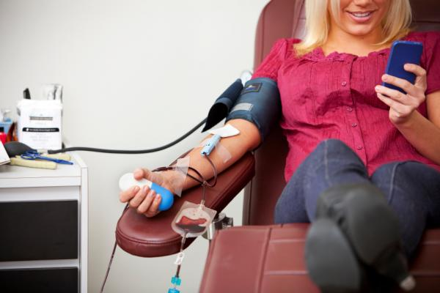

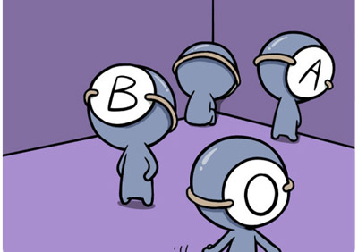

introvert & shy, cautious, mild-mannered, perfectionist, trusting
Blood Type A

Blood Type B

optimist & fearless, easygoing, creative, independent, sociable

Blood Type AB

rational, unpredictable, observant, passionate, friendly, empathic

Blood Type O

extrovert & friendly, calm, patient, strong-willed, self-confident

Before you Read

★ Read each meaning and find its word.

1. ______________________________________ : (verb) to distinguish or discriminate

2. ______________________________________ : (verb) to turn inward

3. ______________________________________ : (verb) be fond of; be attached to

4. ______________________________________ : (adj) not patient; not accepting delay

5. ______________________________________ : (verb) to make agree of correspond; adapt

6. ______________________________________ : (noun) a person who mediates, especially between parties at variance

7. ______________________________________ : (adj) interested in and responsive to others; friendly; sociable

8. ______________________________________ : (adj) excessive, especially extremely so.

9. ______________________________________ : (noun) silly or worthless talk, writing, ideas, etc.

10. ______________________________________: (noun) able to exist together with something else

outgoing introvert accord obsessive compatibility
discern hooey hold dear mediator impatient

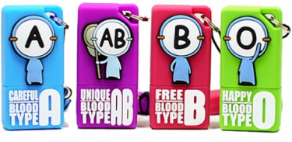
Blood Type Predicts Personality?

Forget the age-old question men and women in North America ask each other in bars: What’s your sign? Try this instead: What’s your blood type? For years South Koreans and the Japanese have believed that a person’s personality can be fully discerned by just knowing his or her blood type without any scientific backing. Here are the personality characteristics for each blood type:

Type-A people are farmers. They are shy, introverted perfectionists. They are considerate to others and cannot tell a lie easily. They are loyal to friends and coworkers. They can be secretive, though, and don’t often share their feelings. They don’t hold their liquor well.

Type-B people are hunters. They have independent spirits with strong personalities. While they don’t care what others think of them, they are extremely passionate about the things they hold dear. They can be lazy, and quite impatient as a stereotype.

Type-AB people are humanists. They are an unpredictable, distant lot, but tend to use their heads over their hearts. They are both introverted and extroverted, and they are often viewed as having multiple personalities because they shift from one personality to another. They are good with money. They seek accord and so work well as mediators; however, they can be viewed as two-faced.

Type-O people are warriors. They are outgoing, expressive, and passionate. They are highly motivated and natural leaders. Blessed with a strong physical presence, they aren’t afraid to gamble because they are so convinced they will win. They are natural athletes. They tend to be obsessive in their quest for success, and this can make them boring to others.

Linking blood types to personalities, which scientists say is a bunch of hooey, has a long history beginning with a series of articles published in 1927 by Japanese scholar Takeji Furukawa called “They Study of Temperament Through Blood Type,” reports Reuters. In 1971, Japanese writer Masahiko Nomi expanded on these initial ideas and wrote “Understanding Compatibility from Blood Types.” It was a pop culture hit in Japan and South Korea.

★ Word Search
E B S I T G F E C K N X R C
I C E C C W B M E Q H Z E V
Z A L U W C G R L B B I V Q
R P F O X X U E B O V L I S
R G F C T E H R A V O B T J
C Q C K R X R A T I O N A L
A T O X E T Y S C C N S E F
U S N H V R A A I U P B R M
T I F J O O R W D P S E C Q
I M I Z R V B N E L F G X O
O I D D T E W D R S H Y F H
U T E Y N R F U P P U G V V
S P N U I T D M N C D C S K
F O T E J D I M U V W O T E

cautious creative extrovert introvert
optimist rational self-confident unpredictable

