Listening Speaking Reading Grammar Writing
Topic: Conductor vs. Cell phone in audience (1 min news)

Instructor:  Debbie | Level:  Intermediate (Adult) | Students:  8 | Length:  50 Minutes

Materials:
- Pictures
- Audio file to listen (about 1 min -mp3 file)
- Video file from internet
- Computer
- New vocabulary worksheets (8 copies)
- Dictation worksheets (Fill in the blanks -8 copies)
- Discussion question worksheets (8 copies- work in pairs)

Aims:
- To learn vocabulary with authentic materials (news)
- To practice listening for getting used to English structure by listening many times.
- To recognize the sound and understand meaning recognition or decoding by echoing and shadowing.
- To practice where to put accent and stress of English by repeating sentence. (or chunk)
- To increase opportunities to speak

Language Skills:
- Reading: Students will read the discussion question sheet about news.
- Listening: Students will listen to audio file and another students’ speaking
- Speaking: Students will discuss with discussion question sheets.
- Writing: Students will dictate (details) and write the answers for discussion question

Language Systems:
- Phonology: practicing new vocabulary
- Lexis:showstopper/concertgoer/culmination/maestro/interrupt/embarrassing/admonish/patron)
- Function: None to discuss
- Grammar: None to discuss
- Discourse: Group discussion

Assumptions:
- Students already know:
- How the class is set up and run
- How to answer listening questions
- All the students can express their ideas and answer

Anticipated Problems and Solutions:
- Students may not be able to pick up details from the listening
- Chunk the listening to recognize the sound (pause-play-pause-play)
- Students may not understand some vocabularies and idioms.
- Model
- If time is short
- Question discussion worksheet can be homework.
- If there is still time to run.
- Present their answer individually for discussion in front of class to share all together
- Make more discussion topics to get more change to speak.

References:
News from monthly Parkcoach’s from March 2012 (Unit 1)
Video file: http://www.11alive.com/video/1388968359001/1/Conductor-vs-Cell-Phone

Lead-In
Materials: Pictures
Time | Set Up | Student Activity | Teacher Talk
3 min | Whole class | Answering teacher’s questions | Greeting  Eliciting by showing 2 pictures for introduction today’s topic  (Present pictures of New York Philharmonic & Avery Fisher hall)

Pre-Activity
Materials: word worksheet , board, board marker
Time | Set Up | Student Activity | Teacher Talk
5 min  5 min | Whole class  (4 student groups)  Whole class | Check the meaning of the new words  Discuss as a group for answering  Answer question | Distribute word worksheet  Let ss check new word with worksheet as group.  CCQ  If they understand instruction how to work with for worksheet.  Monitor discreetly. Answer students if they ask questions. Give time warning. Be flexible with time. Give 1 more minute if they need it.  Go through the words one by one.  Elicit the meaning of the words from students  Explain the meaning if necessary.  Error correction

Main Activity
Materials: Computer / mp3 file/ dictation worksheet

Time | Set Up | Student Activity | Teacher Talk
2min  10 min  5 min  10 min | Whole Class  Whole class  Individually  Whole Class  Whole class | Pre-Listening  Students will listen and fill in worksheets  Students will answer  Students will answer.  Repeat & shadow by one sentence | [Watching video for general understanding]  Play video file from computer  (Distribute dictation worksheets.)  ICQ  -What are you supposed to do now?  [Listening for details]  Ask ss to fill in worksheets.  Play audio file by one sentence 3~4 times  Check the answers as a whole class.  Error correction  Find out if SS understand the text  Check specific details of this topic by letting them speak about what happened in the topic in order. (take 2~3 volunteers, if there is no one, choose specific student.)  Listen audio file by one sentence and let them repeat.  (Ss can check dictation sheet for reference to repeat but better not to see for sound checking)

Post Activity
Materials: Discussion worksheet,
Time | Set Up | Student Activity | Teacher Talk
10 min | As a group  (4 members) | Read worksheet and discuss as a group | Distribute the worksheet  Divide team into 2 group.  ICQ  -So what are we doing?  - Are we working in groups?  - Are we working individually?  - How much time do you have?  Monitoring  Monitor discreetly, Answer students when they ask questions.  Give time warning: 3 minutes, 1 minute,30 seconds. Be flexible with time. Give students 1 more minute if they need it.
SOS Activities
Materials:
Time | Set Up | Student Activity | Teacher Talk
5 min  5 min | Individually  Whole class | Sum-up and speak 1 min  Repeat | Instruction  1 min speech for sum-up this topic individually.  Check time.  ICQ  -So what are we doing?  - Are we working individually?  -Are we working in group?  -How much we should speak?  Review
Listening Script
Conductor vs. Cell phone in Audience
Thousands of performances by the New York Philharmonic at Avery Fisher Hall and no one can remember such a showstopper as Tuesday night’s.
[Ringing]
You heard it. And so did more than 2,700 stunned concertgoers. Just as conductor, Alan Gilbert, war leading the orchestra through the final movement of Mahler’s “Night”, the culmination of the 82-minute long symphony.
[Ringing]
Identified as the “Marimba” ringtone, right in the front row, the maestro did something he has never done in his entire career: put down his baton and stopped the show.
“And it’s shocking when you do that, because you just don’t expect the natural flow of the music to be interrupted. So I said I know it’s embarrassing, to turn it off, you’re going to have to admit that you, that it’s your phone. Just do it so we can get back to the music.”
“Please remember to silent your phones.”
The voice of Alec Baldwin admonishes Philharmonic patrons to silence their cell phones. While the 30 Rock star didn’t take his own advice aboard American Airlines, frequent concertgoers and the conductor wish they would.

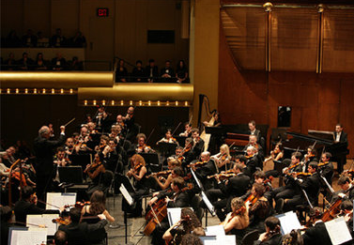
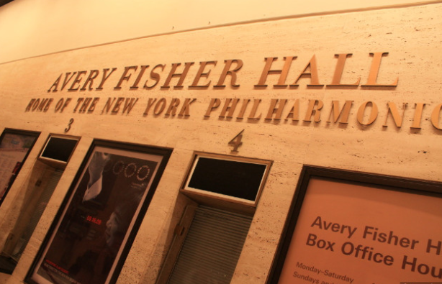

<WORD WORKSHEETS>
- Showstopper
- Concertgoer
- Culmination
- Maestro
- Interrupt
- Embarrassing
- Admonish
- Patron

<DICTATION WORKSHEETS>
- _____________/______ the New York Philharmonic/ ___Avery Fisher Hall / and ____________/____ showstopper / ___ Tuesday night’s.
- You ______ ___. And _____________concertgoers.
- __________ conductor, Alan Gilberts, / was ____________/____________ through the final movement / ____Mahler’s “Night”./______________/ of the 82-minute long symphony.
- _________ ____/ the “Marimba” ringtone,/ ____ __ ____ _____ ___,/ the maestro did something he has ever done in _____ ______ ________.
- Put down his baton and _________ _____ ________.
- “And _____________./ when you do that/ because you just ________/_________/___________________.
- So I said/ I know/_________/ ______________. you’re _______________that you/that it’s your phone.
- Just do it./ so _________________.
- “Please remember/____________/your phones.”
- ________Alec Baldwin/ _______________/________American Airlines,/ _______ concertgoers and the conductor __________/__________.

<DISCUSSION QUESTION WORKSHEETS>
- Have you ever been to a concert or movie like this? Did you enjoy it?
- What would you have done if you were the conductor ? Would you have ignored it or stopped the concert? Why?
- What would you have done if you were the owner of the phone?
- Has your phone ever rung when it was supposed to be off? When? What did you do??

