Listening Speaking Reading Grammar Writing

Topic: Tour guide for foreign friend

Instructor:  Debbie | Level:  Intermediate/Adult | Students:  7 | Length:  50 Minutes

Materials:
- Pictures of food, place, culture
- Free task question worksheets
- White board, board markers
- Time schedule worksheet
- Board, Board markers

Aims:
- Main Aim: To encourage students to speak and involve in the class.
- Secondary Aim: To talk about their ideas and suggestion related to the topic.
- Personal Aim: I want to improve my teaching skills and time management.

Language Skills:
- Reading: None to discuss.
- Listening: Students will listen to teacher’s instruction and other students’ ideas.
- Speaking: Students will have time to speak about planning as a one-day tour guide with partner.
- Writing: Students will write time schedule worksheet for presentation.

Language Systems:
- Phonology: None to discuss
- Lexis: None to discuss
- Function: asking other’s opinion, giving ideas, hypothesizing
- Grammar: None to discuss
- Discourse: Discussing and setting up schedule.

Assumptions:
- Ss have all their experience travel in the country.
- Ss have good communication skills; therefore they would be able to interact with each other for pair work.
- Ss have an adequate ability to understand T’s instructions in English and to perform the productive skill activities.

Anticipated Problems and Solutions:
- Ss may not understand the teacher’s instructions clearly.
→ Give instructions as simple as possible. Check their understanding by asking specific concept questions.
- Ss may run into problems completing their pair work because of their proficiency in English.
→ During the pair work, monitor the students progress and give them a helpful feedback (word, sentence, structure).
- When time is not enough,
→ Make a presentation with volunteer group.
- When there is still time to run,
→ Do another activities (SOS)
- Ss may not understand the teacher’s instructions clearly.
→ If I forget to bring materials such as pictures, worksheets,
- I can find photos from internet and I can just give them papers for time schedule and give more instruction for preparing presentation.

References:
- Visual aids from Google images

Pre-task
Materials: Visual aid (pictures)
Time | Set Up | Student Activity | Teacher Talk
2 min  4min | Whole class  Group  (3-4) | Answer teacher’s  Questions  (If no volunteer, ask specific Ss to answer)  Discuss as a group with pictures | Greeting  -Show picture 1 (Place of Korea) to student and ask questions.(Eliciting)  Give them picture2 (Korean food) ,3 (Korean culture) to students after making group. Make them have a little discussion about the pictures for 4 minutes.  “Times up”  Ask them a question to take a guess of what topic we are going to have today.

Task Preparation
Materials: Preparation question worksheets/ Board/ Board marker
Time | Set Up | Student Activity | Teacher Talk
7 min  5 min  20 min | In Pairs  (2-2-3)  Whole class  In pairs  (2-2-3) | Discuss with partner  Students share the opinions | Free Talking  [Distribute worksheet]  Instructions  We are going to talk about your own personal ideas about traveling Korea.  Based on your personal experience,  I want you to talk freely with 4 questions. Do it with your partner.  You have 7 minutes and then let’s share the opinions.  ICQ  - Are we working individually?  - How much time do you have?  - What are you going to do?  Monitoring  Monitor discreetly. Answers students  if they ask questions.  Give time warning:  1 minute, 30 seconds.  Be flexible with time.  Give students more time if they need it  “Times up”  Ask students to present their opinions.  <Introduction of task>  Write on the board “Plan as an one day tour guide”  [Back ground information]  My foreign friend will come to Korea.  His name is Ali. He is Moroccan-French.  It is his first time to travel abroad.  Unfortunately, I am not available to travel together due to work.  So you will be one-day tour guide.  He is not really good at English.  He can speak French, Arabic perfectly.  He is interested in Korean culture.  How can you give him a memorable trip as a one day tour guide?  I will give you a time schedule table and make your own plan with your partner. .  I will give 20 minutes to discuss.  You will make a presentation based on time schedule.  [Distribute time schedule]  ICQ  - So what are you going to do?  - Are you working alone?  - How much time do you have?  “Now begin”  Monitoring  Monitor discreetly. Answers student  if they ask questions.  Give time warning:  1 minute, 30 seconds.  Be flexible with time.  Give students 1 more minute if they need it  “Times up”

Task-Realization
Materials: Presentation with time schedule worksheet
Time | Set Up | Student Activity | Teacher Talk
10 min | Whole class  (2-2-3) | Make a presentation by each group | Instructions  Let’s share your plan.

Post Task
Materials: Board and a board marker
Time | Set Up | Student Activity | Teacher Talk
2 min | Whole class | Listen to teacher  And vote | Make a vote which plan you want to take.  Instruction  Decide which plan we want to take for Ali.  Conclusion  Today, you talked about how to make a good plan if a foreign friend comes to Korea. And you did a good job as a one-day tour guide. Thank you for sharing your idea.
SOS Activities
Materials: Board, Board Markers
Time | Set Up | Student Activity | Teacher Talk
5min | Group  (2-2-3) | Chat freely | Give the related topic (the best travel in the country) for free conversation to share their experience and give some information for good place and way.

Pre-task / Visual aid (Pictures)
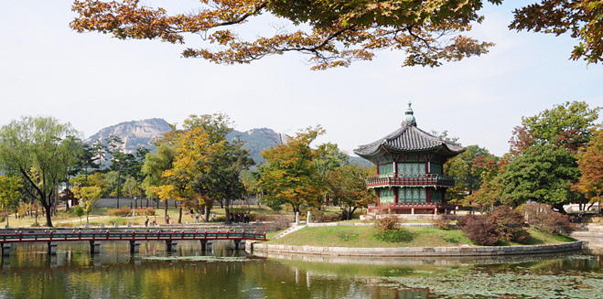
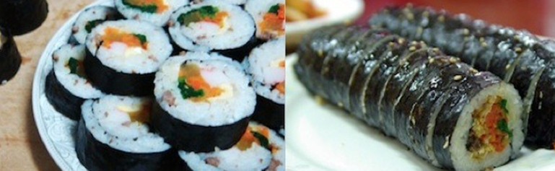
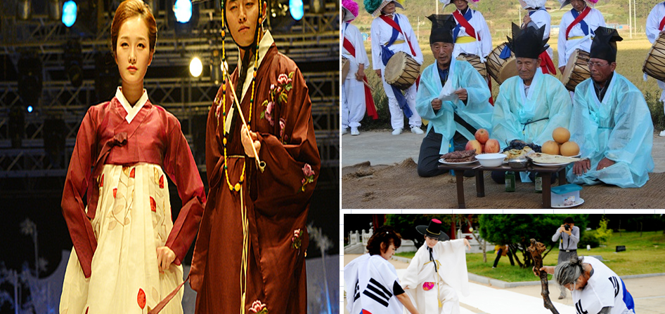
(Pre-Preparation questions- Free talking)

1. Which place is the best in Korea?
Etc) N-seoul tower, Insa-dong, Cheong Gye cheon, Busan, Jeju island.

2. What is the best Korean food?
Etc) Bibimbab, rice cakes in hot sauce(tteokbokki), gimbab

3. What kinds of Korean culture are you proud of?
Etc) Taekwondo, hangul(Korean alphabet), Hanbok (Korean traditional clothes)

4. What would you like to introduce if your foreign friend visit Korea?

Time schedule for Seoul tour
Time | Place | What to do

