|  |
| --- |
| Listening  Speaking ☑Reading  Grammar Writing |
| **Topic: what is your blood type?** |

|  |  |  |  |
| --- | --- | --- | --- |
| Instructor:  **Debbie** | Level:  **Intermediate/Adult** | Students:  **7** | Length:  **50 Minutes** |

|  |
| --- |
| **Materials:**   * Visual aids * White board, board markers * Matching words worksheets(3 copies) * The text/worksheet(7 copies) * Worksheets for activity. (7 copies) * Word search worksheet for SOS activity (7 copies) |

|  |
| --- |
| **Aims:**   * Main Aim: Students will learn about characteristics based on blood type by reading the text and guessing other’s blood type. * Personal Aim: I want to improve my time management and speak clearly. |

|  |
| --- |
| **Language Skills:**   * Reading: Students will read the text & Word worksheet about different blood types and characteristics.   - Listening: Students will listen to teacher’s instruction and classmates’ clues during activity.   * Speaking: Students will speak to each other for their character during activity. * Writing: Students will complete worksheet by guessing other’s the blood type. |

|  |
| --- |
| **Language Systems:**   * Phonology: None to discuss * Lexis: Vocabularies in the text * Function: None to discuss * Grammar: None to discuss * Discourse: Group activity |

|  |
| --- |
| **Assumptions:**   * Students already know: how the class is set up and run. * Students have knowledge about the blood types. * Students have an adequate ability to understand T’s instruction in English and to perform the productive skill activities. |

|  |
| --- |
| **Anticipated Problems and Solutions:**   * Ss may not understand the teacher’s instructions clearly.   → Give instructions as simple as possible. Check their understanding by asking specific concept questions if necessary.   * Ss may have troubles in activities.   →Monitor students and give some demonstrations   * Ss may run into problems completing their pair work because of their proficiency in English.   → During the pair work, monitor the students’ progress and give them a helpful feedback.   * If students finish their tasks earlier than anticipated.   → SOS activity |

|  |
| --- |
| **References:**   * Visual aids from Naver images * Text from http://www.korea4expats.com/article-blood-types.html * SOS activity: http://www.puzzles.ca/wordserch.html |

|  |  |  |  |
| --- | --- | --- | --- |
| **Lead-In** | | | |
| Materials: **Visual aids** | | | |
| Time | Set Up | Student Activity | Teacher Talk |
| 10min | Whole class  In pairs (2-2-2) | Answering teacher’s questions  Talk in pairs.  Answering teacher’s  questions | Greeting  [Ice breaker]  Instruction) We have been studying for 7 weeks already. We got to know each other. I want you to come here and talk in pairs about partner’s character and give some compliments.  (Change partner 2 times/ Teacher also join this activity for making pair work.)  Show visual aids and ask SS question  About the photos (Eliciting)  “What can you see in the picture?”  “If you watch that movie, please explain about it for the point”  “In this movie, Type B guy was shown that sexy, fine and dandy guy. Do you agree?” |

|  |  |  |  |
| --- | --- | --- | --- |
| **Pre-Activity** | | | |
| Materials: **White Board and markers,**  **Word matching worksheet (3piecs)** | | | |
| Time | Set Up | Student Activity | Teacher Talk |
| 10min | Whole class  As a group  (2-2-3) | Answer questions.  Work in a group.  Match the blood types with each personalities  Listen to teacher | **Procedure:**  **1. Write on the board.**  **“Characteristics based on blood types.”**  Today, we are going to learn about Blood Types and Characteristics  Today’s rule: Don’t say your blood type at first time.  Ask SS to answer below questions.   1. Do you believe blood types?   **2. Matching word worksheets.**  [Distribute worksheets]  Instructions  Each blood type will be matched with  Personality.  Work in pairs and match the blood types with each characteristic.  Give 6 minutes.  Monitoring  Monitor discreetly. Answers students  If they ask questions.  Give time warning: 30 seconds.  Be flexible with time.  Give students more time if they need it  “Times up”  Check this answer with main activity  (There will be answered in text worksheets.) |

|  |  |  |  |
| --- | --- | --- | --- |
| **Main Activity** | | | |
| **Materials: The text ( 7copies)** | | | |
| Time | Set Up | Student Activity | Teacher Talk |
| 15min | Individually  Whole class  Whole  Class  (4-3) | Listen to teacher  Read the text  Listen to teacher  Answer.  Discuss topic. | **Procedure:**  **[Distribute text]**  **1. Read the text**  Give Ss 3 minutes to read text.  **2. Check the answer with text for word matching worksheets.**  **3. Free Discussion as a group.**   1. How many people believe blood type theory in your group? 2. If you believe this theory, tell me the reason. 3. What are the different characteristics of people who have type A , B , AB, O blood? |

|  |  |  |  |
| --- | --- | --- | --- |
| **Post Activity** | | | |
| Materials: **Guessing classmate’s blood type worksheets /**  **Board/ Board markers.** | | | |
| Time | Set Up | Student Activity | Teacher Talk |
| 15min | Whole class  Individually  Whole class | Listen to teacher  Speak your own characteristics and work with worksheets. | **Procedure:**  **[Distribute worksheets]**  Instruction  Each person will describe their personality at least three things to the class. You can refer to the text or you can say anything else. Once you listen to classmate’s clues, please guess and write down in your worksheets.  Demonstration  For instance, “ I am very outgoing person. Actually “  And I am flexible. But I am self-centered. Please guess my blood type and write down on the paper.  “ Now begin”  Write down SS name on the board.  Once all students give clues, make Ss to give their blood types.  **2. Conclude lesson**  What do we learn today? |
| **SOS Activities** | | | |
| Materials: **Word search Worksheet** | | | |
| Time | Set Up | Student Activity | Teacher Talk |
| 7 min | Whole class  Individually | Listen to teacher  Do worksheets | **Word search** |

**Visual aids**

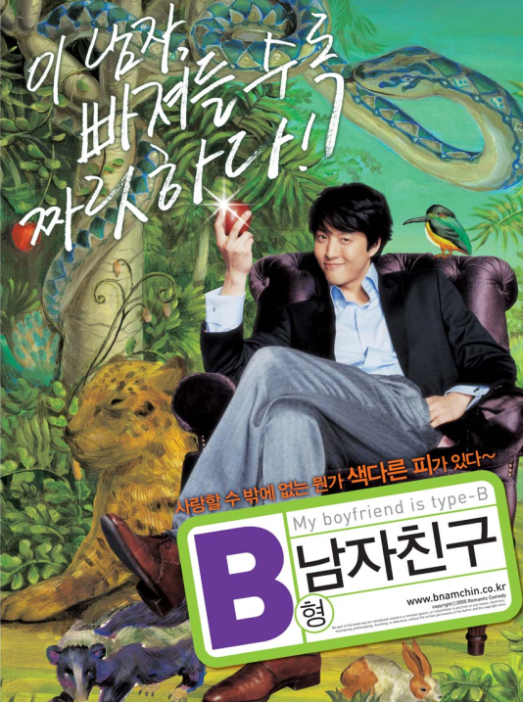

**(Pre-Activity)**

Please guess what blood type will be matched to the listed characteristics.

|  |
| --- |
| The basic blood Types - A, B, AB and O |

1._____________Type :

Positive Traits: Conservative, introverted, reserved, patient, punctual and inclined to be perfectionists.

Worst Traits: Obsessive, stubborn, self conscious and uptight.

2._____________Type :

Best Traits: Cool, controlled, empathic, introverted, rational and friendly.

Worst Traits: Aloof, critical, indecisive and unforgiving.

3._____________Type :

Best Traits: Animal-loving, creative, flexible, individualistic, optimistic and passionate.

Worst Traits: Forgetful, irresponsible and self-centered.

4._____________Type :

Best Traits: Ambitious, athletic, robust and self-confident.

Worst Traits: Arrogant, insensitive, ruthless and vain.

**(Solution: A-AB-B-O)**

**[Main Activity]**

|  |  |
| --- | --- |
|  | **Personalities by Blood Type** |

In Korea, rather than the ubiquitous North American question, “What’s your sign? you are more likely to be asked, “What’s your blood type?” Linking blood types to personalities allegedly goes back to the 1920’s in Japan with the concept being resuscitated in the 1970’s by a Japanese writer, Masahiko Nomi. The idea then spread outward and took root elsewhere, primarily in Taiwan and South Korea.

Following are the personality traits ascribed to the basic blood types: A, B, AB and O.  
  
**Blood Type A:**  
Positive Traits: Conservative, introverted, reserved, patient, punctual and inclined to be perfectionists.  
Worst Traits: Obsessive, stubborn, self conscious and uptight.  
Referred as ‘farmers’ in some descriptions, Type A’s are said to be considerate of others and loyal to a fault. They can also be secretive and reluctant to share their feelings. Apparently they don’t hold their liquor well, either.  
  
**Blood Type B:**  
Best Traits: Animal-loving, creative, flexible, individualistic, optimistic and passionate.  
Worst Traits: Forgetful, irresponsible and self-centered.  
Referred to as ‘hunters’, Type B’s have very independent natures and tend not to be concerned about what other people think of them. Although often described as shallow and lazy, they can be quite passionate about the things they hold dear. Patience is not their strong suit either.  
Type B men have acquired a very negative reputation in Korea and are not considered by many to be good husband material. Often described as ‘players’, they are perceived as being selfish and mercurial, quick to anger and not terribly reliable. That said, their bad boy image makes them very attractive to women, but not for the long term. (Type B women do not share in this bad rep, for some unexplained reason).  
  
**Blood Type AB:**   
Best Traits: Cool, controlled, empathic, introverted and rational.  
Worst Traits: Aloof, critical, indecisive and unforgiving.  
Referred to as ‘humanists’, Type AB’s are said to be controlled more by their heads, than by their hearts. They are rational, good with money, but unpredictable. Although inclined to be distant, they prefer harmony and as such, work well with mediators. Some consider them two-faced, and therefore untrustworthy.  
   
**Blood Type O:**   
Best Traits: Ambitious, athletic, robust and self-confident.  
Worst Traits: Arrogant, insensitive, ruthless and vain.  
Referred to as ‘warriors’, Type O’s are viewed as natural leaders and are often, also, natural athletes. They tend to be outgoing, expressive and passionate, but can also bore others to death with their obsessive drive for success coupled with their absolute convictions that they are winners. This certainty that they will always win explains why they aren’t afraid to take risks or gamble. They have a strong physical presence and are unlikely to ever be overlooked.  
  
Movies have been made dealing with relationships between people of certain blood types and songs have been written, especially about that ‘cad’, the Type B male.   
  
In some countries, one may be asked about one's birth sign; in Korea, you're more likely to be asked about your blood type. It's your choice as to how much credence you give to the question and to the impression you’ll make – one option is to treat it as you would an astrology-related question.  
  
K4E Editor: We try to make the information on Korea4Expats.com as complete and accurate as possible, so if you notice any errors or omissions in the content above, please let us know at [info@korea4expats.com](mailto:info@korea4expats.com).  
  
Photo from the Korean film My Boyfriend is Blood Type B.

**(POST-Activity Worksheets)**

|  |  |  |
| --- | --- | --- |
| Classmate's name | Clues | Blood Type  (Guessing) |
|  |  |  |
|  |  |  |
|  |  |  |
|  |  |  |
|  |  |  |
|  |  |  |
|  |  |  |
|  |  |  |

|  |
| --- |
| **Free Printable Word Search Puzzles** |
|  |
| **Moods & Emotions 1** |
|  |
| Find and circle all of the word that are hidden in the grid. The remaining 12 letters spell an additional word. |
|  |
|  |
|  |
| |  |  |  |  |  |  |  | | --- | --- | --- | --- | --- | --- | --- | | AFRAID AGITATED ANGUISH BLUE BORED CHEERY DARK DOWN DREAD EDGY |  | ELATION FURIOUS GENIAL GLOOMY GROUCHY HELPLESS HOPEFUL HUMILIATED HURT IRKED |  | JADED JOVIAL LONELY LOVE MELLOW MERRY MISERY OFFENDED ORNERY PANIC |  | PEACEFUL PLEASED REMORSE SOMBER SUNNY SYMPATHY UNEASY UPBEAT WEARY | |

|  |
| --- |
| [**Free Printable Word Search Puzzles**](http://www.puzzles.ca/wordsearch.html) |
|  |
| **Moods & Emotions 1** |
|  |
| This is the solution to the puzzle located [here](http://www.puzzles.ca/wordsearch/moods_and_emotions_1.html). |
|  |
|  |

http://www.puzzles.ca/wordsearch.html