TASK BASED LESSON PLAN TEMPLATE
Lesson Plan
Speaking Listening Reading Grammar Writing
Topic: If I were an inventor , I would invent ~

Instructor:  KIM, MINJUNG  (MICHELLE) | Level:  Pre-intermediate | Students:  7 | Length:  50 minutes

Materials:
- White board, board markers
- Vocabulary activities worksheet ( 7 copies)
- Pictures and vocabulary cards related to the topic

Aims:
- Ss will be able to share their idea when they work in group
- Ss will be able to learn vocabularies and expressions related to pictures through group work and expression worksheet
- Ss will be able to practice speaking through group discussions and pair work

Language Skills:
- Speaking: prediction and comparing answers within groups
- Listening: the teacher’s instruction and students’ conversations
- Reading: reading the text and comprehension questions worksheet
- Writing: completing the worksheet

Language Systems:
- Lexis: key vocabularies by worksheet
- Function: predicting, giving and receiving opinions
- Discourse: expressing opinion, talking about their own idea
- Phonology : pronunciation of vocabulary

Assumptions:
Students already know:
- How the class is set up and run
- All students are able to express their ideas and opinions in English
- Most students know of the vocabulary about today’s topic

Anticipated Errors and Solutions:

- Some students may not know vocabulary words in the conversation
→ Encourage students to guess from context
- Students may need more time to work on vocabulary worksheet
→ If it takes longer than 5 minutes, cut answer-checking short by verbally sharing the answers instead of having students write them on the board.
- If time is short
→ Cut reviewing today’s topic and reduce the number of students sharing their opinions.
- Students may feel uncomfortable and intimated about speaking in front of the class
→ Make communicative, fun atmosphere / play the game

References:

- Jane Fulton Sure + IDEO by Jane Fulton Sure
- Try on course book7 Lesson5 - by EJ Plus

- http://cafe.naver.com/beauda/22304
- http://cafe.naver.com/hanabag/23
- http://blog.naver.com/himyjj?Redirect=Log&logNo=30083467094
- http://cafe.naver.com/sheiszzz/109002
- http://tvdaily.mk.co.kr/read.php3?aid=1355706650435538016
- http://blog.naver.com/ommi2?Redirect=Log&logNo=30104628326
- http://blog.naver.com/kwon0020?Redirect=Log&logNo=40177497564
- http://blog.naver.com/shmom0505?Redirect=Log&logNo=120195466509
- http://blog.naver.com/tk_sniper?Redirect=Log&logNo=40145912419

Lead-In
Materials: Picture, Board and Markers
Time | Set Up | Student Activity | Teacher Talk
5min | Whole  Class | Answering teacher’s  questions | Procedure:  Greeting  Teacher will say hello to the Ss.  Show them some pictures related to the topic

Pre-Activity
Materials: vocabulary activities worksheet and Board
Time | Set Up | Students Activity | Teacher Talk
5min  5min  5min | Whole Class  Whole  class  Individually | Listening &  Speaking  Listening &  Speaking  Reading, writing,  Listening & writing | Procedure:  - Look at the pictures about one’s situation  <Elicitation>  Eliciting the today’s topic from students by the use of pictures.  Questions :  - Does he look happy?  - How can you help him?  - Introduce the topic  Explain the topic  If I were an inventor , I would invent ~  < Introduction >  We can recognize what they need to.  CCQ  What are you supposed to think about?  What do you think about their situation?  Why do you think that, Brian?  What will you invent for them?  (Ss think about the topic & gain their won idea)  Vocabulary activities worksheet  Show them vocabulary worksheet and let the Ss explain the word. Most students already know its name.  - Work individually. Answer the questions based on vocabularies work sheet.  - Check the answer as a class  Check answers: let students write the correct vocabularies on their work sheet  - Go through the vocabularies one by one  - Elicit the meaning from students  - Explain the meaning if necessary

Main Activity
Materials: CD & CD player, Comprehensive questions worksheet, Board

Time | Set Up | Student Activity | Teacher Talk
5min  10min | Groups  Individually | Listening& speaking  Speaking & listening | Procedure:  Instruction  - Speaking their own idea  Make groups of 4 people – Group activity  (Hand out the pictures)  - First, pick up a one picture for each person.  - Share the picture story and discuss about what they need to.  - If you were an inventor, what would you invent for them and why?  Get Ss to work together discussing.  Give them 5minutes.  ICQ  - What are you doing?  - Are you working in a group?  - How much time do you have?  Monitor discreetly the groups while they are doing the speaking activity. Set a time limit to10 minutes but give more time when they need more.  - Speaking their own idea - detail  Instructions  Each person will present their idea to the class using with their picture and vocabulary card.  ICQ  How much time do you have?  Are you working alone?  Monitor discreetly each student while they are doing the speaking activity. Set a time limit (1 minutes is usually enough, but let it go on longer if they get into it!)

Post Activity
Materials: n/a
Time | Set Up | Student Activity | Teacher Talk
5 min  5min | Groups  Whole Class | speaking  Listening | Procedure:  Ⅰ. Free Production  Instruction  Imagine If you were an inventor, what would you like to invent? And why?  Discuss with your groups. You have 3 minutes.  ICQ  Are you working in a group?  For how long?  (Monitor actively and participate within each group.)  Share student’s opinions.  Take 2~3 volunteers if running out of time.  Ⅱ. Conclude lesson  Elicit today’s vocabularies for students  Give homework  Write one sentence for each vocabulary you learned today.  Good job today. See you guys tomorrow!  Plan B: Are you feeling sick?  (Make conversations using the examples)  - Illnesses / symptoms  Pretend you are at a medical centre or at a dental clinic. Pair up with a partner and play the roles of a doctor and a patient.  - Pair works  - Fill in the blanks in the sentence with the words from the appropriate columns  - Group work
Vocabulary Activities Worksheet
Draw a line from column A to the name of the appropriate answer in column B.
A | B
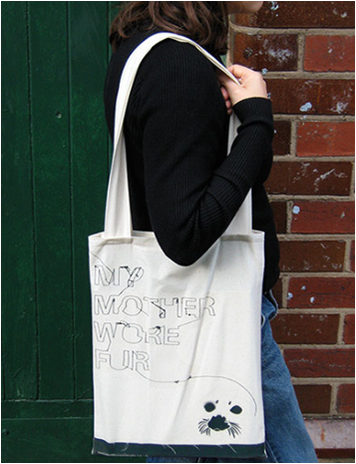 | - A cup holder
 | - Hair pins
 | - Shopping bags
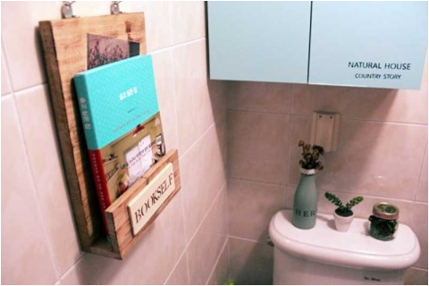 | - A shopping bag
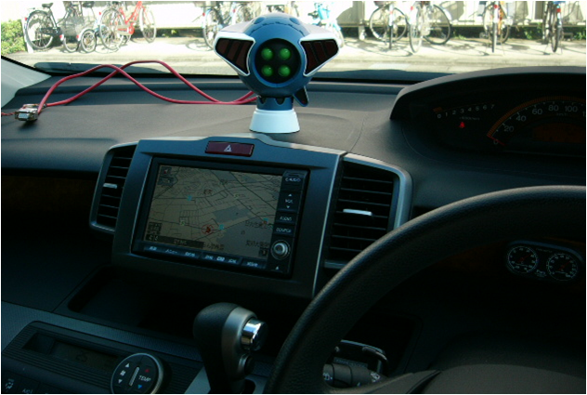 | - Navigation map
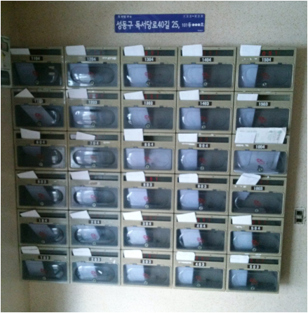 | - Mail Box
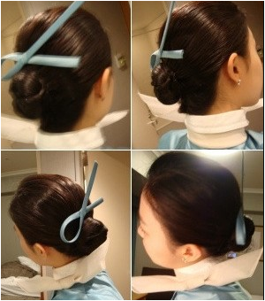 | - A book mark
 | - A book shelf
 | - Post-it
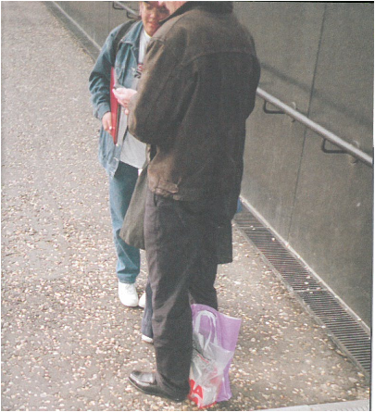
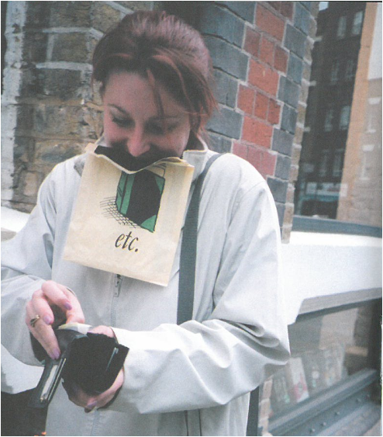
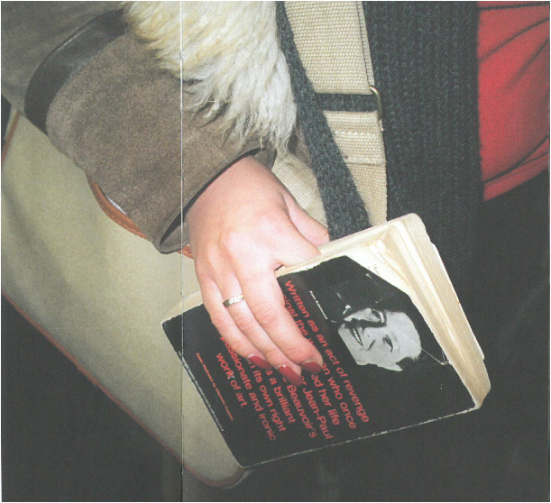
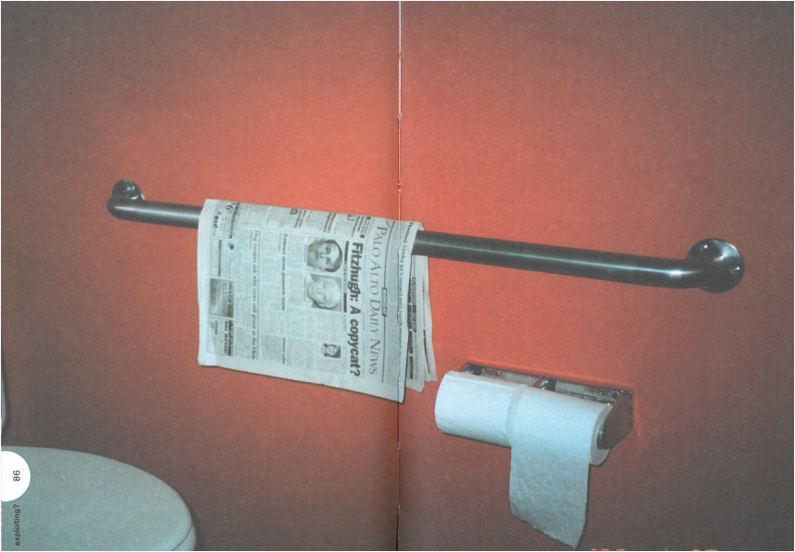
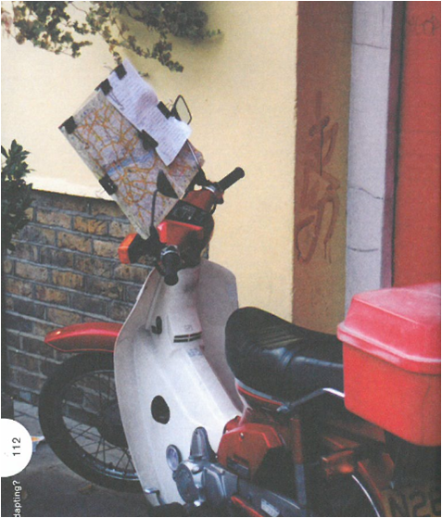
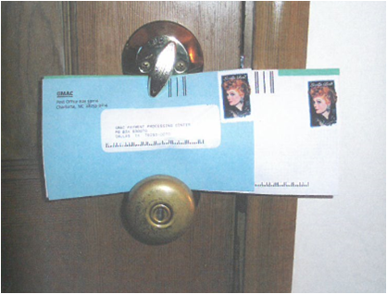
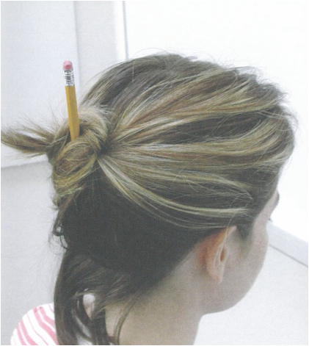
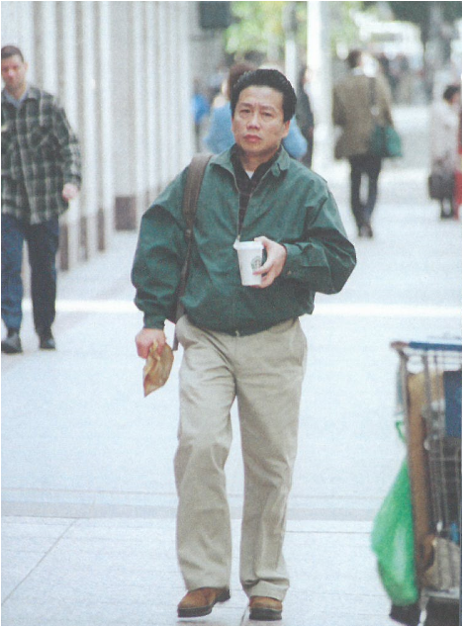
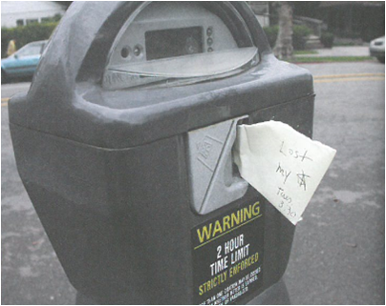

PLAN-B
- Pretend you are at a medical center or at a dental clinic. Pair up with you partner and play the roles of a doctor and patient.
Choose an illness and explain your symptoms to the doctor and let the doctor diagnose your problem. Let the doctor find out what you have by asking questions about your symptoms.
Then reverse the roles with your partner. Make conversation using the example try intensive 10 below.
illnesses | symptoms
1. A common cold (= cold)  2. The flu (= influenza)  3. Allergies  4. A stomach flu  5. An indigestion  6. A migraine headache | - headache, body aches and pain, fever, runny nose, chest congestion, coughing  - high fever (temperature), cold symptoms  - runny/ stuffy nose, congestion, coughing, hives, sneezing  - stomachaches, diarrhea, sometimes accompanied by fever  - sour stomach, stomach pain  - continuous pain in the head (=extreme headache)
- Draw a line from column A to the name of the appropriate doctor in column B.
Then fill in the blanks in the sentence with the words from the appropriate columns.
Someone who ___________________ is called a(n) ____________________.
A | B
- Gives X-rays  - Works with mental  - Delivers babies  - Put braces on teeth  - Treats skin diseases  - Does surgery  - Treats eyes diseases  - Treats animals  - Sees children  - Treats women  - Takes care of teeth  - See whole families  - Fit glasses  - Treats bones and muscles  - See elderly patients  - Specializes on foot problems | - Dermatologist  - Optometrist  - Family practitioner  - Obstetrician  - Dentist  - Psychiatrist  - Gynecologist  - Podiatrist  - Veterinarian  - Pediatrician  - Ophthalmologist  - Radiologist  - Gerontologist  - Orthodontist  - Chiropractor  - Surgeon

