Speaking Lesson Plan

Talking about restaurant problems

Length:

30 minutes

es

Students:

10

Level:

Upper intermediate

Instructor:

Sunny

**Materials:**

* The paper to write their experience. (10 copies)
* The big paper has the dialogue about what happened in the restaurant
* The paper for writing their creating dialogue.
* The different situation cards. (3)
* Visual aid of restaurant and bar (pictures)
* White board and board markers

**Aims:**

* Main aim: Students will improve their speaking skills by having students talk
* about the problem of the restaurant.
* Secondary aim: Students will talk about restaurant problems by having
* students share their own worst dining experience, role paly the bad situation
* at the restaurant and take the speed game related to the famous
* restaurants
* Personal aim: I want to improve time management.

I want to improve on my demonstrations.

**Language Skills:**

* Reading: Students will read the crosswords and the example dialogue before

they do the role-play.

* Listening: Students will be listening to the teacher’s instruction and their

role-play.

* Speaking: Students will talk their about experience and their role-play situation.
* Writing: Students will be writing their own dialogue.

**Language Systems:**

* Lexis: service, overcharge, smoke, order, bill, grill, burn, salty, dessert and so on
* Function: Knowing and explaining restaurant manners and language.
* Discourse : dialogue
* Grammar : want / would like .
* Phonology: None to discuss

**Assumptions:**

Students already know:

* how the class is set up and run
* the teacher’s style of teaching and the pace of the course
* most students have been to a restaurant
* Students had various positive and negative experiences at restaurants

**Anticipated Errors and Solutions:**

* Students may not be able to follow the passage easily

🡪 Follow the task-feedback circle: let them listen to the tracks again until they get the gist of the content

* Students may have not many experiences at the restaurant.

🡪 Let them Imagine that situation or Give them a tip .

* Students may need more time to make their dialogue

🡪 Give the time more to remind that experience.

**References:**

* www. Google . co.kr
* www. Eslflow.co.kr

|  |  |  |
| --- | --- | --- |
| **Lead-In** | | |
| Materials: **Board** | | |
| Time  3 min | Set Up  Whole Class | **Procedure:**  Ask guiding 2 questions to Students  “Hello everyone, How are you today?  “What do you usually do when you meet your friends?”  “What do you usually do on rainy day?” |

|  |  |  |
| --- | --- | --- |
| **Pre-Activity** | | |
| Materials: **Visual Aids(wa bar and vips)**, **Board, paper** | | |
| Time  2 min  5 min  5 min | Set Up  Whole Class  individually  Whole Class | **Procedure: talking the worst dining experience.**  Eliciting  Show the pictures of several restaurants.   * What can you see in this picture? * What idea pops in your head when you see them?   Model “restaurant”  Put a picture on the board  CCQ  Show the pictures of the restaurant and the bar. - Is Wa bar considered to be a restaurant? (No, it isn’t.)  - Is Vips a restaurant? (Yes, it is.)  Demonstration  *“What is your worst dining experience at any restaurant?”*    *For example, my worst dining experience is when I was served bad service by bad waiter at any noodle restaurant. The restaurant is so famous that there are always very crowd. But whenever I go there, the waiter was so unkind. He just threw the cups and spoon down on the table quickly. And he asked what we order with an annoyed look. Even when we finish eating ,he asked us to get out there quickly.*  Instruction  *I’ll give you the paper writing and write them there during 3 minutes individually.*  ICQ  *What you are going to do?*  *How much time do you have?*  *Are you working alone?*  Explicit ICQ  *-please do not start until I passing through all the papers and say begin.*  *- Are you going to start as soon as I give you the paper?*  *- Are you going to start when I say begin?*  (Distribute work sheet)  Okay begin !!    Monitor actively and give time warning.  Answer students if they ask questions.  Be flexible with time. Give 1 more minute if they need it.  “1 more minute! 30 seconds! 10sec.  Ok time is up!  Sharing their expriences.  SS present their exprience ( 3~4 person) |
| **Main Activity** | | |
| Materials: **Board, dialogue script, paper , situation card** | | |
| Time  10 min  10 min | Set Up  Whole Class  In group  Whole Class | **Procedure: make a role-play**  Grouping  What did we talk about before?  ( worst dining experience)  Yes, can you say the worst dining experience in order.  divide 3 groups. And then gather the same team.  Demonstration  I made a bad situation dialogue at any restaurant.  Let’s play the dialogue.  Who wants to be speaker? Come up volunteers.  ( paly the dialogue)  Instructions  Now we will make a role-play with your partners  I will give you worksheet and situation card each group.  ( situation 1 : 2 bad customer , 1 good waiter /  Situation 2 : 2 bad customer, 1 bad waiter /  Situation3 : 1 customer , 1 waiter, 1 manager )  And then I will give you 5 minutes.    ICQ  *What are you going to do?*  *Are you working individually?*  How much time do you have?  Explicit ICQ  - *please do not start until I passing through all the papers and say begin.*  *- Are you going to start as soon as I give you the paper?*  *- Are you going to start when I say begin?*  (Distribute work sheet)  o.k let’s begin !    *Let’s do a role-play.*  *Ss as group come up and present their dialogue.* |

|  |  |  |
| --- | --- | --- |
| **Post-Activity** | | |
| Materials: **Board , speed game card , timer** | | |
| Time  15 min | Set Up  Whole  class  Groups  Whole  class | **Procedure: take the speed game related to the famous restaurants**  Instructions  We are going to do speed game about famous restaurants. Let’s divide 2 groups. . I give 2 minutes each team. At each team , the longest hair person will be explainer. And the shortest hair person help to hold the word card behind the others. The others will answer the gu  Essing word listening the explainer talking.  But when the explainer say about word, we can’t use the prohibition words each word . another team will have to monitor that.  Demonstration  For example, if the helper hold the “ mcdonald”(with the hamburger prohibition), I have to explain that not using the hamburger.  ICQ  *What are you working to?*  Explicit ICQ  Is it o.k we use the prohibition word?  How much time does each team have ?  Run  Monitor discreetly. Answer students if they have questions.  **Conclude lesson**  Error correction  Teacher may note the errors during fluency activities and return to them with accuracy-based activity  If they don’t have any questions , give the unscramble word. (restaurant)  Any question?  *Good job today. See you guys tomorrow!* |

|  |  |  |
| --- | --- | --- |
| **SOS Activity** | | |
| Materials: **crossword big paper .** | | |
| Time  5 min | Set Up  Whole Class  Whole class | **Procedure: crossword activity**  Instructions  I give the crosswords we can solve about restaurant.  I want to do as 2 group. Let’s do the same group before.  The tallest one of each group give the clue about the word.  But if that team don’t answer it in the 10 sec, the other team will get the chance.  Demonstration  ICQ  Are you working in different groups before?  How many time do you have each words?  When the one of your team say the clue, if your team are wrong, then how is it going?  o.k. decide the turn on the game.  Let’s begin !  Monitor discreetly. Answer students if they have questions  Error correction |

|  |  |  |  |
| --- | --- | --- | --- |
| 설명: C:\Bogglesworld Work\111oxford\restaurantmap\restaurantfoodtitle.jpg | | | |
|  | |  | 설명: C:\Bogglesworld Work\111oxford\restaurantmap\restaurant2.jpg  **Down**  **1** A place where people can sit around and drink alcoholic beverages in a restaurant. (3)  **2** A drink that many people have with dessert. (6)  **3** Something you use to cut meat. (5)  **4** Another word for a drink. (8)  **6** The noon meal. (5)  **7** Something you might need to get into a busy restaurant. (11)  **9** Someone who serves you food. (6)  **10** The morning meal. (9)  **12** Something, usually sweet, that you eat after dinner. (7)  **14** The evening meal (6)  **16** The total amount that you have to pay for a meal. (4) |
| **Across**  **2** Someone who makes food in a cheap restaurant. (4)  **4** A meal between breakfast and lunch. (6)  **5** Someone who makes food in an expensive restaurant. (4)  **8** This describes what you can eat at a restaurant. (4)  **11** Something you eat before the main meal. (9)  **12** If everybody pays for their own food then you go __________. (5) | **13** A side dish with lettuce and other vegetables. (5)  **15** What the cook places your food on. (5)  **16** A meal where you help yourself from a table with a variety of dishes. (6)  **17** Long, stringy food. (7)  **18** Something you give your waiter if the service is good. (3) | |

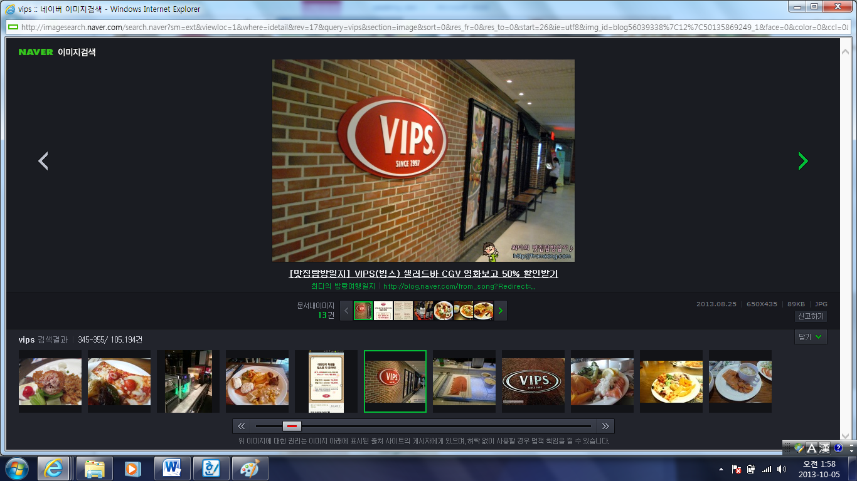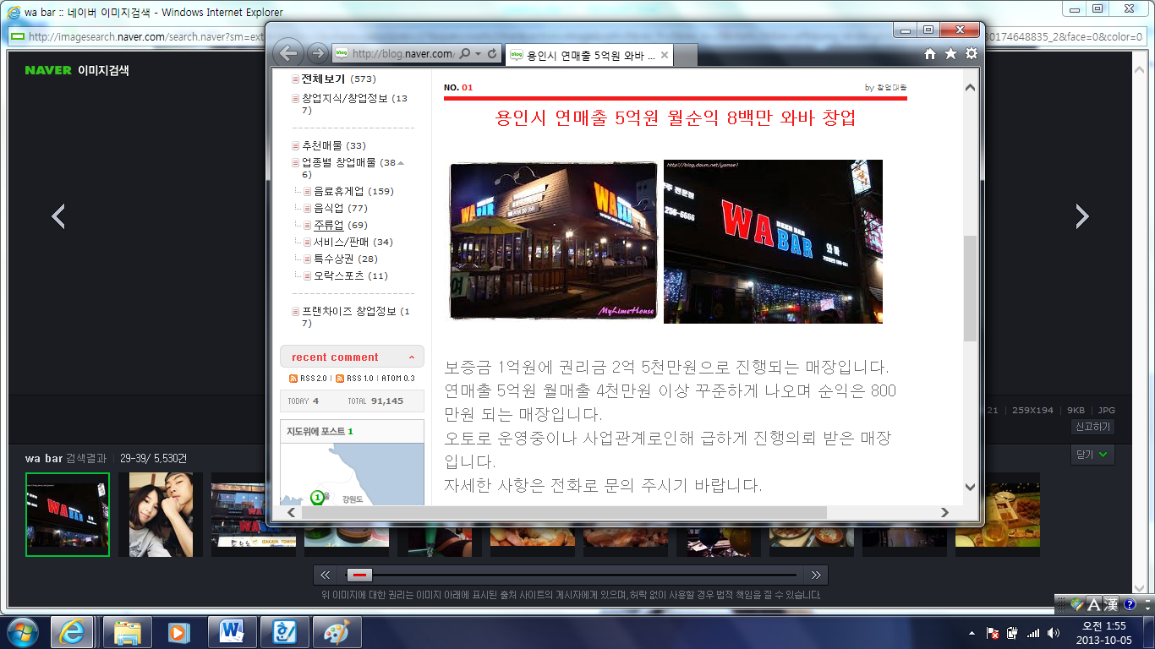

**< situation dialogue >**

**customer**: here, I'd like to order.

**waiter**: ... (busy,busy)

**Customer**: here ,,, I'd like to order.

**waiter**:... what?

**customer**: I would like to eat two noodles.

***waiter****: ....(just frown)*

*(after 5 mins... benig not served yet )*

***customer****: here, why wasn't the food served ?*

***waiter:*** *... what did you order ?*

***customer****: We just ordered two noodles. (a little bit angry)*

*(wait a minutes .. He bring the food . but just throw them down on table. after customer ate the food, they just take a rest. but waiter start to put away the plates.)*

***customer****: we didn't eat all yet.*

***waiter****: I think you are done. another customers waiting there.*

***customer:*** *you are so too much. I won't come here again !!!*