Grammar Lesson Plan
Topic : Countable and Uncountable nouns

Instructor:  Katy (Boram, Kim) | Level:  Pre Intermediate | Students:  12 | Length:  50 minutes

Materials:
- Computer with pictures (PPT)
- 12 copies of worksheet
- Activity paper (role-plays 12 pieces with picture)
- A white board, board markers
- Realia (A bottle of water, fruit, candies )

Aims:
- Students will be able to improve grammar skills by learning countable & uncountable nouns
- Students will be able to make sentences with countable & uncountable nouns and how to use
them correctly in a sentence
-Students will be able to use singular and plural verbs with countable and uncountable nouns

Language Skills:
- Reading: Ss will read worksheet, role play worksheet
- Listening: Ss will listen to teacher’s instruction, role play, others opinions
- Speaking: Ss will speak correctly by using unit for countable & uncountable nouns, finding mistakes, ask questions each other (role play)
- Writing: Ss will answer worksheets (fill in the blank)
Language Systems:
- Grammar: Countable and uncountable nouns
- Lexis: New vocabulary related to unit for the countable and uncountable noun for shopping
- Phonology: Pronunciation of vocabulary
- Discourse: Role play with pairs
- Function: Useful expressions for shopping by counting nouns

Assumptions:
- Students are familiar with teacher’s procedure and style
- Students in the class are interested in grammar lesson
- Students will enjoy the activity and hardworking
- Students know most of vocabulary words related to shopping
- Students can distinguish the deference between countable and uncountable nous

Anticipated Errors and Solutions:
-Students may not be able to follow how to count uncountable nouns
Show the demonstration, wall charts and explain accurately
-Students may need more time to work on activities
Give some hints about activities or give more minutes
-Students may lack of writing a dialogue time
Make post activity shorter and do time management discreetly
-If students finish their tasks earlier than anticipated,
Give students extra questions or make post activity longer or do SOS activity
- Time might be too short to carry out all the activities
Shorten role playor2-3 group present in post-activity

References
http://www.englisch-hilfen.de/en/grammar/nouns_uncountables.htm
https://www.google.co.kr
Role play materials, http://www.onestopenglish.com/
Grammar : Murphy Smalzer, Grammar in use, Cambrige Univ, Press 2010
Pre-task
Materials: Realia, white board, makers
Time | Set Up | Procedure
5min | Whole class | - Greeting students  - Elicit today’s topic  -Elicit “countable and uncountable nouns showing realia to Ss  (Water, candy, fruit, paper : counting )  What am I doing now?  Can we count these? What do we commonly call these words?  -Introduce today’s topic.  CCQ  Did I buy a mandarin? (No)  I bought lots of candies. Did I buy more than one?

Task Preparation
Materials:Computer, worksheet (12 copies)
Time | Set Up | Procedure
5min  3min  3min | Whole class  Individually  Pairs  Whole class | -Show the PPT (with pictures)  -Teacher hands out the countable & uncountable nouns worksheets to students.  -Give Ss 1 minute (Ss put chart down different category)  -Check the answer together  - Explain the rules about today’s unit  (Cannot count liquid, solid, gas, food and sports)  CCQ  - I drink a water, is it right?  - We order a coffee, is it right?  - What do we call these words?  Instructions  When we need to count uncountable nouns, we use the unit like a piece of, bottle of, and so on.  Show Ss the chart (ppt)  Here is unit for the unit uncountable nouns.  You can guess the unit depending on different shapes.  I’ll make pairs. This is Uncountable Nouns Worksheet.  You fill in the blanks in pairs for 2 minutes.  (Distribute the Worksheet)  ICQ  Are you working alone?  How much time do you have?  Give time warning : 1 min  Check the answers  Let’s check the answers. From team 1, come forward and match the answer.  Usually we use these expressions with singular noun. But when we use a bunch of or pair of, we use always plural nouns. Like a pair of socks, a bunch of grapes.

Task Realization
Materials: Computer, worksheet (12 copies)
Time | Set Up | Procedure
10min  2min  3min  6min  6min | Individually  -  Whole class  Individually  Group  Whole class | 1.Making sentences  Instructions  We’re going to do some activities. First I want you to look at the worksheet that I just gave you. Look at the instruction.  “Now, see the shopping list and the picture of what the husband bought. And write the sentences to explain his mistake”(Give Ss an example)  Example> There is much mayonnaise  Make sure that in the case of uncountable nouns, you can only use singular verbs. Use enough, too much, too many, fewer, less, more,,,  (Give Ss 5 minutes)  CCQ  Do you need to write some sentences to explain husband’s mistake?  If Ss are finished, let them check answers with their partners  Teacher check the answers with whole class  2.Role play  -Preparation  Handing out the role paly work sheet (A and B) to students  “Ok, now I hope each of you has a role paly worksheet. Your partner and you must have a different worksheet. One will be A, the wife and the other one will be B, the husband. A wife will complain to the husband about what he bought.  You must not look at each other’s paper and you must write a number next to each food. You have 3 minutes to complete this form. Work individually. When you finish, we will start role-playing”  -Practice  “OK, are you ready to do role paly? Student A, the wife, look at the other student’s paper, which is the husband’s, and compare it with your (wife’s) paper and starts to complain”  Example>  Wife : How much bread did you buy?  Husband : I bought 3 loaves of bread  Wife: There is too much bread!  “You can make sentences using the words in the box from the bottom of your page. You have 6 minutes to do role play. When you finish, change your partner”  CCQ  Are you going to make sentences using the words in the box?  -Performance  Ss show their role plays in front of the class  (If there is not enough time, pick 2-3 pairs to present their role play)  Each team shows role play for 1 minute

Post Task
Materials: Correct sentences, a white board, makers
Time | Set Up | Procedure
5min  2min | Individually  Individually | Instruction  I’ll distribute the worksheet. There are 10 sentences. Correct the underlined part. I’ll give 5minutes individually.  Demonstration  Sarah has a milk. - Sarah has a glass of milk.  ICQ  - Are you working individually or in groups?  - How much time do you have?  Give time warning: 1 min  Presentation  Ask students to answer.  Distribute the answer sheet  Conclude the lesson& Error correction  -Teacher writes expressions on the board that students’ mistakes their role play  -If there are no mistakes, then summarize today’s grammar lesson briefly  -Ss listen and repeat the corrected expression from teacher  - Give Ss homework

SOS Activities
Materials:Drawing paper & colored pencil, crayon
Time | Set Up | Procedure
10  min | Pairs | Instructions  We are going to make a shopping list. Imagine, you prepare your friend’s birthday party. Ten people are invited. So, you have to make a shopping list, and talk about why do you want to buy them. This is a shopping list. Fill in the blanks. I’ll give you 3 minutes. Work in pairs.  (Distribute shopping list)  ICQ  What are you doing?  Are you working in pairs?  How much time do you have?  Give time warning : 1 min  Presentation  Students talk about their shopping list and the reasons for buying.  Conclude lesson  We’ve learned about unit for the uncountable nouns.  Good job everyone.

Uncountable Nouns
Water Milk Tea
Soap Gold Ice
Air Wind Gas
Bread Rice Pizza
Football Baseball Tennis
Solid Gas Food
Liquid Sport

Unit for the Uncountable Nouns
 | a___________ of | coffee / tea
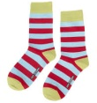 | a___________ of | socks / shoes
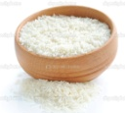 | a___________ of | rice / ice cream
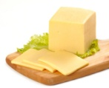 | a___________ of | cheese / pizza
 | a___________ of | water / milk
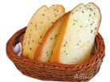 | a___________ of | bread / cake
 | a___________ of | wine / water
 | a___________ of | bananas / grapes
glass pair slice cup
bowlbottle bunch piece

Answer sheet (Uncountable Nouns)
Liquid | Water Milk Tea
Solid | Soap Gold Ice
Gas | Air Wind Gas
Food | Bread Rice Pizza
Sport | Football Baseball Tennis
Solid Gas Food
Liquid Sport

Unit for the Uncountable Nouns
 | acup of | coffee / tea
 | apair of | socks / shoes
 | abowl of | rice / ice cream
 | aslice of | cheese / pizza
 | aglass of | water / milk
 | apiece of | bread / cake
 | abottle of | wine / water
 | abunch of | bananas / grapes
glass pair slice cup
bowlbottle bunch piece

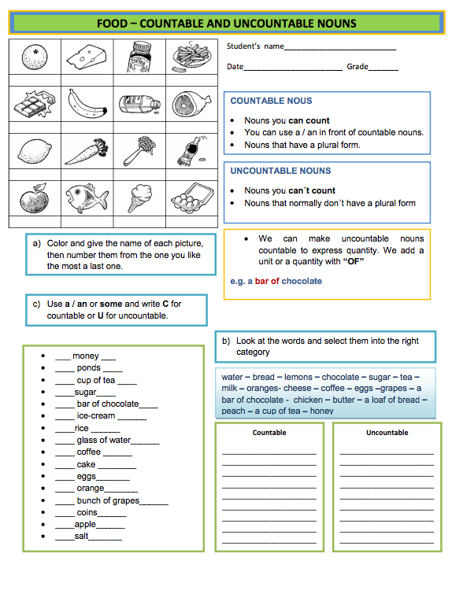
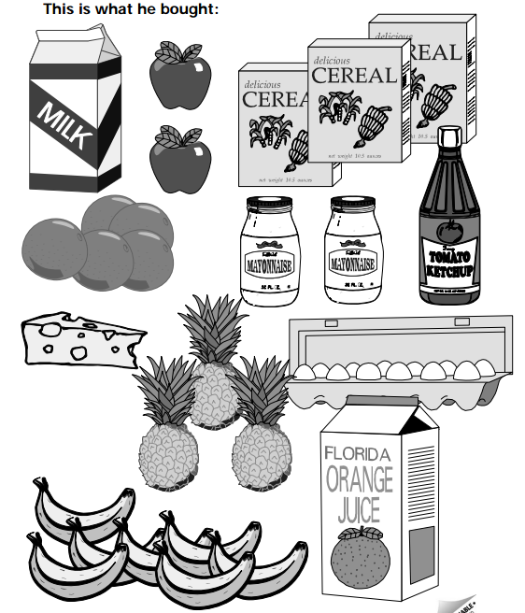

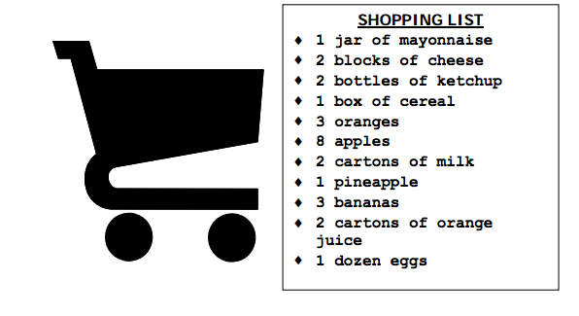
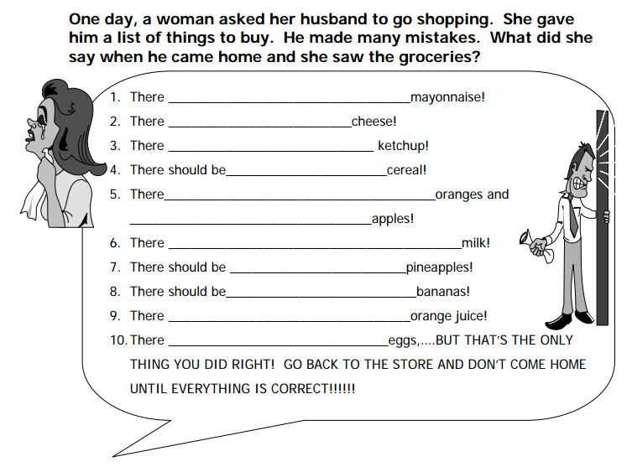

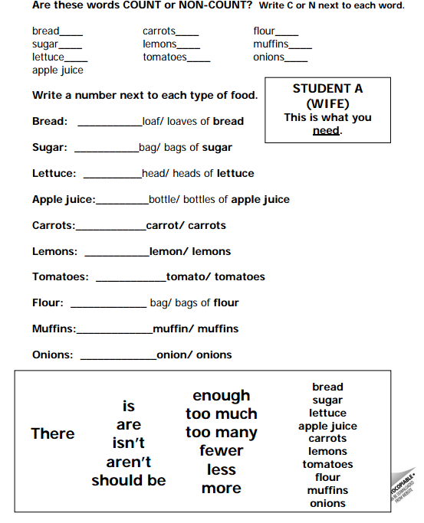
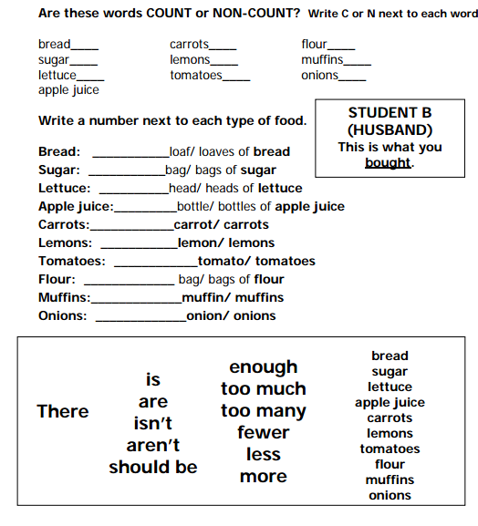

Correct the Sentences

No. | Correct the underlined part
1 | - Sarah has a milk.
2 | - I need two piece of bread.
3 | - Will you have cup of coffee?
4 | - There are five sheep in the field.
5 | - He bought ten cans tuna.
6 | - There are fresh milk in the refrigerator.
7 | - We have to buy a loave of bread.
8 | - I want two glass of juices.
9 | - We’ll buy three bottle of water.
10 | - We need ham and piece of cheese.

Answer sheet

No. | Correct the underlined part
1 | - Sarah has a milk. | a lass of milk.
2 | - I need two piece of bread. | two pieces of bread.
3 | - Will you havecup of coffee? | a cup of coffee?
4 | - There are five bunch of grape. | five bunch of grapes
5 | - He bought ten cans tuna. | ten cans of tuna.
6 | - There are fresh milk in the refrigerator. | There is fresh milk
7 | - We have to buy ten piece of papers. | ten pieces of paper.
8 | - I want two glass of juices. | two glasses of
9 | - We’ll buy three bottle of water. | three bottles of
10 | - We need ham and piece of cheese. | aham and a piece of cheese.

<SOS activity>

Shopping List Worksheet
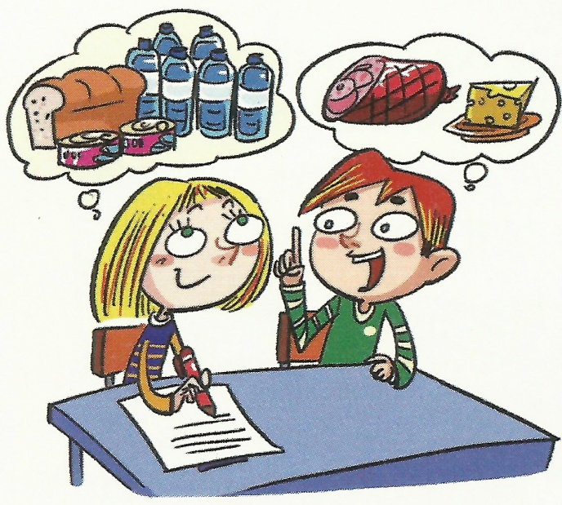
A: Let’s prepare a birthday party. Ten people are invited. This is our shopping list. First, we have to buy a bottle of water. We will also buy…. What else do we need?
B: Well… we need .
Shopping List

