Listening Speaking Reading Grammar Writing

Topic: Oprah Winfrey –Powerful Celebs in 2013

Instructor:  JEAN | Level:  Intermediate(Adult) | Students:  7students | Length:  30 Minutes

Materials:
- Vocabulary & Idiom worksheet (7copies)
- Realia - Some pictures of Oprah Winfrey
- Before listening worksheet –True of False Questions(7copies)
- White board and board markers
- Gap fill worksheet(7copies)
- A piece of paper and a pen(for each group-pairs)
- Listening CD & CD player (tracks 1; about 2minutes)

Aims:
- Main aim: Ss will improve their listening skill by listening to speech of Oprah Winfrey by doing a prediction check list.
- Secondary aim: Ss will learn vocabulary and idioms by doing the definition/synonym matching and true/false activities.
- Personal aim: I want to improve confidence and reduce my commentary to a minimum.

Language Skills:
- Reading: Ss will read an idiom worksheet.
- Listening: Ss will listen to the article, Oprah Winfrey’s short speech about her life.
- Speaking: Ss will predict and compare answers in pairs and in groups.
- Writing: Ss will take notes on details (dictation).

Language Systems:
- Phonology: Vocabularies, idioms.
- Lexis: New vocabulary and idiom used in the article.
(set to, due to, immense, Rags-to-riches, charity, household name, array etc.)
- Function: Greeting, Giving speech about powerful women in the world.
- Grammar: Relative pronoun-Who
- Discourse: Discussion

Assumptions:
Students already know:
  - how the class is set up and run (there will be 2-3students at each table).
  - the teacher’s teaching style and the pace of the course.
  - All students know who Oprah Winfrey is(Age 20 above).
Anticipated Errors and Solutions:
- Students may not be able to understand the article properly.
- Before listening, students will learn new vocabularies in the article.
- If the students can’t complete the gap fill task at the first time.
  - Students will listen to the article again and chunk the listening.
- Students may need more time to work on the worksheet.
  - Give students a little more time to work.
- If students finish their tasks earlier than anticipated,
  - Ask the students about the main idea of the article and what do they think about the person in the article.

References:
- Visual aid( Pictures of Oprah Winfrey on the website) http://www.google.com/imghp?hl=ko
- English definitions from “Naver Dictionary” http://dic.naver.com/
- Listening File http://www.breakingnewenglish.com

Lead-In
Materials: None
Time | Set Up | Student Activity | Teacher Talk
1min | Whole class | Answering teacher’s questions. | Hello everyone! How are you today?  Do you like watching TV?  Who is the most famous celebrity?  Who is the powerful woman in the world?

Pre-Activity
Materials: Board, Board makers, Visual Aid, worksheet #1
Time | Set Up | Student Activity | Teacher Talk
3min  5min  4min | Whole class  Individually  Whole class | Answers elicited questions  Students begin writing down.  Students check answers and learn the idioms . | Procedure:  - Brainstorming  Elicit  (show the students visual aid-picture from google without telling the name.)  Do you know this person?  What is this woman’s job?  What do you know about her?  Model  Write the name “Oprah Winfrey” on the board.  CCQ  Is Oprah Winfrey is a famous singer?  Do you think Oprah Winfrey is the most powerful woman in the world?  - Idioms  Instruction  I’ll give you a worksheet of vocabularies and idioms. Firstly, you carefully read the definition in each rows, and then find the appropriate word from the word box below, and write in the empty box next to the definitions. Work individually. I’ll give you 5 minutes to finish.”  (Distribute the worksheet #1)  “Now please don’t start before I say go”  Demonstration  Look at #1…”right, it means set to…  ICQ  What do you write in the empty box?  Are you working in groups?  Are you working individually?  How much time do you have?  “Now begin”  Monitoring  Monitor discreetly. Answers students if they ask questions.  Give time warning: 3minutes; 1minute; 30 seconds left. Be flexible with time. Give 1 more minute if they need it.  “Time’s up.”  Check answers  Let’s check the answers together.  -Go through the idioms one by one  -Elicit the meaning from students.  -Explain the meaning if necessary.  -Give an example of the idiom if necessary and teach pronunciation.  “You all did a great job”

Main Activity
Materials: CD&CDplyer, Worksheet #2.
Time |  |  | Set Up |  |  | Student Activity |  |  | Teacher Talk
3min  4min  2min |  |  | Pairs  Pairs  Individually  Pairs |  |  | Students guess whether the sentences are true or false.  Prediction  Listening  Students check answers |  |  | - Prediction  “I’ll tell you the name of this listening article.”(write the headline of the article on the board.)  Instruction  I’ll give you another worksheet before listening, we will do some prediction about the article. Just by looking at the headline, guess whether the sentences are true or false. Please do this in pairs. I’ll give you 3 minutes to finish.  (Distribute the worksheet #2)  ICQ  Do you need a partner for doing this worksheet?  Do you do this worksheet before or after listening?  “Ok students, the time is over, Everyone would have different answers for the true/false questions because we didn’t listen to the article yet. You just predicted about Oprah Winfrey. Let’s find out the correct answers after listening.”  - Listening for the main idea.  Instruction  Everyone, put your pens down and listen carefully to the article first. While listening, try to remember the questions in the true/false worksheet.”  ICQ  So what are we doing?  Do you take notes while listening?  (Play the listening CD without pausing or stopping.)  Check answers  “Now, check your True/False worksheet with your partner.”  Check answers with teacher
Post Activity
Materials: CD&CDplyer, worksheet #3
Time | Set Up |  |  |  | Student Activity |  | Teacher Talk
3min  3min  2min | Group  Group  Whole  Class |  |  |  | Students begin discussing about another power woman in entertainment and politics”  Students think about their speech  Students think about their speech  Answers elicited questions of today’s lesson |  | - Free production  - Discussion and speech  Instruction  “Now, we are going to have discussion in two groups. Group A will discuss about “Another powerful woman in entertainment” and group B will discuss about “Another power woman in politics.” In each of group, choose a person to take notes and another person to report to the class. You have about 3 minutes to discuss.”  ICQ  Do you choose one person to take notes?  What will group A discuss about?  What will group B discuss about?  “Now begin”  Monitoring  Monitor discreetly. Answer students if they ask questions.  Feedback  “It’s time to listen to each group’s reporter about their discussions. Please come out to the front and report your results. Speak loudly and clearly. Other students pay attention to the reports.”  - Conclude Lesson  Elicit today’s idioms for students and  do any error correction about grammar  and pronunciation that students often  made mistakes.  “You all did really well today. Please  try to remember the new vocabularies  and idioms that we learnt today.”  “Thank you for your participation and  see you tomorrow!”
SOS Activity
Materials: None are needed
Time |  | Set Up |  | Student Activity |  |  |  | Teacher Talk
3min  4min |  | Individually  Whole class |  | Listening and fill in the gaps  Students check answers read each sentences |  |  |  | - Fill in the gaps.  Instruction  “Now, we are going to listen for the second time. You have to fill the blanks with the right words while listening. Work individually please.”  (Distribute the worksheet #3)  ICQ  Do you fill in the gaps while you listening or after listening?  (Teacher plays the article. Let students to fill the gaps as they listen.)  “Do you need to listen again?”  If yes, Play the article one more time.  Check answer  “I think all of you finished the worksheet. Let’s check the answers together. Please read aloud each sentences slowly and correctly.”  Go through the answers of each sentence one by one.

※ Visual aid
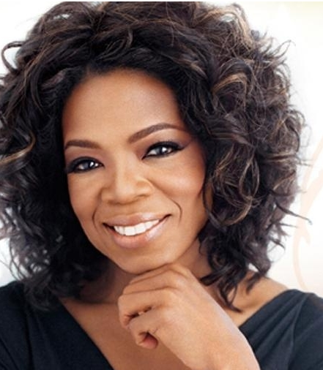

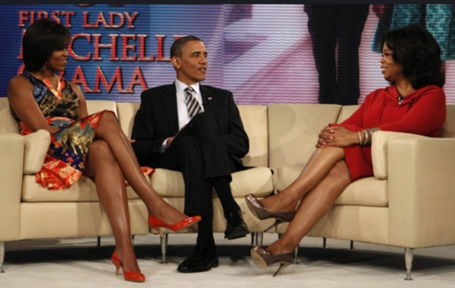
※ Worksheet ＃1
Matching the Definition

Read the definitions and write the appropriate word and idiom from the box.
 | Definition | Word / Idiom
1 | Getting start
2 | The power to make other people agree with your opinions or do what you want.
3 | Someone that is very well known.
4 | If you _____ that something is true, you think that is true.
5 | The amount of money that you gain.
6 | Indicating where they got their information from.
7 | It happens or exists as a direct result of that thing.
8 | An organization which raises money in order to help people who are ill, disabled, or poor.
9 | Different things or people are a large number of a wide range of them.
10 | Refers to any situation in which a person rises from poverty to wealth.
11 | A process in which people vote to choose a person or group of people to hold and official position.
12 | Meaning that is extremely large or great.

set to | profit | array
due to | charity | influence
Rags-to-riches | household name | reckon
chief | immense | according to
※ Worksheet ＃2
Before Reading / Listening

True/False: Look at the article's headline and guess whether these sentences are true(T) of false(F) :

a. | Oprah Winfrey won a competition testing the strength of celebrities. | T / F
b. | Winfrey had an influence on the 2013 US Election. | T / F
c. | Oprah bought Barack Obama over a million votes in the election. | T / F
d. | TIME magazine said Oprah was one of the 20th century’s top people. | T / F
e. | Oprah was born into a very rich family. | T / F
g. | The Oprah Winfrey Show is the most successful show in TV history. | T / F
h. | Oprah may soon be in 70 million living rooms via her own TV network. | T / F

※ Worksheet ＃3 (Gap fill)

Oprah Winfrey
–Powerful Celebs in 2013-
Oprah Winfrey has been named the most powerful woman in _________. This is __________ to the entertainment trade publication The Hollywood Reporter. Her rise to the top may be to the ___________ she had on the US ________ in October 2013. The Hollywood Reporter's chief editor Elizabeth Guider explained: "The _________ to place Oprah at the top of the list was based on her dizzying _______ of Oprah-branded media and her __________ cultural influence," she said. Forbes magazine listed Winfrey as one of the 100 people of the ___________ century. Oprah Winfrey is a _____________ name in many parts of the world. Her __________ life is an incredible success story. She is a ________ woman who became the world’s first black __________ in 2004. Winfrey owns her own production company Harpo (’Oprah’ spelt backwards), which made $345 million in ________ in 2013. She is perhaps most famous for her chat shows. The "Oprah Winfrey Show" began in 1986 and has been one of the world’s most-watched programs ever since. Winfrey's entertainment _________covers TV, magazines, book clubs and online shopping. She is also extremely well known for her _______ work. She is set to launch her own TV channel, OWN (Oprah Winfrey Network), which will reach 70 million homes.

※ Worksheet ＃3 (Gap fill) - SCRIPTS
Oprah Winfrey - Powerful Celebs in 2013-
Oprah Winfrey has been named the most powerful woman in entertainment. This is according to the entertainment trade publication The Hollywood Reporter. Her rise to the top may be due to the influence she had on the US Election in October 2013. Analysts reckon her support of Barack Obama brought him over one million votes. The Hollywood Reporter's chief editor Elizabeth Guider explained: "The decision to place Oprah at the top of the list was based on her dizzying array of Oprah-branded media and her immense cultural influence," she said. Forbes magazine listed Winfrey as one of the 100 people of the twentieth century. Oprah Winfrey is a household name in many parts of the world. Her rags-to-riches life is an incredible success story. She is a self-made woman who became the world’s first black billionaire in 2004. Winfrey owns her own production company Harpo (’Oprah’ spelt backwards), which made $345 million in profit in 2013. She is perhaps most famous for her chat shows. The "Oprah Winfrey Show" began in 1986 and has been one of the world’s most-watched programmes ever since. Winfrey's entertainment empire covers TV, magazines, book clubs and online shopping. She is also extremely well known for her charity work. She is set to launch her own TV channel, OWN (Oprah Winfrey Network), which will reach 70 million homes.

