**Presentation, Practice, Production Lesson Plan**

|  |  |  |  |
| --- | --- | --- | --- |
| Listening  Speaking  Reading  Grammar  Writing | | | |
| **Topic: My Feelings** | | | |
| Instructor:  Jenny Kim | **Students Age – Competency Level**  **8 years old** | **Number of Students:**  **6** | **Lesson Length:**  **50min** |
| Materials:   * Feeling Flash Cards (12 pictures)   (Happy, Sleepy, Thirsty, Hungry, Shy, Hot, Sick, Angry, Tired, In-Love, Cold , Sad)   * Feeling Match Worksheet * Blindfold Feeling Words * Crayon * Bingo Game Sheets | | | |
| Aims: **(What students will be able to achieve by participating in the activities of the lesson.)**  Ss get comfortable and interested in lesson by T presentation and attitude.  Ss will improve listening, writing, and speaking skills by making their storybook, responding to teacher and sharing their feelings in class. | | | |
| Language Skills: **(Lists what language skills students will be using by participating in the activities of the lesson.)**   * Reading: Reading flash cards, the worksheet * Listening: listening the words to the teacher, to their friends the presentation * Speaking: sharing the their feeling answering, and storybook * Writing: writing their story using target words | | | |
| Assumptions: **(What students must already be able to do and what concepts must already be mastered before the lesson in order to achieve the aims of the lesson.)**  Ss will enjoy and also have fun  Ss already know how to play bingo games. | | | |
| Anticipated Errors and Solutions: **(What things might go wrong in the lesson and what the solution will be)**  If students finish their tasks earlier than anticipated 🡪 ask as many students as possible about their feeling  Ss have difficulty writing their story, teacher can give some hints, give some suggestions. | | | |
| References:  www. mes-english.com | | | |

|  |  |  |  |
| --- | --- | --- | --- |
| **Lead-In (Warm-Up Part to activate and create interest in the lesson) 13min** | | | |
| Materials:  Blank paper | | | |
| **Time:** | **Classroom Set Up:** | **Student Activity and Goals:** | **Teacher Procedure Instructions:** |
| 1  2  4  4  2 | Whole class  S  S  S | Greet teacher  Ss listen- become interested  Ss respond    Ss draw a picture  Sharing their friends | Greet students  T shows teacher’ feeling today  Ask Ss about their feeling  Hands out paper. T asks Ss to draw a picture of their face (how you are feeling today)  T asks Ss to share. “How are you feeling today?” |

|  |  |  |  |
| --- | --- | --- | --- |
| **Pre-Activity (Presentation Part Presenting the language structure to be covered in the lesson) 12 min** | | | |
| Materials:  Feeling flash cards (12 pictures)  Feeling match worksheet | | | |
| **Time:** | **Classroom Set Up:** | **Student Activity and Goals:** | **Teacher Procedure Instructions:** |
| 4  5  3 | Whole class  S  S | Ss see the pictures and listen  Ss read and write adjective words  Ss speak using adjective words | * Learn about vocabulary   T shows flash cards and demonstrates what feeling is.  Examples:   * happy // H A P P Y   Handout the worksheet, practicing the feeling adjective words.  T demonstrates first.   * Example: He feels happy   Ask Ss to connect the pictures to the words and then trace the words.  T asks Ss to share. |

|  |  |  |  |
| --- | --- | --- | --- |
| **Main Activity (Practice to Production Part Teacher lead practice of the language presented) 15 min** | | | |
| Materials:  Blank paper  Blindfold Feeling Words  Crayon | | | |
| **Time:** | **Classroom Set Up:** | **Student Activity and Goals:** | **Teacher Procedure Instructions:** |
| 10  5 | S  S | Ss listen  Ss write their story and draw pictures.  Ss present their story | * Making storybook   Hands out blank paper.  T divides team and T ask Ss to pick 3 blindfold words  T asks Ss to make storybook using target words with drawing  Ss share their story |

|  |  |  |  |
| --- | --- | --- | --- |
| **Post Activity (Wrap-Up Part Close the Lesson on a high note to consolidate language learned) 10min** | | | |
| Materials:  Bingo Game Sheets (4X4) | | | |
| **Time:** | **Classroom Set Up:** | **Student Activity and Goals:** | **Teacher Procedure Instructions:** |
| 10 | S  Whole | Ss listen the T’s direction  Ss write words and play the bingo game  Ss say goodbye | * Playing Bingo games   T asks Ss to write down the words of feelings in each box of blank. Each S call out the words. Whoever finishes the two lines will be the winner.  Congratulate and thank Ss for active participation |

Feelings Flash Cards

|  |  |
| --- | --- |
| Happy | Angry |
| Sleepy | Tired |
| Thirsty | Hungry |
| Shy | In-Love |
| Hot | Cold |
| Sick | Sad |

Blindfolded Words

|  |  |  |  |  |  |  |  |  |  |  |  |
| --- | --- | --- | --- | --- | --- | --- | --- | --- | --- | --- | --- |
| Happy | Sleepy | Thirsty | Hungry | Shy | Hot | Sick, | Angry | Tired | In-Love | Cold | Sad |

Feeling Matching Worksheet

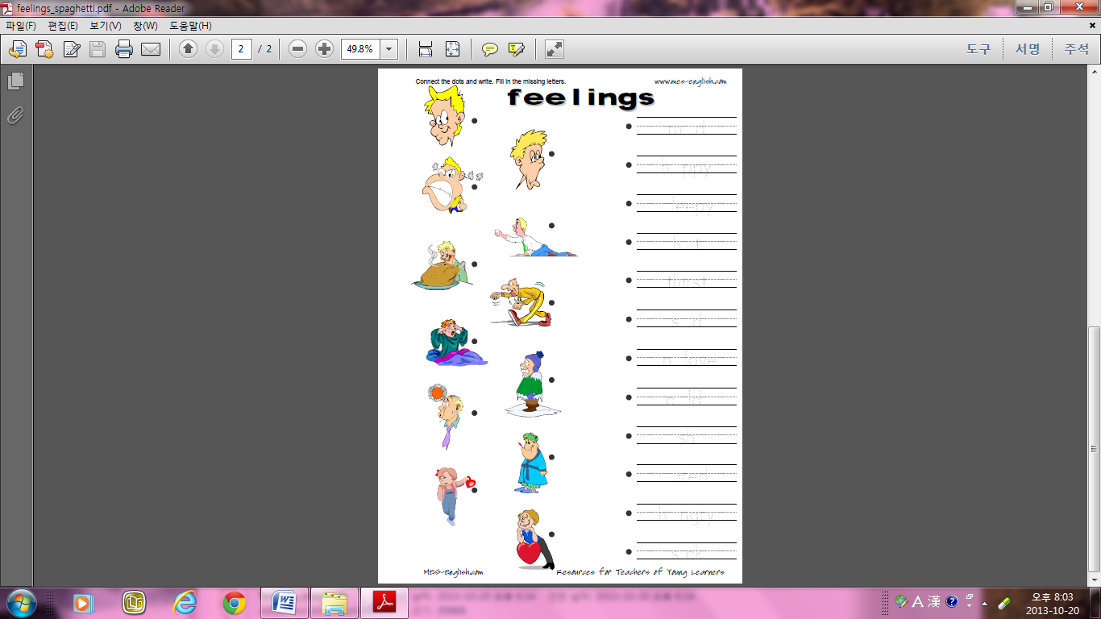

Bingo Game (4*4)

|  |  |  |  |
| --- | --- | --- | --- |
|  |  |  |  |
|  |  |  |  |
|  |  |  |  |
|  |  |  |  |