✔ Listening Speaking Reading Grammar Writing

Topic: How much do you know about Thanksgiving?

Instructor:  Se Yoo Hong | Level:  intermediate | Students:  16 | Length:  50 Minutes

Materials:
- White board, board marker
- Media player
- Vocabulary worksheet#1, Listening worksheet#2 (17copies)
- Blank paper
- Eliciting picture (Turkey)
- Computer, projector.

Aims:
- Main aim: Students will practice listening by watching a video clip and filling in worksheets.
- Secondary aim: Students will learn about vocabularies, history, American culture of Thanksgiving by matching the words, filling in worksheets and writing a letter.
- Personal aim: I want to speak out confidently and provide instructions clearly.

Language Skills:
- Reading: Reading worksheets, letters
- Listening: Ss will listen other students’ speeches and video clip.
- Speaking: Ss will speak their ideas and compare answers within groups.
- Writing: Ss will write the answer and letter.

Language Systems:
- Phonology: Practicing sounds of new vocabularies.
- Lexis: Vocabularies of Thanksgiving. pilgrims, relish, venison, stuffing
- Function: Understanding of Thanksgiving. Saying thank you.
- Grammar: General observation.
- Discourse: monologue, discussion and Q&A

Assumptions:
- Ss are adults at an upper intermediate level and are able to express their ideas in English
- Ss are used to working individually or in groups
- Ss have experienced Thanksgiving every year.

Anticipated Problems and Solutions:
- Ss may not be able to finish in time – get other students who finish their work early help them
- Ss may not have enough information from the listening - get students watch one more time & chunk the listening
- Ss may finish their tasks earlier than anticipated – ask as many students as possible about the activities or get them(groups) to summarize the topic

References:
- Video clip http://www.history.com/topics/thanksgiving/videos#bet-you-didnt-know-thanksgiving
- http://www.englishisapieceofcake.com

Lead-In
Materials: board, picture

Time | Set Up | Student Activity | Teacher Talk
5min | Whole class | Answering teacher’s questions | Greeting  Ask students about their weekend.  Ask students about upcoming event.  Show a picture of turkey and elicit.  Ask students what they know about Thanksgiving.  -Brainstorming & write on the board.  Introduce what the topic is & next activities.

Pre-Activity
Materials: board, worksheet#1
Time | Set Up | Student Activity | Teacher Talk
7min | Whole Class  Individually  Pairs  Whole Class | Listening  Doing worksheet #1  Checking the answer  Answering the questions. | 1.Vocavulary  Instruction  Get students  - work individually  - unscramble the word and match with the picture.  Tell them they have 4minutes.  Distribute the worksheet#1  ICQ  Are you working with the partner?  How much time do you have?  What are you going to do?  Answer students if they ask questions.  Give time warning : 20 seconds left.  Get students check the answers with the partner.  Go through the answers  Elicit the expression if time remains.  : Be stuffed  : go cold turkey  : Let’s talk turkey

Main Activity
Materials: media player, worksheet#2, computer, projector, board

Time | Set Up | Student Activity | Teacher Talk
7min  14min  7min | Whole Class  Groups  Groups  Groups | Listening  Watching  Discussing & talking  Talking & Answering the questions  Listening & Talking  Talking, Discussion | 1.Listening for the main idea  Instruction  Get Ss  - watch a short video clip about Thanksgiving.  - think about what it is and why is it celebrate.  (Watching)  Get Ss  - work as a group.  - talk about what they heard about Thanksgiving and share their ideas.  ICQ  Are you working alone?  What are you talking about?  (Talking)  2. Listening for Details.  Distribute the worksheet#2 to see how much they can remember.  Get Ss  - do worksheet#2(fill in the blank) as a group.  - try to remember the answers from the listening.  (Students talking)  Ask students  - if they want to listen again  - to fill in the blank as they listen  Tell them if they want to pause it and listen again, just say “Stop”, then T will rewind it.  ICQ :  So, what are you doing?  What should you say if you want to listen again?  Compare the answers with the group.  Go through the answers and listen one last time.  Tell Ss that they will be given questions about Thanksgiving based on what they just learned.  - Give Ss time to review the worksheet#2 and discuss.  -Get representatives to write the answers on the board. One who completes the answers first, will be the winner

Post Activity
Materials: Board, paper, pen.

Time | Set Up | Student Activity | Teacher Talk
10min | Whole Class  Individually  Whole Class | .Writing a letter  Reading | 1.Writing a letter  Instructions  Ask Ss about “Thank You”.  -Get students to write a thank you letter  Take back the letter, mix them up, and then distribute them randomly around the class.  Choose 5 students to read the random letter  2.Conclude Lesson  Elicit today’s lesson.  CCQ  How did the Thanksgiving start?  When is the Thanksgiving day?  What do we eat in Thanksgiving day?
SOS Activities
Materials; Board

Time | Set Up | Student Activity | Teacher Talk
10min | Groups | Discussion, making and drawing a sign. | Get Ss-  Make a symbol of Thanksgiving and name it.  Be creative.  Demonstration : Draw a man holding a turkey on the board. Explain why I chose it and what it stands for.  (Discussing)  Representatives draw a sign and explain it.

Thanksgiving –worksheet#1
Unscramble the words and match with the picture.

leihrs
grpilims
sneivno
ftufsgni
ketury

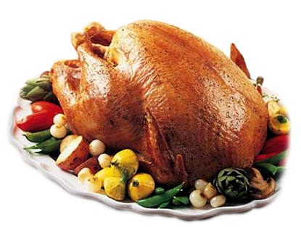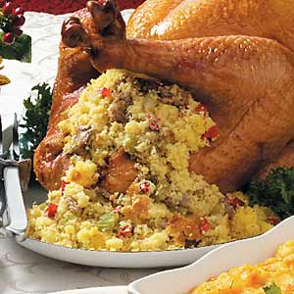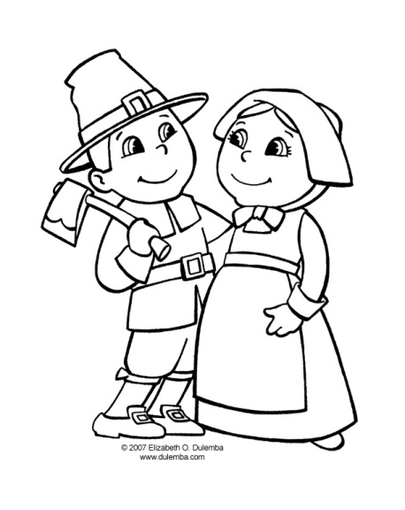

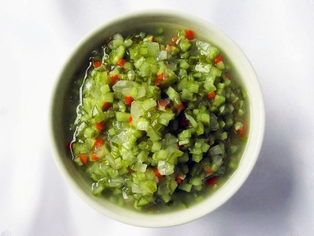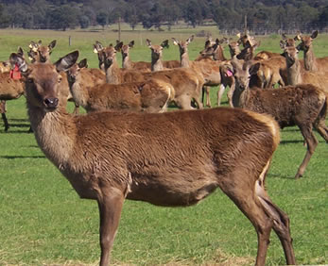

Worksheet#2

We’re all familiar with the story of the first Thanksgiving when the 1._________ invited
local Native Americans to share a meal with them. But we bet you didn’t know
Thanksgiving didn’t become an 2.______________ until more than 200 years later.
That first Thanksgiving in 1621 wasn’t just one big meal, it was a three day festival of
eating and hunting and other 3.________________ in honour of the pilgrim’s first
successful harvest. The Indians killed 5 deer as gifts for the 4._____________ so venison
was definitely on the first Thanksgiving menu. But we bet you didn’t know that turkey
was not. They also didn’t have pumpkin pie or potatoes which hadn’t been introduced to
New England yet. And while they may have eaten cranberries, they would have been
served 5.__________, and not in a sauce or 6.__________. The pilgrims didn’t plan on
starting a Thanksgiving tradition. In fact they didn’t repeat the November celebration in
7._________________ years.
In 1789, President George Washington announced the first ever national Thanksgiving
holiday, which took place on Thursday November 26th. But it didn’t become an annual
tradition 8.____________ until the 19th century, that’s when an American writer named
Sara Josepha Hale, most famous for writing the 9.______________ ‘Mary had a little
lamb’, was inspired by a diary of pilgrim life to 10._____________ that first Thanksgiving
feast, beginning in 1827, Hale 11. _____________ a nearly 30 year campaign to make
Thanksgiving a national holiday. She also published recipes for pumpkin pie, turkey, and
stuffing, that probably didn’t appear on the pilgrim’s plates, but would become the
12.______________ of modern Thanksgiving meals.
In 1863, in the 13._________ of the civil war, President Abraham Lincoln announced that
the nation would celebrate Thanksgiving every year on the final Thursday in November.
But did you know in 1939, President Franklin D Roosevelt decided to move the holiday
up a week to give 14.______________ era retailers more time to make money during the
pre-Christmas shopping season. The move was widely 15._____________, and in 1941
FDR signed a bill fixing Thanksgiving on the fourth Thursday in November, where it stays
today.
One of the 16._______________ Thanksgiving traditions began in 1989 when President
George H.W. Bush granted the first official pardon to a turkey. Every November since
then, the 17._____________________________________ has given a reprieve to one or
two turkeys, sending them to 18.____________________ on a farm rather than to a
dinner table. Though it only began in the late 20th century, this story has become one of
the more unusual chapters in the long history of Thanksgiving traditions.

